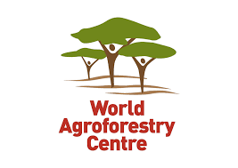

Bringing Agroforestry to Scale for Improved Livelihoods in CARE-Harande resilience zones – Scaling up smart villages for improved livelihoods in CARE-Harande resilience zones

FY2018 ANNUAL RESULTS REPORT

October 1, 2017 – September 30, 2018

Awardee Name and Host Country | World Agroforestry Centre (ICRAF)/ Mali
Award Number | AID-FFP- A-15-00013
Project Name | BrASIL-CSVIL
Submission Date | 19/02/2019
Reporting Fiscal Year | FY 2018
Awardee HQ Contact Name | Dr Tony Simons, General Director
Awardee HQ Contact Address | United Nations Avenue, Gigiri  P.O. Box 30677-00100, Nairobi, Kenya
Awardee HQ Contact Telephone Number | Tel: + (254) 20 722 4000
Awardee HQ Contact Email Address | worldagroforestry@cgiar.org /icraf@cgiar.org
Host Country Office Contact Name | Dr Catherine Dembele, Project manager
Host Country Office Contact Telephone Number | +223 20709200
Host Country Office Contact Email Address | c.dembele@cgiar.org

List of Abbreviations and Acronyms

BrASIL: | Bringing Agroforestry to Scale for Improved Livelihoods in CARE-Harande resilience zones
CSVIL: | Scaling up climate smart village for improved livelihood in CARE-Harande resilience zones
CARE: | Cooperative for Assistance and Relief Everywhere
CMA: | Community Mobilization Agent
CRS: | Catholic Relief Services
FY: | Fiscal Year
ICRAF: | International Centre for Research in Agroforestry (World Agroforestry Centre)
KI-SARL: | Kissima Industrie
MBSA: | Mali Biocarburant S.A.
NGO: | Non-Governmental Organization
WFP: | World Food Program
RRC: | Rural Resource Centre
Sahel Eco: | National Non-Governmental Organization represented in Douentza (implementing partner of Harande program)
USAID: | United States Agency for International Development
YAGTU: | Local NGO in Bandiagara (implementing partner of Harande program)

Table of Contents

1. Program Overview Table 4
2. Context 5
3. Achievement for the period October 1, 2017 – September 30, 2018 5
3.1. Project inception with communities, sites selection and preferred plants species identification 5
3.2. Training workshop on Restoration and Sustainable Management of Agro-Sylvo-Pastoral Resources and Techniques for Fodder Conservation 6
3.3. WP1 (live fence)-WP2 (fodder bank)-WP4 (restoration) WP6 (capacity development on climate services and CSA)-WP7 (improving management practices of nurseries and in farms)-WP8 (homestead gardening) 6
3.4. Establishment of life fence, fodder bank, vegetable and fruit gardens (WP1; WP2; WP9) 9
3.6. Restoration of degraded lands (WP4) 10
3.7. WP5: Linkage creation with potential buyers and promotion of marketing systems for fodder and livestock, byproduct, trees products (seeds and nuts). 14
3.8. Tree-based nutritional practices (WP9): 15
3.9. Strengthening capacities on local climate features and usage of historical records for adapted CSA options (WP6) 16
3.10. Improving management practices of nurseries and on farm activities (WP7) 16
3.11. Keeping record on CSA actions and capitalizing lessons learnt and successes (WP10) 16
4. Gender integration 16
5. Environmental compliance measures during the implementation phase 17
6. Monitoring and evaluation 17
7. Challenges, constraints and solutions 17
8. Conclusion and outlooks 17

1. Program Overview Table

Geographic Focus: The Project operates in 10 villages within 7 targeted communes of two districts, Bandiagara and Douentza in Mopti region, Mali.

Project Name: BrASIL-CSVIL

Project Goal: The main goal of this ICRAF-CARE partnership is to improve food and nutrition security by strengthening the resilience component of CARE-Harande program in the Mopti region. More specifically the FY18 activities are a follow up on the work undertaken under the FY17 initiatives and emphasize on climate related aspects.

WP1: Promote the dissemination of multipurpose life fencing species smallholder plantation with 28 Community Mobilization Agents (CMA) and 500 Harande direct beneficiaries (including 300 women)

WP2: Promote fodder banks through multipurpose tree integration in the cropping system and intensification of cultivated pastures targeting 200 Harande direct beneficiaries

WP3: Promote the use of crop residues from dual-purpose cereals and legumes in the mixed tree crop farming for livestock feeding 200 young farmers organized in 20 groups of 10 farmers each;

WP4: Restore degraded pasture land with native fodder shrub and tree in combination with native herbaceous legumes in 60 communities, 200 Harande direct beneficiaries, on 100 hectares, with 9 management rules and practices documented

WP5: Linkage creation with potential buyers and promotion of marketing systems for fodder and livestock, byproduct, trees products (seeds and nuts). These activities target 500 Harande direct beneficiaries (including 300 women) to be linked with MBSA for Jatropha nuts, and 200 Harande direct beneficiaries (including 100 women) to be linked with Balanites market through the now potential Balanites PPP with KISARL

WP6: Strengthening capacities on local climate features and usage of historical records for adapted CSA options

WP7: Improving management practices in nurseries and in-farms

WP8: Promote homestead gardening and farming diversification on restored lands

WP9: Promoting tree-based nutritional practices and income diversification

WP10: Keeping record on CSA actions and capitalizing lessons learnt and successes

Roles and Responsibilities:
ICRAF in collaboration with CARE Harande and their other implementing partners (YAGTU and Sahel Eco) ensure smooth implementation of the different activities of the project for the sake of harmonization.

2. Context

The BrASIL-CSVIL project is a collaborative project between the World Agroforestry Centre (ICRAF) and CARE Mali (HARANDE Program) for maximizing synergies. The Goal of the Harande program, meaning ‘food security’ in Fulani, consists of “Sustainable food, nutrition and income security for vulnerable household members in Youwarou, Tenenkou, Bandiagara and Douentza in Mopti region. The collaboration under BrASIL-CSVIL aims at ensuring a better intervention that takes full account of adaptation to climate change, optimal natural resource management and reduction of target communities’ vulnerability to climate change. This partnership puts high emphasis on the bottom up and community led, cascading training of trainers and farmer-to-farmers learning approaches. A key strength of the Harande program is its links with other development actors that maximize synergy and multiply impacts for population groups beyond the targeted communities as well as leveraging efforts funded by USAID by establishing linkages with Feed the Future projects. In order to be more inclusive and innovative in its approach, Harande proposed to work closely with all the USAID projects operating in the Mopti region but also other development actors. Initially, the project was planned to be implemented in 10 villages in Mopti region. However, in 2018, the security issues have been degraded within the region especially in the district of Douenza. Therefore, our activities were focused within 2 villages, Dandoli (new) and Sincarma (old) in the district of Bandiagara. Some activities were done in three other new villages including Koé Doe (Commune of Pignari), Wendéguélé (Commune of Dandoli) and Ourou (Commune of Dourou), all in the Cercle of Bandiagara of Mopti region.
The present report gives an overview of activities conducted in the Fiscal Year of 2018 from October 1, 2017 to September 30, 2018 under the BrASIL-CSVIL project.

3. Achievement for the period October 1, 2017 – September 30, 2018

3.1. Project inception with communities, sites selection and preferred plants species identification

In October 2017, ICRAF in collaboration with CARE-Harande staffs met with communities in the nine (9) remaining villages where the BrASIL-CSVIL project intervenes. It should be noted that the BRASIL-CSVIL project target 10 villages and in one of them (Sincarma), activities had already begun in June 2017. The purpose of the October trip was to visit the target villages, discuss with communities to explain the BrASIL-CSVIL project objectives, assess their interest/willingness to be engaged and also express what was expected from them for successful implementation of the project.
It should be noted that the village of Manko is replacing the village of Bore which was initially targeted but where communities and their leader did not show much interest during field visit. Also field information from communities mentioned potential risk of troubles in the village of Koumbena (initially targeted) and this village was replaced by Koira-Bery.
Overall, for the retained villages, interesting communities' mobilization was observed. About 220 participants including 54% women attended the meetings and the team was able to gather relevant information that was used for planning and implementation of the activities under the different work packages of the BRASIL-CSVIL project.

3.2. Training workshop on Restoration and Sustainable Management of Agro-Sylvo-Pastoral Resources and Techniques for Fodder Conservation

This training contributed to materializing the idea of synergies between USAID funded projects. Indeed, it was jointly organized for state extension staff and NGO agents working in the framework of SmAT-Scaling and BrASIL-CSVIL projects, on 20-24 November 2017 in Mopti. The workshop focused on a range of management practices and information services that could improve the agro-pastoral systems’ productivity and resilience to climate shocks including improved range and pasture management, rotational grazing and pasture improvement, regeneration of degraded rangelands and improving rainfall capture, soil cover and fodder bank establishment. The training also covered the regulatory frameworks governing agro-sylvo-pastoral resources in Mali. In total, 28 participants (including 4 women) coming from CARE Harande, its partner NGOs namely YA-G-TU and Sahel-Eco, Government technical services (Agriculture, livestock and Forestry), and national research institution (IER) and ICRAF attended the training workshop.

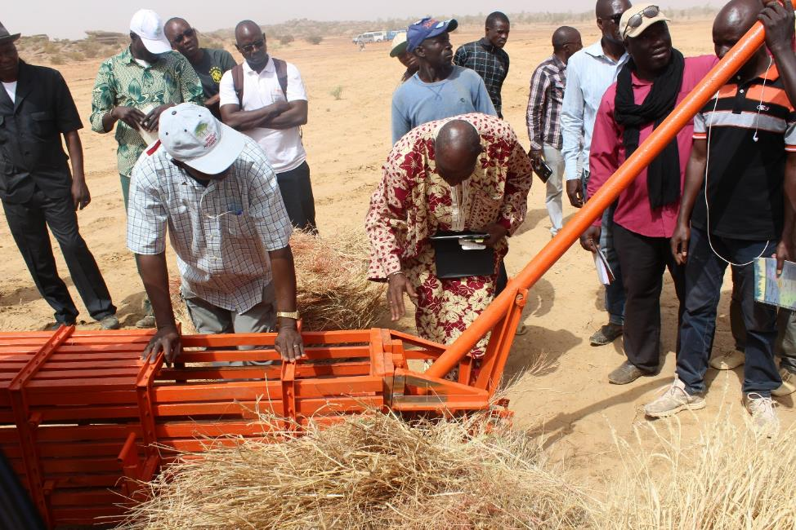
Photo 1: ICRAF staff demonstrating various methods of fodder conservation (Credit: Camara I.)

3.3. WP1 (live fence)-WP2 (fodder bank)-WP4 (restoration) WP6 (capacity development on climate services and CSA)-WP7 (improving management practices of nurseries and in farms)-WP8 (homestead gardening)

Most of the work ackages needs trees for implementation. In order to capacitate the stakeholders to plant good plant material, ICRAF organized trainings on plants production in nursery, plant grafting, vegetable and food bank plots establishment, and assisted communities to effectively establish their nurseries (one in 9 intervention villages out of 10). For security reasons, participants of village of Batouma attended the training session in the village of Manko. In total, 648 people including 420 women attended the trainings (Table 1).

Table 1: Number of participants in the training sessions in each village
No | Village/Nursery | Communes | Women | Men | Total
1 | Sincarma | Dandoli | 34 | 11 | 45
2 | Dandoli |  | 83 | 11 | 94
3 | Wendéguélé |  | 45 | 4 | 49
4 | Ourou | Dourou | 36 | 22 | 58
5 | Koe Doe | Pignari | 12 | 51 | 63
6 | Kayel Toupé | Lowel Guehou | 13 | 13 | 26
7 | Koïra Bery | Koubewel Koundia | 37 | 32 | 69
8 | Tabaco |  | 89 | 24 | 113
9 | Manko | Boré | 71 | 45 | 116
10 | Batouma |  | 0 | 15 | 15
 | Total |  | 420 | 228 | 648

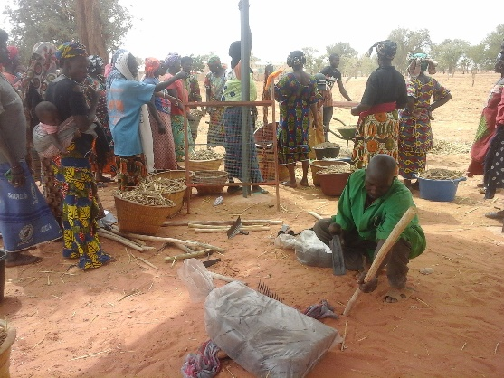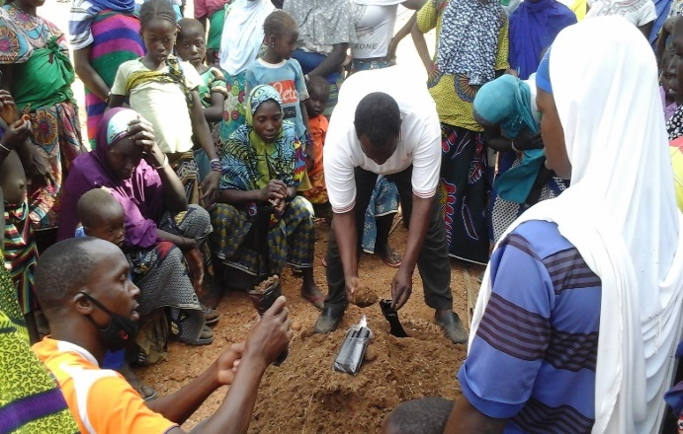

Photo 2. Planting substrat preparation and filling of the nursery bags

The number of bags filled and sown during the training is given per species and per village in Table 2 below. It should be noted that each village received 10,000 bags and they agreed to continue plants production after the training sessions.

Table 2: Number of bags prepared and sown in each nursery during the training
Species | Dandoli | Sincarma | Wendéguélé | Ourou | Koé Doe | Kayel Toupé | Koïra Bery | Tabaco | Manko | Batouma | TOTAL
Piliostigma reticulatum | 390 | 400 | 210 | 440 | 200 | 838 | 200 | 200 | 200 | 0 | 3,078
Adansonia digitata | 260 | 200 | 400 | 310 | 400 | 480 | 0 | 0 | 0 | 0 | 2,050
Acacia colei | 650 | 400 | 500 | 340 | 400 | 0 | 0 | 200 | 0 | 0 | 2,490
Grewia molis | 260 | 0 | 200 | 360 | 200 | 0 | 200 | 200 | 200 | 0 | 1,620
Ziziphus mauritiana | 780 | 600 | 300 | 230 | 400 | 1040 | 200 | 200 | 200 | 0 | 3,950
Moringa oleifera | 520 | 400 | 367 | 270 | 423 | 240 | 0 | 0 | 0 | 0 | 2,220
Tamarindus indica | 390 | 0 | 100 | 120 | 0 | 0 | 200 | 200 | 100 | 0 | 1,110
Pterocarpus lucens | 260 | 0 | 200 | 260 | 200 | 0 | 200 | 0 | 200 | 0 | 1,320
Ficus platiphyla | 0 | 0 | 0 | 80 | 200 | 0 | 0 | 0 | 0 | 0 | 280
Prosopis africana | 0 | 0 | 0 | 480 | 400 | 0 | 200 | 200 | 200 | 0 | 1,480
TOTAL /VILLAGE | 3,510 | 2,000 | 2,277 | 2,890 | 2,823 | 2,598 | 1,200 | 1,200 | 1,100 | 0 | 1,9598

For security reasons, participants of the village of Batouma attended the training session in the village of Manko

During the follow up of the success of plants production, the village of Manko (Boré) had the highest (10102) filled bags while Dandoli had the lowest (4155). Manko also had the highest number of species being propagated at the nursery (12), followed by Koïra Bery (11) while the lowest number was observed in Kayel Toupé and Koé Doe, with only 6 species. The two communities had more species because, on their own initiative, they had sown other tree species (such as Eucalyptus camaldulensis, Lawsonia inermis and/or Mangifera indica) in addition to those provided by ICRAF team composed of essentially indigenous tree species such as Andasonia digitata (baobab), Taamarindus indica (tamarin) or Ziziphus mauritiana (jujube).

In terms of germination, overall, the germination rate was satisfactory with relatively better state in Kayel Toupé, Manko, Koïra Bery and Dandoli. The supervising team advised to collect seedlings from bags with more than one seedling and transplant them in empty bags to increase the success of plant propagation. Also renewing the sowing was advised when necessary.
Some communities got low germination rate at the beginning as they did not follow the prescription given for seeds pre-treatment for some species (Acacia colei, Prosopis africana, Tamarindus indica and Adansonia digitata, etc.); they therefore had to re-sow and consequently run out of seeds (Kayel Toupé, Koé Doe, Wendéguélé, Koïra Bery and Tabaco). Instructions for seeds pre-treatment were emphasized again during this supervision mission and the communities were provided with new sets of seeds. A bio pesticide was prepared from extracts from leaves and fruits of neem tree (Azadirachta indica) and used to treat plants attacked by insects. Both leaves and fruit of neem plants are known to have bitter taste having fungicidal, insecticidal and nematocidal properties.

3.4. Establishment of life fence, fodder bank, vegetable and fruit gardens (WP1; WP2; WP9)

A total of 1180 m of life fences were established within 3 villages, Dandoli (400 m), Sincarma (610 m) and Koe-doe (170 m). There are in total 1756 plants propagated from 5 tree species including Balanites aegyptiaca, Ziziphus mauritiana, Jatropha curcas, Lawsonia inermis, and Moringa oleifera. The detail showing the number of plants per species per village is summarized on Table 3.

Fodder banks and vegetable and fruit tree gardens were established in 3 villages, Dandoli, Sincarma and Koé Doe protected with live fences. For the old site of Sincarma dead plants were replaced in the fodder bank. The plantation of Dandoli were established inside the rural resource centre (RRC) constructed by CRS on an area of 2,500 m² (50m x 50m) while in Koé Doe it was done on a communal land of 1,750 m² (50m x 35m). The plantation for all these activities is detailed in Table 3.

Table 3: List of tree species planted for life fences, fodder banks, fruit and vegetable gardens in Dandoli, KoeDoe and Sincarma.
Technologies  Species\Village | Life fence (WP1) |  |  | Fodder bank (WP2) |  |  | Fruit and vegetable garden (WP9) |  |  | Total
 | Dandoli | KoéDo | Sincarma | Dandoli | KoéDoe | Sincarma | Dandoli | KoéDoe | Sincarma
Gliricidia sepium |  |  |  | 104 | 0 |  | 0 | 0 |  | 104
Grewia molis |  |  |  | 26 | 13 | 30 | 0 | 0 |  | 69
Ficus platyphylla |  |  |  | 26 | 16 | 30 | 0 | 0 |  | 72
Prosopis africana |  |  |  | 26 | 16 |  | 0 | 0 |  | 42
Piliostigma reticulatum |  |  |  | 26 | 32 | 30 | 0 | 0 |  | 88
Pterocarpus lucens |  |  |  | 26 | 19 | 69 | 0 | 0 |  | 114
Adansonia digitata /Nonokènè |  |  |  | 0 | 0 |  | 11 | 8 | 65 | 84
Balanites aegyptiaca | 102 |  |  | 0 | 0 |  | 11 | 0 |  | 113
Mangifera indica |  |  |  | 0 | 0 |  | 0 | 16 |  | 16
Tamarindus indica |  |  |  | 0 | 0 |  | 22 | 8 | 30 | 60
Tamarindus indica Sucré |  |  |  | 0 | 0 |  | 11 | 0 |  | 11
Eucaliptus camaldulensis |  |  | 7 |  |  |  |  |  |  | 7
Ziziphus mauritiana | 188 | 0 | 80 | 0 | 0 |  | 11 | 16 |  | 295
Jatropha curcas (direct seeding) | 297 | 164 | 178 | 0 | 0 |  | 0 | 0 |  | 639
Lawsonia inermis | 102 | 164 | 55 | 0 | 0 |  | 0 | 0 |  | 266
Moringa oleifera | 138 | 57 | 194 | 0 | 0 |  | 0 | 0 |  | 389
Total | 827 | 415 | 514 | 234 | 96 | 159 | 66 | 48 | 95 | 2,369

3.5. Dual-purpose crops (WP3)

For the production of both fodder and grain, 200 sets of 5 kg of seeds of dual-purpose cowpea (Sangaraga) and 200 sets of 5 kg of fertilizer NPK have been distributed to 200 farmers by site coordinators in Bandiagara and Douentza. The farmers were volunteer producers targeted by the CMA and supervisors of CARE Harande.

3.6. Restoration of degraded lands (WP4)

Contour lines outlining and contour bunds management

Contour binding technician from AMEDD, a national NGO based in Koutiala were committed to find and delineate contour lines, evaluate the slope level and the direction of water run-off on degraded lands identified by farmers in the 4 villages including Koé Doe, Wendéguélé, Ourou and Dandoli (Table 4). Following the identification of contour lines in the degraded lands, a tractor was hired to plow deeply the contour line delineated and allow carrying out other water and soil conservation techniques. During the year 2018, 509 farmers including 221 women and men 288, were organized and trained to construct earth bunds (60 cm at the base with 30 cm height) on contour lines, half-moons, zai pits and tree planting following food for work strategy of CARE.

Table 4: Degraded land area managed for restoration in the project area
No. | Villages | Area (Ha)
1 | Koé Doe | 9.02
2 | Wendéguélé | 2.8
3 | Ourou | 23.1
4 | Dandoli | 66.2
TOTAL |  | 101.12

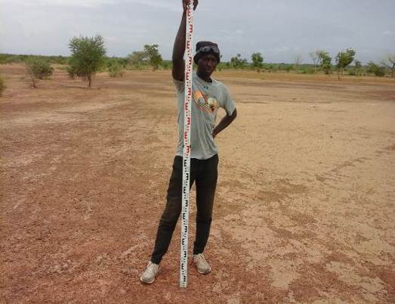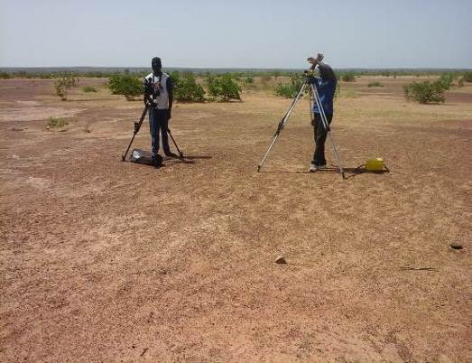
Photo 3: Determination of contour lines, slope level and direction of water using theodolite (Credit: O. Samaké)

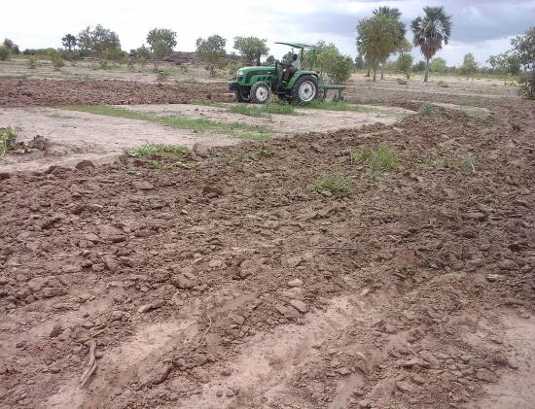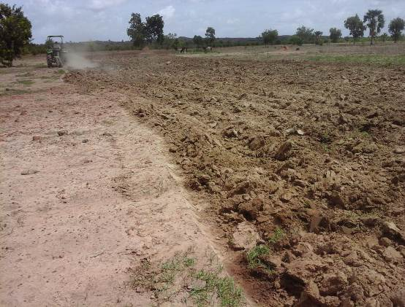
Photo4: Deep subsoiling of degraded land using tractor (Credit: O. Samaké)
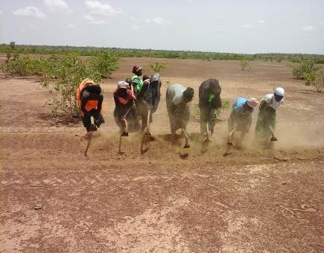 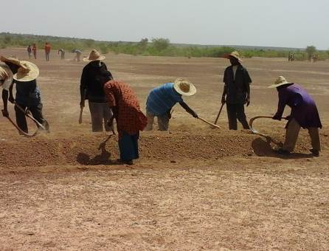 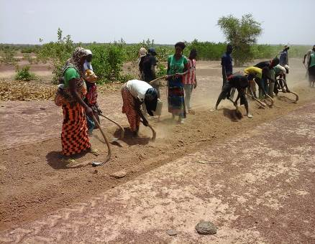 Photo5: Earth bund construction by farmers (Credit: O. Samaké)

Half-moon construction, fodder herbaceous and fodder tree planting

About 1146 half-moons were constructed for the restoration of 101 ha of degraded lands within the 4 villages. Half-moons were combined with direct seeding of more than 170 kg herbaceous and four fodder tree species plantations for improving fodder production on the degraded land while increasing soil water infiltration. Various types of haft-moon were constructed: (4m X 2m), (6m X 3m) and (8m X 4m). The larger sizes of half-moon were the result of collaboration with PALM Harande who had taken advantage of our activities to train trainers and farmers on new approach of half-moon associated with zai pits and trenches. The opening of the half moon is oriented toward the slop. After construction, manure was applied before fodder tree planting and seeding of 8 herbaceous species (Table 5). The fodder tree species include Gliricidia sepium, Prosopis africana, Pterocarpus lucens, Ficus platyphyla. Table 5 shows the fodder herbaceous used. In addition to the fodder herbaceous, farmers have sown fonio (Digitaria exilis), a local cereal species within some half-moons. This is an innovation of farmers of Sincarma who have sown on the fly fonio in 15 half-moons. Zai pits were also dug within large size half-moon for improved cowpea seed sowing. The dual-purpose cowpea varieties (both fodder and grain production) were sown in the zai pit within some half-moon.

Table 5: List and seed quantity of fodder herbaceous species used for reinforcing half-moon
No | Scientific names | Quantity (kg) | Name in Dogon, a local language
1 | Alysicarpus ovalifolius | 20
2 | Cenchrus biflorus | 20 | Kòlòmò
3 | Eragrostris tremula | 20 | Sadeypògò
4 | Panicum laeta | 20 | Dikérou / Goumon
5 | Schoenfeuldia gracilis | 20 | Olon
6 | Senna tora | 30 | Sambagankana
7 | Zornia glochidiata | 20
8 | Leptadenia hastata | 20
9 | Digitaria exilis | 5 | Pognol

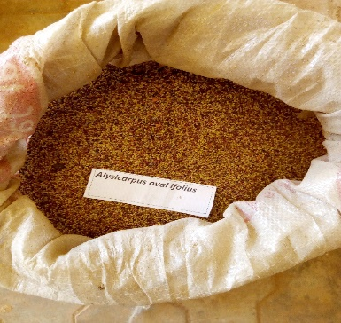
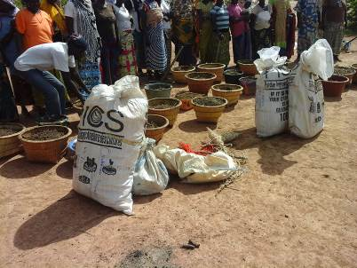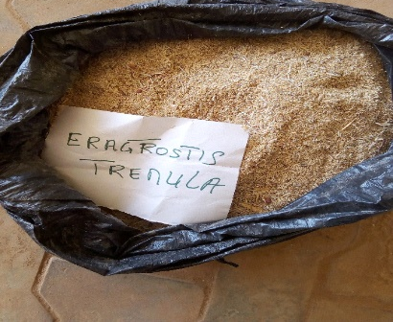
Photo 6: Seeds of herbaceous species and fonio exposed to communities during the construction of half-moon on the degraded lands in Sincarma
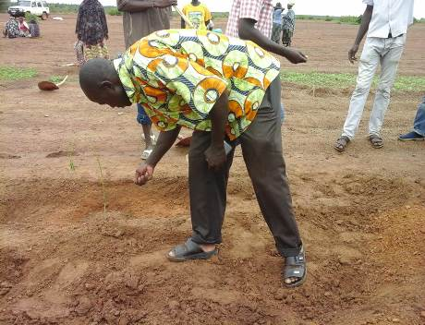 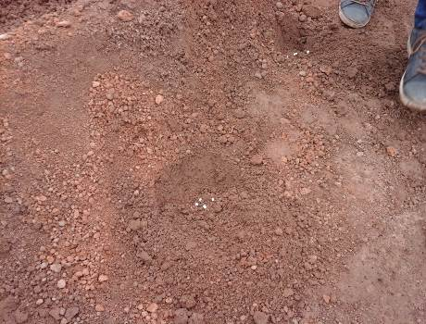 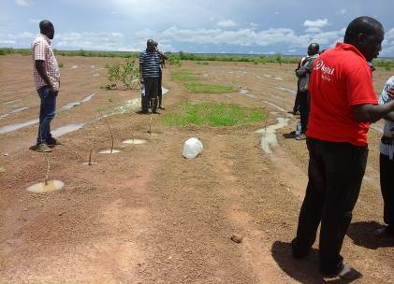 Photo7: Fodder tree planted along contour bunds

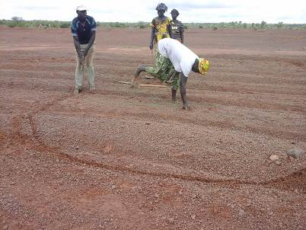 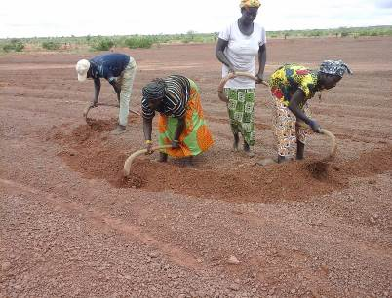 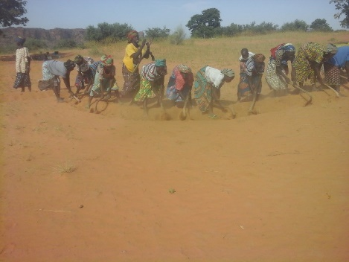Photo 8: Delineation and construction of half-moon by farmers

Other multipurpose tree planting along earth bunds and half-moon constructed on the degraded lands

More than 22,000 plants of various multipurpose tree species were planted along the earth bunds, in line between the earth bunds and on the border of the half-moon constructed on more than 100 ha of degraded land mainly in Dandoli (66 ha), Sincarma (10 ha), and Koé Doe (9 ha). Acacia colei, Boscia senegalensis, Gliricidia sepium and Jatropha curcas were planted along earth contour bunds with spacing of 0.5 m x 0.5 m while Balanites aegyptiaca and Ziziphus mauritiana were planted in line between the contour bunds with a spacing of 15m x 15m (Table 6).

Table 6: List of multipurpose tree species planted along with degraded land restoration technics in Dandoli (V1), Sincarma (V2), Koé Doe (V3)
Technologies  Species\Village | Tree planting along earth bunds |  |  | Tree planting between earth bunds |  |  | Tree planting on half-moon |  |  | Total
 | V1 | V2 | V3 | V1 | V2 | V3 | V1 | V2 | V3
Acacia colei | 873 | 0 | 220 | 0 | 0 | 0 | 0 | 0 | 0 | 1,093
Balanites aegyptiaca | 0 | 0 | 0 | 4,395 | 650 | 0 | 0 | 0 | 0 | 5,445
Boscia senegalensis | 1,003 | 350 | 0 | 0 | 0 | 0 | 0 | 0 | 0 | 1,353
Ficus platyphylla | 0 | 0 | 0 | 0 | 0 | 0 | 50 | 0 | 0 | 50
Gliricidia sepium | 2,959 | 105 | 0 | 0 | 0 | 0 | 81 | 0 | 0 | 3,145
Grewia molis | 70 |  | 0 | 0 | 0 | 0 | 87 | 71 | 0 | 228
Jatropha curcas | 4,072 | 117 | 0 | 0 | 0 | 0 | 0 | 0 | 0 | 4,189
Piliostigma reticulatum | 0 | 0 | 0 | 0 | 0 | 0 | 43 | 0 | 0 | 43
Prosopis africana | 0 | 0 | 0 | 0 | 0 | 0 | 35 | 0 | 0 | 35
Pterocarpus lucens | 0 | 0 | 0 | 0 | 0 | 0 | 21 | 0 | 0 | 21
Sclerocarya birrea | 0 | 0 | 0 | 105 | 0 | 0 | 0 | 0 | 0 | 105
Ziziphus mauritiana | 0 | 0 | 0 | 5221 | 787 | 563 | 0 | 0 | 0 | 6,571
Total | 8,977 | 572 | 220 | 9,721 | 1,437 | 563 | 317 | 71 | 0 | 22,278

3.7. WP5: Linkage creation with potential buyers and promotion of marketing systems for fodder and livestock, byproduct, trees products (seeds and nuts).

On the 29th of May 2018, a meeting was organized in the meeting room of CARE in Bandiagara for establishing connection between BRASIL-CARE project and two Private partners of the SmAT-Scaling project Mali Biocarburant (MBSA) and Kissima Industrie (KISARL).

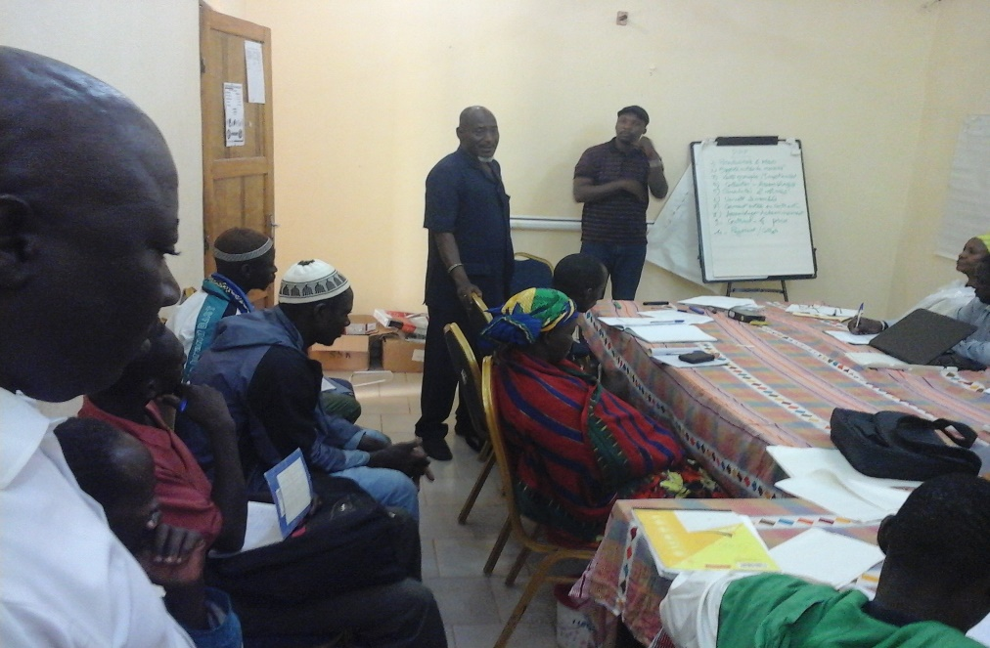
Photo 9: Session of setting relation with private partners, Bandiagara

The meeting was attended by:
- The Coordinator of ICRAF SAHEL
- The director of KISARL
- A representative of MBSA
- The Livelihood Specialist of CARE
- The Coordinator of Mopti Tombouctou site
- The assistant of non-agricultural activities of CARE
- The CMA of BRASIL-CARE intervention zone
- A field supervisor of YA-G-TU
- And 18 farmers including 2 women from the villages of Dandoli, Sincarma, Wendeguele, Ourou, Koe Do and Kayel Toupe.

The objective of the meeting was to (i) Discuss with involved partners; (ii) Define collaboration pathways; (iii) Establish a formal partnership between partners; (iv) Identify needs of Jatropha producers; and (v) Collect suggestions / recommendations from partners.
Ten major points were specifically discussed namely, (1) Potentials and Assets, (2) Market opportunities, (3) Group sales / Importance, (4) Product collection and gathering, (5) Quality and standard, (6) Requested varieties, (7) How to get linkage? (8) Products gathering and transport to market, (9) Contracts and prices and (10) Payment / collection.
In order to link farmers and PPP (private and public partnership) and to increase the opportunities of market for seeds that will be produced from Jatropha plantation, farmers have been sensitized for planting. About 600 kg of jatropha seeds were distributed to volunteer farmers in Bandiagara (400 kg) and Douentza (200 kg) for testing as life fence and for seed production.

3.8. Tree-based nutritional practices (WP9)

Vegetable boards of food bank of baobab and moringa have been established in the 10 nurseries installed for leafy vegetable production. Farmers were trained to established and manage the plots to produce leafy vegetable for household consumption or selling.
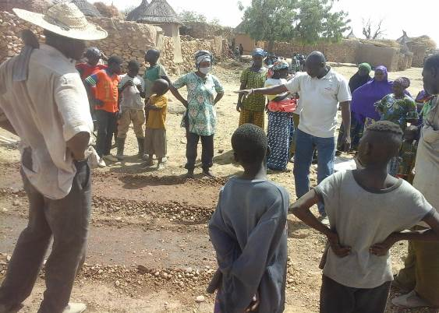 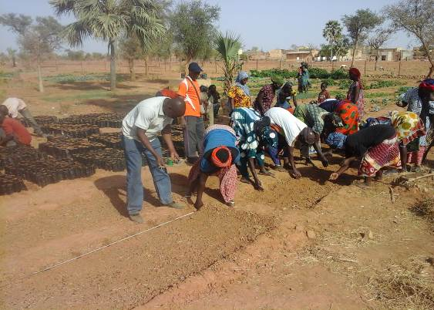 Photos 10: Confection and seeding of baobab and moringa seeds in the vegetable food bank, Wendéguélé & Kayel Toupé

Fruit gardens were also established using fruit tree species indigenous to the Sahel in 3 villages Dandoli, Sincarma and Koé Doe from August 27 to the 6 September 2018 (Table 7). The various fruit species planted include Adansonia digitata (grafts), Balanites aegyptiaca (seedlings), Tamarindus indica (grafts and seedlings), Slerocarya birrea (seedlings), Mangifera indica (seedlings), Ziziphus mauritiana (grafts). A total of 209 trees were planted. The use of grafted plants is to fasten and improved fruit production.
A culinary demonstration to diversify household diet with the use of fresh and dry leaves of baobab and moringa were organized in October 29, 2018 in Dandoli. 67 participants including at least 31 women have attended the demonstration.

Table 7: Fruit species planted in Dandoli, Sincarma and Koé Doe
Species | Village |  |  | Total
 | Dandoli | Sincarma | KoéDoe
Adansonia digitata/Nonokènè | 11 | 65 | 8 | 84
Balanites aegyptiaca | 11 | 0 | 0 | 11
Manguifera indica | 0 | 0 | 12 | 12
Tamarindus indica | 22 | 30 | 8 | 60
Tamarindus. indica / Sucré | 11 | 0 | 0 | 11
Ziziphus mauritiana | 11 | 0 | 16 | 27
Totaux | 66 | 95 | 48 | 205

3.9. Strengthening capacities on local climate features and usage of historical records for adapted CSA options (WP6)
To enhance the resilience of farmers to the negative effect of climate change and variability, we have planned to strengthen the capacity of farmers on new concepts and approaches such as climate smart village (CSV) and Participatory Integrated Climate Services for Agriculture (PICSA). The training will be done within the 6 month no-cost period requested for 2019.

3.10. Improving management practices of nurseries and on farm activities (WP7)
The training has been continuously made for 46 farmers to well manage the nurseries established and the activities carried out in the project area. About 46,362 trees produced in the nurseries in the villages (26,919 in Bandiagara, 19,943 in Douentza) along with 25,000 plants propagated at ICRAF were all transported to the BrASIL-CARE project areas and planted for fodder, fruit and vegetable production and for restoring more than 100 ha of degraded lands identified by the communities.

3.11. Keeping record on CSA actions and capitalizing lessons learnt and successes (WP10)
Ongoing documentation is being made for lessons learnt from the implementation of the technologies in the project area.

4. Gender integration
For the different activities (All WPs for BrASIL-CSVIL), women, men and youth had actively participated as shown on Table 8. Everywhere, women mobilization was important. For instance, for the training on plant propagation and nursery establishment conducted in Q3-FY18, 420 out of 648 participants (64.81%) were women.

Table 8: Number of participants to all activities implemented in the project area-2018
 | Women | Men | Total
Inception meetings with communities | 119 | 101 | 220
Training on nursey plant propagation and grafting | 420 | 228 | 648
Training on natural resources management and pasture improvement | 4 | 24 | 28
Degraded land restoration and tree planting | 221 | 288 | 509
Meeting for linking private sector with farmers | 14 | 29 | 43
Culinary demonstration | 31 | 36 | 67
Total | 809 | 706 | 1,515

5. Environmental compliance measures during the implementation phase
The technologies have been installed with the absolute respect of the environment, especially, to the level of the parcels to restore. The natural vegetation including shrubs, trees and herbaceous has been preserved while new species were introduced for enrichment and increasing the diversity. Seedlings were produced sometime reusing plastic waste of mineral water. CARE was taken to collect all plastic waste from the site and burying or burning them after plantations.

6. Monitoring and evaluation
During the year 2018, the main activities were the implementation of several agroforestry technologies for soil and water conservation, for vegetable and fruit production and consumption and fodder production with active participation of farmers. The community mobilization agents were required to monitor each activity implemented on the ground. We can say the year has been successful in spite of the security issue.

7. Challenges, constraints and solutions
Challenges/Constraints | Solutions and Responses | Status
In the project intervention areas, security continues to be a serious issue impeding the implementation and supervision activities according to the workplan. | The project team is finding alternative adapted operation modes (using local vehicle for field trips, etc.). | Continuous

8. Conclusion and outlooks
During the year 2018, the communities have actively participated to all the activities carried out with focus on degraded land restoration in the project area. The local authorities including village chief and mayor have also supported the implementation of the project. They have contributed to sensitizing and mobilizing the communities along with communal mobilization agents (AMC). The agent of YaGTu-Harande land also had been very active in supporting and helping in the field from the beginning to the end. Moreover, the site of Dandoli was used by the World Food Program (PAM) for training and demonstration of some of their activities such as the use of bigger size half-moon (6m x 3m) combined with trenches and zaï pits. This was an opportunity of collaboration between ICRAF and PAM through degraded land restoration implemented by ICRAF in Dandoli.

