

IMPROVED HOUSEHOLD LIVELIHOOD SECURITY IN TRANSITIONAL AREAS

PROGRESS REPORT
October- December 2005

Executive Summary

This report illustrates the activities undertaken by the Improved Household Livelihood Security Project as from October through to December 2005.

A considerable achievement has been accomplished in terms of promoting community awareness in issues pertaining to peace building and sustainable livelihood strategy of the targeted communities. This reporting period concentrated on building the managerial and leadership qualities of the VDCS to foster better understanding about the community needs and CPA dissemination as a pre-requisite for conflict mitigation, peace building, and peaceful coexistence. Thus 14 community gatherings were organized to widen the scope of the community on the most potential challenges most likely to occur during the post conflict era. The sessions were attended by more than 2,000 IDPs, residents and return populations.
Various training, community dialogue, community gathering and trust sharing, rebuilding social fabric and peaceful coexistence between the residents and return population were launched. Strengthening capacity building sessions were organized for creating an enabling environment that would foster information sharing and explore innovative capacity of partners in handling developmental activities more effectively and sustainably.
The capacity building component (which is funded by the FSWD project) has made good progress. The literacy training for 1060 participants (out of which 70% were female) has been on going during the reporting period, the project was faced with a number of factors that had either positive or adverse effects on the implementation process. Those were:

Disadvantage factors
- Slow implementation process of the CPA
- Logistical/transportation difficulties for the returnees from the north to their places of origin in the south
- Lack of services in the areas of population return
- Lack of employment opportunities, unlike in the north in which the displaced are occupying marginal jobs hence can earn some income.
- Insecurity in some areas because of landmines

Advantage factors
- The general security situation has improved throughout the areas of operation during the reporting period, thus creating an enabling environment for communities to travel freely, and undertake livelihood activities that sustain their living conditions.
- The attention given for empowerment of the traditional/community leaders by the project and local authority in issues pertaining to conflict mitigation and management so as to avoid conflict over land resources due to massive population return to the places of origin.
- The high expectation among most farmers that this season is more favorable compared to the previous years because of good rainfall in terms of quantity and distribution. Thus would increase production.

PART ONE

Contextual analysis

The political and administrative vacuum

Western Bahr el Ghazal is made up of three counties namely Wau, River Jur and Raja counties. The inhabitants of the State are composed mainly of three ethnic groups. Fertit group form the majority of the population followed by Luo/Jur and Dinka. Unity State is made up of 9 counties, inhabited by approximately 1,560,000 inhabitants that are mainly from Nuer and Dinka ethnic groups.

The government structure includes the Governor, Ministers, Advisors and Commissioners. Wau and Bentiu are the government seats for Western Bahr El Ghazal and Unity States respectively.

The areas had been seriously affected due to the civil war and tribal conflicts since the early 1980’s. Many of the citizens had escaped the war and are living as IDPs both in the north and within south Sudan. After the signing of the CPA between the government and SPLM, a large number of spontaneous returnees have since arrived in the area and it is expected that a greater number of the IDPs will continue returning voluntarily. This trend entails some preparedness to receive them and render some basic services.

Following the implementation of the CPA the area has witnessed a series of political and administrative events. These events seriously hampered economic and administrative policies that could have been formulated by the States government as a basis for better economic and social wellbeing of the people in the area. The vacuum created by delayed formation of the States government adversely affected perception and attitudes of people in the area towards the CPA. Equally when the government was established in November 2005, the new government seems not to be accepted by some politicians and the people because of the following:

- The policy of exclusiveness in civil service lays on party loyalty creating personal grievances.
- Practices of tribalism and nepotism emerging in the two states.
- Less attention on Priority area for water, electricity and working environment not conducive
- The integration of some militia forces to SPLA/M forces
- The delay in payment of salaries of employees

Population movement

About 60% of the internal displaced people in the Sudan are from Bahr el Ghazal and Unity States. As mentioned above many spontaneous returnees have returned to Wau and Bentiu towns mainly from the former SPLM controlled areas within southern Sudan as well as from the northern States. The slow rate of return could be attributed to:

- Slow process of implementation of the CPA
- Logistical/transportation difficulties from the north to the places of origin.
- Lack of basic services in the areas of return
- Lack of employment opportunities, only marginal jobs to earn money
- Insecurity in some areas because of landmines

It is worth mentioning that the rate of population return to the area has considerably increased after the death of SPLA/M leader last September 2005, formation of the Southern government and integration of some militias to the SPLA and the national Sudanese army.

Market
Most of the essential commodities in the area were transported from Khartoum to Unity State by land and expensively flown by air to Wau. After the signing of the CPA, some roads became accessible and flow of goods/commodities by land from Uganda and Kenya has been witnessed but the prices are still high although there is increase in local products such as meat, vegetable and fruits.

General Security

General security situation in Bahr el Ghazal and Unity States has been calm after the SPLA /GOS have signed the CPA (January 9/2005). The arrival of the UN peace monitors and presence of the SPLA troops in the two States reduced the aggressiveness of the militia groups who were opposed to the CPA agreement citing that they were not represented in the talks. This initially prompted fears and panic among local population, currently the situation has been controlled by both GOS and SPLA/M and no violence or harassment experienced during the reporting period. The security situation has been further enhanced by the continuous appeal made by the president of Southern Government for the need to integrate the militia groups to either the national army or SPLA by latest January 2006.

PART TWO

Objective 1

5,444 and 3,078 residents and returnee households in Unity and Bahr El Ghazal States respectively living in war-affected areas have improved (levels of sustainable income) livelihood copping mechanisms through the provision of capacity building and inputs for small business enterprises.

Achievements/Accomplishments made during this quarter

Bahr El Ghazal State

- Capacity and knowledge of 600 persons have increased in identifying issues pertaining to their livelihood through better understudying and perception of CPA and its challenges. This was attained through community participation in the 4 communities gathering organized at 4 villages.
- 400 agricultural hand tools were distributed to 100 women vegetable growers at 2 villages so as to increase vegetable production for home consumption and the surplus can be taken to the market.
- The 28 Village Development Committees formed, their capacities have been improved through, management and skills training conducted.
- 26 persons from the IDPs have engaged in bricks making activity. Thus, their incomes reported to have increased.
- 93 traditional/community leaders representing 28 villages attended sessions for conflicts mitigation and peace building.

Village Development Committees’ representatives and traditional
Leaders after an awareness session in Bahr El Ghazal
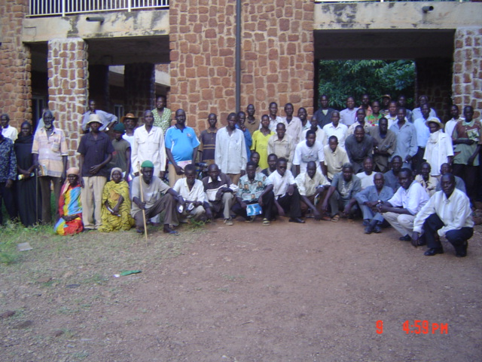

Unity State

- 13 VDCs were formed and one day training was organized to better understand the role and responsibilities of the VDCS.
- Workshops were organized for three CBOS so as to better improve their skill in prioritizing the needs of the community they serve.
- Training for 18 native court chiefs was done on issues of conflict resolutions and conflict transformation for the nine native courts in the counties by an external evaluator.
- 40% of farmers have reported increase in crop yield after harvesting of their field crops.
- 230 fishermen have been registered and distributed fishing equipments in 11 villages.

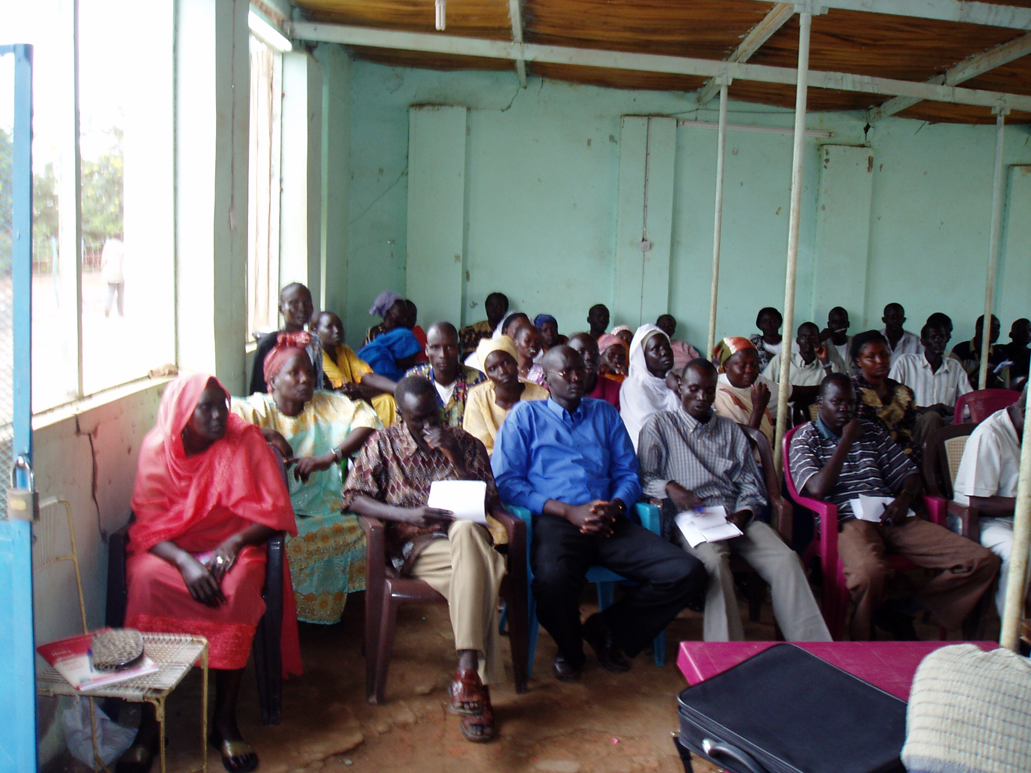
Training of Trainers Unity State

Objective # 2

Improved general food security situation for approximately 10,000 households in Unity State and 3,500 households in Bahr el Ghazal through increased provision of agricultural goods and services.

Achievements/Accomplishments made during this quarter

Bahr El Ghazal
- A total of 6 M.T of seeds was distributed to be planted in area of 1, 1750 feddan. This would increase area under cultivation per family by one feddan.
- The improved variety of seeds planted is expected to improve productivity, thus would increase crop production.
- 10 trust building, conflicts mitigation and resolution sessions conducted, attended by 1200 persons and 62 traditional and community leaders representing the ethnic groups of Fertit, Lou and Dinka
- 2 extension sessions on usage of the best recommended agricultural practices at 2 villages conducted that aimed at increasing production.
- 100 vegetable growers underwent 2 extension sessions on vegetable growing techniques at 2 villages.
- 1,750 farmers adopted growing of the improved crop seeds variety at 28 villages
- 28 VDCs are better able to manage village affairs as a result of the 5 training sessions they underwent.
- 2 sites were identified for construction of community seeds stores.
- 176 members of Village Development Committees representing 28 villages trained in planning and management with the purpose fostering achievement of sustainable livelihood.

Unity State
- 3 basic education schools were provided with tools and vegetable seeds (I kg of tomato, egg plant, sweet paper and water Mellon) to establish school gardening each 2 feddans at 3 villages.
- 33 feddan of land was allocated by county authorities to 3 partners for vegetable and field crops cultivation.
- 0.5 M.T of various seeds and 1,000 pieces of agricultural hand tools were provided to 3 partners.
- 6 feddan of vegetable production was established at 3 schools aimed at generating income and act as avenue for training the students on how to grow vegetables.
- An amount of SD 50,000 reported to be an average income per partner every week as a result of selling the surplus production from the vegetable.
- Increase in production of field and vegetable crops reported have increased as a result of the provision of seeds and tools.

Capacity Building program component

Objective 3: Increased potential of vulnerable women to access employment opportunities

Objective 4: The technical and organizational capacity of partners to provide adequate standard basic services to IDPs strengthened.

Under these two objectives, the capacity building component of Food Security for War Displaced Project (funded by FFP) has been specified and budgeted. The progress made during this quarter is described below:

Life Skills Training
Literacy training
Background
The program is working with PNGOs/CBOs in Jebel Aulia, Mayo, Tawidat and Haj Yousif to achieve the objective of increasing potential of vulnerable women to access employment opportunities. The FSWD Project has signed 12 agreements with PNGOs/CBOs for food for training activities. The literacy classes are going on well and most of PNGOs staff were trained in commodity management. The food for training dispatched to the partners on a monthly basis according to their request and the number of registered participants attendance.

Progress /achievement
- A total of 1,060 participants (out of which 70% are female) were participating in the literacy program included HIV/AIDs and health awareness training.
- 25 literacy classes supported with education materials to enhance their activities e.g. chalks, blackboard, exercise books, audio-visual aids etc.

Capacity building for partners
- A workshop is planned for PNGOs/CBOs on during January 2006 on general organizational management to strengthen their organizational capacity to better manage and advance their livelihood recovery initiatives. A total of 25 participants from 10 different PNGOs /CBOs will attend the workshop.

- Several training sessions are planned for PNGO partners (SIDO, SUDRA and GHF) and CBOs aiming to improve their organizational and managerial capabilities in managing nutritional programs. The trainings are planned to take place at the feeding centers in Wed el Bashir (WeB), Mayo and Jebel Aulia. The first session of this training has been conducted in WeB IDP camp.

- The program has signed an agreement with BAMOJA literacy network to conduct training for 30 participants from different CBOs/PNGOs within the literacy program using the REFLECT approach. The ultimate objectives of the training are internalization of the literacy education using ‘REFLECT’ approach with the participants to enable them to apply it in their different contexts and to provide the participants with training and facilitation skills to carry out research and correct baselines. The training will start in late January 2006.

Expected Results
- Participants are able to carry out baselines studies in their areas of operation and collecting information needed for designing the REFLECT program.
- Participants develop working documents to map out strategies for implementation of REFLECT in their respective areas.
- Planning and implementation of literacy programs using REFLECT approach including training of facilitators.

Progress made so far
- 10 NGOs/CBOs members received training on organizational management, participatory rapid assessment (PRA), project planning, design and management
- 25 participants from 10 CBOs and NGOs received training on financial management, book keeping saving mobilization and fund raising.
- 1060 participants (70% females) are participating in literacy classes and receive FFT as incentive.
- 51 participants (Nutritionist, Nutrition assistant, store keeper, CHPs and TBA) attended the management of nutritional activities workshop. The same group also received training on report writing and awareness on HIV/AIDs.

PART THREE
Emergency Distributions in IDP camps in Khartoum

Disaster/Hazard: Demolition of IDP areas in Khartoum
Period of the program: June 2005 up to August 2005
Total number of beneficiaries targeted: 196,920 direct and indirect beneficiaries
Dollar amount requested from OFDA: USD $750,879

a) Demographic Profile:

OES
Omdurman es Salaam is an official IDP camp, which has been “replanned”. However, a large percentage of the residents have not yet received a plot and are living in temporary shelter while they await their plot allocation or are forced to relocate elsewhere. A breakdown of population figures (source: Khartoum State Inter-Agency Rapid Assessment, November 2004) shows that an average household has 6.6 members, with 1.5 children under the age of five and 2.1 children between six and fourteen years old; in other words, 54% of the population is under the age of fourteen. Almost every third household is female headed.

In November 2004 about 80% of the camp population was living in temporary shelters made up of plastic, textile and cardboard pieces (Khartoum State Rapid Assessment) and although some people have since been able to rebuild their houses it is estimated that about 50% of the population still live in temporary shelters. (Figures based on a count of houses/temporary shelters within the Medair target area of OES.) Plastic sheeting distributed last year has now deteriorated due to wear and tear and exposure to the harsh climate, and cannot be expected to remain waterproof.

Wad el Bashier:
Located 15 km northwest of Khartoum, Wad el Bashier, with an estimated population of 74,800 people, is another official IDP camp that has been demolished and “replanned” An estimated 13,500 families had their homes demolished in 2004, but by November 2005, only 5,400 had received plots and 8,100 had not. According to responsible authorities these families will be given plots in new blocks 51 and 52 south of OeS camp approximately 6-8 kilometers from WeB.

Soba Aradi
Soba Aradi is a squatter area composed of twelve zones (Murba'at) or blocks with an estimated population of 64,000 people. Demolitions started in Soba during August 2004 and by November 2004, all 12 blocks were demolished. According to the Ministry of Engineering and the Ministry of Planning, the residents of Soba Arradi are not considered to be IDPs, because there is said to be a high level of involvement of businessmen (Samasra) and there are also illegal citizens suspected of grabbing free land. This has created a different situation than in the other areas. In addition, a portion of the land belongs to University of Khartoum faculty of agriculture and another portion to the armed forces. There is an agreement between the government and those institutions where the government wants to reconsider the land for residents to settle. The fees for the land are commercialized. On May 18, 2005, the government attempted to relocate IDPs from Soba Arradi to a place further south between Jebel Aulia and Kalakala, which resulted in a violent clash between the local communities and the police. The community members have been informed that on July the 7th 2005 up to 4,000 households will be relocated to the new area.

Mayo Farms
Mayo Farms is an IDP Camp with an estimated population of 133,000 people located immediately south of Khartoum. The residents of Mayo are war-affected population from southern Sudan and the Nuba Mountains. Areas adjacent to Mayo Farms Camp have been re-planned and sold/allocated to citizens, including IDPs, over the past years. Mayo Farms itself has not yet been re-planned, although there has been indications that replanning will soon occur in this area. The rapid assessment in December 2004 revealed that 44% of deaths in the past year was caused by diarrhoeal disease, and that with the upcoming rainy season and the proposed replanning of this area, the situation could considerably worsen in upcoming months.

El Fatah
Shikan area is one of the numerous IDPs un-official camps (squatter area) in Khartoum State. It is located North-West Omdurman. The first inhabitants arrived there in 1983. Since then, the flood of IDPs (as well as urban poor pushed to the periphery by lack of means) continued to grow, the population of Shikan squatter area reaching 80 000 people in the mid 90s. The area has been through 6 demolitions, in the framework of the urban planning process that started in the mid 90s. Families are removed without prior notice and often during raining season or winter. The process starts with the demolitions of the houses, some families are allocated a plot and have to rebuild while a high proportion of the families do not get a land and start again living in makeshift shelters, with no latrines, then rebuild, and so on until next demolition.

In the context of the re-planning of Shikan squatted area, the local authorities of Khartoum began demolitions of IDP houses on the 28th of December 2004, leaving more than 12,000 people homeless. During the registration process for plot allocation, the families have put up makeshift shelters nearby the demolished area. Some of the families were relocated to El Fateh, 20 km north of Omdurman, where there are no water, health or education facilities. While these families are now struggling to get money and build their house, the families who did not get a plot are still living in makeshift shelters in Shikan (made of cardboard, plastic bags, rakuba). Even though some of the families received plots in the surrounding planned area, the majority of them are still waiting to get their piece of land. Among those who remained in Shikan, some are « ineligible » and others are supposedly entitled to plots in the re-planned Shikan (according to their « koteyeb » stating their date of arrival in Shikan), but up to now the area is not cleared and no land has been attributed so far.

As for those who received plots, the families do not receive compensation when their house is demolished and completing the process of registration of the plot is very costly. People spend a large proportion of their money in rebuilding, at the expense of other basic needs which become a non priority (education, Health, etc.) or unaffordable in the current situation. Although there are two health centers and one dispensary in El Fateh (1, 2 and 3) many can not afford to go and get treated. In addition, many have not yet build their house and have no access to latrines and have to defecate in the open.

As usual the most vulnerable are the children and the women, however due to the prevalent poverty among the population of Al Fateh, this program intends to address all categories within the population of Al Fateh.

Overall objective
To reduce the prevalence of waterborne diseases and mitigate the negative effects of the demolitions among the population of El Fatah, Omdurman es Salaam, Wad el Bashier, Soba Arradi and Mayo Farms IDP areas of Khartoum State.

Specific objectives

- “Shelter and settlement standard 3: covered living space
People have sufficient covered space to provide dignified accommodation. Essential household activities can be satisfactorily undertaken, and livelihood support activities can be pursued as required.” (Sphere Standards)
The objective is to contribute to the above standard and to improve the existing temporary shelters substantially in order to meet the basic shelter needs of IDPs and to prevent Crude Mortality Rate (CMR) and Under Five Mortality Rate (U5MR) from rising.

- “Excreta disposal standard 1: access to, and numbers of, toilets
People have adequate numbers of toilets, sufficiently close to their dwellings, to allow them rapid, safe and acceptable access at all times of the day and night.” (Sphere Standards)
The objective is to contribute to the above standard by building community and household latrines in order to meet the basic sanitation needs of IDPs and to prevent/help contain a possible outbreak of diarrhoeal diseases (e.g. cholera, usually referred to as “Severe Acute Watery Diarrhoea” within the North Sudan health context.)

- Community Hygiene Promotion
Communities have access to education regarding hygiene related illnesses and are encouraged to adopt practices that minimise risk.
The objective is to increase the knowledge of the local community regarding how to prevent diarrhoeal disease within the current context, and to raise the capacity of local CBOs/NGOs to promote hygiene in their communities.

- Progress against Objectives:

Preamble:

CARE signed sub-grant agreements with three INGO ( Medair, FAR and Solidarites) on July 6th 2005 for the implementation of this project. CARE procured and delivered over 22,000 plastic sheets and 15,600 jerry cans to the partners for delivery.

Objective 1:

CARE obtained permission for it’s 3 partners to implement the project from CVHW. Plastic sheeting was procured by CARE and delivered to the 2 INGOs ( Medair and FAR ) partners for distribution. Both had, through the community leaders identified beneficiary households which comprised at least one of the following vulnerability classes: Female headed household, a child under 5 years of age, pregnant woman, elderly person, sic person or disabled person, within the communities of El Salaam, Soba Aradi, Wad el Bashir and Mayo Farms. The plastic sheeting was distributed as follows:

Location | Plastic Sheeting
Soba Aradi | 11,250
Mayo | 750
Wad el Bashier | 1000
El Salaam | 7,600
Al Fateh | 1,400
Total | 22,000

Objective 2:

This component of the grant funded and facilitated the construction of 10 communal and 400 household latrines as follows:

Location | Type | Number
Soba Aradi | Communal | 6
Mayo | Communal | 4
El Fateh | Household | 400
El Salam | Communal | 18

Objective 3

  - Under this project Hygiene promotion took different forms. Jerry cans were distributed as follows:

Location | Jerry cans | Families
Soba Aradi | 5,000 | 2,500
Mayo | 1,500 | 750
Wad el Bashier | 1,500 | 750
El Salaam | 7,600 | 7,600
Total | 15,600 | 11,600

  - FAR procured and distributed soap:

Location | Families
Soba Aradi | 11,250
Mayo | 2,000
Wad el Bashier | 2,500
Total | 15,250

  - Across the project area community animators provided hygiene education sessions to a total of 3,200 families and whilst in Soba, Mayo and Wad el Bashier 30 additional community sessions on hygiene behaviour were conducted to a minimum of 200 women at each during jerry can and mosquito net distributions.

PART FOUR

Plan for Next Quarter

- Transportation of approximately 18 MTs of seeds to Wau.
- Germination test of these seeds at El Obeid before transportation to Wau
- Identify beneficiaries and develop a plan to distribute these seeds
- Identify the requirement of agriculture tools for the beneficiaries and preparation of a plan to procure those
- Procurement of vegetable seeds and distribution of those to the vegetable growers
- Extension service for the farmers in both Bahr El Ghazal and Unity States
- Plan for development of demonstration plots and seed multiplication plots in Bahr El Ghazal
- Training of Community Leaders and VDC members on different issues related to the livelihood of the communities
- Conducting of Community awareness sessions
- Training of carpenters on their trade
- Training of fishermen on hygienic preservation of fish
- Finalization of agreements with PNGOs in Unity and Nuba Mountain areas to conduct literacy activities
- Identification of total 2040 participants for literacy classes (with special focus on women) and starting of these literacy classes in all three places like Khartoum, Rubkona and Kadugli.

PART FIVE

1. Story

Chiefs from SPLA/M and GOS while attending the trust building discussions

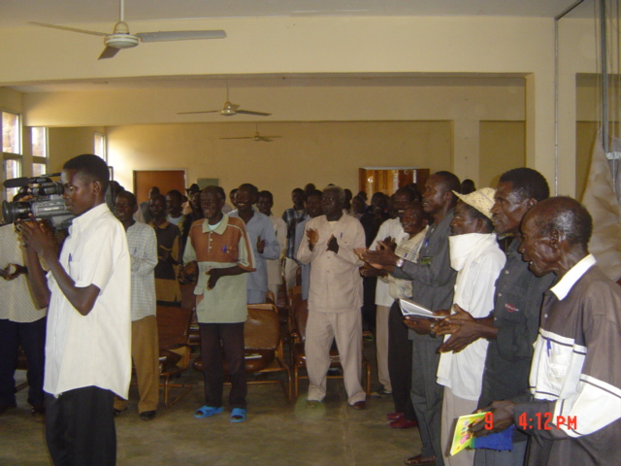

Ten traditional leaders from the former SPLM controlled areas invited by CARE –Wau to share information with their counterparts in the former government control areas arrived in Wau town after an average 15 years of absence from their home town. They joined 15 traditional leaders from displaced camps and villages around Wau to learn from each other and deliberate on ways to contribute for the rehabilitation process now that the comprehensive peace has been signed.
The leaders stated that in the past, donors and external aid organizations have been reluctant to delegate project responsibilities to local organizations or work in partnership with civil society organizations. This is in part due to the relatively limited institutional capacity and experience of indigenous organizations. An implementation strategy by external organizations that is heavily dependent on direct implementation carries the risk of people becoming heavily reliant on externally mobilized assistance, rather than their own, locally-based and supported organizational structures. This has to change and our leadership is needed especially in supporting the village development committees which are within the powers of the chiefs/traditional leaders stated by chief, Joseph Peter Abdella.
In their joint communiqué the traditional leaders concluded that “External relief and recovery efforts in Western Bahr el Ghazal alone will not be able to provide or support the provision of all basic services needed by the people. It is the local organizations and administrative structures, working in collaboration and with initial support from external agencies that hold the greatest potential to address the long-term development needs of local communities in a sustainable manner.

3. Monitoring and Evaluation
Monitoring of activities is a joint responsibility of the project field staff, extension officers and members of the VDCs. The VDCs are solely responsible to follow the work plan they prepared and submitted to the project. The sub grants and cash disbursements are being monitored by the finance officers of the project.

Monitoring formats have been designed in the form of questioners by a consultant and to be administered by the VDCs and the extension officers to obtain data and information about the performance, effect and impact created by the project interventions. The formats are currently being used by Unity project.

4. Lessons learned

- Effective grassroots participation in planning, implementation, monitoring and decision making process fosters project ownership.

- Close coordination with GOS /GOSS private sectors and academic institutions would highly enhance project implementation particularly in delivery of goods and services.

- Procurement of seeds and tools caused delays in start up of agriculture activities and coupled up with the issues of transportation hindered activities in time rendering project ineffectiveness in certain areas. ?

- Political and administrative stability would greatly help the smooth implementation and sustainability of the project

- Exchange visits of the project staff and the beneficiaries are important in the learning and information sharing process.

In reality, the “replanning” has only referred to the demolition of homes and demarcation of plots, but not to the provision of services etc.
People’s Popular Committee- Sudan. October 2004
dispensary build but not active yet, Cf. last visit held by EM-DH project coordinator on the 05/05/2005

