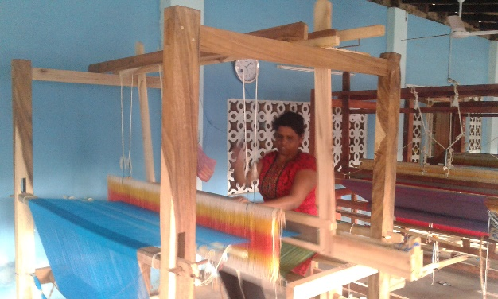
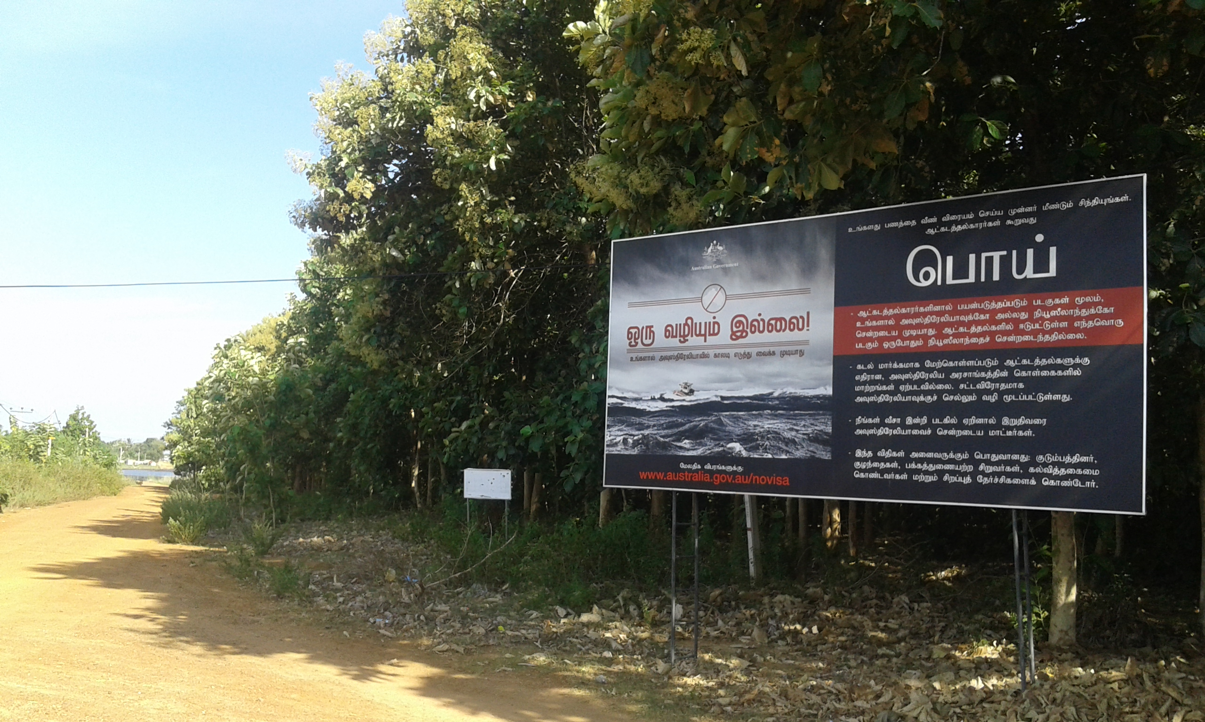
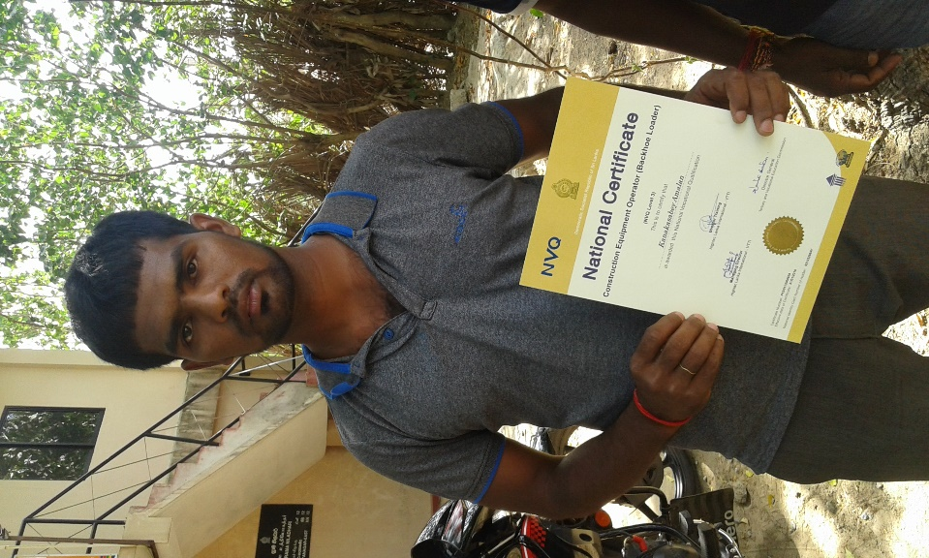
End of Project Evaluation
INTEGRATE PROJECT Kilinochchi Mullaitivu Vavuniya and Mannar
23.09.2016
Ramanaish Katheravelu
M.H. Dhaanish
Authors
Ramanaish Katheravelu & M. H. Dhaanish – Inno Consulting Service
www.innoconsultingservice.org

Acknowledgements
This report has benefitted from the valuable contributions from CARE Sri Lanka colleagues, especially Pulendran Tharmendra, Nicholane Jeyanthiran and Nirmalan amd the moderator Rachael O’Mara of CARE Australia.
The views in this report are those of the authors alone and do not necessarily represent those of the CARE or its programs, or the Australian Government/any other partners.
Cover page photo: A Vocational Trainnee with National Vocational Qualification in Kilinochchi & Another beneficiary at hand loom in Mullaitivu. In the background a bill board installed at Udayarkaddu, Mullaitivu.
Image: Ramanaish Katheravelu

Contents
Abbreviations 1
Executive Summary 2
Conclusion 2
Introduction 3
End Project Evaluation 3
Context 3
INTEGRATE Project 3
Evaluation Methodology 5
Findings and analysis 6
Deliverable 1 6
Deliverable 2: 9
Deliverable 3 10
Deliverable 4 11
Overall Design, Implementation and Impact 11
Conclusions 13
Recommendations 14
First recommendation 14
Second Recommendation 14
Annexes 15
Annex 1: List of Documents Consulted 16
Annex 2: List of Persons Consulted 17
Annex 3: Field Data Collection 18
Annex 4: Evaluation Matrix 19
Annex 5: Terms of Reference 26

Abbreviations
CBO Community Based Organisation
CDO Community Development Organisation, a Partner Organisation
CG Career Guidance
DO Development Officer
DS Divisional Secretary
FGD Focus Group Discussion
FOSDO Federation of Social Development Organisation
GA Government Agent
GBV Gender Based Violence
GOSL Government of Sri Lanka
GS Grama Sevaka (Public Servant)
JSAC Jaffna Social Action Centre, a Partner Organisation
LCBT London College of Business Technology
NAITA National Apprentices and Industrial Training Authority
NGO Non-Governmental Organisation
PA Partner Organisation
RDS Rural Development Society
SME Small and Medium Enterprises.
TVET Technical Vocational Education and Training
Vidhatha Science and Technology Centres
VT Vocational Training
VTA Vocational Training Authority
VTP Vocational Training Provider
WRDS Women Rural Development Society

Executive Summary

Thirty years of conflict in Northern Sri Lanka saw hundreds of thousands of Sri Lankan Tamils internally displaced while many others sought to migrate, legally and illegally, to other countries due to fear, political persecution or economic reasons.

The INTEGRATE Project (July 2014 to September 2016) aimed to contribute to the successful reintegration of Indian and Australian returnees into their communities in Kilinochchi, Mullaitivu, Vavuniya and Mannar Districts in the Northern Province. INTEGRATE Project activities were implemented by partner organisations throughout these districts.

Both quantitative and qualitative methods were employed to systematically and objectively assess the design, implementation and impact of the project. The evaluation was implemented in four main stages over the months of August and September 2016.

A total number of 6,118 males and 6,362 females totaling 12,480 were direct beneficiaries of the project. This is well above the target of 500 youths directly benefiting from vocational training activities, and 4,050 individuals from livelihood support and other activities.

Another 26,118 indirect beneficiaries benefited from the project. This is well above the target of 11,200 individuals (including family members of youth and family members who benefit from livelihood support and other project activities).

A total number of 348 males and 219 females equaling 567 youths successfully completed vocational training courses with 59% of them being employed within three months of completing their training. Of the 40 women who were trained in preschool education, 88% became employed. Of the 45 men who completed a CCTV placement, 84% received employment. CARE organised and facilitated a Job Fair in which 2,640 youth participated with 22 job and education stalls available. It is commendable that the project was able to mobilise almost all the stakeholders in respect of vocational training and worked together to address the social stigma, gender and geographical isolation. More attention is needed in respect of career guidance, job preference, mentoring and NVQ certification to sustain the achievements.

Sports coaching camps and sports events at the divisional and district level were facilitated by the project aiming to achieve greater participation of the community. Around 24 youth, primarily from Kilinochchi and Mannar districts, were trained in Forum Theatre techniques and 16 programs (each last two to three hours) were successfully executed informing community members about the consequence of migration.

Men and women, including returnees have improved access to institutional support mechanisms including means to access civic documents and quality counselling services.

INTEGRATE Project and partner organisations systematically identified and screened the existing SMEs and individuals with strong entrepreneurial skills. A total number of 56 SMEs significantly increased individual income (between 20 to 40% against the baseline) and new employments ranging from two to eight.

Introduction

Context

Thirty years of conflict in Northern Sri Lanka saw hundreds of thousands of Sri Lankan Tamils internally displaced while many others sought to migrate, legally and illegally, to other countries due to fear, political persecution or economic reasons. While the conflict has ended, many people are still trying to illegally migrate to developed countries like Australia as they want to seek a better life.

Sri Lankan Tamils living in refugee camps in Tamil Nadu also started to return either voluntarily or through a facilitated process with the assistance of organisations such as the United Nations High Commissioner for Refugees.

Most returnees are re-settling in districts such as Mannar, Mullaitivu, Killinochchi, and Vavuniya, in the Northern Province which is where other illegal migration attempts have been documented. The project aimed to work with returnees as well as their broader communities, including those in which, anecdotally, it is known people are at risk of trying to migrate illegally.

INTEGRATE Project

CARE International has implemented a project (INTEGRATE) for the successful reintegration of Indian and Australian returnees into their communities in Kilinochchi, Mullaitivu, Vavuniya and Mannar Districts in the Northern Province from July 2015 to September 2016. The project was funded for the duration of 27 months by the Department of Immigration and Border Protection of the Government of Australia.

The main objective of this evaluation is to assess the overall performance of expected results stipulated in the logical framework and the proposal, in terms of relevance, efficiency, effectiveness, impact and sustainability of the project. The evaluation identified lessons learned, summarises experiences gained, and recommends approaches for future interventions and monitoring required in implementation arrangements to effectively and sustainably contribute to the project improvement in the target areas.
The report outlines the findings from the key informant interviews in Kilinochchi, Mullaitivu, Mannar and Vavuniya, as well as analysis of quantitative data collection and relevant documentation.

The overall objective of the project was the sustainable integration of returnees and returnee communities in targeted locations and the specific objectives of the project are as follows:

- Objective 1: Enhancing access to, and utilisation of, financial resources, productive assets, skills and networks have improved employment prospects for men and women, including returnees from Australia and India, within two years;

- Objective 2: Strengthened community and institutional support systems promote greater social integration of male and female returnees from Australia and India within two years;

- Deliverable 3: Returning youth and families are accepted as valuable members of community-based organisations and engage in socio-cultural and development activities of the community; and

- Deliverable 4: Men and women, including returnees, have improved access to institutional support mechanisms including means to access civic documents and quality counselling services.

INTEGRATE Project activities were implemented by partner organisations.

Table: Partner Organisation and Geographical Coverage
 | Local Partners | Key Activities | Geographical Coverage
1 | Community Development Organisation (CDO) | Deliverable 2, 3, 4 | Mullaitivu and Kilinochchi
2 | Jaffna Social Action Centre (JSAC) | Deliverable 1 | Mullaitivu and Kilinochchi
3 | Federation of Social Development Organisations (FOSDO) | Deliverable 1, 2, 3, 4 | Vavuniya and Mannar

Evaluation Methodology

Both quantitative and qualitative methods were employed to assess the implementation and impact of the project. The evaluation was implemented in four stages over the months of August and September 2016. Including:

- Desk Review
A broad understanding of the project was developed for the purposes of preparing the evaluation report which included a work plan and an evaluation matrix which gathered together the evaluation criteria and cross-cutting themes.

- Qualitative Data Collection
In-depth interviews, Focus Group Discussion, Direct Observation with project beneficiaries, implementing partners and CARE Sri Lanka. The format remained flexible to allow the evaluation team to delve deeper into certain aspects, depending on the informant.

- Quantitative data collection
Telephone interviews were used for quantitative data collection amongst the vocational trainees. Representative sample size was calculated by using the following formula for probability sampling.

- An analysis of the information collected, concluding in the writing of the final report
The final report was prepared by the Evaluators Ramanaish Katheravelu and M. H. Dhaanish.

Findings and Analysis

Deliverable 1

Young men and women in target locations, including returnees, have improved vocational and life/soft skills that will enhance their ability to gain employment.

- This Deliverable was the major component of the project with 21% of the total budget. Vocational Training of the project beneficiaries was implemented through the partner organisations.

- Perception - In the Sri Lankan context, Vocational Training is not popular amongst youth. Tertiary and Vocational Education Policy 2016 has highlighted that Sri Lanka has in theory recognised the need for a system where two streams, namely academic courses and training for practical jobs. However, in practice the two streams are not considered parallel and the Focus Group Discussion with the trainees revealed that their perception has changed toward skilled based craftsmanship and vocational jobs based on their own experiences.

- Participatory Approach: While demand for job-specific skills has been growing, the enrollment for industry sectors and other courses is considered to be poor due to lack of awareness and negative attitude towards TVET. INTEGRATE Project Team and Partner Organisations with the participation of CBOs and government counterparts successfully reached out to the trainees and facilitated the job seekers to choose a profession of their choice.

- Social Stigma: It is noted that the Vocational Training Activity is a relatively new arena to the implementing partner organisations. The Project Team has taken precautionary measures to mitigate the risks in respect of career preference of the trainee, social stigma, NVQ Certification and labour demand in the chosen field.

- Labour Demand and Supply – Detailed and formal labour market assessment was not conducted prior to selecting the courses. The courses were merely selected on the basis of requests made through the applications. However, some of the courses selected have their own niche market in northern region.

- Quality and Relevance - National Vocational Qualification (NVQ) certificates were issued to very few courses. Vocational Training Provider (VTP) namely LCBT informed that the module and syllabus would be based on Scottish Quality Authority (SQA) and LCBT would provide International Vocational Qualification (IVQ). Issuing NVQ certificate, although preferred, was not materialised by the VTP. Some participants in Focus Group Discussions observed that they found it difficult to follow the theory courses, particularly Hospitality course as they were conducted in English without interpretation in Tamil.

- Career Guidance and Mentoring – Participants observed that the Vocational Training Providers, particularly for ICT training, have not provided sufficient market information about the job profile, job locations, and initial salary, etc. As vocational training activities are a relatively new arena for the Implementing Partner, adequate conditions were not considered in the contract with the VTPs. E.g. Impose a condition for mentoring and career guidance to trainees for at least a six months’ post-training.

Apart from contractual obligations, there were no attempts made to inform the trained about the job openings except one VTP. However, in Cheddikulam, CARE has developed a good rapport with HRDA who informs the trainees of impending jobs in the government sectors. It would have been more effective, if CARE had more labour market related information and good linkages with government and private entities.

Absence of guidance for children passing the adolescent period was highlighted by stakeholders including psychiatrist in Kilinochchi, Doctors, RDHS, Deputy Director of Education, WDO, NCPA, SGBV coordinator, WV, SLRC and CARE. CARE has extended its support to conduct career guidance program in the Kilinochchi with the participation of parents and students.

- Enabling Environment for Employment - the INTEGRATE Project has supported public organisations and CBOs to enable an environment for job seekers. As a result of equipment supply, Vidhatha Resource Center at Puthukudiyiruppu started Computer Courses for the job seekers. In 2015 it has conducted courses for 26 students in three batches and in 2016 for 75 students in five batches. Support extended to BPO Centre at Maritimepattu provides technology transfer service and created four employments (three females and one male).

- Employment Status of VT Trainees - Employment placements have had mixed results. Hotel Management and Travel Tourism sector was widely given more priority. However, those who attended, especially females, eventually declined jobs at hotels due to cultural taboos (working at hotels and long distance travelling) and low initial salary. As a result, only 18% remained in the same sector. Others found other jobs or moonlighting.

As informed by Instructors, ICT trainees had high expectations in terms of salary. Upon completing the course, trainees who were offered jobs outside their places complained that the basic salary is not even enough to cover their lodgings. Focus group discussion with ICT trainees revealed that around 25% of the trainees remain in the same employment. Total number of 567 youths (272 male and 295 female), out of which 55% are employed within three months which is above the acceptable level.

Table: Vocational Training- Kilinochchi and Mullaitivu
 | Vocational Training | Total trainees | Employed | %
1 | Hotel Management | 38 | 19 | 50.00
2 | Travel & Tourism | 18 | 8 | 44.44
3 | ICT | 80 | 30 | 37.50
4 | Heavy Machinery | 60 | 20 | 33.33
5 | Motorbike Assembling | 30 | 21 | 70.00
6 | Combined Harvester | 64 | 64 | 100.00
7 | CCTV | 45 | 38 | 84.44
 | Total | 335 | 200 | 59.70

Table: Vocational Training- Mannar and Vavuniya
 | Vocational Training | Total trainees | Employed | %
1 | Hotel Management | 44 | 31 | 70.45
2 | Travel & Tourism | 32 | 14 | 43.75
3 | ICT | 85 | 24 | 28.24
4 | Combined Harvester | 31 | 8 | 25.81
5 | Preschool training | 40 | 35 | 87.50
 | Total | 232 | 112

Pic: FGD with SMEs at Kilinochchi Pic: VT Trainees
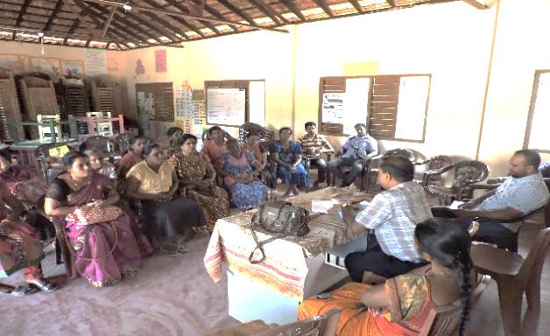 | 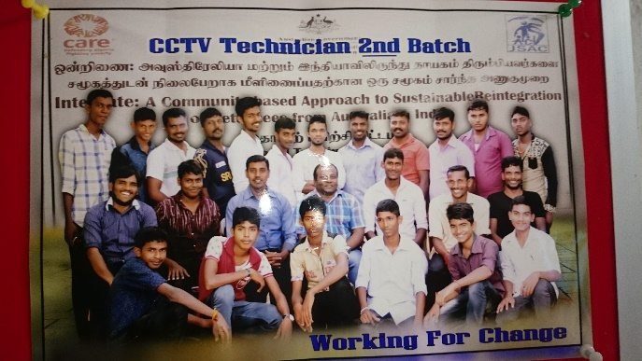

Deliverable 2:

Families in target locations, including returnee families, have improved access to productive assets, access to services, and market linkages.

This Deliverable is the second largest component of the project with 16% of the total budget. CARE International has worked with all relevant stakeholders and made sure that the SMEs that they supported would sustain after their exit of project support. Documents related to financial and book keeping, handing over, land approval, etc. proved proper consultations with government stakeholders, necessary approvals and joint monitoring practices had been in place at appropriate times.

Many SMEs supported by CARE have not only impacted the income of the beneficiary but also created employments for others e.g. Kayal Broomstick SME in Piramanthanaru has employed eight new employees both male and female, Good Luck Batik in Cheddikulam employed five new employments. SME participants revealed that their monthly income has increased by 3,000-6,000 per employee. As per the baseline survey findings, 82% of the households in the project location draw monthly income between 10,000 and 20,000. Hence the project has assisted the individual member’s income by 20% to 40%.

Table: Household Income Baseline Survey, July 2014
Income Range | Response | %
0-10,000 | 0 | 0.0
10,000-10,999 | 173 | 45.4
11,000-20,999 | 139 | 36.5
21,000-30,999 | 51 | 13.4
31,000-40,999 | 9 | 2.4
41,000-50,999 | 4 | 1.0
51,000-60,999 | 2 | 0.5
71,000-80999 | 1 | 0.3
<=91000 | 2 | 0.5
 | 381 | 100.0
Source: CARE International, Sri Lanka

- Exposure Trips, Fair and Exhibition - The Project supported the SMEs to participate in the Fairs and Exhibitions. Participants in the Focus Group Discussion observed that this not only instilled confidence but also widened their horizon in terms of markets, potential customers, networking and linkages.

- Capacity Development – a total number of 56 SMEs were supported by INTEGRATE Project and they displayed their book keeping practices which are at a good stage. Business plans, a key guide for entrepreneurs in leading businesses for sustainability, had been formulated for every SME. However, providing necessary guidance and mentoring is missing in all SMEs that the Evaluation Team met. The participants are well aware and commend the training of being useful but the true benefit of having a Business Plan is not. They were just given the training. Mentoring based on the Business plan should be done as the entrepreneurs are still at the initial stages of expanding their operations. The business plans also guide them to maneuver through the competitive markets that are emerging after the conflict.

Market related assessments are very important when planning for support for SMEs in rural settings. However, since these SMEs already exist or provided for people as a backstop, a brief analysis (which was not conducted) would have been sufficient in terms of enhancing and strengthening their positions in the market system. This was also endorsed by one of the Partner Organisation of CARE.

Environmental consideration should be given for industries like pottery and broomstick production. Although there are no explicit threats envisaged, there will be heavy restrictions on mining and deforestation in the future in the north.

Comprehensiveness in terms of supporting SMEs was missing. Many beneficiaries commended the support but also complained of bottlenecks that still hampers their development. E.g. Good Luck batik designers require more support in acquiring materials for the processing. Drying Bed for Farmers in Cheddikulam lack the capacity to support the whole farmer community. Only 50 bags can be dried in a single day. It will take more than six months to dry the output of the 221 farmers in the designated area. This might cause conflicts among them in the future.

Many SMEs that were supported by CARE have seasonality effects, meaning, will be affected by demand and supply. For people who are primarily engaged, there should be more exposure on business diversification (product value addition, new markets and geography).

Deliverable 3

Returning youth and families are accepted as valuable members of community-based organisations and engage in socio-cultural and development activities of the community.

- Sports- INTEGRATE Project supported sports coaching camps, sports events at the divisional and district level aiming to greater participation of the communities and returnees and the youths. 3% of the project Budget was allocated to these activities.

- Forum Theatre Program – Under Youth Create activity, around 24 male and females primarily from Kilinochchi and Mannar districts, were trained in Forum Theatre techniques. 16 programs each last two to three hours were conducted in different locations. The script touched on the ill effects on the family and society of men migrating to other countries. The programs, in general, were received well by audience and approximately reached over 200 and 400 male and female respectively.

Deliverable 4

Men and women, including returnees, have improved access to institutional support mechanisms including means to access civic documents and quality counselling services.

Although it was envisaged to conduct mobile service in majority of the locations, due to number of reasons including availability of authorised staff and the attitude of the public officials, the approach was changed in Kilinochchi and Mullaitivu. Accordingly, first needs were identified on the first day and asked to come another day. Around five and ten such services were organised in Kilinochchi and Mullaitivu respectively.

The project supported public officials to enhance knowledge and skills to provide the service efficiently among others 5S, MS Access, exposure visits and training on GBV. The support rendered by the INTEGRATE Project to key institutions, that cater the needs of returnees and vulnerable, was highly commended by the recipients – General hospital, Mannar/Women and Child welfare unit, Manthai West DS, Additional District Registrar, and Manthai West DSD.

Overall Design, Implementation and Impact

- Risk Management: There is evidence that the INTEGRATE project team regularly met with partner organisations, vocational service providers and other stakeholders to identify and document the issues and risks systematically.

The political risks and other risks identified in the project proposal did not affect the project in general. Beneficiary selection did not create tension between the returnees and host communities. The potential tension between the Northern Provincial Council and Central Government has no impact on the project.

Due to delay in getting proper business registrations many SMEs have restricted their operations geographically curtailing their returns e.g. Pasumai Sweets in Manduvil, Sri Priya Sweet Products. These risks shall be mitigated by establishing linkages with the government authorities.

Potential risks emanating from partner organisations were minimised by agreeing to have the associated partner organisation staff based in CARE premises more than 50% of their time. This approach not only boosted the implementation but also increased the capacity of the partner staff by working closely with CARE INTEGRATE team.

- Relevance: Objectives, expected outcomes and activities were relevant to the context and in line with CARE’s vision of ensuring social justice, where poverty has been overcome and people live in security. INTEGRATE’s approach and the focus on cross cutting issues such as gender and working with partners reinforce its commitment to the program approach.

Project activities, so far, are mostly needs based. Attention has to be shifted more towards rights based in accordance with the program principles and also market based when it comes supporting SMEs. Institutional Capacity Building has been weak so far with limited support. There is no strategy to ensure long term partnerships with local NGOs and service providers. Advocacy and research components were lacking in the project.

- Effectiveness: All the activities identified in the proposal and work plan were implemented as planned either by implementing partners or directly by CARE. Due to unavoidable circumstances, the project took more than one year on pre-field activities leaving a limited time for field activities. Though the progress on a few critical interventions was less than expected by the end of August 2016, the project managed to achieve substantial progress during the first four months of 2016. It indicates CARE’s dedication and commitment in reaching its targets within the project period.

Overall, the Vocational Training Courses has proved to be satisfactory from the point of beneficiaries. However, the effectiveness of some of the courses is questionable based on selection, design and implementation. Missing expert advice during the selection of course types, designing phase and lack of proper coordination among the stakeholders negatively impacted the effectiveness of some of the courses conducted. Courses which had higher demand such as motorbike maintenance proved to be very effective in terms of achieving its desired result.

All the SMEs, supported by CARE, demonstrates positive growth trend owing to its position already carved in the market system. The support rendered by CARE has made the businesses to grow and also in many cases has enabled for businesses to employ more people, a welcoming sign for local economic development. As the businesses supported by CARE are still at very micro scale and in the process of expanding, it’s also very early to deduce that the SMEs would sustain against the potential market competitors who have more access to financial, transport facilities and also with products that meet required standards in the country. However, CARE needs to invest more in terms of facilitating for comprehensive support when it comes to business expansion and diversification.

The effectiveness of the Deliverable 3 component tends to be very limited as the evaluation team does not see any interlinked or follow up activities done prior and post implementation. It might have influenced attitudinal change if it is executed systematically and followed up over a period of time.

Efficiency: The working relationship with CBOs and the POs are satisfactory and POs expressed that they were very comfortable talking directly to CARE as and when necessary. A common grievance expressed by a partner organisation is that the financial incentives are not that attractive and there is no organisational strengthening component in this project. Furthermore, the financial procedures of CARE are tedious and hinder the effectiveness of the organisation. CARE’s handling of the program and financial management was appreciated by all the partner organisations interviewed. Their on-time support allowed the Partner Organisations to implement their activities without any problems except in one instance where there was a delay in acquiring land approval from the government in putting up the Dry-Bed. Beneficiaries and other stakeholders are generally appreciative of CARE’s interventions, delivery mechanism, effectiveness and transparency.

Financial re-allocation allowed by the donor for VT is appreciable in adjusting to the changing needs in the districts. Despite this, some of the courses like ICT would have been more efficient if the course duration were increased allowing for the students to catch-up, specifically in the districts of Vavuniya and Mannar. Project efficiency was boosted by beneficiary participation in many instances like the construction of Palmyrah Handicraft building where resource availability is enhanced through beneficiary contribution and the Project facilitated to sustain the gain.

Impact and Sustainability: Beneficiary satisfaction on the benefits received was clear from the discussions. Provision of support for SMEs was the most appreciated intervention in heavily conflict affected areas as people are struggling their way out from poverty. CARE needs to invest more in terms of mentoring these businesses to sustain in their respective market systems.

Provision of vocational training has enabled many youths to build up their confidence in getting jobs. Between 30% to 50% of the participants in the focus group discussion reported that they are happy with their jobs thanks to the vocational training.

Signs of continuation of SMEs are visible. CARE has managed to deliver the pre-requisites for business sustainability such as financial and management training, business plan development and also looking at avenues for business expansion. However close mentoring and facilitation for about another six months would further reinforce their positions in the market system.

Getting a job is the ultimate objective of vocational training. Depending on the vocational training course chosen, the employment rate varied. Due to number of reason among others job mismatch, low salary, job proximity, and social and cultural constraints to be employed away from home, meant that participants are now employed from between 30% and 100%. A further follow-up and support for the participants who are still struggling to find a job is required.

Conclusions

A total number of 6,118 males and 6,362 females totaling 12,480 direct beneficiaries and another 26,118 indirect beneficiaries benefitted from the project.

Total number of 272 males and 295 female totaling 567 youths have successfully completed the vocational training courses and around 55% of the trained are employed within three months which is above the acceptable level in Sri Lankan context. It is commendable that the project was able to mobilise almost all the stakeholders in respect of vocational training and worked together to address the social stigma, gender and geographical isolation. More attention is needed in respect of career guidance, job preference, mentoring and NVQ certification to sustain the achievements.

INTEGRATE Project and Partner Organisations systematically identified and screened the existing SMEs and Individuals with strong entrepreneur skills. The SMEs, including the SMEs created by the Project significantly increase individual income (20-40% against the baseline) and new employments ranging from two to eight.

Sports coaching camps, sports events at the divisional and district level are facilitated by the project aiming to greater participation of the community.

Under Youth Create activity, around 24 youth primarily from Kilinochchi and Mannar districts were trained in Forum Theatre techniques and 16 programs each last two to three hours were conducted in different locations focusing on ill effects on the family and society of men migrating to other countries. The programs, in general, were received well by audience.

Men and women, including returnees have improved access to institutional support mechanisms including means to access civic documents and quality counselling services. Monitoring, field level supervision, identifying and assessing risks, providing technical support to the Partner organisations and information management were systematically followed by INTEGRATE Team.

Due to high level of staff turnover in one of the partner organisation (CDO) the project slightly suffered. The credibility of a Vocational Training Provider (e.g. E-Soft) was questioned. Adequate attention is needed in screening the vocational training providers in respect to their capability to give recognised certificate and assurance of employment.

Recommendations

First recommendation

The existing and newly created SMEs need further support so that SMEs will be equipped with skills to assess new markets while strengthening the existing market opportunities. The majority of the SMEs supported by the project demonstrated their local marketing skills and accessing their own market linkages. Thorough business planning for diversification and mentoring for the SMEs is highly recommended in respect of seasonality, pricing, quality control, branding, value addition and joint ventures. It is also worth exploring common brand to reach out new but potential markets including diaspora.

Second Recommendation

In Sri Lanka there is a need for a system where two streams - academic courses and practical training for jobs is recognised. However, in practice the two streams are not considered parallel. Much needed craftsman courses and jobs are the least preferred by job seekers. The Project successfully engaged with government and community based organisation to achieve the objectives in respect of employment by enhancing technical and soft skills. It is highly recommended to collaborate with Public Vocational Training providers, behavior change communicators, mentors and industry sectors to sustain the result.

CARE Australia
1800 020 046
info@care.org.au
care.org.au
ABN:46003380890
Canberra Office
Ground floor
243 Northbourne Avenue
Lyneham ACT 2602
Phone: (02)6279 0200
Fax: (02) 6257 1938
Melbourne Office
Level 8, 406 Collins Street
Melbourne VIC 3000
Phone: (03) 9421 5572
Fax: (03) 9421 5593

About CARE
CARE works with poor communities in developing countries to end extreme poverty and injustice.
Our long-term aid programs provide food, clean water,basic healthcare and education and create opportunities for people to build a better future for themselves.
We also deliver emergency aid to survivors of natural disasters and conflict, and help people rebuild their lives.
We have 70 years’ experience in successfully fighting poverty, and last year we helped change the lives of 72 million people around the world.

n=${{(z)}^{2} pq}/{d^{2}}$ Where n = Desired sample size, z = Standard normal deviation usually set at 95% (z=1.96) confidence interval for social researches, p = Proportion of population is usually estimated 0.5 (which is more conservative assumption) when the true proportion is unknown, q = 1.0 – p confidence limits (0.5), d = Degree of accuracy desired set at 0.05. Correction for Finite Population n=((n*N))/((n+N-1) )

