

Emergency Relief and Rehabilitation (ERR) Project

FINAL EVALUATION REPORT
(This report has been produced and financed by at the request of CARE International in Vietnam through ERR project. The comments contained herein reflect the opinions of the evaluators only)

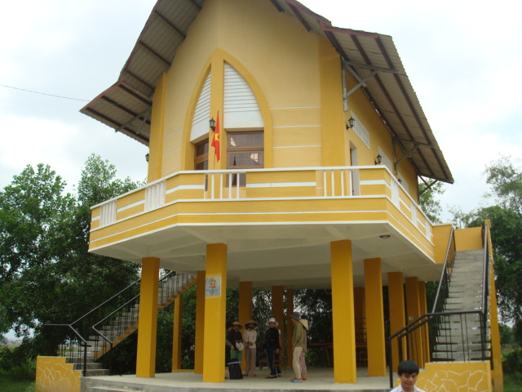

Prepared by the Evaluators’ Team
Hoàng Văn Dương and Nguyễn Thị Thu Quế

Hà nội, May 2011

I. List of Abbreviations 4
II. General information about the project 5
1. Purpose of evaluation: 5
2. Specific objectives: 5
3. Scope 5
4. The methodology 6
5. Tools have been used 6
6. Time schedule 6
III. Summary of the final evaluation 8
1. Achievement to date 8
2. Relevance and Appropriateness 10
3. Effectiveness 15
4. Sustainability issues 16
IV. Learnt Lessons and Recommendations 17
1. Closely consult the communities and local authorities in assessment and development of lists of beneficiaries 18
2. It needs clear criteria with weigh for the selection of beneficiaries of big supports. 18
3. Ensure high community ownership and participation to improve the effectiveness of the interventions 18
4. It needs to organize relevant occupational and working safety trainings to peoples who are mobilized to provide cleanup and sanitation activities 18
5. Document the processes, best practices for knowledge management and replication. 19
6. A flexible administrative and accountant system is needed to emergency relief supports 19
7. Standardize the monitoring and evaluation (M&E) methods and tools of emergency relief and rehabilitation project and organize training on M&E methods and tools to all staffs and key stakeholders 19
V. Annexes 20
1. Annex 1: ToR for the evaluation 20
2. Annex 2: Technical and financial proposal from consultants including methodology and tools 24
3. Annex 3: List of interviewed peoples 27

Foreword

The final evaluation on the results of the Emergency Relief and Rehabilitation Project for post- Ketsana typhoon in Quang Nam was implemented by the Independent Consultant Team from 15th to 29th of May, 2011. This report aims at evaluating the achievements against the set objectives of the project, project’s effectiveness, impacts, and sustainability, and making recommendations for future improvement.

The Consultant Team would like to express sincere thanks to the CARE International in Vietnam, the officers of the Quang Nam Emergency Relief and Rehabilitation Project, Tam Tay Commune People’s Committee (Nui Thanh district), Que Xuan 1 Commune People’s Committee and Que Xuan 2 Commune People’s Committee (Que Son district) for their supports in timely implementation of this activity. We are also grateful for 61 people living in the three communes for their enthusiastic participation in group discussions and personal interviews to provide useful information and data for the report to be comprehensive as being required by the donor and relevant stakeholders.

This succinct report will help project managers, donor, and relevant stakeholders to draw out lesson learnt for improvement of future projects.

The Evaluators’ Team

HOANG VAN DUONG | NGUYEN THI THU QUE

List of Abbreviations

ADPC | Asian Disaster Preparedness Center
CBDRM | Community-based Disaster Risk Management
CCFSC | Central Committee for Flood and Storm Control
CECI | Center for International Studies and Cooperation
CPC | Commune People Committee
DARD | Department of Agriculture and Rural Development
DDMFSC | Department of Dyke Management and Flood and  Storm Control
DM | Disaster Management
DMC | Disaster Management Centre
DRM | Disaster Risks Management
DRR | Disaster Risks Reduction
ECHO | European Commission's Humanitarian Aid Office
FF | Front Father
HVCA | Hazard-Vulnerability-Capacity Assessment
I/NGO | International/Non Government Organization
IFRC | International Federation of Red Cross and Red Crescent Societies
JANI | Joint Advocacy Network Initiative
M&E | Monitoring and Evaluation
MARD | Ministry of Agriculture and Rural Development
MOET | Ministry of Education and Training
NLRC | The Netherlands Red Cross
PC | People Committee
PPC | Provincial People Committee
PRA | Participatory Rural Appraisal
RC | Red Cross
RT | Rescue Team
SMART | Specific, Measurable, Achievable, Relevant, Time bound
VCA | Vulnerability and Capacity Assessment
VNRC | Vietnam Red Cross Society
WU | Women Union

General information about the project

CARE in Vietnam is the representative of CARE International in Vietnam. CARE in Vietnam operates under the lead membership of CARE Australia. The laws and regulations of the Government of Vietnam apply to all staff, contractors and consultants. Within CARE in Vietnam the Country Director has overall management authority as the representative of the lead member and of CARE International.

Emergency Relief and Rehabilitation project established in October 2009 in Quang Nam province. This project funded by multi donors with the total of budget is 1,8 millions USD. Its goal is to contribute to the emergency relief and rehabilitation after storms in selected communes in Quang Nam province includes Tam Tra, Tam Hai and Tam My Tay of Nui Thanh district, Que Xuan 1 and Que Xuan 2 of the Que Son district.

The emergency relief period, project organized distribution food and non-food for the beneficiaries are elderly poor, women poor and children poor in five communes above.

The rehabilitation period, project supported rice seeds and fertilizer in four communes: Que Xuan 1, Que Xuan 2, Tam Tra, Tam My Tay. From May to November, 2010 the project supported to upgrade two bridges affected by ketsana storm for Que Xuan 1 commune and Que Xuan 2 commune. From November to March, 2010 the project will supports to build two safe houses for Que Xuan 1 and Que Xuan 2 communes and upgrade a canal in Tam My Tay commune.

The project will be completed at the end of May 2011. In order to verify and quantify the outcomes and affect of the Project, CARE hired the independent consultants to conduct a final project evaluation. The evaluation had the full cooperation and support of the project team at CARE.

Purpose of evaluation:
This evaluation aims to evaluate and document the project results including outputs, outcomes, impact as well as the process and capture learning which can inform future emergency work.

Specific objectives:
- To assess the outcomes and impacts in people’s lives that occurred during the project time in the target areas and contribution of the project to these changes against the specific objectives of the Emergency Relief and Rehabilitation project.
- To identify key lessons learned from the project and make suggestions for future use for CARE and partners.

Scope
The consultant evaluated all relevant issues as below.
  - Achievements to date
  - Relevance and Appropriateness
  - Effectiveness
  - Sustainability issues
  - Recommendations

With the scope of the project, objectives, activities, results of the services, the consultants used the methodology, time schedule as follows:

The methodology
The participation methodology for the assessment has been used during assessment process and there are 2 ways as follows:

Top- Down
- Work with targeting provincial (DOFA), Project staffs;
- Work with CPCs that they are involved in the project (1 communes of Nui Thanh District and 2 communes of Que Son District in Quang Nam);
Bottom up
- Work closely with vulnerable groups (elderly poor, women poor and children poor in 5 communes);
- Interview and discuss directly with vulnerable people, who faces to the disaster and also be the beneficiaries of the project;
- Discuss with them about the activities have been done to meet the needs of vulnerable groups;

Tools have been used

Nr. | Name of Tool | Describe
1 | Desk review of relevant documents | - Collect project information, documents to review and understand;  - Get the basic knowledge about the project;  - Have the overview of the project;
3 | Semi-structured questionnaire for focus group discussions | - Share information about the implementation of the project;  - Open talking about the project activities;  - Get comments from different groups (CPCs and focus groups) about supporting activities such as food and none-food, shelters, small civil works  - Discuss with Project staffs to clarify the comments from benerficiaries
3 | Structured questionnaire for self evaluation | - Provide opportunities to beneficiaries for self evaluation;  - Get feedback from beneficiaries about the supports from project: Food and none- food, shelters.....
4 | Observation | - Get opportunities to see the results  - Get comments from beneficiaries  - Withdraw lesson learnt and recommendation for better
5 | Findings presentation | - Brief the results of evaluation  - Get feedback and comments from stakeholders and project staffs  - Adjust and correct the contents, figures for the draft report
6 | Reporting | - Report the results of evaluation  - Give the objective recommendation for better

Time schedule
With the duration from 23rd to 29th May 2011 to work in the field, the consultants spent time to work closely with stakeholders, beneficiaries in the field
- 23rd May: Worked in the project office at Nr 50 Nguyen Chi Thanh Str. Tam Ky City
- 24th May: Work at Tam My Tay Commune- Nui Thanh Dist
- 25th May: Work at Que Xuan 1 and Que Xuan 2 Communes- Que Son Dist
- 26th May: Work with Project staff in the office.
- 27th May: Collect information and Data, process and analysis the data
- 28th May: Prepare findings meeting
- 29th May: Present first findings
- 31st May: Submit draft report
- 4th June: Finalize, complete and submit the final report

Summary of the final evaluation

Achievement to date
Nr | Activities | Item | Tam Mỹ Tây Commune |  |  |  | Quế xuân 1 Commune |  |  |  | Xã Quế xuân 2 Commune
Nr | Activities | Item | 2009 | 2010 | 2011 | Total | 2009 | 2010 | 2011 | Total | 2009 | 2010 | 2011 | Total
1 | Food
 | Packages (rice, dried fish, cooking oil, seasoning, instant noodle, brush, tooth past, drink water) | Packages |  | 656 |  | 656 |  | 903 |  | 903 |  | 734 |  | 734
2 | None- food
 | Clother | set |  |  | 100 | 100
 | Rain coast | piece |  |  | 157 | 157 |  |  | 100 | 100 |  |  | 100 | 100
 | Hat | piece |  |  | 157 | 157 |  |  | 100 | 100 |  |  | 100 | 100
 | Life vest | piece |  | 57 |  | 57 |  | 72 |  | 72 |  | 72 |  | 72
 | lifebuoy | piece |  | 57 |  | 57 |  | 72 |  | 72 |  | 72 |  | 72
 | Handy takies | piece |  | 51 |  | 51 |  | 65 |  | 65 |  | 65 |  | 65
 | Touch | piece |  | 51 |  | 51 |  | 65 |  | 65 |  | 65 |  | 65
 | Blanket and mosquito net | Set | 1249 |  |  | 1249 | 600 |  |  | 600 | 1000 |  |  | 1000
 | Iron roof | piece | 340 |  |  | 340 | 70 |  |  | 70 | 90 |  |  | 90
 | Fertilize | kg | 14.562 | 36.450 |  |  | 28490 | 28490 |  | 56980 | 50420 | 50410 |  | 100830
 | Rice seed | kg | 7295 | 7.281 |  | 14576 | 14160 |  |  | 14160 | 25135 |  |  | 25135
 | Seedling | tree |  | 750000 |  | 750000
 | pump | piece |  |  |  |  |  |  |  |  |  | 4 |  | 4
 | Cash for work | people |  | 100 |  | 100 |  | 100 |  | 100 |  | 100 |  | 100
3 | Small civil works
 | Shelters for poor people | House |  |  | 4 | 4 |  |  | 6 | 6 |  |  | 6 | 6
 | Bridge and canal | cái |  |  | 1 | 1 |  |  | 1 | 1 |  |  | 1 | 1
 | Community safe house | căn |  |  |  |  |  |  | 1 | 1 |  |  | 1 | 1
 | Upgrading the road to the health care centre | công trình |  |  |  |  |  | 1 |  | 1
 | Building pump station | cái |  |  |  |  |  | 1 |  | 1
4 | Others
 | Training for women on sanitation after disaster | People | 100 |  |  | 100 |  |  | 120 | 120 |  | 120 |  | 120
 | Training on First Aid for rescue team | People | 30 |  |  | 30 |  |  | 30 | 30 |  | 30 |  | 30
 | Capacity building on Gender and disaster mitigation for management levels | People |  | 3 |  | 3 |  | 3 |  | 3 |  | 3 |  | 3

Relevance and Appropriateness
- Targeting strategy
There are 100% of 61 interviewees (85% are direct beneficiaries) and they have confirmed with the consultants that all the targeted beneficiaries are relevant, the right peoples have been selected for emergency as well as rehabilitation supports, they are poor, elderly peoples and poor women playing key productive roles in the families, poor families having many children. The consultants have cross checked the list of beneficiaries provided by the project team and those provided by CPC and based on results of FDGs with beneficiaries, the results show that 44,26% are not poor with the well ranking of Government but they are poor with ranking of community of direct beneficiaries are expected targeted peoples of project (elderly, poor women, children of poor families, lonely women, poor female householders, peoples with disabilities, injured peoples). See the summary table below:
Summary information of interviewers

Nr. | Location | Elderly poor | Women poor | Man | Total | Poor | Not poor | Beneficiaries | Not beneficiaries
I | Nui Thanh District
1 | Tam My Tay Commune
1.1 | Village 6 | 8 |  |  | 8 | 5 | 3 | 6 | 2
1.2 | Village 9 |  | 10 |  | 10 | 8 | 2 | 10 | 0
II | Que Son District
1 | Que Xuan 1 Commune
 | Trung Vinh Village |  | 10 |  | 10 | 4 | 6 | 9 | 1
 | Thanh Hoa Village |  | 2 | 11 | 13 | 7 | 6 | 9 | 4
2 | Que Xuan 2 Commune
 | Thuong Vinh Village | 10 |  |  | 10 | 6 | 4 | 8 | 2
 | Phu Nguyen Village |  |  | 10 | 10 | 4 | 6 | 10 | 0
III | Total | 18 | 22 | 21 | 61 | 34 | 27 | 52 | 9
 |  |  |  |  |  |  | 44,26% | 85%

All the interviewed key stakeholders have confirmed that CARE has closely coordinated with local authorities at grassroots' levels (commune and village level) such as CPC, WU, Fatherland Front (FF), Red Cross, Youth Union, Rescue Team, Community Volunteers and systematically consulted with targeted communities in finalization the lists of beneficiaries and of foods' and non-foods emergency and rehabilitation needs and requirements before ordering to suppliers and implementing response actions. CARE has adopted a highly appropriate approach in targeting the beneficiaries, CARE first use the list provided by local authorities, then CARE has closely working with communities, using objective and participatory approaches and tools (PRA and VCA approaches and tools) to conduct quick capacity, vulnerability and needs assessment to develop and finalize the list of eligible beneficiaries, these implementing processes and tools have received very high appreciation from interviewed key stakeholders and beneficiaries. The consultants were really impressive of the high appreciation to the working processes of CARE in targeting the beneficiaries of all the peoples they have meet during the evaluation.

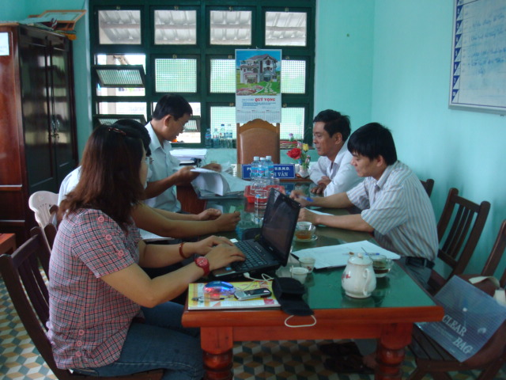
Appreciation of the representatives of local authorities about the implementing processes adopted by CARE in ERR project (can we have the names of these quotations?
We highly appreciate the working processes of CARE, the right peoples have directly received supports from the project;
The project staff have closely worked with us to manage the activities, ensuring the transparence and ethics;
All the infrastructure schemes supported by the project with "key to hand approach" are well functioning with high quality, it is largely thanks to the good monitoring and management of CARE;
We are really very happy in hearing high appreciation and feed backs from communities about CARE' supports.
Evaluation meeting with local key stakeholders in Que Xuan 1 Commune, Que Son District
(May 24, 2011)

In all evaluation meetings, discussions, interviews, any time when the consultants asked the question "how do you think about the selected peoples who have received supports from the project?" the consultants always received immediate answers without any hesitation from the participants (both direct and indirect beneficiaries) that "they are eligible peoples". All the interviewed representatives from key stakeholders also confirmed with the consultants that local authorities did not receive any complaints from communities regarding the results of selection of beneficiaries; they all believe that the implementing processes adopted by CARE are relevant and receive high appreciation from all.
The results of consultation with communities, local authorities and key provincial stakeholder (DOFA) showed there wasn't duplication of the works in project area. Few interviewed beneficiaries reported that they received supports from other organizations/peoples. There are several peoples received foods from Red Cross and FF, but in a different time with CARE, they were individual sponsors, pagoda.

- The provided items for emergency needs and implemented activities for rehabilitation' measures
Based on the evaluation' results through discussions and interviews of relevant stakeholders and beneficiaries and field observations, investigations, the consultants believe that most implemented activities are highly relevant and appropriate to the needs of beneficiaries and local conditions and context.
The consultants have interviewed the beneficiaries on the provided foods and non-foods as well as implemented rehabilitation infrastructure schemes in comparing with their priority rankings, there are high matching percentage of their evaluation between what were provided and implemented with what were expected and voted as priorities, with 10 provided and implemented items including Food' packages (rice, dried fish, noodle, safe water, sugar, cooking oil); Hygiene kit (soap, toothpaste, toothbrushes, sanity napkins, washable diapers); Safety kit (blankets, mosquito nets, water jars); Tree seedling; Rice seedling; Fertilizes; Shelters; Community safe houses; Cannels and Dams; Bridges, all of these provided items and implemented activities have received 100% of votes as their highest expected needs and priorities.
The cash-for work opportunities given to poor women were highly appreciated by all interviewed peoples, including commune authorities, communities, targeted women and women union. In each targeted commune, a group of around 100 poor women playing main productive roles has been mobilized to support the cleanup the public places to minimize the risks of pollution and diseases. Each woman has been mobilized to provide cleanup services of 15 days/month for total three months, a small allowance of 30,000 VND (1,5 USD) per day has been given to those peoples for their services. This initiative was high relevant and appropriate, in one hand it helped poor women playing main productive role in the family to earn reasonable money for their immediate livelihoods, in the other hand, it helped to encourage communities to participate in cleanup and sanitation activities and to increase the awareness on community participation to after natural disaster responses.
However, the consultant also noted that the provision of tree seedlings (cây keo) was not very relevant. With 15 interviewed peoples who received tree seedlings, there were only 5 who voted that tree seedlings are relevant. The reason why peoples are not happy with tree seedlings is because the project bought the tree seedlings from companies that locate far from the communes, it was rainy season and trucks can't reach the villages due to flood and bad roads, a big number of trees were died after planting, while there are peoples in the targeted and neighboring were able to provide those tree seedlings to the project.
A number of peoples in visited villages of Que Xuan 2 commune in Que Son district are not happy with X21 rice seedlings, according to them, the X21 rice seedlings are not appropriate to the soil and climate characteristics of the commune. All the peoples who received X21 rice seedlings had bad crop, they had only the yield of 100kg rice per sào (500 square meter), while the other rice seedlings provided the yield of 250kg rice per sào. Fortunately, the number of peoples who received X21 rice seedlings was not big, with 61 interviewed peoples who received rice seedlings, there were only 6 peoples were not happy. The consultants found that CARE worked closely with relevant technical stakeholders (DARD, AEC and recommended seeds suppliers) to process the procurement, but according to CARE, the reason maybe because it was emergency action and CARE did not have enough technical staffs to check into details of each delivered package of seeds.
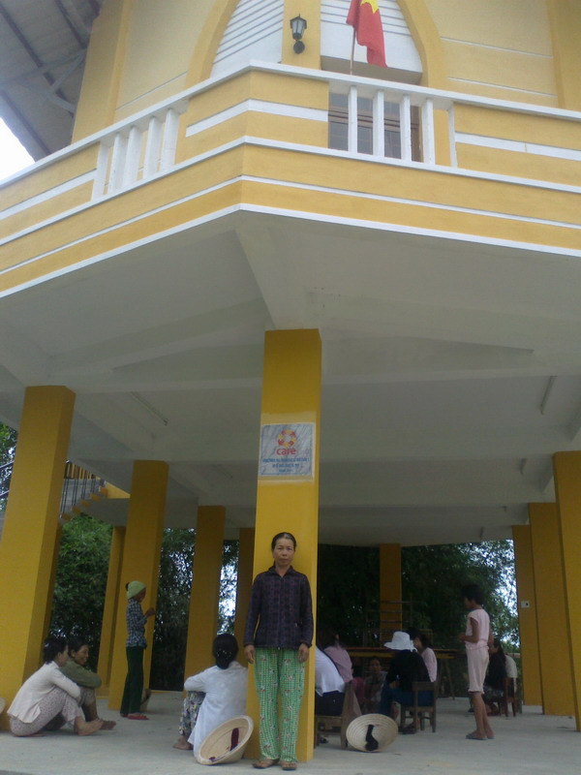
Appreciation of Mrs. Xuan about the support of CARE
Mrs. Ngo Thi Xuan, a poor woman, head of a family with 6 children (4 boys and 2 girls), 4 children left lower secondary school to find jobs in cities, 2 others risk leaving their secondary school due to poverty
The flood in 2009 broke my leg; I've also lost 4 pigs due to diseases after flood. We have only 1,500 square meters for rice production, but the land is poor and we had bad crop before flood, I was in terrible situation, because I am the main bread winner for my family with 4 peoples, before the flood, I often went to the forest to collect firewood and sell them to have money for foods, with a broken leg, I was thinking that we will all die.
We first were able to get by on a reasonable provision of foods from CARE, the terrible fear of hunger was over and I had self confidence to the bad situation.
Three months later, when I was getting better and able to do light works such as cleanup, sanitation, and the project provided me cash-for-work opportunity, it was really helpful, I was able to earn money for our livelihoods with works that are relevant to my health.
Then the project provided me rice seedling and fertilizer, thanks to its good quality, I had good yields of the last crops and we had enough foods for all the family.
Our two children risked leaving their secondary schools are now continuing the studies and I am very happy of the current situation.
With this safe community house, I am able to sleep well during heavy raining days, because I know that we will safety get there if we will be flooded.

Communities Evaluation Meeting and individual interviews in Trung Vinh Village, Que Xuan 1 Commune, Que Son District, Quang Nam
(May 25, 2011)

- Project' implementation arrangements
The consultant believe that the implementing arrangements with field based small team including one Project Manager, two Project Officers (one for each district), two Project Assistants (one for each district), one Administrative/Accounting Assistant and a fulltime construction engineer is relevant and appropriate, because the project implements activities in two district with five communes and many villages, the supporting activities to emergency needs requires systematic and non-stop technical assistance as well as monitoring and management supports, ensuring the good governance, transparency and humanitarian ethics. The roads from district to communes and especially from communes to villages are bad and staff had to spend much time for traveling, with these geographical and the emergency contexts, the personnel structure of the project is appropriate.
However, the consultants believe that the selection of provincial DOFA as key implementing and management partner is not very relevant. DOFA does not have the mandate or the role of DRR coordination and management and it does not have relevant specialists to work in DRR activities. In the evaluation meeting with DOFA, the consultants found that DOFA does not have much information about the project' progress and results, the interviewed peoples (vice director and two specialists) can't provide much evaluation' ideas about the ERR project as well as areas for improvement to DRR activities in the future, the consultants believe that the selection of DOFA as key provincial partner is for diplomatic purposes rather than coordination and management purposes.
The consultants also found that the project does not have much communication with key provincial and district department in charge of coordination of Emergency Relief and Rehabilitation such as RC, FSC, and FF. The consultants do think that the project does not need to closely work with these organizations, but the systematic communication and coordination with those organizations were needed to synergy and information exchange of best practices and learnt lessons for replication purposes.

- Monitoring and Evaluation (M&E) Framework
The consultants found that the M&E Framework developed and implemented by field team in Quang Nam is a real good initiative. For distribution activities, a Continuous Improvement Cycle had been developed as guiding steps to planning, implementing, monitoring and evaluating processes. The local authorities have confirmed to the consultants that the CARE project' staffs had review and evaluation meeting with them after each distribution activity for improvement and they have learned a lot about emergency relief from these review meetings. However, only CARE staffs are well aware of these steps and able to adopt these steps in practice, the detailed guidelines for each step has not been developed yet and best practices and learned lessons also have not been documented to handover phase and local peoples will face up to challenges to replicate CARE approaches.
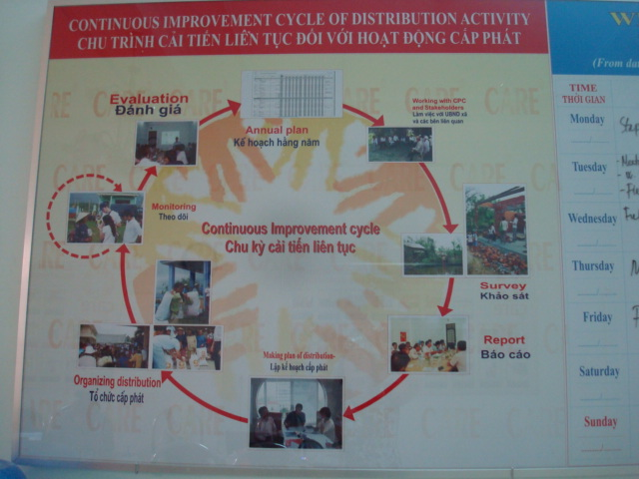
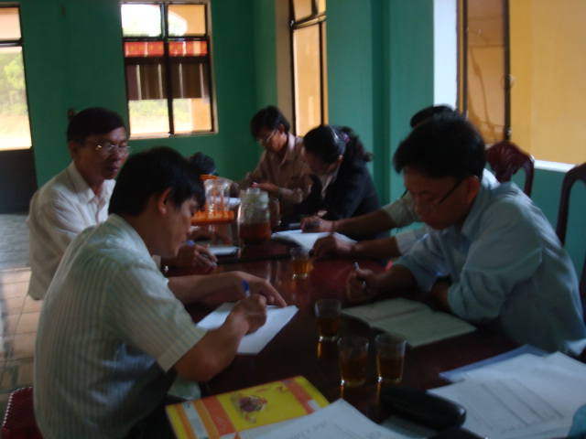
Appreciation of stakeholders in Que Xuan 2 about M&E of the project
CARE has adjusted the list of beneficiaries after each distribution, ensuring the fairness and equality;
Our proposed lists of beneficiaries were for references only, CARE staffs went directly to the fields for assessment and double check;
Thanks to good monitoring and control of CARE, the quality of all the project supports was very good.
We highly appreciate the monitoring, control and attitude of CARE staffs.
Continuous Improvement Cycle of Distribution Activities
Evaluation Meeting with key stakeholders in Que Xuan 2 Commune of Que Son (May 26, 2011)

The communities have confirmed with the consultants that they have been clearly informed of the type of supports and quantity in community meetings. The lists of eligible beneficiaries as well as the supports of the project to each beneficiary have been displayed in cultural village houses and in CPC entrances. All the beneficiaries had to come to the distribution places to take the provided items and to sign on the monitoring sheets, it was forbidden to take and sign on behalf of the others, ensuring the right peoples took their parts.
All data and information project' implementing progresses have been well recorded and filed in both project office and in CPC offices. The consultants were very impressed in meetings with key stakeholders at CPC; the vice chairmen of all visited communes were able to mention all the activities of the project with exact quantity (the number of packages of foods and the equivalent value in cash, the quantity of rice seedling, of fertilizer, the number of trainings and participants of each training, the number of constructed infrastructure schemes and value…). Each CPC has organized a filing folder containing all the data and information about the project.
CARE has conducted poverty assessment, using PRA wealth ranking method and tool to develop the list of poor and vulnerable peoples ensuring the relevance and appropriateness of the targeting method. How ever, the interviewed villagers and local authorities complained that the list of beneficiaries has not been updated regularly and with the targeting strategy of the project with priorities given to poor women, poor women playing main productive role in the families, there were a number of officially recognized poor had too much opportunities, while a big number of near poor (cận nghèo), whose poverty situation is similar to those targeted poor received nothings, that may arouse envy and had broke the solidarity within community and local authorities had challenges in explanting the rules of the project to unhappy peoples.
This table will show the general evaluation of relevant indicator:

Evaluation
Nr. | Contents of Evaluation |  | Number of interviewers | Number of voted interviewers | Percentage (%)
1 | Needs
 | 1.1 | Needs of food | 61 | 61 | 100%
 | 1.2 | Needs of none-food | 61 | 61 | 100%
 | 1.3 | Needs of small civil works | 61 | 61 | 100%
2 | Quality of supporting
 | 2.1 | Food | 61 | 61 | 100%
 | 2.2 | Seedlings | 15 | 5 | 33%
 | 2.3 | Seed rice | 61 | 55 | 90%
 | 2.4 | Fertilize | 61 | 61 | 100%
 | 2.5 | Shelters | 61 | 50 | 82%
 | 2.6 | Houses | 3 | 3 | 100%
 | 2.7 | Brige | 61 | 61 | 100%
 | 2.8 | Cannel | 61 | 61 | 100%
3 | Time to delivery
 | 3.1 | Food | 61 | 61 | 100%
 | 3.2
4 | Effectiveness
 | 4.1 | Food | 61 | 61 | 100%
 | 4.2 | Seedlings | 15 | 8 | 53%
 | 4.3 | Seed rice | 61 | 50 | 82%
 | 4.4 | Fertilize | 61 | 61 | 100%
 | 4.5 | Shelters | 61 | 61 | 100%
 | 4.6 | Houses | 3 | 0 | 0%
 | 4.7 | Brige | 61 | 61 | 100%
 | 4.8 | Cannel | 61 | 61 | 100%

Effectiveness
According to interviewed local authorities and communities, CARE was the first INGO that came to Quang Nam 10 days after the storm and flood in 2009, CARE need only 15 days to finalize good lists of eligible beneficiaries and their needs of emergency relief, it strongly confirmed the good effectiveness of CARE in "Just in Time" operations.
According to results of individual interviews, FDGs with communities and commune key stakeholders, all the provided foods and non-foods items as well as constructed infrastructure schemes are high sensible and useful to the communities. The interviewed beneficiaries have confirmed with the consultants that they all used the provided items for their families; there were nobody who did not need the provided items and gave to someone else. With 60 interviewees, there were 100% have confirmed the quality of foods, fertilizers, safe community houses, bridges; canals were good and very useful.
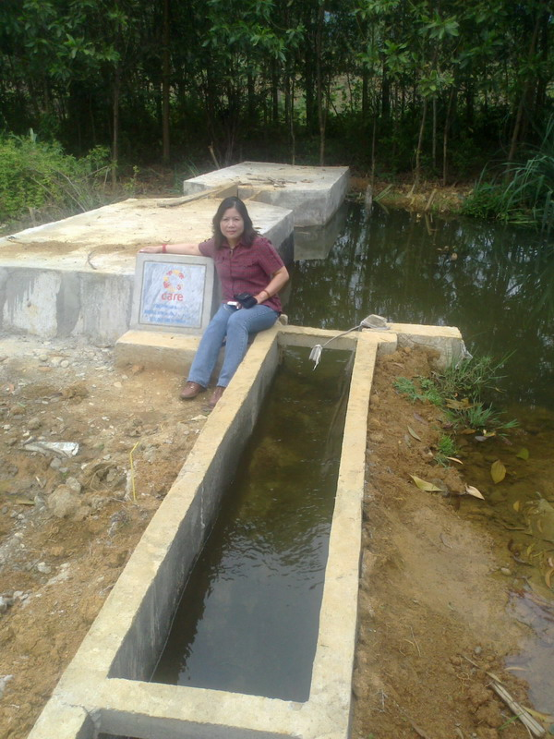
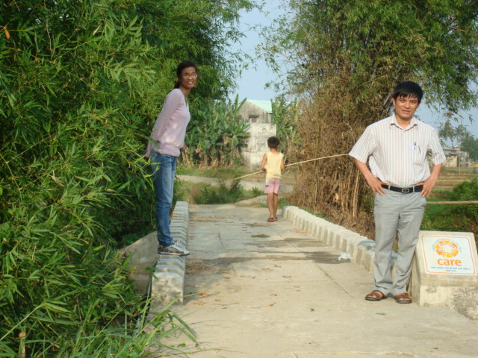
Some comments noted from unplanned meet peoples working around the constructed works
The quality of this canal is very good, investment is small, but it is irrigating to 7ha of rice-land of two villages.
Before, there was only a small iron tie here connecting two villages with our rice-fields, we had many difficulties in heavy rainy days to go there and we lost our crop in flooded years. Now a flood was over and the bridge is still very strong. All of us are very happy with this new bridge.
Well functioning constructed infrastructure schemes for rehabilitation

The emergency as well as periodical technical support missions from CARE' team in Hanoi and in other related projects of CARE are highly appreciated by the field team in Quang Nam, especially in the first phase of the project, the communities need emergency supports and experienced staffs of CARE DRR' team in Hanoi and other provinces had been effectively mobilized to supports Quang nam, ensuring a well starting phase to a good implementation in next phases, the emergency mobilization of experienced staffs between projects executed by CARE is a real effectiveness, especially in the case of ERR in Quang Nam, where human resources in DRR area were still limited.
CARE has successfully promote the community volunteerism in supporting the emergency relief, in each targeted commune, a group of 10-12 community volunteers composing of representatives of CPC, WU, YU have been effectively mobilized to support the project in delivering the services of emergency relief, those volunteers worked under the technical guidance of CARE staffs and this was part of capacity development and empowerment of community participation to emergency activities. This implementing mechanism was highly appreciated by the local authorities and targeted communities. The consultants meet a number of volunteers during the evaluation meetings with commune key stakeholders and found that these volunteers are priding and pleased of what they have done to the communities with CARE staffs. These active participation and appreciation would confirm the effectiveness of supported activities, because peoples are happy to do voluntary works only when they understand that their efforts are useful and effective.
According to the discussions with key commune stakeholders, the project has made very positive changes in local government policies and practices regarding to emergency relief and rehabilitation activities. The interviewed local authorities confirmed with the consultants that they will apply the assessments adopted by the project to the identification of needs and to the development of lists of eligible beneficiaries, ensuring the right peoples will receive expected items. They will also promote the community volunteerism to support emergency relief. The quality management with booking system, field' monitoring, assessments and control of the project, the working attitude of CARE staffs with high professional working ethics were highly appreciated by the local government authorities, they commented that these good practices of the project had made high positive impact to them and they will adopt these practices in the future.
However, the consultants believe that implementing approach regarding to the support of shelters (temporary houses) was not very effective. The project had built 6 shelters for six poorest families in each targeted commune, with 61 interviewed peoples, there were only 50 peoples commented that the quality of these shelters were good. The consultants visited three families who received shelters and interviewed the owners; all of them complained that the project pressured them into accepting the design of the house and implementing approach. The project gave them only one option (the design and implementing approach) and asked peoples to sign the agreement, peoples were afraid that if they did not accept the approach, they would lost a very big support. They were not happy because the design was not relevant (the houses are too small and too short and hot with metal roofing, there weren't water through), the project contracted with companies to do all the construction works, and communities can't take the advantages of voluntary labors, local materials to build their houses. They are not happy when comparing the shelters supported by the project with total cost of 42 million with the shelters supported by other government programs with total cost from 12 to 19 millions. They commented that if the project signed agreement with beneficiaries, clearly specified the technical requirements on design and quality and encouraged the community participation in construction of these shelters, their houses would be bigger and stronger and the project' supports would be more effective, because they would be able to develop a relevant design and to take the advantages of voluntary labors and local materials.
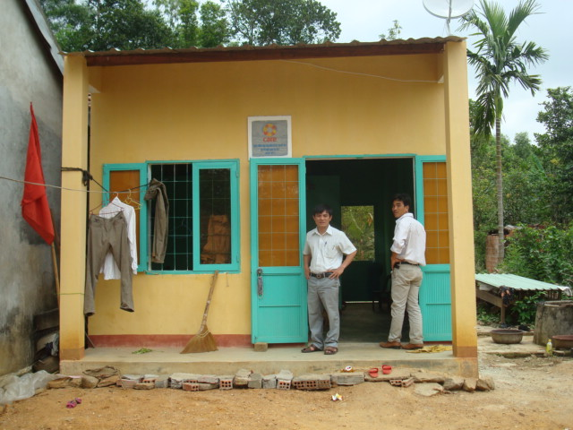
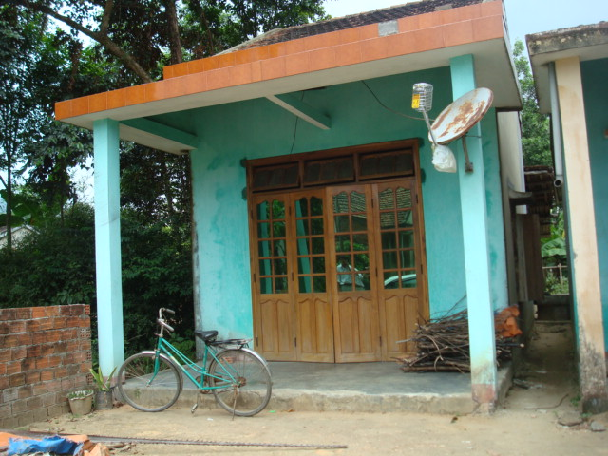

On the left side – Shelter supported by government program with total cost of 18 millions VND
One the right side – Shelter supported by CARE Project with total cost of 42 millions VND

Sustainability issues
The project works directly with CPC, RC, WU, FF and RT in the implementation and management of the project activities, this implementing and managing structure is relevant to small and short DRR project, ensuring the high participation and ownership of the local peoples to sustainability of the project.
With relevant emergency relief and rehabilitation supports, many poor peoples had overcome hunger threats and had basic livelihoods conditions for productive activities. The consultants also found a very high self confidence of the communities of their current situation and future natural disasters. They commented that with the relevant and effective supports of the project, they are now well educated of preparation and response to emergency situation such as storm and flood. With 61 interviewed peoples, all of them replied that "We will better plan for the natural disasters" to the question "How will you do with future natural disaster?".
The interviewed peoples and local government authorities also confirmed with the consultants that the acquired knowledge and skills through working together with CARE staffs and participating to trainings will be sustainable and productive. The women now are able to effectively participate in cleanup and sanitation activities after flood and storm, they are also able to mitigate diseases due to flood and storm and take reasonable actions to take care themselves and to face up to future natural disasters.
The experienced community's volunteers are now able to provide voluntary supports to the communities in emergency relief, because they had good experiences with the project and they are pride to do voluntary works. The consultants noted the high enthusiasm and commitment of those mobilized volunteers in supporting their communities in emergency actions in the future.
The consultants also noted the high appreciation of the local government authorities and benefited communities to the appropriateness and quality of the constructed rehabilitation infrastructure schemes. They showed high interest and commitments to the monitoring, maintaining and controlling these transferred infrastructure schemes. They had developed maintenance policies, ensuring the productivity and sustainable use of these supports.
The below table shows the needs of interviewers:

Needs ranking
Nr. |  | Number of interviewers | Number of voted interviewers | Percentage (%)
1 | Food | 61 | 61 | 100%
2 | None- food
 | Seedlings | 15 | 5 | 33%
 | Seed rice | 61 | 61 | 100%
 | Fertilize | 61 | 61 | 100%
3 | Small civil works
 | Shelters | 61 | 61 | 100%
 | Houses | 61 | 61 | 100%
 | Brige | 61 | 61 | 100%
 | Cannel | 61 | 61 | 100%
4 | Others
 | Cash through work | 61 | 61 | 100%

Learnt Lessons and Recommendations
The following recommendations may be considered in the planning of any future emergency and rehabilitation project or as part of CARE projects which seek to address issues related to addressing the needs of communities after natural disasters. They represent conclusions drawn during this evaluation based on respondent information, the review of project documentation and the current facilitating environment for emergency relief and rehabilitation in Vietnam.

Closely consult the communities and local authorities in assessment and development of lists of beneficiaries
The interviewed communities and local government authorities commented that most beneficiaries are right peoples (poorest and most vulnerable peoples), but due to the need of quick response, the assessment had been quickly conducted and local authorities and communities did not have enough time to assessment and reflection, several families were poor and had heavy damages due to flood and storm, their houses were totally collapsed and they had to make all the efforts, including take loans from private money lenders to immediately repair their houses for their living, while a number of families that were not very poor and the damages were not very severe to them, they did not make much efforts to repair their houses, when doing the quick assessment, peoples just focused to the actual facts and tangible situation and did not pay enough attention into the intangible facts. The issue was that several eligible peoples did not receive supports and several peoples who are not in the poorest and most vulnerable the group received supports, which had broken the solidarity in communities and local authorities had challenges in responding to informal complaints of the communities.

It needs clear criteria with weigh for the selection of beneficiaries of big supports.
The support of package of foods, fertilizer or seedlings is not very big to each family, but the support of shelters with total cost of 42 million is a very big support, the project had carefully conducted the assessment and consultation, but it mostly based on qualitative information and on subjective ideas and feeling of project staffs and local government authorities. The interviewed communities and local government authorities suggested that need to develop clear criteria with weigh and all concerned stakeholders, including communities and authorities will assess the eligibility based on these objective criteria with weigh with the list of all potential eligible peoples. This working approach and tools will ensure the high consent from communities to the selection of the communities.

Ensure high community ownership and participation to improve the effectiveness of the interventions
The interviewed communities and local authorities commented that for any supports directly to families, it should encourage the community ownership and participation for effectiveness (example the shelter). When beneficiaries own and fully participate in the processes, they are able to mobilize community labor and materials' resources for productivity and effectiveness. The interviewed local government authorities also commented that the bids for construction' works should be opened and informed widely in the affected areas, where communities groups and community constructors can't participate and if the quality of technical proposals and costs are similar between different bidders, priorities should be given to community bidders, because communities and local authorities are able to request more responsibilities from bidders to maintenance if these bidders operate their businesses in the areas.

It needs to organize relevant occupational and working safety trainings to peoples who are mobilized to provide cleanup and sanitation activities
Even the cash-for work opportunities given to poor women were highly appreciated by all interviewed peoples, but the consultants believe that a short training on occupational and working safety needs to be organized to peoples before mobilizing them to ovoid accidents that may happen. These peoples will need to have basic knowledge on cleanup and sanitation and occupational safety during and after natural disasters, if no, they may fall and be injured in accidents such as touching the fragment of broken bottle and, be bitten by insects, snacks or centipede… they also need to wear Safety working clothing when working in flooded areas.

Document the processes, best practices for knowledge management and replication.
CARE staffs has implemented excellent processes and initiated many good practices and those are being highly appreciated by local government authorities and communities, for example the Continuous Improvement Cycle had been developed by the field' staffs of ERR project in Quang nam to planning, implementing, monitoring and evaluating processes of distribution activities, but it is showing the Cycle only and isn't describing the details of each steps such as: what are the main objectives and activities of the planning, implementing, monitoring and evaluating steps of a distribution activity, which tools peoples should use? How to implement these steps, who are the best peoples to implement these steps? For sure that CARE staffs know by heart those steps and they do not need clear description of these steps for their actions, but for knowledge management and handover processes to replication purposes, it is recommended to CARE to find the way the document those knowledge and the field experienced staffs of CARE are the right peoples to do this work with some support from external consultants.

A flexible administrative and accountant system is needed to emergency relief supports
CARE is adopting a professional administrative and accountant system and policy, ensuring good governance and transparence to all actions and interventions. This system and policy has being applied to all staffs, stakeholders and projects and delay in financial and administrative clearance may create negative impact to emergency relief support due to its characteristics. For examples, the contracted tree seedlings company can't deliver their products on time due to the delay of financial and administrative clearance and the seeds were died after planting. It is suggested to study and pilot a more flexible administrative and accountant system to emergency relief supports for effectiveness' enhancement and efficiency of just in time operation.

Standardize the monitoring and evaluation (M&E) methods and tools of emergency relief and rehabilitation project and organize training on M&E methods and tools to all staffs and key stakeholders
CARE field' staffs and key stakeholders commented that they had to initiate their own M&E methods and tools and they are not sure of the relevance and appropriateness of what they have initiated. They expect that CARE in Hanoi would develop a well (M&E) methods and tools and organize trainings to all new staffs and key stakeholders. This effort will ensure a systematic M&E, ensuring the logical and standardized monitoring, controlling and evaluating system and tools to interventions in the future.

Annexes

Annex 1: ToR for the evaluation

Evaluation of Emergency Relief and Rehabilitation Project
Terms of Reference
- Background

Emergency Relief and Rehabilitation project established in October 2009 in Quang Nam province. This project funded by multidonors with the total of budget is 1,8 millions USD. Its goal is to contribute to the emergency relief and rehabilitation after storms in selected communes in Quang Nam province includes Tam Tra, Tam Hai and Tam My Tay of Nui Thanh district, Que Xuan 1 and Que Xuan 2 of the Que Son district. The project was divided two periods: the emergency relief period with the budget is...... from October, 2009 to April, 2010 and rehabilitation period with the budget is....... from April, 2010 to March, 2011.
The emergency relief period, project organized distribution food and non-food for the beneficiaries are elderly poor, women poor and children poor in five communes above.

The rehabilitation period, project supported rice seeds and fertilizer in four communes: Que Xuan 1, Que Xuan 2, Tam Tra, Tam My Tay. From May to November, 2010 the project supported to upgrade two bridges affected by ketsana storm for Que Xuan 1 commune and Que Xuan 2 commune. From November to March, 2010 the project will supports to build two safe houses for Que Xuan 1 and Que Xuan 2 communes and upgrade a canal in Tam My Tay commune.

- Purpose of evaluation:
This evaluation aims to evaluate and document the project results including outputs, outcomes, impact as well as the process and capture learning which can inform future emergency work.

- Specific objectives:
- To assess the outcomes and impacts in people’s lives that occurred during the project time in the target areas and contribution of the project to these changes against the specific objectives of the Emergency Relief and Rehabilitation project.
- To identify key lessons learned from the project and make suggestions for future use for CARE and partners.

- Scope
The consultant will raise and address all relevant issues that may emerge during the evaluation, including the key areas highlighted below.
d.1. Achievements to date
Consider results achieved of Emergency Relief and Rehabilitation (ERR) project and the measures of success set out in the project plan:
    - What results have been achieved by ERR since its establishment in 2009? What were the challenges and if they were solved properly?
    - What progress has been achieved against the measures of success for project set out in the project plan?
    - Identify and document the available evidence of the project impact on emergency relief and rehabilitation activities to the beneficiaries
d.2. Relevance and Appropriateness
Consider how ERR's approaches and activities serve its target population
    - Are the types of activities carried out most appropriate in the circumstances and in line with community priorities and culture?
    - Was the targeting methodology sufficient to ensure that the most vulnerable groups needs were addressed?
    - Was there any duplication of work in the project areas?
    - How effective were the different approaches in the emergency relief and ERR’s rolling workplans in pursuing the targets of ERR set out?
    - Did ERR, have the necessary resources and capacity to undertake the activities required to achieve its strategic goals?
    - Are ERR’s key stakeholders satisfied with the approaches and activities used to date in achieving its target?
d.3. Effectiveness
    - Were the activities implemented at appropriate time?
    - Were sufficient resources made available at the right time to the field office? Was sufficient management support provided to the field office?
    - What was the level of participation from target population including women and partners? If this was adequate?
- Has the project made any positive or negative changes in government policies and practices?
d.4. Sustainability issues
    - What contribution has the project made in reducing current and future vulnerabilities and how has it strengthened community resilience?
- How well did the project build on existing capacities of the beneficiaries and partners?
- Are the main changes achieved likely to last?
d.5. Recommendations
- What are recommendations for the partners to maintain the project impacts?
    - What are recommendations in strategy for scaling up and deepening impact on the quality and accountability of humanitarian action?
    - What are lessons in managing relations with key stakeholders, including beneficiaries, Province People Committee, District People Committee, Commune People Committee and donors and
    - Lessons in organization of ERR project
- Activities/ Methods
A combination of primary data collection and secondary data review is expected during the evaluation. Primary data will be collected through a variety of methods, including key informant interviews, focus group discussions and e-mail/phone survey with representatives of key stakeholder groups. Visits to beneficiaries at two different locations are budgeted for this work.
It is expected that the consultant will undertake the following tasks:
    - Familiarization with the ERR project work plans, budgets and reports.
    - Onsite interviews with ERR staff
    - Interviews with key stakeholders:
      - District People Committee
      - Commune People Committee and
      - Beneficiaries at two locations
    - Cross-referencing of field data and seeking further clarification
    - Draft report
    - Review draft report
    - Finalize report
To consult over critical questions, present preliminary findings and collect further data for the evaluation; the consultant will facilitate a ½ day session at the ERR project office

- Management
The evaluator will formally report to the Project Manager while day-to-day support, facilitation and coordination will be provided by the Project Manager. In the event of any major disagreement over the content of the evaluation, the Project Manager will endeavour to find a consensus, and, if necessary, ensure that any strategically critical dissenting perspectives are acknowledged in the final report.

- Expected outputs and timeframe
It is estimated that the consultancy will be completed within 30 working days, the time of evaluation conducting will beginning at early of May 2011. The consultant will produce the following by the stated deadlines:
    - Evaluation framework, including methodology and a draft outline of the report
    - List of critical questions
    - Draft report for review by the Project Manager
    - A final evaluation report with an executive summary within 2 weeks of submitting the draft for comments to ERR. The main report should not exceed 30 pages (excluding relevant material in the appendices). It will include:
      - Findings regarding achievements and the relevance, appropriateness and effectiveness of ERR approaches in serving the target population.
      - Specific recommendations to inform the local partners and future projects of CARE International in Vietnam.

- Report format
The consultancy will result in an evaluation report containing a comprehensive presentation of the methodology, findings, lessons learned and recommendations in English and covering, but not limited to:
    - Title Page
    - Executive Summary
    - Table of contents (with page numbers)
    - List of tables and figures (with page numbers)
    - Background
    - Description of the methodologies used
    - Evaluation findings
    - Lessons learned
    - Recommendations
    - Annexes:
    - Evaluation work plan
    - TORs of the evaluation
    - List of key informants

- Expertise required
    - Experience with organizational development, capacity building and learning.
    - Experience with monitoring and evaluation techniques, preferably in the area of humanitarian relief.
    - Knowledge of Emergency Relief and other quality and accountability initiatives.
    - Excellent analysis and report writing

- Terms and conditions
    - Daily consultancy fee is negotiable, although it must be commensurate with CARE’s policy.
    - The consultant will be contracted on a standard CARE International in Vietnam consultancy contract.
    - ERR will cover all reasonable accommodation and subsistence costs while the consultant is out of her/his home base, and will reimburse any direct administrative costs agreed in advance.
    - Payment will be made on the agreement between ERR and the consultant.

- Expression of interest
Applications are invited from suitably qualified consultants. Interested individuals or teams should submit a draft evaluation framework (max 2 pages) and a CV to ERR Project Manager by email on: hoa.ntm@care.org.vn
Deadline: ......./......2011
Shortlisted candidates (only) will be contacted by...../..... 2011

Annex 2: Technical and financial proposal from consultants including methodology and tools
With the scope of the project, objectives, activities, expected result of the services, the consultants will propose the Methodology, Time schedule and Estimated costs for the service as follows:
  - The Methodology
The participation methodology for the assessment will be used during assessment process and there are 2 ways as follows:

Top- Down
- Work with targeting provincial, district and the commune government (such as Provincial, district and commune Committees) and donor;
- Mass organizations such as the Red Cross Vietnam Quang Nam branch and Women’s Unions at local levels;
- Discuss, share information and data directly with those stakeholders;
- Work with DPCs, CPCs and Hamlets that they are involved in the project (3 communes of Nui Thanh District and 2 communes of Que Son District in Quang Nam);
Bottom up
- Work closely with vulnerable groups (elderly poor, women poor and children poor in 5 communes);
- Work with representatives, mass organizations at Communes and Hamlets;
- Interview and discuss directly with vulnerable people, who faces to the disaster and also be the beneficiaries of the project;
- Discuss with them about the activities have been done to meet the needs of vulnerable groups;

  - Tools will be used

Nr. | Name of Tool | Describe
1 | Desk review of relevant documents | - Collect project information, documents to review and understand  - Get the basic knowledge about the project  - Have the overview of the project
2 | Semi-structured questionnaire for individual interviews | - Get information and data for assessment and analysis  - Select the idea from beneficiaries about the activities have been carried out and the efficient of them
3 | Semi-structured questionnaire for focused group discussions | - Share information about the implementation of the project  - Get feedback from the beneficiaries  - Open talking about the project activities  - Get comments from different groups
4 | Structured questionnaire for self evaluation | - Provide opportunities to beneficiaries for self evaluation of the capacity building activities supported by the projects.
5 | Stakeholders' evaluation workshops | - Debate on the draft findings of the evaluation;  - Obtain consents from stakeholders on draft findings.
4 | SWOT Analysis | - To analysis the strength, the weakness of stakeholders  - To assess the success factors, the challenges
5 | VEEN Diagram | - Identify the stakeholders will be involved  - The role and responsibility of each organization

  - Time schedule
With the tentative duration of 35- 40 days/2 persons, the consultants plan the timeframe as follows:

Activities | Days
Desk reviewing works | 11 working days (from 16th to 21th May 2011)
Field works included findings workshop | 17- 22 working days (from 22th May to 1st June 2011)
Draft report writing  Finalisation of evaluation report following comments received from CARE on the draft report | 7 working days (from 2nd  to 5th June 2011)
Total timeframe | 35 days

  - Consultants (see the attached files)
Ms. Nguyen Thu Que - Team Leader
Ms. Que is a consultant with several years working on Disaster Risk Management field, in which she was working for UNDP, ActionAid, CARE, WB, she had chance to work with CARE International Vietnam to provide the final Evaluation work at Hau Loc District - Thanh Hoa in term of DIPECHO project and then joined to conduct the Need Assessment work to prepare the new DIPECHO project for Nga Son District - Thanh Hoa. She has experience to conduct survey, individual interview, focus group discussion, working with stakeholders and relevant agencies as well as organize the workshop. She has a good methodology using Participatory approach. In this assignment, Que will be responsible as Team Leader to prepare the work plan, field work program and draft report writing.
She has strong record in conducting studies using PRA tools and training in PRA, TOT and many other topics. Que is strongly familiar with the government SEDP and M&E processes. Que hold a master degree in Small and Medium Enterprise Development and a bachelor degree in agriculture economics.

Mr. Hoang Van Duong - Team Member
Mr. Duong has solid background and more than 5 years working experience as national program officer, in charge of strategic planning to disaster risks reduction and climate change projects/programs to CECI in Vietnam. He worked as a National Project Coordinator for CECI-UNDP "NDM-Provincial Priority Project for Disaster Risk Reduction" in Danang and Binh Dinh provinces. Recently, he has successfully provided consultancy services to CARE in Vietnam on projects’ review and evaluation, new programme’ development, including Team leader for documentation and lessons learnt of DIPECHO DRR in Hau Loc, and design new DIPECHO DRR project in Nga Son, Thanh Hoa; Key facilitator for policy dialogues on access to credits with VBARD and VBSP and National consultant for New Credit Products Development for EC funded ECCODE project in Thai Nguyen; Team leader for Final evaluation and new program development of Gifts Project in Hoa Binh, Team leader for Design and facilitation of training on Communication Skills to PWM project in Ba Thuoc, Thanh Hoa.

Annex 3: List of interviewed peoples

Nr. | Location | Name | Position
I | DOFA
1 |  | Mr. Nguyen Ngoc Kim | Vice- Director of DOFA
2 |  | Ms. Huynh Thi Thanh Mai | Head of INGO Division
3 |  | Ms. Do The Thanh Nhung | INGO Division
II | CARE Quang Nam Staffs
1 |  | Ms. Nguyen Thi Mai Hoa | Project Manager
2 |  | Mr. Pham Van Quang | Project Officer
3 |  | Ms. Truong Thi Thu Ha | Project Assistant
4 |  | Ms. Nguyen Thi Phuong | Project Accountant
III | Tam My Tay Commune- Nui Thanh Dist.
1 |  | Mr. Nguyen Kim Suu | Vice- President of CPC
2 |  | Mr. Huynh Ngoc Long
3 |  | Ms. Nguyen Thi Tham | President of CPC Women Union
4
5
 | Village 9
6 |  | Ms. Chau Thi Kim | Villager
7 |  | Ms. Nguyen Thi Tam | Villager
8 |  | Ms. Nguyen Thi Nhu Tam | Villager
9 |  | Ms. Chau Thi Le | Villager
10 |  | Ms. Vo Thi Le | Villager
11 |  | Ms. Pham Thi Ly | Villager
12 |  | Ms. Tran Thi Huong | Villager
13 |  | Ms. Le Thi Oanh | Villager
14 |  | Ms. Cao Thi Xuan Nuong | Villager
15 |  | Ms. Pham Thi My Huyen | Villager
 | Village 6
16 |  | Ms. Tran Thi Lan | Villager
17 |  | Mr. Mai Nen | Villager
18 |  | Ms. Tran Thi Ly | Villager
19 |  | Ms. Luong Thi Y | Villager
20 |  | Ms. Nhuyen Thi Tri | Villager
21 |  | Ms. Nguyen Thi Cuc | Villager
22 |  | Mr. Bui Ngoc Mai | Villager
23 |  | Mr. Tran Binh | Villager
24 |  | Ms. Ha Thi Thanh | Villager
IV | Que Xuan 1- Que Son Dist.
1 |  | Mr. Luu Thanh Van | Vice- President of CPC
2 |  | Mr. Nguyen Van Bien | Culture and Socia of CPC
3 |  | Ms. Le Thi Thanh | President of CPC Women Union
4 |  | Mr. Nguyen Thanh Thanh | CPC Redcross
 | Thanh Hoa Village
5 |  | Mr. Nguyen Nen | Villager
6 |  | Mr. Phan Phuoc Nuoi | Villager
7 |  | Mr. Phan Tam | Villager
8 |  | Mr. Nguyen Minh | Villager
9 |  | Mr. Nguyen Cu | Villager
10 |  | Mr. Phan Ba | Villager
11 |  | Mr. Phan Van Xich | Villager
12 |  | Mr. Nguyen Van Vui | Villager
13 |  | Mr. Phan Hoa | Villager
14 |  | Mr. Tran Thinh | Villager
15 |  | Mr. Le Quang Truong | Villager
 | Trung Vinh Village
16 |  | Ms. Le Thi Nghe | Villager
17 |  | Ms. Phan Thi Hong | Villager
18 |  | Ms. Tran Thi Van | Villager
19 |  | Ms. Truong Thi Duc | Villager
20 |  | Ms. Le Thi Nghiem | Villager
21 |  | Ms. Ngo Thi Anh | Villager
22 |  | Ms. Tran Thi Lan | Villager
23 |  | Ms. Phan Thi Phuong | Villager
24 |  | Ms. Ngo Thi Xuan | Villager
25 |  | Ms. Le Thi Khanh | Villager
VI | Que Xuan 2- Que Son Dist.
1 |  | Mr. Le Tho Quang | Vice- president of CPC
2 |  | Mr. Nguyen Van Muoi | President of CPC FU
3 |  | Ms. Le Thi Hien | President of CPC WU
4 |  | Mr. Doan Dinh Hieu | Culture and Socia of CPC
5 |  | Ms. Duong Thi Kim Hue | President of front father
6 |  | Mr. Nguyen Van Thiep | Invalid and Social Affair
 | Phu nguyen Village
7 |  | Mr. Le Thanh Trung | Villager
8 |  | Mr. Le Van Anh | Villager
9 |  | Mr. Pham A | Villager
10 |  | Mr. Le Cuong | Villager
11 |  | Mr. Le Ngoc Anh | Villager
12 |  | Mr. Le Nho An | Villager
13 |  | Mr. Doan Hai Au | Villager
14 |  | Mr. Tran Quang trung | Villager
15 |  | Mr. Doan Anh Tam | Villager
16 |  | Mr. Doan Trong Binh | Villager
 | Thuong Vinh Village
17 |  | Mr. Le Phuong | Villager
18 |  | Mr. Phan Ha | Villager
19 |  | Mr. Le Huy Thanh | Villager
20 |  | Mr. Le Tho | Villager
21 |  | Mr. Le Sang | Villager
22 |  | Mr. Doan Nhu | Villager
23 |  | Mr. Ngo Ha | Villager
24 |  | Mr. Phan Khoa | Villager
25 |  | Mr. Doan Cuc | Villager
26 |  | Mr. Le Tao | Villager

Tools will be designed upon signature of the contract by both parties

