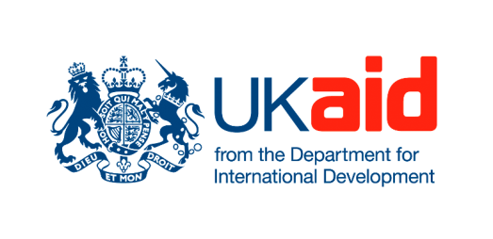

EVALUATION REPORT: XOOJINTA NABADA (STRENGTHENING PEACE) PROJECT

July 2012

Omar B. Da’ar, Ph.D.
Principal/Lead Consultant
Research & Evaluation International Consulting (IREC®)
P.O Box 67906-00200
Email: info@ireconsulting.com, or omar.daar@ireconsulting.com
Website: www.ireconsulting.com

_______________________________________________________________________________
Disclaimer: The views expressed in this evaluation report do not necessarily reflect the views of CARE International Somaliland/Puntland/Somalia, Implementing Partners, or the donor of the project (DfID).

Table of Contents

Table of Contents 2
List of Figures 3
Abbreviations 4
Abstract 5
Acknowledgments 6
1.0 Summary of Key findings 7
2.2 Conceptual Framework 10
2.3 Focus Group Discussions (FGDs) 11
2.4 Key informants 12
2.5 Consultant's own field observation and participation 13
2.6 Sampling technique and tools 13
2.7 Data Analysis Methodology 14
2.8 Assumptions 14
3.0 Background & project rationale of the project 15
4.0 Relevance 16
4.1 Project design, appropriateness and relevance 16
5.0 Efficiency 18
5.1 Project's inputs/Resources used efficiently 18
5.2 Project efficiently enhanced capacity of local partners 19
6.0 Effectiveness 20
6.1 Enhanced existing conflict resolution mechanisms 20
6.2 Enhanced Peace and conflict skills/knowledge of committees 21
6.3 Enhanced environmental and natural resource consciousness 23
6.4 Enhanced skills in dealing with unrelated issues – Police station and garbage handling 24
7.0 Impact 24
7.1 Significant Project Outputs and Outcomes achieved 24
7.2 Overall Project Impact 29
8.0 Stakeholders' views about project sustainability 31
9.0 Limitations of the Project and Evaluation 32
9.1 Some challenges/barriers during project implementation 33
9.2 Limitations related project evaluation 34
10.0 Recommendations 34
12. Appendix 37

List of Figures

Figure 1. Composition of the FGD participants by village and gender 12
Figure 2. Composition of the FGD participants by village and committee type 12
Figure 3. Participants of key Informant interviews 13
Figure 4. Percent (%) of committees conscious of environment 23
Figure 5. Number of women trained in leadership, conflict sensitivity, peace-building and advocacy 25
Figure 6. Number of gender balanced community conflict mediation and resolution meetings held project life 26
Figure 7. Stakeholders involved in peace monitoring 27
Figure 8. Engagements with parliament for enactment of the revised policy and representatives trained in integrated NRM 27
Figure 9. Women and committees in NRM governance and structures 28

Abbreviations

DfID – Department for International Development
FGDs – Focus Group Discussions
GBP – Great Britain Pound
HR – Human Resource
IT – Information Technology
KI – Key Interviews
M&E – Monitoring & Evaluation
NRM – Natural-Resource Management
SGBV – Sex and Gender-Based Violence
ToR – Terms of Reference

Abstract

CARE International in Somalia contracted Research & Evaluation International Consulting (IREC®) in July 2012 to carry out a final evaluation by examining the achievements of the implementation of the Xoojinta Nabada (Strengthening Peace) Project (hence forth “the project”) over the past year. Funded by DfID, the project involved the establishment of peace-building committees in several villages in Sanaag/Sool regions. The Peace Committees were trained on how to identify the root causes of conflicts and carry out conflict resolution at community level. The methodology for this evaluation involved combining focus group discussions (FGDs), key informant interviews and field observations. This approach also ensured triangulation by cross-checking the field information against project documents.
Overall, the project was a win-win situation for stakeholders and participants and adequately employed resources and involved all parties in its activities so as to achieve the set objectives and targets. Thus, its performance in the first year of implementation was satisfactory in terms of relevance, efficiency, effectiveness, impact and sustainability. If peacebuilding training can be effective, efficient, effective for Peace Committees in the areas with vulnerable groups, it is likely to be effective with other stakeholders that have fewer problems and tend to seek solutions regarding their conflict issues.

Acknowledgments

IREC ® wishes to thank all the people who facilitated the completion of this final evaluation report. CARE Somaliland/Puntland staff and field coordinators who were involved in this project were most helpful and supportive and we benefited greatly from the opportunity to travel with them for the field visits. We are also grateful to the other CARE International staff who facilitated, planned and provided crucial information about the project during the key informant consultations. We benefited immensely from interviews with local partners, local elected officials, and government officials. Throughout our discussion, these stakeholders clearly referenced different aspects of the project, an indication that they were engaged and conscious about peace and prosperity in the region. Finally, we thank all those who commented on the initial draft.

1.0 Summary of Key findings

- Our assessment from both project documents and field research determined that the conceptualization, design, and implementation of the Xoojinta Nabada Project in Somaliland/Puntland reflected the needs and interests of key stakeholders, indicating a broader utility and relevance of the project. In addition, the project appears to have performed fairly well on value for money.
- Our assessment showed that the project staff and local partners both indicated that the project had a clear and well- designed communication and relationship management strategy. This was also evident from the way the project developed strong ties with the target stakeholders – beneficiaries, elders, community leaders, local council officials, local partners, and line government agencies during this period. Furthermore, there was ample coordination with Head Office on day-to-day field operations.
- Our evaluation showed that the project efficiently enhanced the capacity of local partners. Project staff and local partners grew over the course of the project, which was a learning process for both. The performance of CARE and local NGOs as implementers and partners has improved over the first year of implementation of the project, in a large part because of a clear project goal and the involvement of local partners during the design of the project and training, and the consideration of the prevailing socio-economic, and cultural sensitivities such as developing traditional mechanisms of solving conflicts. Thus, the local partners’ ability to deliver their components as required in the project proposal was satisfactory.
- Our evaluation showed that the project was effective, especially in enhancing existing conflict resolution mechanisms. Although participants in the various FGDs said they often employ these mechanisms in conformity with their tradition and culture, there was ambivalence about them before the implementation of the project. In part, this can be explained as an absence of skills/knowledge to manage certain conflict cases. Committees therefore reported that the project eliminated uncertainties, particularly those related to SGBV and women’s empowerment which hitherto were taboo. Thus, the project created hybrid conflict resolution mechanisms (a combination of traditional and modern approaches) that are far more effective than those reported in the baseline. This clearly indicates that the training offered to the Peace Committees was appropriate, adequate and efficient.
- Our evaluation showed that the project enhanced the skills and knowledge of the Peace Committees. The implementation of the project generally enhanced and reinforced residents/beneficiaries’ existing knowledge capacity, especially in preventing and resolving conflict situations in their respective villages. Both committees, beneficiaries and local partners perceive that the project's planned benefits have been delivered and received, an indication that the project has been effective.
- The project enhanced awareness on environmental issues and natural resource management. One of the expected outcomes of the project was for communities to understand the relevance and importance of inclusiveness in natural resource governance. This has been achieved to some extent and committee members enthusiastically talked about the inter-linkages between drought, theft and inheritance of frankincense (fox), lack of pasture, water, deforestation and irrigation canal sharing as issues fueling conflicts which they now understand how to address. Committees and by extension residents now understand and are somewhat conscious about the absence of effective natural resource management not only as a root cause of conflict but also as having negative environmental consequences. A number of discussions in all the villages appear to concur that it is this understanding combined with increasing monitoring of natural resource management issues that certain issues, for example, charcoal burning, are resolved.
- The project also enhanced skills in responding to unrelated issues such as the need to set up local police stations and waste management. The project enabled committees to deal with these additional issues, which nevertheless may directly or indirectly trigger local conflicts. These results give an indication that the project’s establishment of peace-building committees and training on how to identify the root causes of conflict has been effective.
- The well conceptualized, designed and implemented project activities have enabled good progress in meeting the overall objectives. In turn, the project can be attributed to an overall reduction in conflict and violence through sustainable natural resource governance and improved responsiveness of community conflict resolution mechanisms in the target areas. This was evident from both project documents and field data.
- The project reduced incidences of conflict and the ability to monitor potential conflict triggers within target communities. The progress reports, for instance, indicate an increase in the number of women, religious leaders, youth groups, and local authorities who are participating in monitoring triggers and flashpoints in order to pre-empt local level conflict. Compared to the baseline assessment, the number of women able and actively participating in conflict resolution at the household and community levels, has increased significantly. Additionally, the reports show an increase in the number of women represented officially in natural resource governance structures and customary NRM committees and is collaborated by field assessment data. Whilst previously resource-based conflicts were the norm, committee members in all the villages visited indicated that such conflict has become an exception after the implementation of the project. In all the villages there was a clear demarcation of functions of the various village committees, reducing the ambivalence in particular of how SGBV issues are addressed.
- Analyzing the progress against the planned overall objectives and indicators, women's abilities to negotiate non-violent conflict resolution at household levels have also been strengthened by the project.

2.0 Study purposes and methodology

2.1 Evaluation purpose
As part of a broader assessment of the Xoojinta Nabada (strengthening peace) project, CARE Somaliland/Puntland contracted Research & Evaluation International Consulting (IREC®) in July 2012 to carry out a final evaluation by examining the achievements and the implementation of the project over the past year. As per the terms of reference (ToR), the we reviewed activities and project objectives so as to analyze the extent to which output and outcomes have been achieved and progress made towards project targets and milestones.

The guiding questions of the evaluation were:
- Whether or not the program achieved its set objectives and targets
- Whether or not the parties involved conducted all project activities to the satisfaction of meeting the project objectives
- Whether or not the implementation processes employed were adequate to achieve the set objectives
Facilitated by CARE, we undertook field visits to conduct focus group discussions, meet with project stakeholders and completed field observations.

2.2 Conceptual Framework
Individual/HH level: Contribute to reduced conflict and violence through sustainable natural resource governance and improved responsiveness of community conflict resolution

Improved relevance and inclusiveness of natural resource governance

Increase in rural women participation in conflict resolution

Xoojinta Nabada (Strengthening Peace) - Training committees in Peace, NRM, & SGBV issues

1. Strengthened women's ability to negotiate non-violent conflict resolution at household and community levels
- Increase in number of women, religious leaders, youth groups, and local authorities participating in monitoring triggers and flashpoints in order to pre-empt local level conflict
- Increase in number of women ably and actively participating in conflict resolution at the household and community levels
2. Improved relevance and inclusiveness of natural resource governance
- Increase in the number of women represented officially in natural resource governance structures
- Increase in the number of community committees of the customary NRM governance structures established

Goal setting

2.3 Focus Group Discussions (FGDs)
During the field visits, we conducted 6 focus group discussions (FGDs) - from three different villages in the Sanaag region of Somaliland/Puntland. We had in each village 2 FGDs - one for female and one for male participants. The need to have FGDs was decided on the understanding that certain group dynamics would play an important role in the assessment process. By bringing together identified stakeholders in an appropriate place familiar to the participants, we created an environment in which critical assessment issues could be discussed.

Specifically, we designed the FGDs to examine whether the project has built a critical mass of expertise in strengthening peace and improved the lives of vulnerable rural communities, particularly women through improved governance and conflict resolution mechanisms at various levels in the Sool/Sanaag regions. Thus, the FGDs helped to understand beneficiaries’ views, experiences, learning, expectations and the impact of being involved in peace-building, natural resource governance and SGBV mechanisms intended to reduce conflict and violence.
During the FGDs we observed all the house-keeping rules and basic underlying assumptions. We conducted the FGDs on July 5th, 6th, and 7th and designed them to elicit answers to specific evaluation questions with the length of discussions varying from village to village. The FGD questions followed a 'converging' or 'funnel strategy' in which we first asked broad, open-ended questions. The purpose of this strategy was to learn and examine what is the uppermost in the beneficiaries/committees’ mind with the overarching objective of examining the achievements of the implementation of the project over the past year. These were followed by a set of probing techniques, with follow-up questions aimed at gauging the value of establishing peace-building mechanisms and the effectiveness of such committees created through the project. In this regard, we developed unique questions designed to understand the experience of beneficiaries and effectiveness of the activities linking the response wherever possible to the indicators developed during the project design period by CARE and its partners.

Overall, FGDs were useful in gathering qualitative information on the progress towards project outcome, perception and behavior change among beneficiaries and success and failure of the project implementation in achieving desired outcomes.

Figure 1 illustrates the breakdown of the composition of the FGD participants by village and gender.

Figure 1. Composition of the FGD participants by village and gender
 | Participants
Village | Women | Men | Total
Huluul | 12 | 10 | 22
Laas Doomare | 9 | 13 | 22
Fadhigaab | 11 | 15 | 26
Total | 32 | 38 | 70

Figure 2 further illustrates the breakdown of the composition of the FGD participants by village and committee type.

Figure 2. Composition of the FGD participants by village and committee type
 | Participants
Village/Committee type | Peace | NRM | SGBV | Elders | Total
Huluul | 5 | 4 | 11 | 2 | 22
Las Doomare | 5 | 6 | 8 | 3 | 22
Fadhigaab | 7 | 5 | 11 | 3 | 26
Total | 17 | 21 | 32 | 8 | 70

2.4 Key informants
A key task of the evaluation was to consult widely within the scope of the project and, as per the ToR, to seek the views of key informants (KI) by gauging interest, support, and assess the achievements of the project against specific criteria, including relevance, efficiency, effectiveness, impact and sustainability. In this regard, we developed a key informant Interview guide and met staff from CARE Somalia, coordinators of local partners, local elected officials, and representatives from government to discuss project design issues, identify lessons learned and other emerging issues that need to be incorporated to ensure successful implementation of the Strengthening Peace project. During those interviews we assessed challenges and barriers posed by the project's operating environment and sustainability. We conducted face-to-face interviews that varied in length from person to person. Overall, the KI interviews gave us the opportunity to understand the project and triangulate the views of the target population.
Figure 3 illustrates the breakdown of the key informants interviewed during this evaluation:
Figure 3. Participants of key Informant interviews
Key Informants | No. of Participants
Care Staff | 5
Elected Officials | 7
Government personnel | 1
Local Partners | 4
Total | 17

The CARE staff included two field officials and two key informants represented each of the two local partners (Candlelight and Nagaad Network). The elected officials were from Ceel Afweyn and Ainabo districts. An official from the Ministry of Planning and Environment represented the government.

2.5 Consultant's own field observation and participation
In addition to key informant interviews, we both observed and participated in informal discussions and conversations involving key project personnel, various beneficiary committees and local government elected officials throughout the field visit. Firstly, this helped to collect better qualitative information to supplement the key informant interviews and FGDs. Secondly, and more importantly, gained an understanding of the thoughts of the field project officers and beliefs and appreciation of the beneficiaries.

2.6 Sampling technique and tools
We followed no systematic sampling, however, a sampling of both the FGDs and key informants was purposive. We carried out the selection of the various committees and identification of the areas to visit with the assistance of the project and field staff. Since we aimed to understand peace and conflict resolution processes, it was more effective to obtain culturally specific information about the judgment, values, opinions and social contexts and perspectives of key stakeholders to establish current status of the project. In addition, accessibility and security considerations informed every decision in the FGD selection process.. In total, we conducted 6 FGDs and 17 key informant interviews. We attempted to record all participants' perspectives, in all the FGDs and interviews, but without attributing them individually.

2.7 Data Analysis Methodology
In analyzing the data we followed the following steps:

- We reviewed data from the first interviews in order to capture initial thinking and tentative conclusions, patterns, and relationships.
- With the goal of assessing the project’s achievements in terms of relevance, efficiency, effectiveness, impact and sustainability, we developed codes and coded the data using predefined categories and themes. We also looked for categories and themes that emerged from the field data and in instances where codes were broad, we merged categories to make themes narrower and sharper.
- This allowed us to develop themes, patterns, and relationships emerging from the codes and categories developed and transcripts to be identified examining in particular, similarities and differences in key informants and FGD participants' responses
- Finally, we summarized important themes that emerged from the data, each time reinforcing these themes with quotes while being cognizant of the main evaluation criteria as per the ToR.
- Finally, we carried out a triangulation process by cross-checking the information collected through field work against the available background literature in order to monitor and evaluate progress in regards to the expected project outcomes.

2.8 Assumptions
- Participants of FGDs and key informants have knowledge about the project and are able to provide information that is qualitatively better than individual interviews, providing synergies, motivation, naturalness and candor.
- The FGD compositions are representative of the general population in the target areas and have a degree of homogeneity, i.e. share common interests.
- The ideal group size of 8 to 12 participants are available for each FGD
- The evaluation is limited to the implementation of the Strengthening Peace Project over the past year up until July 2012.
- The scope of the evaluation is also limited to few villages in which the project targeted
- The consultant is fully briefed on the project and will remain conscious of CARE's Do No Harm policy

3.0 Background & project rationale of the project
Women have suffered the brunt of the crisis in Somalia – not only have they struggled to nourish their children in the face of drought, but they have also been at significant risk of both domestic sexual and gender based violence (SGBV) and SGBV linked to community-level conflict. Furthermore, women have suffered the impact of harmful cultural practices such as FGM which is compounded by serious reproductive health provision gaps and bear the largest labor burden in the household. Moreover, they also have far less influence on the political process and decision making at household, community and regional levels than men. Many of these problems, when studied in more depth, originated from two underlying causes: (a) the overarching lack of governance, conflict and lawlessness in Somalia and (b) the limited influence women have had in governance mechanisms at various levels.
This project aimed to improve the lives of vulnerable rural women through improving governance and conflict resolution mechanisms at various levels. It aimed to mitigate the impact of conflict and lawlessness on the lives of women at two levels – communal and individual. At the communal level, poor natural resource management is the major cause of conflict; at the individual level, sexual and gender based violence is the leading cause of vulnerability for women in the household and community.
The project built on lessons learnt from the DfID funded peace-building pilot project in Ainabo district in 2010 in addition to research carried out in much of Northern Somalia during the period of June 2010 to March 2011 and 5 years of work in Puntland in natural resource governance with pastoralist communities. These studies and experiences have underlined first and foremost the urgency of addressing conflict and competition over scarce natural resources – most of the North is a pastoralist society scourged by drought and environmental degradation resulting in serious competition over scarce resources.
The DFID-funded pilot project demonstrated that access to pasture and water, charcoal burning, and access to aid resources are the main causes of conflict at community level; and are exacerbated by political (Somaliland/Puntland/Puntland) and wider clan considerations. Studies conducted by CARE in the last year have highlighted the importance of increasing the space of women to negotiate for their interests at household and community level, help them expand the space to be part of community conflict resolution mechanisms and build their ability to negotiate for their interests and seek justice where appropriate. The project is based on the understanding that these are the most urgent governance issues that affect the lives of vulnerable rural women – and if addressed would have significant impact on their vulnerability to both drought and conflict.
The project aimed to contribute to reducing conflict and violence through the improved responsiveness of community conflict resolution mechanisms and sustainable natural resource governance in four districts of Somaliland/Puntland and Puntland. It also aimed to improve women’s ability to participate in peace-building and conflict resolution structures within their communities and improve the skills of both men and women in analyzing the triggers and potential flashpoints within their communities.
The project built on a four month pilot funded by DfID in which CARE supported the establishment of peace committees in six villages of Ainabo district (Somaliland/Puntland); the peace committees were trained on how to identify the root causes of conflict, and carry out conflict resolution at the community level. The committees identified the root causes of conflict in Sool/Sanaag regions to be largely focused on natural resource management issues particularly pastureland and water, aid resources and political maneuvering of Somaliland/Puntland and Puntland political actors. Often these causes are in themselves interlinked. Based on the lessons learnt from the pilot phase, CARE extended this project to other areas in Somaliland/Puntland and Puntland with a particular emphasis on solving resource-based conflicts.

4.0 Relevance

4.1 Project design, appropriateness and relevance
Our task to assess the relevance of the project entailed assessing the extent to which the overall goal and purpose of the project was in line with community needs and priorities. In other words, we assessed whether the design of the project and its project objectives have contributed to reduced conflict and violence through sustainable natural resource governance awareness and improved responsiveness of community conflict resolution mechanisms. In order to achieve this, we considered, reviewed, and analyzed the project's documents and information gathered during field visits including FGDs, KI interviews, and our own field observations. Overall, the information we collected helped us make judgement on appropriateness of project implementation and assessed whether the project activities were properly tailored to the needs of the target areas.

Existing secondary sources of project information we reviewed included the following:
- Baseline assessment report
- Final revised logframe
- Revised concept note
- 1st quarter project report
- September 2011 report
- Quarterly programmatic and financial reports submitted by CARE to the DFID.
In terms of design, the project entailed CARE International supporting the establishment of peace-building committees in several districts (Somaliland/Puntland) following a four month pilot project funded by DfiD. Peace Committees were trained on how to identify the root causes of conflict, and carry out conflict resolution at community level. The committees identified the root causes of conflict in Sool/Sanaag regions to be primarily natural resources, particularly pastureland and water, aid resources and political maneuvering of Somaliland/Puntland and Puntland political actors. Based on the lessons learnt from the pilot phase, CARE extended this project to other areas in Somaliland and Puntland with a particular emphasis on solving resource-based conflicts.
Additionally, we examined the baseline report which contained key information about the peace and conflict dynamics in the target areas. It is our view that the information contained in the baseline report was appropriately used to improve the quality of implementation of the project and, as will become apparent in the impact indicators assessment, enabled us evaluate whether the project created a reasonable counterfactual.

Furthermore we discussed with project staff about the central concept in regards to the proposed project. We understand that the background, project rationale, results and lessons learnt were written on the basis of the 4 month DfID funded pilot in Somaliland/Puntland. This also informed the project's context, especially in terms of the history of local peace and conflict dynamics, conflict over natural resources, local governance, cultural norms, and gender-based violence. Additionally, a clear understanding was gained of CARE’s theory of change for peacebuilding and conflict resolution and pathways of change, targeted beneficiaries, proposed project outcomes, as well as description of the methodology and approaches. Finally, CARE’s overall program framework and plans for monitoring and evaluation (including impact measurement) was introduced.
Moreover, the project's logical framework was examined. The logframe matrix contained clearly divided levels of activities, outputs, outcomes, and impacts. More importantly, it is our view that these activities were logically implemented, outputs produced as expected, and outcomes realized. It is our judgement that such logical level of activities ensured the realization of the project's objectives and hence contributing to the overall impact goal – the reduction of conflict and violence through improved responsiveness of community conflict resolution mechanisms and sustainable natural resource governance in four districts of Somaliland and Puntland.

Furthermore, we reviewed project inputs (human, money, time, materials and equipment) that were committed to the project. Overall, these resources were well planned and the budget and logistics of getting project staff to the targeted areas were developed to guide this allocation. It also emerged during KI interviews that the project allowed for the involvement of local partners during the design of the project and for the training manuals which were later developed.
Additionally, the gathering of data from the various stakeholders, notably the various committees, key project personnel, elders, community leaders, local council officials, local partners, and government officials were helpful. Such data enabled us to better understand and evaluate the current peace and conflict situations in the target area in relation to the situation before implementation and to identify areas and means of performance improvement. Overall, the appropriateness of the project design was evident during implementation and that there were strong ties with the target stakeholders
Together, the secondary documents and field information were not only helpful in providing basis for conceptualization, design, and implementation of the Xoojinta Nabada Project in Somaliland/Puntland, but also reflected the needs and interests of key stakeholders, indicating broader utility and relevance of the project

5.0 Efficiency

5.1 Project's inputs/Resources used efficiently
The project's inputs were efficiently allocated and delivered in the target areas throughout the duration of the project. Indeed, the efficiency of the project was satisfactory, especially in terms of day-to-day management, including budget oversight, management of personnel, project sites, communication, and relationship management with elders, community leaders, and other development partners.

CARE ensured that significant resources were devoted to the project as planned. In terms of human resources, a number of international and national staff worked directly in the project. International staff included: - CARE Somalia Conflict and Governance Advisor, Security Officer, Program Quality Director, Program Manager for Rural Program, Country Director, Assistant Country Director – Programs, Finance Controller and Program Support. The national staff included - Area Manager Rural Program, Senior Program Officer, Project Officer, Monitoring and Evaluation Officer, Gender Advisor, M&E Advisor, and CARE Field/Nairobi support staff, including IT, HR, Proc. and Finance staff). The proportion of time spent on the project ranged from 10% to 30% for international staff, and from 15% to 100% for national staff. Additional resources that went into this project included equipment, materials, services, consumables, travel and transportation.

Finally, local partners also inputted in terms of both human resource and time. At every level there was efficient coordination and management of the resources devoted to this project and overall the project appears to have performed fairly well on value for money.

Project staff and local partners both indicated that the project had clear and well-designed communication and relationship management. This was also evident from the way the project developed strong ties with the target stakeholders – beneficiaries, elders, community leaders, local council officials, local partners, and line government agencies during this period. There was ample coordination with Head Office on day-to-day field operations.

5.2 Project efficiently enhanced capacity of local partners
It emerged from our field observation and consultations with key informants and local partners that the project enhanced the capacity of local partners. Officials of the two local partners interviewed indicated that overall, the project had enhanced their capacities, especially in engaging issues that were considered "very hot" or "untouchable". Our discussions with local partners further pointed to the fact that they considered all of the components and the target areas of the project "a no-go zone" because of their sensitivity with regard to peace and conflict. For example, an official of one of the local partners interviewed said:

"Although we had expertise in dealing with women issues, this project enhanced our capacity to engage women more about SGBV issues that were hitherto taboo in rural areas and in coordination with other agencies".

This appreciation by local partners, especially in terms of improved capacity, indicates efficiency of the project. Because of their expertise and geographical presence as well as their commitments and capabilities in jointly harmonizing their activities, local partners’ abilities to deliver their components of the project was satisfactory. CARE consulted local partners in all aspects of programme management. However, local partners saw the need to expand the project geographically and implement it over a longer period of time. In addition, the training of local people who could act to sustain the project beyond the implementation of activities was somewhat inadequate. A programme coordinator of one of the local partners had the following view:

“Although this was a good capacity building peace project, training of local people who could be trained to continue in the local areas, during such a short implementation period was somewhat challenging.”
Finally, both project staff and local partners gained from this project somewhat which was a learning process for both. The performance of CARE and local NGOs as implementers and partners has improved over the first year of implementation of the project. This was, in large part because of a clear project goal and its involvement of local partners during the design of the project and training, and the consideration of the prevailing socio-economic, cultural sensitivities and conditions such as the traditional mechanisms of solving conflicts. Thus, the local partners’ ability to deliver their components as required in the project proposal was satisfactory.

6.0 Effectiveness

6.1 Enhanced existing conflict resolution mechanisms
Residents principally employed two mechanisms to prevent and resolve conflicts. These are maamul dhaqaneed/Xeer and Wacyigalin. Maamul dhaqaneed/Xeer involves using a traditional system where certain penal xeer code is used to manage a conflict in collaboration with all parties. This is headed by elderly men and takes into account cultural and clan dynamics. Wacyigalin involves elders and religious leaders preaching about conflict as a vice and peace as a virtue. Both of these mechanisms involve the aggrieved person approaching committees along with his/her clan, then talking to them and sending letters and emissaries where possible. To a lesser extent, residents liaise with government authorities when necessary, that is when a case particularly proves to be complicated. Of all these conflict resolution mechanisms, residents employ maamul dhaqaneed/Xeer more often because it is deeply rooted in their tradition and culture.
It is worth noting that although these mechanisms are deeply rooted in residents’ traditions and culture, the project aimed to strengthen such mechanisms. Although participants in each FGD said they often employ these mechanisms in conformity with their traditions and culture, there was an ambivalence about them before the implementation of the project. Part of this has to do with the absence of skills/knowledge to manage certain conflict cases. Committee members therefore reported that the project addressed particular types of conflict, particularly those related to SGBV and women empowerment which hitherto remained taboo. In fact, field observations, views from the project staff, local partners, government officials and beneficiaries all point to the fact that the project created a hybrid conflict resolution mechanism (a combination of traditional and modern approaches) that are far more effective than those identified in the baseline assessment. This clearly indicates that the training offered to the Peace Committees was appropriate, adequate and efficient.

6.2 Enhanced Peace and conflict skills/knowledge of committees
The implementation of the project generally enhanced and reinforced residents/beneficiaries’ existing knowledge and capacity, especially in preventing and resolving conflicts in their respective villages. In both the male and female FGDs, beneficiaries concurred that the systems gained from the project for example by hosting regular meetings and collaborations with other committees reinforced their existing knowledge, especially in preventing and transforming conflicts in their respective villages. Consequently, the competency of the committees was enhanced, especially in terms of the impact the project on their life/role as community members or leaders. During the FGDs Committee members in all the villages indicated that increasingly residents are talking about natural resource preservation. Beneficiaries noted increased mobilization, participation, and cooperation with other committee members and communities, especially in mediating neighborhood, family, and NRM conflict. They play these broader roles while they continue with their individual responsibilities, an indication of skills learnt during this project. Consequently, beneficiaries’ capacities as committee members improved through peace-building training, which in turn strengthened community resolution mechanisms.
At the community level, there is now widespread understanding of how to deal with peace and conflict issues by most residents in the area at both individual and household level. More importantly, the project has improved committee members' ability, particularly women to participate in peace-building and conflict resolution structures within their communities and improve the skills of both men and women in analyzing the triggers and potential flashpoints within their communities. To reinforce this gain in skills, a male beneficiary from Fadhigaab summed it this way:
“We frequently liaise with elders…. it has become part and parcel of us to deal with elders… As human beings we have lots of feeling and instincts ….., we collect news, analyze news, and prevent situations and attempt to solve conflicts, and seek authorities help when situations call for that”.
In the same vein, two male committee members in Huluul village concurred:
“The stages of conflict using the “tree diagram” – roots etc. and the synergy between the other parts of the tree were intriguing. This which was obscure to us before this project but now it has greatly helped us to prevent and resolve conflicts of all kinds.
In many ways this simplified the work of the committees and that residents now everywhere urge one another to keep the peace as this will attract development, including government services and development partners. There is general consensus among beneficiaries and key informants that the project produced a peace that is agreeable to all, with men and women sharing roles, with respect, peace and understanding.
When probed whether beneficiaries employ the skills themselves and at a household level, one male committee member in the village of Huluul summed it this way:

“Yes, I start with myself because if I don’t, no one will respect me as a credible committee member … so, we are duty and morally bound to put into use the skills learnt at individual and household level”.

Most participants appeared to agree that peace starts in the home. When the committees were further probed on whether they all employ the skills gained during the training, nearly all responded positively. With committees now employing skills learned during project implementation at individual and household level, we can surmise that it is received well across the target areas.

Finally, key informants interviewed indicated that the objective of the project was achieved because not only are beneficiaries’ roles and skills improved, but also because they understand the benefits of such a project. One program coordinator of a local partner made the following assessment:
“ ….beneficiaries came to know the benefits and appreciated peace in ways not seen before this project because they now live relatively well which was not the case when conflicts were rampant in the area”.

These results indicate that committees/beneficiaries and local partners perceive that the project's planned benefits have been delivered and received, an indication that the project has been effective.

6.3 Enhanced environmental and natural resource consciousness
One of the expected outcomes of the project was improved relevance and inclusiveness of natural resource governance. This has been achieved to some extent and committee members enthusiastically talked the inter-linkages between drought, theft and inheritance of frankincense (fox), lack of pasture, water, deforestation, irrigation canal sharing as issues fueling conflicts, but which they now understand how to address. It emerged during FGDs that committees and by extension residents are somewhat conscious about the absence of proper natural resources management not only as a root cause of conflict but also having negative environmental consequences.
Transcripts of the FGDs participants indicated some degree of environmental and natural resource awareness. About 59% (13 out of 22) in Huluul, 64% (14 out of 22) in Laas Doomare, and 58% (15 out of 26) in Fadhigaab indicated that they now have an awareness of natural resource-related conflicts. Committee members gave answers either directly or indirectly during follow-on questions.
Figure 4. Percent (%) of committees conscious of environment
Village | Women | Men | Total | %
Huluul | 5 | 8 | 13 | 59%
Laas Doomare | 6 | 8 | 14 | 64%
Fadhigaab | 5 | 10 | 15 | 58%
Total | 16 | 26 | 42 | 60%
For example, an elder in Huluul village had this to say:
"Now we understand and know charcoal burning and its effect, including loss of vegetation cover in our area."
A number of discussions in all the villages appear to agree that as a result of this understanding and increased committees’ surveillance/monitoring of peace, natural resource governance has minimized and stopped charcoal burning in some areas. However, it emerged from beneficiaries’ FGDs and key informant interviews that containing and resolving charcoal burning did also have the potential to rekindle fresh conflicts because there was no immediate economic substitute. In some instances, even though residents and key informants were aware, there was no clear solution related to containing charcoal burning.

6.4 Enhanced skills in dealing with unrelated issues – Police station and garbage handling
It emerged from the FGDs that the project also enhanced capacities to respond to other unrelated issues that may be termed unintended consequences, which nevertheless directly or indirectly may trigger conflicts.. For example, during FGDs it emerged that there is great need to establish police stations or institute other mechanisms to handle important issues which maybe not directly linked to conflict issues. To this end, committee members in the village of Huluul, for instance, have formed a committee structure similar to CARE’s to request for the establishment of a police station to ‘reinforce the peace’ realized through this project. In the same vein, they also indicated using the skills gained in this project to deal with garbage disposal and management which can potentially ignite conflict on NRM and SGBV, making use of improved collaboration and synergies. This shows that that the project has made significant progress towards the impact goal by strengthening the beneficiaries/stakeholders capacity to resolve land and natural resource conflicts and engage them in natural resource initiatives and livelihoods projects.
These results indicate that the project’s establishment of peace-building committees and the training on how to identify the root causes of conflict and conflict resolution at community has been effective.

Residents to a lesser extent noted the existence of some disadvantages and have a degree of ambivalence about the project. For example, a male committee member and beneficiary in Huluul village noted:
“There are some small cliques of people who dislike or have reservation about the project maybe because they do not have employment".

7.0 Impact
This section analyzes the full logic of the project from project progress reports and field information. While the full logic of the strengthening peace project should be considered, certain indicators are given emphasis because they either had a more significant weighting on the on the overall project impact, or were more readily discussed during field interviews.

7.1 Significant Project Outputs and Outcomes achieved
The overall objective of the Xoojinta Nabada Project was to contribute to reduced conflict and violence through sustainable natural resource governance and improved responsiveness of community conflict resolution mechanisms in the target areas. To ascertain whether the project met the overall goal and impact, we evaluated progress against expected outputs and outcomes.
The project's activities included capacity building and advocacy, leadership, advocacy, mediation, conflict sensitivity, peace-building skills training and facilitation of networking events for women participating in peace-building from target villages were conducted. The project's quarterly reports indicate that progress have been made when compared with the baseline assessment.

Important outputs produced as a result of the planned and implemented project activities are that women are now demonstrating positive leadership in resolving conflict and that men and women are successfully participating in mediation of conflict together. An important indicator of these outputs that have had significant weighting on the overall project impact is the increased number of women trained in leadership, conflict sensitivity, peace-building and advocacy as shown in the figure 5.

Figure 5. Number of women trained in leadership, conflict sensitivity, peace-building and advocacy

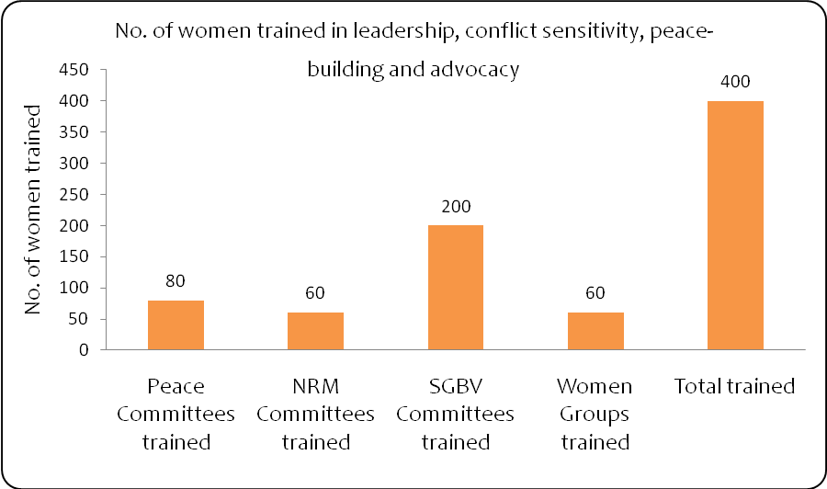

Compared to the 80 women who had previously received some training in leadership, conflict sensitivity, peace-building and advocacy at baseline, this represents an increase of 400%.

Another important output of the project which also had a significant weighting on the project’s impact is the increased number of gender-balanced community conflict mediation and resolution meetings held. As shown in figure 6, the number of gender balanced community conflict mediation and resolution meetings held increased from 5 to 20, a growth rate of 300%.

Figure 6. Number of gender balanced community conflict mediation and resolution meetings held project life

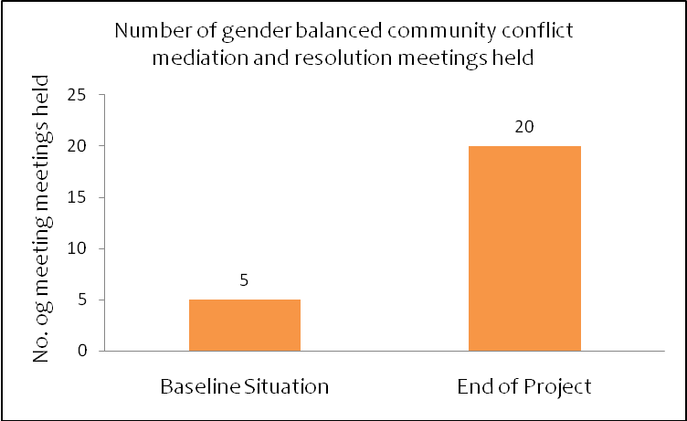

Together these activities and outputs resulted in a strengthening of women's ability to negotiate non-violent conflict resolution at household and community levels. This outcome is clearly indicated by the increased number of women ably and actively participating in conflict resolution at the household and community levels, as well as increased number of women, religious leaders, youth groups, and local authorities participating in monitoring triggers and flashpoints in order to pre-empt local level conflict as shown in figure 7.

Figure 7. Stakeholders involved in peace monitoring

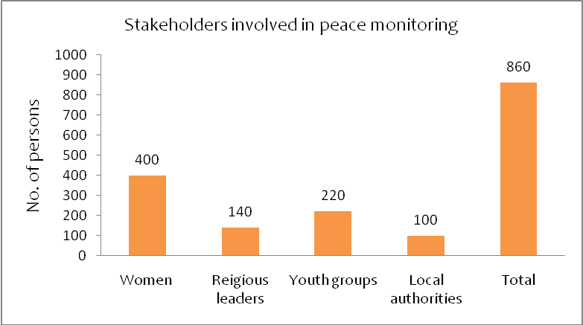
Furthermore, the project activities enabled a strengthened NRM policy and regulatory framework to operate in line with existing customary laws as well as effective community structures and mechanisms to prevent and mitigate resource based conflict. Two important indicators of these outputs include the increased number of engagements with parliament for enactment of the revised policy document such as document and the increased number of group members and local authority representatives trained in integrated NRM. This included stakeholders such as grazing land protection monitoring groups, local authorities, judiciary, police units and traditional elders. Figure 8 shows these indicators compared to baseline scenarios.

Figure 8. Engagements with parliament for enactment of the revised policy and representatives trained in integrated NRM
 | Baseline Situation | End of Project
Number of engagements with parliament for enactment of the revised policy | 0 | 3
Number of group members and local authority representatives trained in integrated NRM | 0 | 260

Together these activities and outputs resulted in improved relevance and inclusiveness of natural resource governance as indicated by the increased number of women represented officially in natural resource governance structures and the number of community committees of the customary NRM governance structures established.

Figure 9. Women and committees in NRM governance and structures
 | Baseline Situation | End of Project
Women represented officially in natural resource governance structures | 0 | 60
Number of community committees of the customary NRM governance structures established | 0 | 20

There are also other important project progress indicators revealed by project quarterly documents. For example, 45 women have taken up formal and informal leadership roles in the community. While this represents 7.78 % of all the women trained, a comparison with the baseline situation (15 women) reveals a 200% increase. However, there was a noticeable variation of these leadership roles across committees. Of the 45 women taking up formal and informal leadership roles in the community, 20 were in Peace Committees, 20 in SGBV committees, while there were only 5 in NRM committees. Additionally, the project additionally enabled expanded fora for dialogue on rural women's role in peacebuilding, improved community structures and mechanisms to address SGBV.
These results indicate the project had some impact on gender equity. In this respect, our field interviews reveal that the project expanded women space and roles. The project increased space for women to be included in day-to-day community conflict resolution. More than ever before, the project enabled women to take charge and lead in the initial investigation of SGBV and NRM issues. In this respect, a female beneficiary in Laas Doomare village had this to say:
“This project has ensured greater recognition of, appreciation and respect for our (women) abilities, roles more than before …there is respect among residents because they now know who is supposed to lead when it comes to peace and conflict …..this is good for us as women and we feel much accepted….thanks to CARE”.
Gaps identified during the baseline and consultation meetings showed that traditional attitudes and cultural beliefs coupled with illiteracy and lack of awareness of their own value inhibited women’s capacity to play greater role in conflict mediation and resolution meetings with their male counterparts. However, through training and capacity development of women this project has made it possible for women to participate in meetings and discussion forums.
The progress against expected outcomes of the project activities also appears to be consistent with results from the field. For instance, when participants were probed whether women made trips to attend meetings an discussion forums or networked, there was a nearly unanimous response in confirming that it was not possible for women to handle conflict issues let alone networking before the implementation of the project.
More importantly, in all FGDs in the villages of Huluul and Fadhigaab, women concurred and indicated that they actively participated in the identification of the root causes of conflict, particularly those related to SGBV, pastureland, water, and aid resources.
Women widely confirmed that this change and composition of committees are attributable to the project. Women are now aware of their active participation in community leadership roles in peacebuilding and advocacy, and their roles in conflict resolution processes are accepted by the community including public discussion on previously taboo issues such as SGBV.

7.2 Overall Project Impact
Overall, the project had two intended impacts - reduction of resource-based conflicts and perceived improvement in inter/intra household SGBV related conflict management and resolution. According to the baseline report there were 84 resource-based conflicts in the 4 districts of Ainabo, Ergavo, Boocame and Ceel Afweyn districts. The baseline report also uncovered only 3 reported incidences of SGBV whilst 79% of community members were silent on the existence of SGBV in the community. The planned activities of the project included the development of NRM policy and the carrying out of training for community interclan Peace Committees on conflict management techniques. Additionally, the project also included the establishment of SGBV committees setting up a recording and reporting mechanism and the enhancement of community capacity on SGBV.

The project targeted to resolve 9 conflicts and indeed there were 9 resource-based conflicts resolved at the end of the project. Although such achievement represents 10.7% reduction in the four districts against the baseline of 84 resource-based conflicts , it should be noted that conflicts have become exceptions after the implementation of the project. Thus, achievement points to the fact that the project met its target.
Additionally, the project had a target that 25% of households would report an improvement in inter/intra household SGBV related conflict management and resolution. The project reported that 24% of target households perceived improvement in inter/intra household SGBV related conflict management and resolution.
Our field assessment also appears to validate this level of progress. Interviews with committees and key informants indicate conflicts have been reduced to minimum levels. While resource-based conflicts appeared normal at the time, committee members in all the visited villages indicated that such conflicts have become exceptions after the implementation of the project. A programme coordinator of one of the local partners had this to say about committee members about conflicts:
“It is rare for full-blown conflict over resources to occur now, much less killing after project implementation.....because the various committees work together, detect, investigate and arrest situations that may lead conflict .... there used to be over ten killings related to this".
Finally, in all villages visited there were clear demarcations of the functions of the various village committees, reducing the ambivalence about SGBV issues and the community silence on the issue. Additionally, our field assessment also shows that there was considerable capacity building in NRM. In the baseline assessment, 90% of the respondents stated that there was no committee on natural resources governance that handled resource based conflict in some villages despite natural resources being the major source of conflict. Through the implementation of the project, however, all interviewed committees widely indicated that every targeted village they represented now has a system of committees in place which handle matters related to conflicts. Therefore, it comes to no surprise that resource-based conflicts have become an exception after the implementation of the project.
Together, these impact/outcomes have contributed to reduced conflict and violence through sustainable natural resource governance and improved responsiveness of community conflict resolution mechanisms in the targeted areas. It is our view that the project in all likelihood appears to have met most of its pre-determined targets.

Caveat on impact assessment
It should be noted that although the gathering and compilation of information were reliant on feedback committees and key informants, one could argue that their views may be open to question. This is specially so given that the method was more of a qualitative aimed at establishing current status of the project and understanding peace and conflict resolution from the point of view of culturally specific information about the judgement, values, opinions and social contexts and perspectives of key stakeholders. Thus, using this method, there was no reliable way for the project team to determine the efficacy of such data. However, process elements of the projects, such as set up of committees, and all the documents such as the logframe appear to have been well designed and executed and widely shared across stakeholders. On average, it is probably safe to conclude that most of the original (revised) targets appear to be realistic although in some instances they were over ambitious.

8.0 Stakeholders' views about project sustainability

The stakeholders of the Strengthening Peace Project had a number of mixed strategies and initiatives to ensure sustainability. Although they were buoyed by the careful and well-designed project and the expectation of funding, there was neither a clear theme that emerged from FGDs and key informant interviews around the sustainability of the project, nor were there direct initiatives to ensure sustainability of the project on the part of local partners because of the nature of their role. An official of one of the local partners noted:
“Yes, we laid the foundation and though limited activities we may transfer some resources to ensure its sustainability just in case CARE International pulls out or DfID funding is not forthcoming.”
In general terms, the local partners noted attitudinal change as the biggest difference brought about by this project and believe that some of the trainees will continue to use the skills learnt for the long term. Nonetheless, the local partners had reservations about the sustainability of the project because of some underlying problems. For example, they noted that there were not enough beneficiaries trained and that the project implementation period was too short. In addition, there was also the high degree of mobility of people because of the perennial droughts in the project areas. Until and unless such underlying problems are addressed, the gains that were made by the current intervention might be reversed and this might lead to further escalation of community-level conflict.
There appeared to be some indirect initiatives and strategic plan on the part of the government that might affect the sustainability of the project at community level. For example, Somaliland’s Ministry of Planning and Environment monitors resource conflict situation, shares information and liaises with the community.
Local elected officials on their part had mixed views about project sustainability. Although they were limited by resources, logistics, and absence of proper policies, locally elected officials at least have some vision and strategy for the sustainability of the project. For example, elected officials in Ceel Afweyn and Ainabo appreciated the project. Consequently, they promised to support the continuity of the Peace Committees, and will continue to bring people together, mobilize resources, invite local partners and liaise with central government to ensure the sustainability of the project. They are determined to do so even if the funding of the project does not continue.
The original design of the project was three years and CARE Somalia has implemented for one year. Based on the results so far, it is imperative that follow up phase is completed so as to maintain and sustain the gains made in this project.
CARE Somalia has put in place in exit strategy through its focus on working with local partners whose capacity and skills were built in order for them to be able to work with community committees to solve resource-based conflicts, as well as sexual gender based conflicts. Officials of one of the local partners indicated they continue to support the women participants and therefore were somewhat confident that they might sustain the outcomes achieved to date, at least in the short-run. One executive director summarized it as follows:
"We have no specific long-term funds for this project, but we have other projects either running or in the pipeline about women. So we feel we will play our part as far as sustainability goes."
As discussed earlier, the most significant lesson learnt is that vulnerable rural women’s basic rights are violated on a daily basis and that projects like Strengthening Peace can go a long way in exposing their potential to actively participate in conflict resolution. This in itself can be a strong case for ensuring that such project does not end at this early stage.

9.0 Limitations of the Project and Evaluation
We determined from our assessment and reports two sets of limitations experienced during the implementation and evaluation of the project. The first set relates to variety of barriers/challenges and obstacles associated with the implementation of the project. While some of these challenges/barriers are particular to a given conflict issue, other barriers are due to the type of committee and role it plays in conflict resolution mechanisms and sustainable natural resource governance to reduce conflict and violence. The second set of limitations is found in the evaluation of the achievements of the project over the past year.

9.1 Some challenges/barriers during project implementation

- Female beneficiaries reported having difficulties in accessing or participating in some project activities. For example, proving cases related to SGBV was both difficult and convoluted. This was widely viewed in all villages and across committees.
- Female beneficiaries reported having difficulties accessing the project as this impacted their household routine. For example, women committee members reported that they were accused by their husbands as having abandoned their household chores, causing disagreements which in some cases nearly led to divorce. One female committee member cited a case in the Village of Huluul.
- In an instance where burden of proof of SGBV cases fell on the victim, female beneficiaries reported that it was hard to confirm that such case was indeed SGBV because invariably there was the counter argument that it was consensual. Again, a case was cited in the village of Huluul.
- Key informants as well as project committee members reported that at times women members were misunderstood to have an ulterior motive, subverting and usurping men’s roles in the community. This was heard during FGDs in Laas Doomare.
- According to NRM project committees charcoal burning minimized and stopped in some areas due to increased committees’ surveillance/monitoring of peace and natural resource governance. Participants reported weaknesses in the sustainability of negotiated agreements. For example, it emerged during FGDs and key informant interviews that containing and resolving charcoal burning rekindled fresh conflicts because there was no immediate economic substitute. This was highlighted in all the villages visited.
- Some key informants reported that the general lack of development in the targeted areas made the Strengthening of Peace Project more difficult to engage with beneficiaries. They also suggested that there is need for interventions which focus on establishing infrastructures such as police stations which will go a long way in reinforcing the progress observed in the project.
- Some key informants reported uncertainty about continued project funding given that the sustainability of the project is somewhat contingent on the success of the current phase.
- Project activities in some districts were to some extent negatively affected by the security issues arising from disagreements between Kahtumo regional state, Puntland and Somaliland governments.

9.2 Limitations related project evaluation

- There are limitations inherent in evaluating the achievements of the implementation of the project over the past year. The evaluation has found evidence that establishing Peace-building Committees and providing training has noticeably contributed to a reduction in conflict and violence through sustainable natural resource governance and improved responsiveness of community conflict resolution mechanisms in the target areas. In comparison to the baseline assessment, these achievements were significant even though they small in absolute terms. There is therefore need to understand peripheral factors/issues influencing the impacts to fully attribute the impact to the activities of the project. In addition, although the project appears to have performed fairly well on value for money, there are some aspects of the evaluation, especially intangible benefits to target communities that require complete and extensive data collection and impact indicators that can be monetized. Consequently, a significant part of the narrative of the impact of the project was qualitatively discussed.
- Finally, the evaluation is qualitatively biased and the sampling of both the FGDs and key informants was purposive. However, it was more effective to obtain culturally specific information about the judgment, values, opinions and social contexts and perspectives of key stakeholders to establish current status of the project.

10.0 Recommendations
One key purpose of an evaluation should be to encourage and inform future decision-making. Thus, the findings and recommendations of the evaluation need to feed back into direct or indirect management of the project so as to positively influence future plans, resource allocations and management activities. Based on our assessment of the Xoojinta Nabada Project, we invite stakeholders to consider the following recommendations. Already, this evaluation of the Xoojinta Nabada project shows tremendous stakeholders’ commitment and capacity to address the findings and recommendations.
- There is a great desire to expand the project so that the benefits of the project can reach more people covering a greater area and it is likely that this would contribute significantly to mitigating and reducing conflict. It will also widen the scope of local partnerships with CARE, essentially building the capacity of local organizations and engaging residents who would otherwise be unemployed.
- There is need to have clear information relating to new funding, leveraging the current relative success and stakeholders interest in the project to date. This would, among other issues, promote greater certainty, confidence, ownership and sustainability by all stakeholders.
- Since the project changed beneficiaries’ attitudes towards peace and conflict resolution, there is need to carefully select and train local people who have a good understanding of the prevailing regional and cultural dynamics and who can disseminate far and wide the knowledge gained. This would, among other issues, promote greater certainty, confidence, ownership and sustainability by all stakeholders.
- There is need to continuously share information to ensure the trained committees continue to benefit from regular meetings and resources.
- There is great desire to liaise with or establish police stations in villages to reinforce and sustain the peace gains made during the implementation of the project.
- There is great desire to train and retrain elders, women, and youth in conflict prevention and transformation given the number of trainees in the various committees is still too low. It is also our view that trainer of trainees (TOT) program should be carried out periodically.
- Though hampered by limited resources, the Government of Somaliland through the Ministry of Planning and Environment monitors resource-driven conflicts, shares information and liaises with the community. The Government should strengthen and continue to support NRM policy development and monitor droughts to minimize reversing the gains made in the project.

11.0 Conclusion
Changing attitudes and peace-building skills among rural communities, we believe, best happens with such projects as the Strengthening Peace that involve Peacebuilding Committees in villages and training them on how to identify the root causes of conflict. The target areas clearly benefited from this project and beneficiaries can in turn share their learning and experiences and carry out conflict resolution at household and community level. With peacebuilding training skills and support from program staff and local partners, the trained Peace Committees clearly benefited from their experiences in the project in ways that will help them be instrumental in future efforts to resolve conflict, especially to mobilize, participate and cooperate within their communities when mediating in neighborhood, family, and natural-resource related conflicts. The villages as a whole no doubt benefited from the project, particularly via enthusiastic committee members engaged in community conflict resolution mechanisms and sustainable natural resource governance to reduce conflict and violence. These positive changes point to the fact that not only was the overall Strengthening Peace Project aim relevant, but also that its activities and strategies were appropriate. Given the nature of the target region, it would have been difficult for such project to be sustained. However, the fact remains that all trained committees including rural vulnerable women and elders are putting into practice their new skills and overall has made a real difference to the beneficiaries and target areas, cutting across political, social and environmental sectors.

12. Appendix

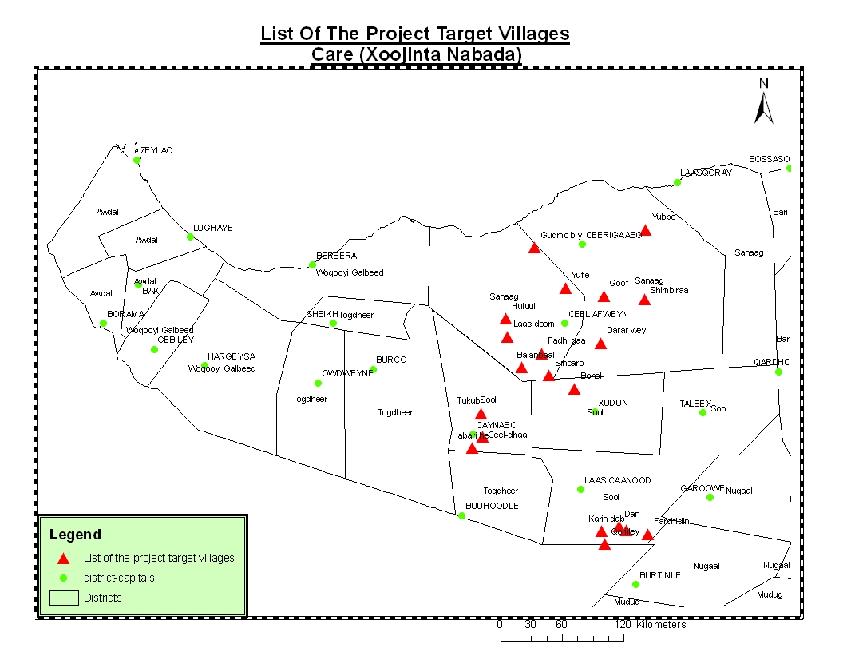

The Ministry’s and by extension the government’s resources come from internal revenue and partnership with international and local NGOs and Mission because it still lacks international recognition.
It emerged from our consultation and interviews that despite their existence these challenges were considered not worthy of a concern because they were far less than the benefits of the project.

