
KAP BASELINE SURVEY REPORT
Water and Sanitation -Garissa District

Commissioned by Care International in Kenya (CIK)
Garissa Office

September 2010

Lead Consultant:
Austin Odhiambo
Aeons Consult
austinodhiambo@gmail.com
KP Flats, off Milimani Road
PO Box 5379-00200, Nairobi

TABLE OF CONTENTS Page
LIST OF TABLES AND CHARTS 4
ACKNOWLEDGEMENTS 5
ACRONYMS AND ABBREVIATIONS 6
EXECUTIVE SUMMARY 7
1.0: INTRODUCTION 10
1.1 Overview of the project 10
1.2 Objectives of the baseline survey 10

2.0: METHODOLOGY 11
2.1 Survey instrument 11
2.2 Sample selection 11
2.3 Structured Observation 12
2.4 Selection and training of enumerators 12
2.5 Survey procedure 12
2.6 Data Collection, Coding, Entry and Analysis and Production of Report 13

3.0: BASELINE FINDINGS AND ANALYSIS 14
3.1 Household Demography 14
3.1.1 Gender of Respondents 14
3.1.2 Education 14
3.1.3 Household Composition 15
3.1.4 Livestock Holding 16
3.1.5 Asset Holdings 17
3.1.6 Participation in Decision making process 18
3.1.7 Other Household Characteristics 19
3.1.8 Household Fuel consumption 19
3.1.9 Observation on the Main Houses 20
3.2 Access to water 20
3.2.1 Water Sources during the rainy Season 20
3.2.2 Water Sources in the dry season 21
3.2.3 Distance to water sources 22
3.2.4 Time HHs take to reach water source 22
3.2.5 Duration of getting water 23
3.2.6 Other sources for household’s drinking water 24
3.2.7 Quantity of water 24
3.2.8 Water treatment 25
3.2.9 Productive use for water 26
3.2.10 Waste water disposal 27
3.2.11 Community water management 28
4.0 Sanitation and hygiene 29
4.1 Availability of Latrines 29
4.2 Other observations made on household 31
4.3 Cleanliness of latrines 31
4.4 Sharing latrines / toilets 32
4.5 Public Toilets 32
4.6 Rubbish Disposal 32
4.7 Disposal of children’s feces 33
4.8 Hygiene practices and Livestock Rearing 33
4.9 Hand-washing 34
4.10 Drinking water Observations 36
4.11 Environmental conservation 36

Part 4: RECOMMENDATIONS AND CONCLUSIONS 38
Appendices 40
Appendix 1: Profile of Garissa District 40
Appendix 2: Garissa District –“Population and Household Distribution
by Socio-economic Characteristics “Source: 2009 Kenya Population Census. 42
Appendix 3: More data on sources of water (cross tabulations) 43
Appendix 4: Household Survey Questionnaire 45

LIST OF TABLES AND CHARTS
TABLES
Table 1: Households characteristics 14
Table 2: Household Sizes (Adults and children) 15
Table 3: Number of children aged between 5-17 years living in a HH 15
Table 4: Number of children under 5 years living in a HH 16
Table 5: Sources of drinking water most often used by HH in the rainy season 21
Table 6: Sources of drinking water most often used by the HH in the DRY season 21
Table 7: Main reason for not treating water 25
Table 8: Utilization of water for other HH activities 26
Table 9: Satisfaction levels with how community committees are managing
the water points 28
Table 10: Does the HH have its own latrine? 29
Table 11: Estimated distance from house to the latrine 30
Table 12: How many people share this toilet/ latrine? 32
Table 13: Disposal of feces of children under 5 years within HHs 32
Table 14: Hand washing 34
Table 15: Why it is important to wash hands with soap/ ash 35
Table 16: Reason why HHs would want plant trees or shrubs 37

CHARTS
Chart 1: Household livestock ownership 17
Chart 2: Households assets in working conditions 18
Chart 3: Other household characteristics 19
Chart 4: Household fuel consumption 20
Chart 5: Distance to water sources during the dry and the rainy seasons 22
Chart 7: Queue time at the water sources 23
Chart 8: Daily household water consumption 24
Chart 9: How often water is treated within households 26
Chart 10: Other desired uses for water 27
Chart 11: Waster water disposal 27
Chart 12: Reasons for dissatisfaction with community water management committees 28
Chart 13: Reasons why some households do not have latrines 30
Chart 14: Observations on household latrines 31
Chart 15: Disposal of rubbish/ household refuse 33
Chart 16: Where animals spend night within HHs 34
Chart 17: What is used for handwashing 35
Chart 18: Drawing drinking water from the containers within HHs 37

ACKNOWLEDGEMENTS
On behalf of Care International in Kenya-Garissa Office, we would like to convey sincere thanks and gratitude to everyone who contributed to the successful completion of this KAP baseline survey.
Sincere gratitude goes to the management and staff of Care International in Kenya-Garissa who did a great job organizing and ensuring that logistical support to the entire team was adequate and efficient. We also extend our deepest appreciation to the supervisors and enumerators, village elders and chiefs; we note with gratitude their contributions towards this study.
We would also like to thank the development partners for their support in this effort of enhancing sustainable livelihoods in this region. Their financial, technical and material support is greatly appreciated.
Finally, we would like to thank all community members for their cooperation during the survey. We reiterate that the findings have been handled as confidential and were only used for purposes of statistical compilation of this report.

Lead Consultant
Austin Odhiambo

ACRONYMS AND ABBREVIATIONS
ACF: | Action Against Hunger  Arid and Semi Arid Lands  Households  Statistical Program for Social Scientists  Millennium Development Goals  Focused Group Discussions  Care International in Kenya  Non-Governmental Organizations
ASAL:
HHs:
SPSS:
MDGs:
FGDs:
CIK:
NGOs:
USAID: | United States Assistance for International Development  Australian Aid
AusAID:
GWI: | Global Water Initiative  Gross Domestic Product  Greater Horn of Africa  Millennium Water Alliance  Catholic Relief Services
GDP:
GHA:
MWA:
CRS:
KAP: Knowledge Attitudes and Practices

EXECUTIVE SUMMARY
The water, sanitation and hygiene KAP baseline survey was conducted in Garissa District in the month of September 2010 to inform indicators on GWI supported project in this area. This household based study focused on households’ current socio-economic status in addition to information about households’ water sources, water treatment, productive use for water, water management, hygiene, sanitation and environmental conservation.

The situation in Garissa District reveals a vicious cycle in which numerous factors contribute to ongoing poverty. Living conditions are difficult as witnessed by low purchasing power, low levels of education, lack of access to information, overcrowded households, houses made of mud bricks, latrines in poor condition and poor access to safe drinking water etc. These factors lead to inadequate hygiene and basic sanitation, resulting in a prevalence of waterborne diseases in the community. As there is a lack of awareness about waterborne diseases and preventative measures are not widely known or practiced by the local population, preventable common illnesses afflict the households. Consequences are high health care costs and reduced in the community.

The baseline survey shows that:
62.8% of the respondents were in the youthful age of less than 35 years and 72.7% of the households had families of between 3-8 people. This is typical in most African societies.

The household findings revealed that out of every ten female household heads (90.5%), nine have no education or are outright illiterate compared to 72.1% of the male household heads who were illiterate or lacked education.

In terms of available sources of drinking water during the rainy season, 34.4% of the households reported that they source water from surface water (river, dam, lake, ponds, stream, irrigation etc) while 21.2% have piped water to yard or plot of the house. However, during the dry season there is an increase in the number of households that use surface water and protected dug wells.

48.2% of the households travel for more than a half kilometer to the water sources during the dry season compared to 43.2% who cover the same distance during the rainy season. Majority had water sources within 2km of the household (2km standard Kenya – rural and 30 minutes waiting time urban areas).
64.6% of the households take 30 minutes or less to reach a water source during the rainy season compared to 60.4% who take 30 minutes or less to reach their main source of water during the dry season. During the rainy season, more than half of the households (77.6%) reported that there are no queues at the water sources, while during the dry seasons majority of the households take comparatively longer on queues get water.
Six out of ten households (62.4%) of the households use between 60-200 litres on a daily basis for drinking, cooking, hygiene, cleaning and other household needs. Considering the household sizes, this quantity is far below the WHO standard of 40 liters per person per day for rural areas.

At the household level 89.7% of the respondents reported that they do not treat their drinking water with slightly more than half (58.7%) of the respondent saying they believe the water is safe and there is no need to treat it.
The study revealed that most households use water for other commercial purposes like irrigation (6.9%) and animal watering which recorded 43.2%

The survey also shows that only 32.3 % of households use water sources managed by community.

Sanitation
61.1% of the households reportedly have no toilets and majority of these households (68.5%) defecate in the bush. 89.3% of these households lacking latrines said they are expensive thus they cannot afford.

41.9% of households having a latrine share it with five to ten other people with only 1.8% not sharing toilets.

85.2% of the respondents said that they do not have community toilets and where there are 57.5% said there family members do not use these latrines.

Most of the households with children under 5 years do not practice safe disposal of feces with 52.9% reporting throwing in an open field, while 7.4% dispose the feces near the house and only 26.4% used a container to put the feces in a toilet.

Hygienic behaviour
On soap use within the household, 63.2% reported using soap to wash their hands. More than six out of ten respondents (62.9%) wash their hands after defecation, 88.6% wash their hands before and after eating. More significantly, most respondents adhere to the Islamic faith and hand washing is done before prayers. The level of hygiene awareness is relatively low.

On observations of latrines, 98.3% did not have any hand washing facility in or nearby. 91.8% did not have soap at the hand washing place. Likewise, 91.8% lacked water at the hand washing place. Generally, available sanitation facilities are ordinary and do not take into consideration key hygienic practices.

On soap use at the household level, 68.7% of the respondents reported using soap.

Based on results of the baseline survey, the following actions are recommended:
- Training and capacity building of community management committees where they exist
- Educate the community about waterborne disease prevention and how to treat contaminated water.
- Increase access to clean water by constructing more boreholes and shallow wells.
- Strengthen and support behavior change for improved sanitation and hygiene.
- Strengthen partnership with community members in the project area to construct latrines.

1.0 INTRODUCTION
  - Overview of the project –GWI
The Global Water Initiative (GWI) is a Global initiative operating in three regions namely Central America, West Africa and East Africa. In East Africa Region, the project which covers Ethiopia, Uganda, Tanzania and Kenya and is aimed at total transformation of communities. Global Water Initiative goal for East Africa is for poor rural communities in arid and semi-arid zones to reduce their vulnerability to water-related shocks and improve their quality of life through Integrated Water Resource Management in both Garissa and Tana River Districts. The program aims to achieve this through three objectives: Good Governance, Sustainable Multiple Uses of Water and Risk management.
In Kenya, GWI activities are implemented by three partners namely CARE, CRS and Action Against Hunger (ACF) and the project is focused in Garissa and Tana River Districts within a similar catchment area. CRS in partnership with Catholic Diocese of Garissa is implementing its activities in Bangale division of Tana River district while ACF and CARE is implementing in Sankuri, Central and Balambala Divisions in Garissa district.
It is essential that GWI program is able to measure its achievements and provide information about its successes and failures ensuring consistent, accurate and meaningful data. It is in this context that Care Kenya conducted this baseline survey.

  - Objectives of the KAP baseline survey
The baseline survey was aimed at setting benchmarks and establishing the current status of water, sanitation, hygiene, governance, learning and natural resource management in Garissa in order to provide for measurements of indicators at both the institutional and household levels developed by the MWA/USAID and GWI for CARE and stakeholders.

Specific objectives: In specific terms, the survey was intended to establish the following:
- Access to drinking water
- Access to water for other purposes
- Rain water collection
- Household water usage
- Drinking water at the household handling and storage
- Sanitation
- Participation in community leadership institutions , communities and social groups
- Households socio-economic demographics
- Water resource management

2.0: METHODOLOGY
2.1 Survey instrument
The KAP survey instrument consisted of a questionnaire divided into eleven sections. The sections required that questions on various topics be asked to the respondents. Demographic information, water sources, water treatment, productive use for water, water management and satisfaction, sanitation, hygiene, tree planting, other household characteristics formed part of the survey. All responses were unsolicited, so most questions included a space for “other” responses. Several observations were also made by the enumerators including drinking water container, latrines and demonstration of how the water is drawn from the vessel was also required. The last section of the questionnaire required that the enumerator record observations in regard to water and sanitation issues within the households.
The questionnaire was translated into Kiswahili to ensure precision in wording of the questions. The questionnaire was then field-tested by enumerators and necessary revisions made. The questionnaire is attached as an appendix.
2.2 Sample selection
Appropriate sampling methods were employed in this KAP baseline survey with four hundred and forty households participating. Respondents targeted were aged more than 12. The household survey sample was based on stratified random sampling from a universe consisting of residents of the areas of the study. The choice of enumeration areas was made on the basis of the recommended villages by the MWA/USAID and GWI intervention which served as the strata for the purposes of sampling. Administration units (wards) served as an additional layer of organizing fieldwork particularly for analytical purposes. Households were selected randomly in the study sites and within the household interviewees were household heads or responsible adults aged more than 12 years.
The sampling universe was the population in Garissa District which stands at 190,062 (KNBS, 2009. Kenya National Census Report) Our final sample was 440, representing more 100% achievement. The number of interview per enumeration area generally reflected the proportion of estimated vulnerable population in the target area. This type of sampling means that data obtained carries a margin of error of at least +/-3.0% at 95% confidence.
The sample size was calculated using the formula below:

n≥ Z² .p .q
D²

Therefore, we could survey up to 440 households.
Z = parameter related to the risk of error = 1.96 for a risk of error of 5 percent
p = expected prevalence in the population. This value was estimated at 50 percent (extreme
Value)
q = 1 - p
d = 5% = 0.05, absolute accuracy desired.
The sample consists of 440 households. This sample allows us to draw statistically make significant conclusions from general observations of the targeted communities.
The collected data allowed the team to better understand the situation of households in the areas targeted by the study.
All of the questions that were asked in the quantitative study have been analyzed.
To ensure the effectiveness of the fieldwork, 5 supervisors, one field coordinators and thirteen enumerators were contracted.
Participants in the focus group discussions on the other hand were selected purposively, given the respondents were selected on the basis of their pre-eminent roles in the community, and, or their generally acknowledged understanding and custodianship of the community values, norms, heritage and knowledge.
2.3 Structured Observation
Enumerators were also provided with guidelines to undertake observations of households’ settings, latrines, hygienic practices, and general environment.
2.4 Selection and training of enumerators
All 13 enumerators plus the supervisors hired for this assignment were qualified local residents who understand the socio-cultural dynamics of the study area. All the enumerators participated in a one week training prior to the survey. The program included sessions on the purpose of the survey, the role and responsibilities of the enumerator, interviewing techniques, research ethics, consenting respondents and importance of randomness and bias during sampling. There was a pre –testing exercise that was carried out at Modika Village in Modika Location, Garissa District
The bulk of training was devoted to reading and familiarizing the enumerators with the questionnaire, both in English, Swahili and in the local language. First the purpose of the question was explained. Then the instructions on how to fill out the questionnaire were reviewed to familiarize the enumerators of the skip patterns and open ended questions.
2.5 Survey procedure
During the actual survey enumerators walked in pairs while sampling households. From the starting point identified by the supervisors, they moved in opposite directions. Before commencement of interviews in the villages, while accompanied by the supervisors, they presented themselves to the area chief or village elders. Although the local authorities had been informed, the enumerators explained again the purpose and procedure of the survey sought the consent of these leaders to conduct interviews.
To assure standardization, in the use of language, interviewers read the questionnaire in the language in which it was printed (Swahili or English). However, where respondents had problems with either of the languages, the enumerator used the local language.
2.6 Data Collection, Coding, Entry and Analysis and Production of Report
The enumerators underwent a seven-day training prior to conducting the survey so that they were able to prompt and record appropriate responses. Data collection was done on the basis of a household questionnaire. The survey was conducted by passing from home to home, using the methodology described above. Enumerators were recruited based on their intellect, knowledge of fieldwork and previous experience. The selection of surveyors was done by CIK-Garissa through individual interview sessions. The training was followed by a pre-survey test in a community not targeted in the baseline study.
Upon completion of the interviews in the field, the questionnaires were coded and entered using Epi info 5.0. This data was cross checked for accuracy. The data was then exported to SPSS 16.0 for analysis. Frequency tables were then used to discern tendencies and cross tabulations were used to compare sub-groups.

Possible bias and methodological limitations
1. “No response bias.” The fact that household interviews were conducted from 9 a.m. to 4 p.m. meant that some heads of household were not at home during the survey and thus were not included in the study.
2. Despite the high number of surveys that have taken place in the targeted areas, "refusal to participate bias" was not observed in all visited communities and the enumerators were generally well received. This demonstrated the will of the population to work closely with the team during future programs.
3. "Translation bias.” Interpretation of questions may be different in Kiswahili or the local language compared to the original question in English. Accordingly, during the training session the survey team took sufficient time to translate the questionnaire into Kiswahili and the local language. The enumerators had the translated text in Kiswahili next to the questions in English.
4. "Enumerator bias." The opinions of the enumerators and their supervisors can skew the results. For example, when enumerators show verbal or non-verbal responses to what is “correct” during the interview. The team tried to minimize this bias during training through role playing.
5. “Respondent bias.” Respondents may have an interest in providing incorrect answers because they think that they may benefit later, especially in the event that their responses lead to support from donors. In each household, the enumerators explained the objectives of the study to avoid this bias.
6."Privacy bias." In order to ensure the respondents’ confidentiality, the enumerators were advised to make certain that crowds are not present during the interview.

To reduce the risks of bias, the survey coordinator:
- Dedicated time and effort to select experienced enumerators.
- Started with a pre-survey (pilot test) and supervised enumerators during the study.
- Verified the completed questionnaires each day and provided feedback to the enumerators before conducting fieldwork the next day.
3.0: BASELINE FINDINGS AND ANALYSIS
3.1 Household Demography

3.1.1 Gender Distribution

Of the 440 interviews deemed valid, 80.7% respondents were female while 19.3% were male. The biggest numbers of respondents were sampled from Mbalambala Ward (17.5%) Saka Ward (15.6%) and Sankuri ward (14.3%). Male heads of household in the study area preferred that women participate in this study because issues under study are matters handled by the female gender in this community. This partly explains the huge disparity in gender of household respondents.

Slightly more than half of the household respondents (59.7%) fall within the productive age of 18-45. On the other hand at least two thirds of the household respondents (62.8%) can be classified as youth as they are 35 years or younger. Table 1 below displays the characteristics of respondents.

Table 1: HH Characteristics | Values | Percent (%)
Gender of HH respondents | Males | 19.3%
Gender of HH respondents | Females | 80.7%
Distribution of Age of HH respondents | <18 yrs | 17.6%
Distribution of Age of HH respondents | 18-25 yrs | 18.5%
Distribution of Age of HH respondents | 26-35 yrs | 26.7%
Distribution of Age of HH respondents | 36-45 yrs | 14.5%
Distribution of Age of HH respondents | 46-55 yrs | 11.7%
Distribution of Age of HH respondents | 55-65yrs | 6.8%
Distribution of Age of HH respondents | >65 yrs | 4.2%
Household head | Male head of HH | 73.2%
 | Female head of HH | 22.9%
 | Child living in HH | 1.0%
 | Other adult living in HH | 2.9%

As in most African societies, most households were male headed (73.2%) but there is a significant proportion of households that have women as the heads. In our analysis of water fetching, assets and decision making regarding livelihood we pay special attention to the significance of gender issues in regard to information, support and livelihoods.
3.1.2 Education

The household findings revealed that out of every ten female household heads, nine (90.5%), have no education or are outright illiterate compared to 72.1% of the male household heads who were illiterate or had no education. 13.1% of the male household heads are able to read and write in comparison to 3.0% of the female household heads who are able to do so.
However, 4.2% of the female household heads have been to school between 1-8 years while 10.8% male household heads had been to school for a period ranging between 1-14 years. This finding underscores the general low level of literacy in the larger North Easter Province where the average adult literacy level rate is estimated to be 20%. In addition these findings present challenges to the realization of the MDGs and the Kenyan Vision 2030 both of which put emphasis on attainment of education for all.

3.1.3 Household Composition

Typical of the pastoral areas, the household sizes are inordinately large compared to a national average of about 5. The survey findings revealed that only 8.7% had family sizes in the range of 6-10 aged between 5-17. On the other hand, most households in the area had families of 1-5 children aged 5-17.

Table 2: HH Size (Adults and children)
 |  | Frequency | Percent | Valid Percent | Cumulative Percent
Valid | 1-2 | 17 | 3.9 | 3.9 | 3.9
Valid | 3-5 | 161 | 36.6 | 36.7 | 39.7
Valid | 6-8 | 162 | 36.8 | 36.9 | 76.6
Valid | 9-10 | 77 | 17.5 | 17.5 | 93.1
Valid | > 10 children | 22 | 5.0 | 5.0 | 100.0
Valid | Total | 439 | 99.8 | 100.0
Missing | System | 1 | 0.2
Total |  | 440 | 100.0

This is so considering that most of the respondents (62.8%) were in the youthful age of less than 35 years, yet already some have big families of five children. See table 2 above and 3 below.
Table 3: Number of children aged between 5-17 years living in a HH
 |  | Frequency | Percent | Valid Percent | Cumulative Percent
Valid | 0 | 86 | 19.5 | 19.7 | 19.7
Valid | 1-2 | 141 | 32.0 | 32.3 | 51.9
Valid | 3-5 | 172 | 39.1 | 39.4 | 91.3
Valid | 6-8 | 32 | 7.3 | 7.3 | 98.6
Valid | 9-10 | 6 | 1.4 | 1.4 | 100.0
Valid | Total | 437 | 99.3 | 100.0
Missing | System | 3 | 0.7
Total |  | 440 | 100.0

Additionally, almost all households in the area have children aged less than 5 years. Half (50.1%), have 1 or 2 children aged less than 5. Further analysis reveals that, 74.5% of the families have between 1-5 children while 3.0% of the households have between 6-10 children aged less than five. Table 4 below presents this finding.
Table 4: Number of children under 5 years living in a HH
 |  | Frequency | Percent | Valid Percent | Cumulative Percent
Valid | 0 | 98 | 22.3 | 22.5 | 22.5
Valid | 1-2 | 218 | 49.5 | 50.1 | 72.6
Valid | 3-5 | 106 | 24.1 | 24.4 | 97.0
Valid | 6-8 | 12 | 2.7 | 2.8 | 99.8
Valid | 9-10 | 1 | 0.2 | 0.2 | 100.0
Valid | Total | 435 | 98.9 | 100.0
Missing | System | 5 | 1.1
Total |  | 440 | 100.0

3.1.4 Livestock Holding

Livestock holding is regarded as one of the more important pro-poor livelihoods. More than 40.0% of the poor world wide are dependent on livestock for their livelihoods (Thornton et al, 2002). It is estimated that around 560 million livestock keepers live in extreme poverty, of which 40 million are pastoralists or agro-pastoralists (Thornton et al, 2002). In the Greater Horn of Africa (GHA) for instance livestock provides 20-30 percent of the GDP and significant employment. In sub-Saharan Africa, livestock are significantly important in the diets and incomes of the rural poor (Thomas and Rangnekar, 2004) generating as much as 70.0% of the households cash incomes (Ndikumana et al, 2004).

The non-market benefits of keeping livestock while difficult to value are important. Fafchamps et al (1998), and Ouma et al (2002), illustrate that livestock, specifically cattle remain an important component of bride price payments, and of social status in general in Burkina Faso and Kenya respectively.

All households in this area of study have at least one animal; however the holdings vary widely with by species and by numbers kept. Chart 1 below shows livestock holdings by the surveyed households. Camels, sheep and chicken appear to be the least common livestock species amongst the households with slightly more than quarter of the households holding between 1-5 animals. Almost 73.0% of the households own at least a goat on the other hand camel ownership is limited by household but for those households with camels 9.1% own between 1-20 camels. Most households in this area do not consider chicken as an important livestock as is the case with cattle, goats and camels; yet chicken farming is an economically viable activity just like goat farming when done in large scale as is the case in other regions like Central and Nairobi Provinces.

Our studies also confirm that camels and donkeys are the most resistant to drought and diseases. Group discussions reported deaths of cattle and goats are more common than those of camels and donkeys. Camels are also more the most expensive livestock fetching as much as Ksh. 80,000 followed by cattle. Livestock ownership in this region presents a scenario similar to what professor Hardin refers to as “The Tragedy of the Commons”.

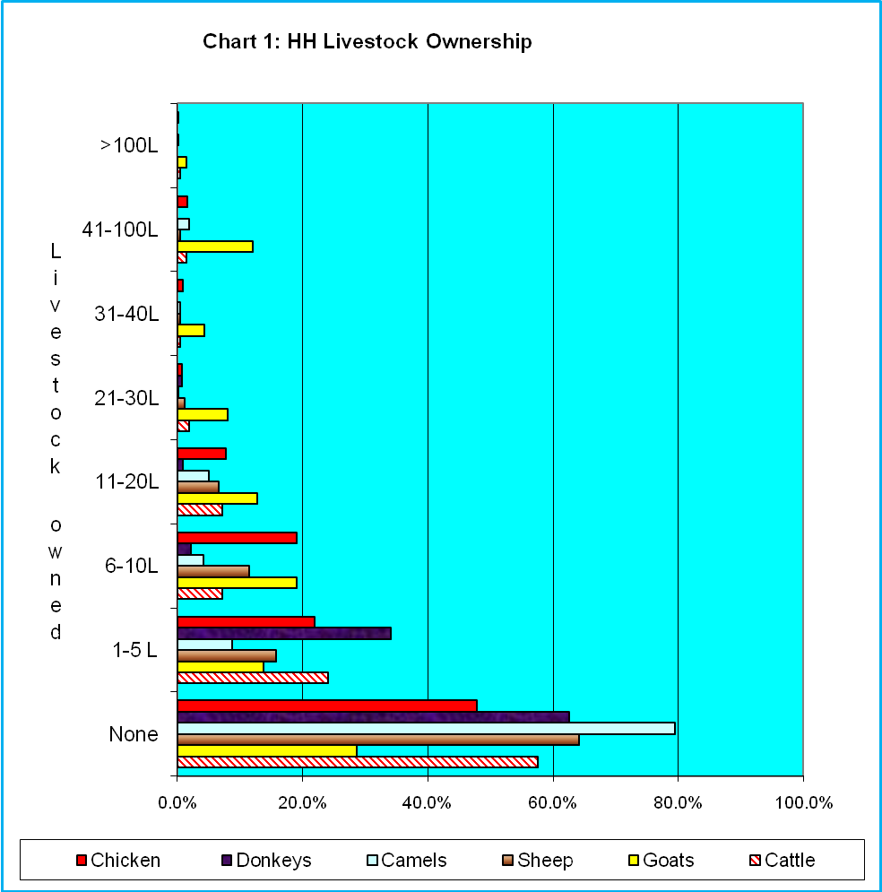

3.1.5 Asset Holdings

To gauge the level of household asset holdings, we asked respondents about their ownership of various items in working order including, vehicle, motor cycle, refrigerator, television, radio, bicycle, telephone, solar power and electricity. Seldom does any household have any of these items in working order with the exception of the radio and telephone (mobile phones) albeit with still lower density when compared to other regions in Kenya.

Mobile phone penetration (39.8%) and ownership of the radio (52.5%) might provide an indication of access to information and social networking which are key to risk management in a dynamic environment.

In general the choice of asset holding in the pastoral situation is dictated by livelihoods. Nomadic and semi-nomadic households would generally not invest in fixed assets. Similarly, they may be more inclined to put in more resources into productive assets like livestock consumption. Chart 2 below presents household assets in working order.

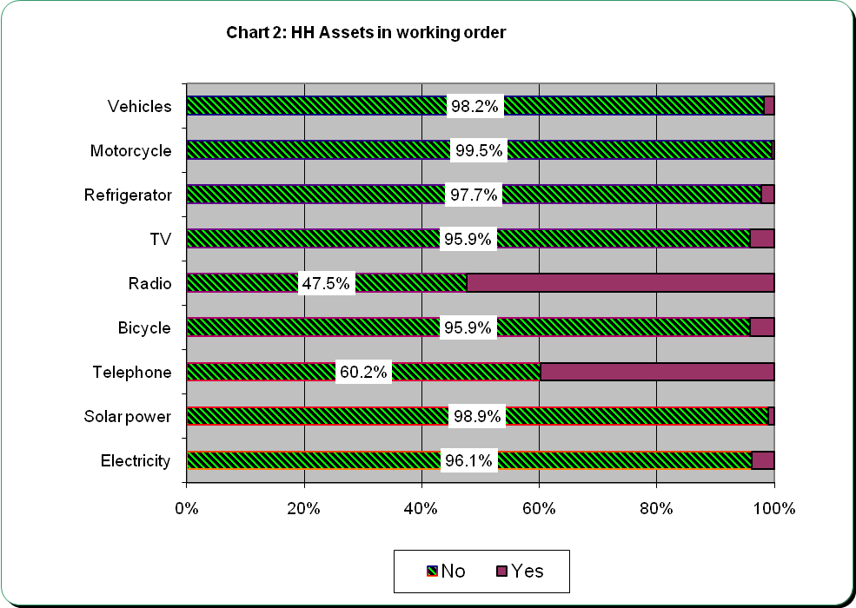

An important asset like solar power is owned by a paltry 2.1%of the households that were sampled in this survey. Ownership of such energy sources should be encouraged but the challenge of access to information presents itself in such scenarios.

3.1.6 Participation in Decision making process

Other household characteristics like membership in committees at the village or sub-village committees indicate that an overwhelming, 82.20% do not have any household member in these committees. This clearly indicates that most households do not participate in decision making processes and in many cases ignore activities in the community.

During the survey we realized that women make decisions on the domestic arrangements like what is eaten, fetching water, sleeping arrangements etc. However, when it comes to greater decision making, it is men who call the shots. This presents a challenge to realization of goal three of the MDGs whose aim is to Promote Gender Equality and Empower Women.

3.1.7 Other Household Characteristics

15.0% of the households have a member who is disabled (visual impairment, hearing impairment, speech and language difficulties, physical disabilities, mentally retarded, self care difficulties and others), 10.3% of the households have a member who is chronically ill (bed ridden for 3-4 months in the last 12 months. Also, 22.1% of the households have orphans living with them.

These findings reiterate design of programs and activities that focus more on the vulnerable and weak in the society in regard to provision of water and sanitation for the numbers are considerably high.

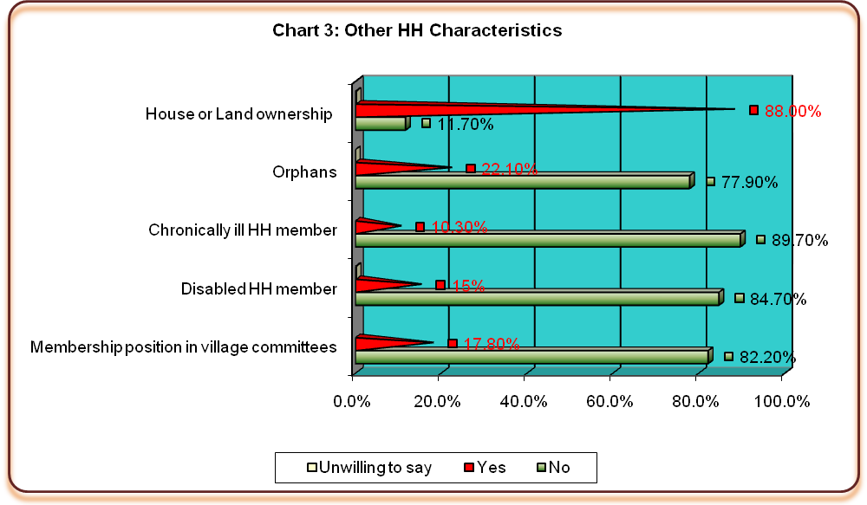
On the other hand, an overwhelming majority (88.0%) own the houses and land they inhabit. Due to the condition of land in this area, densities are low and most households congregate near water point.

3.1.8 Household Fuel consumption

Three quarters of the households (75.2%) use firewood/ straw/ dung for cooking, 23.4% use charcoal from wood with a paltry 1.4% using electricity. Typical of pastoralist communities most households use firewood as the main source of fuel. This in some instances has devastating effect on the environment for such sources of energy are not sustainable and they destabilize the ecosystem. The households should be encouraged to use more environmentally friendly energy sources including cow dung and harnessing solar energy.

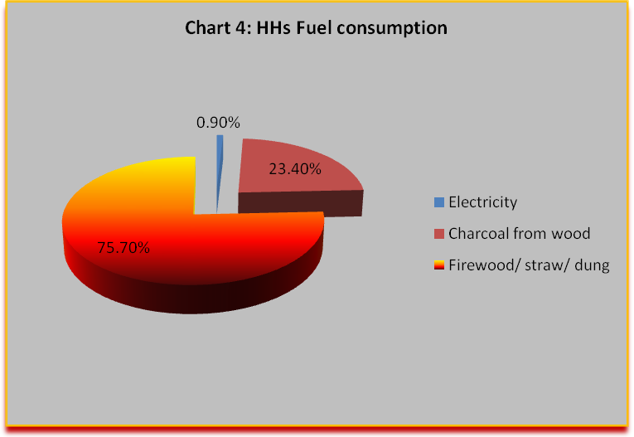
3.1.9 Observation on the Main Houses

The enumerators were required to make several observations while at the homestead of the sampled participants. 70.6% roofs of the main houses of the surveyed households have been thatched while only 29.3% of the roofs were made of corrugated metals. Other roofs were made of makuti, mud/dung or tin roofs. None of the households surveyed had tiled roof. The floors of the main houses within households were also observed, 80.1% were earth/ mud, 19.6% (cemented) and 0.2% tiled. Observations made on walls of the main house noted that out of every five households (80.5%), four were made of mud, 15.2% (bricks/ block) and 1.9% of these households had walls constructed using timber. Some households had walls made of grass reeds, tins or polythene. These observations on the main households are a manifestation of high incidences of poverty in this area.

3.2 Access to water
3.2.1 Water Sources During the Rainy Season
On sources of drinking water to the households, the main sources were surface water which included rivers, dams, lakes, ponds, streams, canals and irrigation channels (34.3%), followed by piped water to yard/ plot or house (21.1%) and unprotected dug well with 15.0% during the rainy seasons as shown in Table 5. These were followed by public or stand pipe at 10.0%.

Table 5: Sources of drinking water most often used by HH in the rainy season
 |  | Frequency | Percent | Valid % | Cumulative%
Valid | Piped water into house | 13 | 3.0 | 3.0 | 3.0
Valid | Piped water to yard/ plot of the house | 93 | 21.1 | 21.2 | 24.2
Valid | Public tap/ standpipe | 44 | 10.0 | 10.0 | 34.2
Valid | Borehole | 12 | 2.7 | 2.7 | 37.0
Valid | Protected dug well | 29 | 6.6 | 6.6 | 43.6
Valid | Unprotected dug well | 66 | 15.0 | 15.1 | 58.7
Valid | Unprotected spring | 5 | 1.1 | 1.1 | 59.8
Valid | Rainwater collection | 9 | 2.0 | 2.1 | 61.9
Valid | Cart with small tank/ drum | 2 | 0.5 | 0.5 | 62.3
Valid | Surface water (river, dam, lake, pond, stream, canal, irrigation | 151 | 34.3 | 34.4 | 96.8
Valid | Other | 14 | 3.2 | 3.2 | 100.0
Valid | Total | 438 | 99.5 | 100.0
Missing | System | 2 | 0.5
Total |  | 440 | 100.0

Amongst villages with cleaner water sourcea are Mbalambala and Isadek where more than two thirds of the households interiviewed either use piped, water into house, piped water into yard/ plot or house and public tap/ stand pipe. These are more hygienically acceptable sources of water for drinking water.
3.2.2 Water Sources in the dry season
During the dry season the main sources of drinking water for 39.5% of the households remain the same as the rainy season. However, 18.8% of the households resort to fetching water from ther rivers, dams, lakes, ponds, streams, canals and irrigation channels followed by public tap/ standpipe (11.9%). During this time reliability of drinking water is greatly affected within households for they resort to fetching water from all sources.
Table 6: Sources of drinking water most often used by the HH in the DRY season
 |  | Frequency | Percent | Valid % | Cumulative %
Valid | Same as the rainy season | 166 | 37.7 | 39.5 | 39.5
Valid | Piped water into house | 2 | 0.5 | 0.5 | 40.0
Valid | Piped water to yard/ plot of the house | 32 | 7.3 | 7.6 | 47.6
Valid | Public tap/ standpipe | 50 | 11.4 | 11.9 | 59.5
Valid | Borehole | 11 | 2.5 | 2.6 | 62.1
Valid | Protected dug well | 23 | 5.2 | 5.5 | 67.6
Valid | Unprotected dug well | 10 | 2.3 | 2.4 | 70.0
Valid | Protected spring | 1 | 0.2 | 0.2 | 70.2
Valid | Cart with small tank/ drum | 6 | 1.4 | 1.4 | 71.7
Valid | Surface water (river, dam, lake, pond, stream, canal, irrigation | 79 | 18.0 | 18.8 | 90.5
Valid | Other | 40 | 9.1 | 9.5 | 100.0
Valid | Total | 420 | 95.5 | 100.0
Missing | System | 20 | 4.5
Total |  | 440 | 100.0
The importance of water in sustaining life and preventing disease is clearly demonstrated with the findings of this baseline survey. There are recommendations on the quantity and quality of water that must be available to the population. These recommendations serve as benchmarks in establishing water supply systems. None of the households cited rainwater as a main source of drinking water during the rainy season; this presents challenges to implementation of rain water harvesting.

3.2.3 Distance to water sources

Typical of most African societies, women and girls were most often cited during focus groups discussions as the household members responsible for water collection. Thus the burden of collecting water is placed upon the female household members. During the rainy season distances travelled to water sources reduce compared to the dry seasons. 48.2% households travel for more than half kilometer to the water source during the dry season compared to 43.2% who travel the same distance during the rainy season.

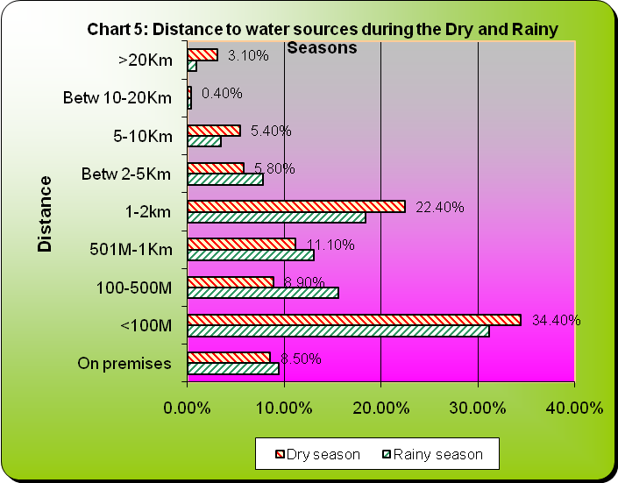
3.2.4 Time HHs take to reach water source

The findings indicate that time taken by households to fetch water varies depending on the season. 64.6% of the households take 30 minutes or less to reach a water source during the rainy season compared to 60.4% who take less than 30 minutes to reach their main source of water during the dry season. Therefore, 26.0% of households take more than 30 minutes to reach a water source during the rainy season compared to 30.8% who take more than 30 minutes to reach a water source during the dry season. Households with water on premises also reduced from 9.4% during the rainy season to 8.8% in the dry season. Geographic accessibility is poor, but the biggest problem is the quality of water in the targeted areas, as was observed by the survey team at a shallow well dug next to Tana River at Balich that basic hygienic measures are not observed at the water points. For instance women just wash clothes next to shallow wells, kids bathe at this places while the taps are mishandled and have been spoilt. Repairs take longer because community members are not trained on maintenance and they also lack repair facilities.

3.2.5 Duration of getting water

Duration of getting water also varies with the seasons and sources. During the rainy season, more than half of the households (77.6%) reported that there are no queues at the water sources, 10.7% queue for less than 30 minutes and 7.1% queue for between 30minutes to 2 hours. A paltry 4.3% of the households queue at the water source for more than 2 hours. This is also due to the fact most households use surface as the main source of water.
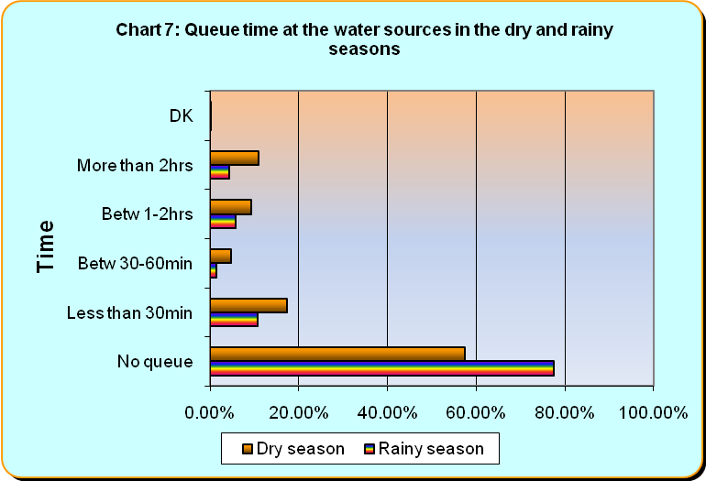
During the dry season however most household take longer on the queues for water, only 17.4% queue for less than 30 minutes, 14.0% (30 minutes -2 hours) and 10.9% queue for more than two hours at the water sources. Further Analysis of time, distance and queue time for most families at the water source reveals no much difference implying that water source for most households in the survey area remains the same during the rainy and dry seasons: surface water and piped water, or wells.

In response to the question on whether households are able to use rainy season water sources throughout the year, more than half (52.5%) replied negatively with the remaining 47.5% being positive that they use the same water sources throughout the year. On the other hand, 52.3% of the households agreed that their water sources during the dry season are able serve them throughout the year.

3.2.6 Other sources for household’s drinking water

The household respondents were further asked to state whether they relied on collecting drinking water from other sources including rivers, lake, stream, pond, open well or unfenced spring any time during the last year, and it emerged that more than half (58.9%) did so while 41.1% did not. For those who rely on other sources, 27.1% said they relied on other sources for between 1-3 months, 30.1% (between 3-8 months), 20.1% (between 8-12 months) and 23.2% (collected water from other sources for more than 1 year). (77.8%) of he households have no any other sources for drinking water throughout the year, while 4.4% and 6.8% use public tap or stand pipe and surface water respectively as other alternative sources of drinking water. Other sources of drinking water are used mostly during dry seasons.

3.2.7 Quantity of water

Without water, life is impossible. Lack of water will result in increased morbidity due to increased transmission of germs and poor hygiene in a community. Specific findings show that the amount of water used in each household in litres each day for drinking, cooking, hygiene, cleaning and other household needs in insufficient in the project area considering the household sizes.

Many factors may contribute to this problem including distance coverage, time spent to fetch water and other challenges. Less than one third of the surveyed households have access to sufficient quantities of water. For households with insufficient water the following reasons were cited:
- Lack of public taps.
- Water points are far away
- Lack of boreholes
- Lack of water storage facilities

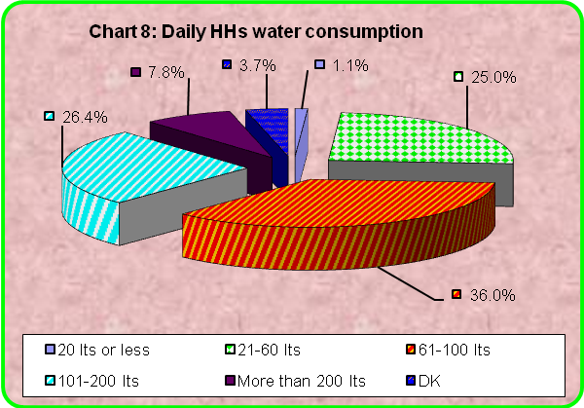
The amount of water used by households in often simultaneously an indicator of overall well being and of sanitation standards. Most households (62.2%) reportedly use less than 100 litres of water daily for drinking, cooking, hygiene, cleaning and other needs including watering animals and bathing. When requested to state whether the amount of water used in the household in enough, 67.3% were negative, 32.2% were positive while 0.5% respondents did not know whether the water was sufficient. (The required minimum is 40 litres per person for rural /ASAL areas classified to have low potential (rainfall below 500 mm)

3.2.8 Water treatment

Water treatment is considered key in ensuring that water is clean and safe. However, an overwhelming 89.7% of households do not treat their drinking water. The proportion of households that do not treat their drinking water is significantly high suggesting a high level of exposure to water borne diseases. Those households who do not treat their drinking water cited several reasons, notable was that the water is already safe (59.0%), too expensive to treat water (22.5%). Table 7 below illustrates the main reasons for why majority of households do not treat water.

Table 7: Main reason for not treating water
Valid |  | Frequency | Percent | Valid Percent | Cumulative Percent
 | Water is already safe/ no need to treat | 231 | 52.5 | 59.0 | 59.0
 | Too expensive to treat water | 99 | 22.5 | 25.3 | 84.2
 | Don't know how | 42 | 9.5 | 10.7 | 94.9
 | Don't like the taste of treated water | 2 | 0.5 | 0.5 | 95.4
 | Other | 3 | 0.7 | 0.8 | 96.2
 | Won't give specific answers/ DK | 15 | 3.4 | 3.8 | 100.0
 | Total | 392 | 89.1 | 100.0
Missing | System | 48 | 10.9
Total |  | 440 | 100.0

For households that do treat their drinking water, methods are varied: 25% boil, 22.0% use chlorination/ add water guard/ PUR/ Aquaguard or tabs/ bleach, 2.5% use water filter, 7.5% let it stand, 30.0% use alum and the rest use other methods. We further sought to know how often households treat their drinking water and it emerged that only 28.2% of those who treat their water did so always. We also realized that traditional herbs are used in some household for water treatment.

There are still considerable efforts required to treat water in the communities in Garissa.
In some households, water is stored for a long time in wells without treatment and is used for drinking and other household purposes. At times the water has alga and makes it very dangerous for human consumption. For households that treat water, the practice is not regular, only 28.2% treat water regularly other households do this sometimes (60.9%) or never (10.9%).
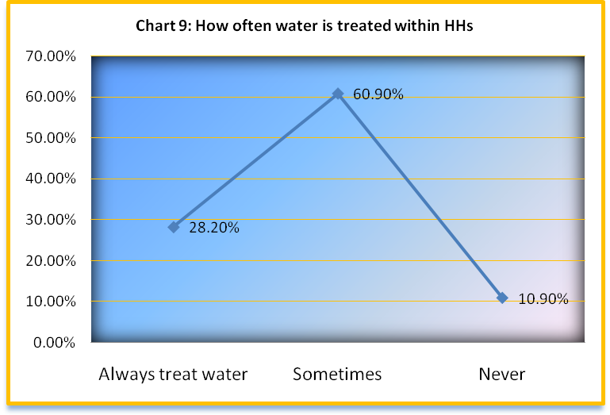

3.2.9 Productive use for water

The survey also established that households use water for other productive uses in addition apart from drinking. Such initiatives sustain their coping mechanisms in this harsh environment and subsidize household’s main livelihood activities. Apart from drinking water and other livelihood uses apart from cooking, washing, cleaning and bathing, most households (43.2%) use water for livestock watering and a few utilize water for agricultural purposes including irrigation, vegetable production, fruits and trees watering. See table 8.

Table 8: HH utilization of water for other activities like income generation, livelihood uses apart from cooking, washing, cleaning and bathing
 |  | Frequency | Percent | Valid % | Cumulative %
Valid | Irrigation | 28 | 6.4 | 6.4 | 6.4
Valid | Livestock/ watering animals | 188 | 42.8 | 43.2 | 50.1
Valid | Vegetables | 1 | 0.2 | 0.2 | 49.8
Valid | Fruit trees | 4 | 0.9 | 0.9 | 50.7
Valid | Other trees | 23 | 5.2 | 5.3 | 56.0
Valid | None | 192 | 43.6 | 44.0 | 100.0
Valid | Total | 436 | 99.1 | 100.0
Missing | System | 4 | 0.9
Total |  | 440 | 100.0

This findings show that with capacity development, households can adopt other agricultural practices that are more sustainable. The challenge faced in this locality is a market for horticultural products as was cited during group discussions. Most households however, said they would undertake livestock watering (36.3%), irrigation (19.0%) or grow vegetables amongst others if more water is can be available.
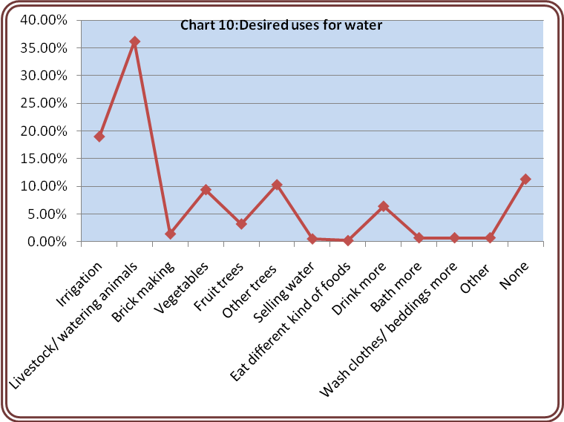
3.2.10 Waste water disposal

The survey further sought to understand how households dispose of waste (grey) water. In response, well over half of the households (61.9%) said that they dispose grey water on the street surface or empty space outside the premises, 34.9% dispose grey / waste water into premises’ yard. Only 2.8% dispose waste water into septic system/soak away/cesspit. The rest of the households either dispose off waste water into toilet facility (0.2%) or other places (0.2%). Most households however live within their homesteads.

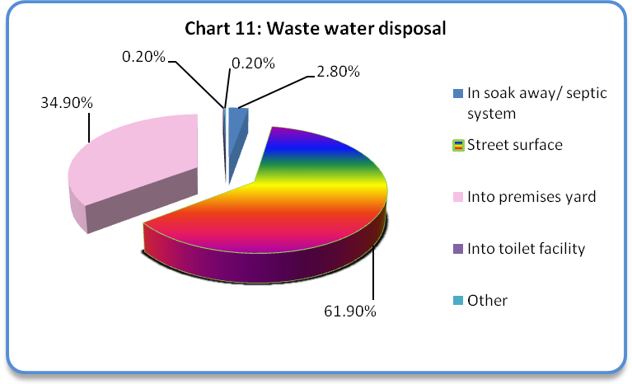

3.2.11 Community water management

In response to the question whether households uses any water source managed by a local committee, more than two thirds (66.8%) of the respondents were negative, one third (32.3%) confirmed using sources of water managed by a local committee and 0.9% said they did not know. This finding ascertains that most community members do not know that water sources are managed by committees or the committees are very weak and ineffective in regard to water management. However, some communities have put in structures to mitigate risks and conflicts at the grassroots level; but there is limited capacity to implement and sustain the strategies in place. This brought about dissatisfaction in some communities owing to several reasons. Encouragingly though is that 78.0% respondents who use water sources managed by local committees are satisfied with the management.

Table 9: Satisfaction levels on how committees are managing the water points
 |  | Frequency | Percent | Valid Percent | Cumulative Percent
 | Satisfied | 113 | 25.7 | 78.0 | 77.9
 | Neither satisfied nor dissatisfied | 8 | 1.8 | 5.5 | 83.4
 | Dissatisfied | 24 | 5.5 | 16.6 | 100.0
 | Total | 145 | 33.0 | 100.0
Missing | System | 295 | 67.0
Total |  | 440 | 100.0

The survey noted that 45.9% of the household are dissatisfied with the fees charged by the community water management committees at the water points while others are dissatisfied with the conflict management, management of finances (due to corruption and embezzlement of funds), and lack of maintenance. Chart 12 below presents the findings.
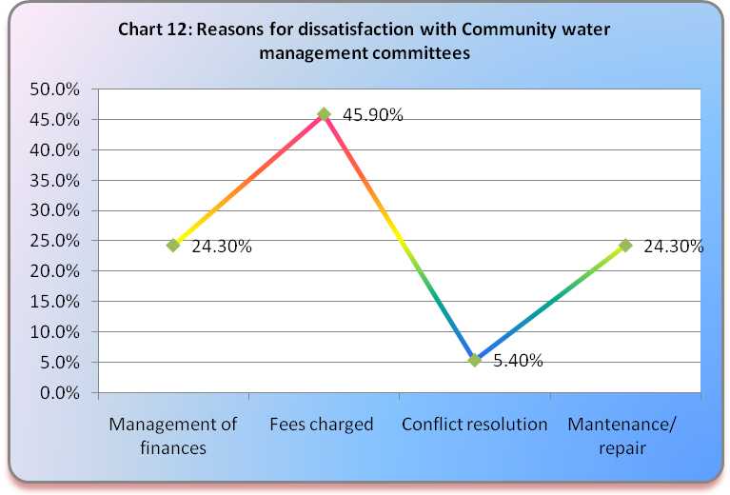
4.0 Sanitation and hygiene
4.1 Availability of Latrines

Availability of latrines for most household was abysmally low. Only 38.9% of the households have their own latrines while an overwhelming 61.1% households lack own latrines. Observation of most latrines revealed that they were not in good condition and this remains a key concern in the targeted communities. Among those without latrines, 68.5% defecate in the bush (open defecation). Others (31.5%) reportedly use the neighbours’ latrine.

While there is a general lack of latrines, the situation is bleaker in other areas like Jariot, Deley, Kasha, Bulla ifini, and Modika and Makaliba. The high number of households in this area is a recipe for outbreak of diarrhoea and other diseases in the rainy season. However some household especially within urban areas shared toilets in plots.

Table 10: Does the HH have its own latrine? |  |  |  | Total
 |  | No | Yes | Total
Village | Dolowyen | 14 | 4 | 18
Village | Jarirot | 12 | 5 | 17
Village | Bantich | 9 | 9 | 18
Village | Duley | 17 | 0 | 17
Village | Sambul | 3 | 12 | 15
Village | Ohio | 8 | 10 | 18
Village | Kasha | 15 | 3 | 18
Village | Bulaifin | 23 | 6 | 29
Village | Jarajara | 8 | 9 | 17
Village | Bulla Mzuri | 6 | 12 | 18
Village | Bulla Game | 1 | 2 | 3
Village | Bulla College | 3 | 7 | 10
Village | Bulla Argi | 12 | 10 | 22
Village | Modika | 14 | 1 | 15
Village | Makaliba | 26 | 8 | 34
Village | Hadley | 18 | 7 | 25
Village | Libalhow | 21 | 15 | 36
Village | Saka Junction | 15 | 7 | 23
Village | Isadek | 8 | 9 | 17
Village | Dolomide | 12 | 7 | 19
Village | Karakora | 9 | 12 | 21
Village | Mbalambala | 5 | 11 | 16
Village | Ashadin | 4 | 1 | 5
Total |  | 253 | 167 | 420

Our findings are in tandem with enumerator observations showing that 60.4% lacked a toilet facility within their compounds and slightly more than a quarter of sampled households have traditional pit latrines. These findings call for concerted efforts to ensure households in this area have hygienic toilets.
Most respondents (89.3%) explained that they do not own latrines because constructing latrines is too expensive and they can not afford. This is supported by the low levels of expenditure as can be seen from findings on household’s asset ownership. 6.7% however cited lack of manpower, yet still 1.2% of the respondents did not offer any reasons. Reasons why some households lack toilets are presented in chart 13 below.

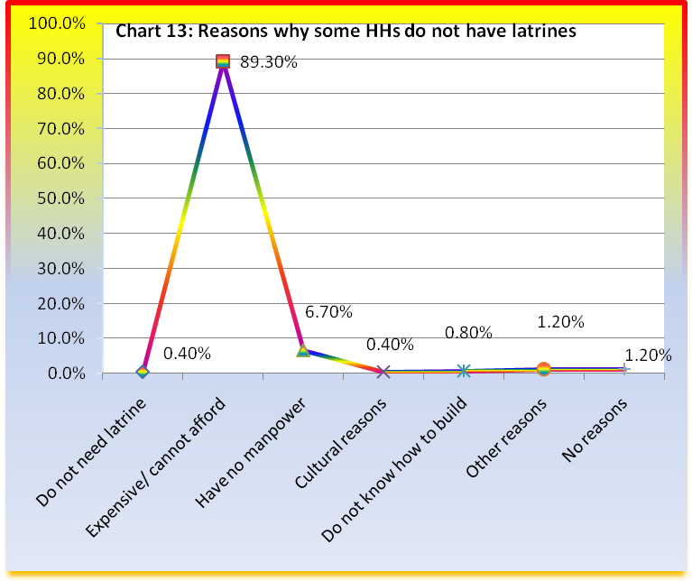
For the households with toilets (167 households), enumerators observed that 97.6 percent were in use while the rest (2.4%) were no in use. Further, slightly more than half (54.4%) households were estimated to cover a distance of less than 20 metres to their latrines. Approximately 40% of the households cover more than 20 metres to their latrines; this was understood to be as a result of the smells emitted from the toilets.

Table 11: Estimated distance from house to the latrine
 |  | Frequency | Percent | Valid Percent | Cumulative Percent
Valid | On premises | 11 | 2.5 | 6.4 | 6.4
Valid | Less than 20m | 93 | 21.1 | 54.4 | 60.8
Valid | Betwn 21m-50m | 39 | 8.9 | 22.8 | 83.6
Valid | Betw 51m-100m | 21 | 4.8 | 12.3 | 95.9
Valid | betw 101m-200m | 3 | .7 | 1.8 | 97.7
Valid | betw 201m-500m | 4 | .9 | 2.3 | 100.0
Valid | Total | 171 | 38.9 | 100.0
Missing | System | 269 | 61.1
Total |  | 440 | 100.0

4.2 Other observations made on household latrines
“...the latrines smell so bad forcing some people to defecate in the bushes.......this is one of the reasons why they are built far away from the houses.....most of toilets are infact not cleaned thus they are very very dirty...” Chief-Balich Area

4.3 Cleanliness of latrines

The survey team observed that 50.6% of surveyed families have a slightly dirty or have feces or used paper outside of pit latrines while only 49.4% of the households have clean latrines. 52.4% of the latrines also were noted to smell inside while only 47.6% were clean and did not smell. However, observations by the enumerators revealed that 56.6% of the household latrines had no flies, 41.6% (a few flies {4-5}) while 1.8% of latrines were observed to have many flies. The high incidences of unclean latrines indicate why some households that own latrines would rather go to the bushes to defecate.

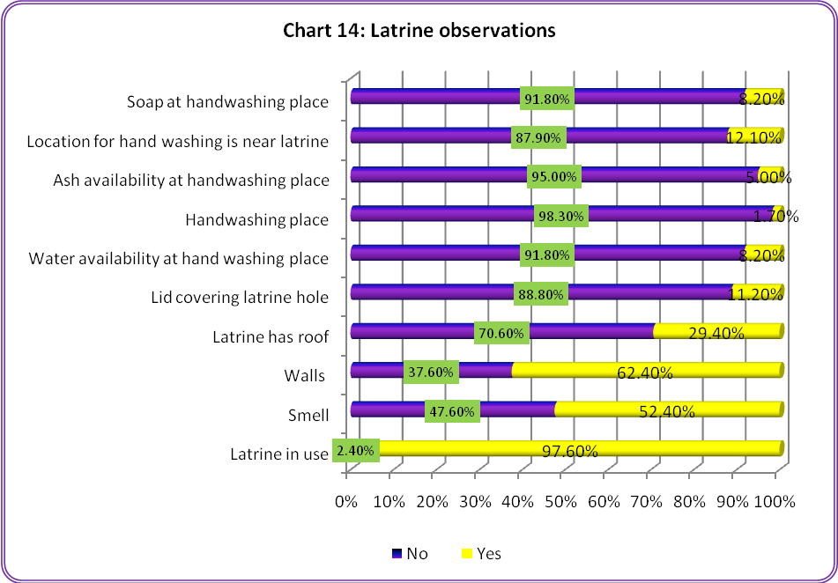

Most of the latrines observed (61.3%) were noted to have superstructures constructed using natural materials like wood, sticks, mud, stone, grass etc. while 38.7% of these latrines were constructed with improved materials. 68.9% of the households’ with latrines were observed by the enumerators to be secure and 31.1% were noted to be unsafe, 51.9% of these latrines have doors while 48.1% latrines observed lacked door or had door that do not close.

Further observation of the slab material showed that 82.1% of the households with latrines used cleanable or cement materials for construction compared to 17.9% that constructed latrines using non-cleanable or natural materials. This therefore implies that due to inadequacy of water most latrines are not cleaned regularly hence many latrines are dirty in this area or households just lack of hygienic education.

4.4 Sharing latrines / toilets

52.5% of households possessing latrines share with two, three, or four people. 41.9% of households having a latrine share it with five to ten other people and only 1.1% of the households share their latrines or toilets with more than 10people. However, virtually all respondents would like to have their own family latrine for convenience purposes as was realized during focus group discussions. Where latrines are shared by many households, there is need for hygienic standards to be maintained.

Table 12: How many people share this toilet/ latrine?
 |  | Frequency | Percent | Valid Percent | Cumulative Percent
Valid | Only One | 8 | 1.8 | 4.5 | 4.5
Valid | 2-4 | 94 | 21.4 | 52.5 | 57.0
Valid | 5-7 | 74 | 16.8 | 41.3 | 98.3
Valid | 8-10 | 1 | .2 | .6 | 98.9
Valid | More than 10 | 2 | .5 | 1.1 | 100.0
Valid | Total | 179 | 40.7 | 100.0
Missing | System | 261 | 59.3
Total |  | 440 | 100.0

4.5 Public Toilets/ latrines
An overwhelming, 85.2% asserted that there were no toilets open to the public in the communities, 13.4% were positive that this toilets were available while 1.4% said they did not know. Further, less than half of household respondents (42.5%) who said they have community toilets open to the public have some members of their families using these community toilets while 57.5% households do not use this community toilets that are open to the public.

4.6 Rubbish Disposal

In response to the question on rubbish disposal, 46.0% reported that they scatter their rubbish, 27.8% said they have designated pits while 23.0% of the households burn their rubbish. The rest of the households either dispose rubbish on the garden or give it to organized garbage collection. No household respondent mentioned that they give refuse or rubbish to the animals, bury or compost their rubbish. This finding emphasizes the need for concerted efforts to educate the community on issues of sanitation and public health. There is need to also build the capacities of village leaders and elders to play a leading role on these issues.
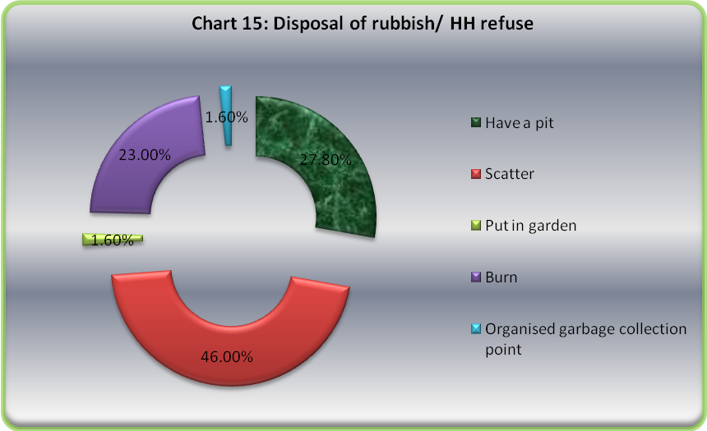

4.7 Disposal of children’s feces

It should be noted that knowledge of disposal of feces in proper manner is quite wanting in this area. More than half (52.9%) of the households dispose children feces in the open field, 7.4% dispose children feces near their compounds. However, 26.4% use containers and put in the latrine. See finding on table 13 below

Table 13: Disposal of feces of children under 5 years within HHs
 |  | Frequency | Percent | Valid Percent | Cumulative Percent
Valid | Open field | 230 | 52.3 | 52.9 | 52.9
Valid | Near the house in the compound | 32 | 7.3 | 7.4 | 60.2
Valid | Using container and putting in the latrine | 115 | 26.1 | 26.4 | 86.7
Valid | DK [Have no child below 5 years | 58 | 13.2 | 13.3 | 100.0
Valid | Total | 435 | 98.9 | 100.0
Missing | System | 5 | 1.1
Total |  | 440 | 100.0

4.8 Hygiene practices and Livestock Rearing
In response to a question on where household livestock spend their nights, more than half (61.8%) of the households stated that the animals spend nights in separate shed, 8.6% (within the compound). However, 7.3% of the households who own livestock stated that their livestock spend the night in the house. This they say is for security reasons, but it has negative repercussion are regards hygienic issues within households. Chart 16 below presents this finding.
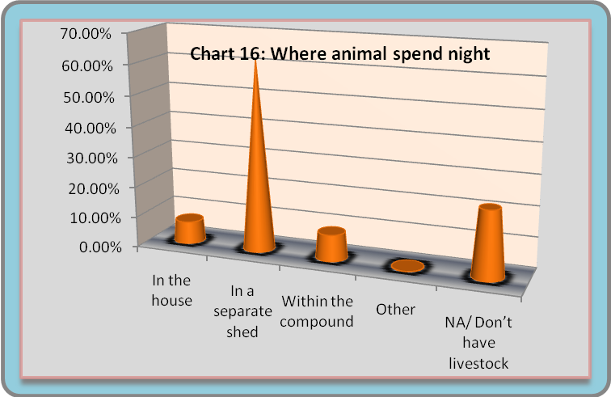
4.9 Hand-washing

In response to the question “When do you wash your hands?” households responded as follows:

Table 14 : hand washing
 |  | Responses |  | Percent of Cases
 |  | N | Percent | Percent of Cases
Hand washing | After defecation / using the toilet | 275 | 33.0% | 62.9%
Hand washing | Before/ after eating | 387 | 46.5% | 88.6%
Hand washing | Before food preparation | 72 | 8.6% | 16.5%
Hand washing | Before feeding the child | 15 | 1.8% | 3.4%
Hand washing | After changing the baby | 1 | .1% | .2%
Hand washing | After touching dirty things | 73 | 8.8% | 16.7%
Hand washing | Before praying | 10 | 1.2% | 2.3%
Total |  | 833 | 100.0% | 190.6%
*Multiple responses were allowed in this question.

More than six out of ten respondents (62.9%) wash their hands after defecation, 88.6% wash their hands before and after eating. More significantly, 2.3% of the respondents wash their hands before prayers even though this was not included as a response in our questionnaire. Subsequently during focus group discussions, it emerged that the communities here are predominantly Muslim; hence hand washing before prayers is paramount.

In response to the question "What do you primarily use for hand washing?” 63.2% of respondents said that they use soap, 0.5% use ash and 36.4% of respondents use water only.

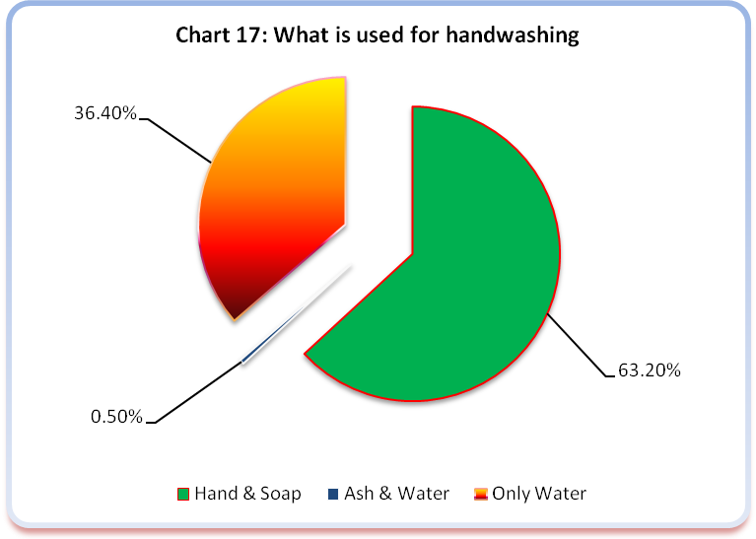

When asked “whether washing hands with water but without soap is as good as washing hands with water and soap”, an overwhelming 92.0% disagreed while only 5.5% agreed with 2.5% saying that they did not know.

Asked why it is important to wash hands with soap or ash, 35.2% cited health reasons (prevent diseases, remove germs, prevent dirt from getting into mouth or food) while more than half of (56.8%) cited hygienic reasons. Group discussion however cited scarcity of water in some places e.g. Dugis as a factor that may contributes to individuals avoiding washing hands.

Table 15: Why it is important to wash hands with soap/ ash]
 |  | Frequency | Percent | Valid Percent | Cumulative Percent
Valid | Health: prevent disease/ remove germs/ prevent dirt from getting into mouth or food | 147 | 33.4 | 35.2 | 35.2
Valid | Hygiene | 250 | 56.8 | 59.8 | 95.0
Valid | Other people: everybody does so, its normal | 3 | 0.7 | 0.7 | 95.7
Valid | Appeal or appearance: smells good/ looks good/ feels clean | 13 | 3.0 | 3.1 | 98.8
Valid | DK | 5 | 1.1 | 1.2 | 100.0
Valid | Total | 418 | 95.0 | 100.0
Missing | System | 22 | 5.0
Total |  | 440 | 100.0

4.10 Drinking water Observations

Safe drinking water is a factor for healthy living. The study was thus concerned with drinking water storage within households. For households with a container designated for drinking water, enumerators were to observe whether it was covered. As the chart below illustrates 81.4% have covered containers for drinking water while the rest of households (18.6%) had drinking water containers not covered. 76.3% of the drinking water containers were observed to be narrow necked / mouth or the households respondents couldn’t fit hand into the opening while 23.7% had drinking water containers observed to be wide necked/ mouth.

The respondents were also requested to demonstrate how they draw water out of the drinking water container and 69.2% pour drinking water into cups. Chart 18 below presents how respondents draw water from drinking water containers. This finding invites concerted efforts in sensitizing target communities on perceptions regarding safe drinking water as well practices for making water safe.

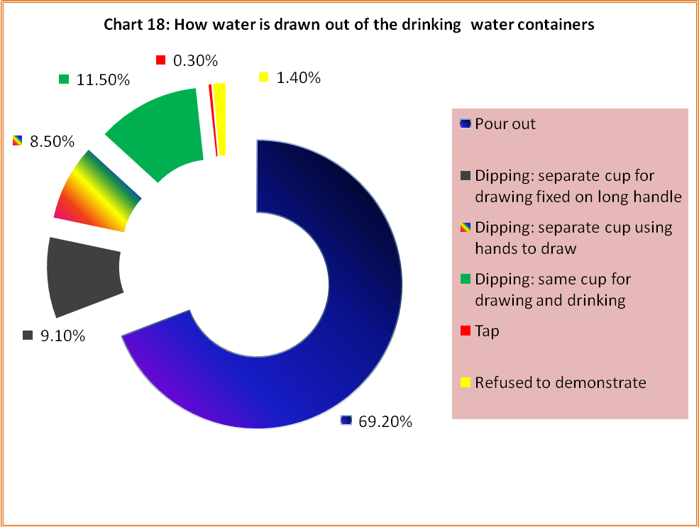

4.11 Environmental conservation

Garissa District is is classified as Arid and Semi Arid Lands (ASAL), where insufficient, erratic and poorly distributed rainfall results in chronic water shortages and food insecurity. The area is prone to prolonged drought, which results in the drying up of seasonal water sources. A considerable drought occurs once every three to four years while a major drought can be expected approximately every seven years.
Thus, environmental conservation and preservation is vital for the livelihoods in this region where temperatures range from 20ºC to 38ºC and a bimodal type of rainfall, long rains (March to April) and the short rains (October to December) with and average annual rainfall is 320mm. We asked the household respondents if in the last one year trees or shrubs have intentionally been planted within their compounds. In response, well over half (58.0%) said No with 41.7% saying they had done so while 0.2% did not know.

Several respondents consequently gave reasons why trees should be planted. Majority (46.9%) of respondents said trees should be planted within homestead to provide shades while more than a quarter of the respondents think they should be planted to provide fruits. Few respondents cited environmental reasons like: wind breakers, aesthetic appeal and to prevent soil erosion. Table 16 below presents the reasons cited by the respondents on why trees should be planted at home.

Table 16: Reason why HHs would want to plant trees or shrubs
 |  | Frequency | Percent | Valid Percent | Cumulative Percent
Valid | Fuel for cooking | 5 | 1.1 | 1.1 | 1.1
Valid | Wind breaker | 34 | 7.7 | 7.8 | 8.9
Valid | Fencing | 18 | 4.1 | 4.1 | 13.0
Valid | Fruits to eat | 110 | 25.0 | 25.2 | 38.2
Valid | Beauty, the place looks nice | 56 | 12.7 | 12.8 | 51.0
Valid | To provide shade | 205 | 46.6 | 46.9 | 97.9
Valid | Prevent erosion | 3 | .7 | .7 | 98.6
Valid | Other | 1 | .2 | .2 | 98.9
Valid | DK | 5 | 1.1 | 1.1 | 100.0
Valid | Total | 437 | 99.3 | 100.0
Missing | System | 3 | .7
Total |  | 440 | 100.0

Overall, the existing water sources are prone to contamination with human waste as the majority of the households have no latrines, as well as animal wastes, particularly at earth dams as was cited during discussions with community members.
Due to the fact that the water supply infrastructure is not evenly distributed, there is severe environmental degradation of land and pasture resources. These conditions also contribute to inter-ethnic conflict.

Part 4: RECOMMENDATIONS AND CONCLUSIONS
- Water
All protected water sources that are introduced to a community should include the formation and training of a water point committee to ensure that there are community members to repair the pump, collect money to purchase spare parts and ensure hygiene around the well

In areas where there are insufficient protected water sources (in the event of pump break-downs), the treatment of drinking water should be taught. Either boiling or filtering and treating with chlorine bleach should be an integrated part of the water point committees training program

A mid term evaluation should determine the reliability of water recently constructed water points, their proper maintenance, the effectiveness of the water point committees in collecting, funds to purchase spare parts for the maintenance and repair of pumps, and the community compliance with the rules established by the committee and other efficient production uses for water should be determined by this study.

Additionally, the regular cleaning of water storage containers and promotion of a lid to minimize opportunities to contaminate drinking water should be part of a water hygiene program

- Latrines
When mounting a latrine promotion campaign, the safety, security and hygiene of a concrete slab should be emphasized. The former to encourage households teach their young one use the latrines. However, the construction of any type of latrine should be encouraged. If people do prefer a traditional design, staff should offer maximum help to ensure that the latrine is safe and can be maintained properly.

In cases where people do not have latrine because of lack of tools or there is no on to dig it, means to eliminate these excuses should be offered.

Sanitation education should include messages about excreta disposal when away from home. As the majority of the rural population is pastoralists they spend long periods of time away from the house. In addition, use of river for defecation and urination should be strongly discouraged, especially because many people obtain their drinking water from this source.

Households should be trained to properly locate latrines so that at the projects end when and if people continue to construct latrines, they will not risk contamination of water sources.

- Hygiene
Many people reported washing their hands before eating or after eating and before prayers. Relatively few, however, reported washing hands after “using the latrine” it is recommended that education should proceed to increases community awareness.

Additionally, proper rubbish disposal should be encouraged as part of hygiene education campaign. For example, disposing waste/ grey water on the street surface or empty space outside the premises, avoiding leaving empty tins, bottles and broken utensils or glasses around the compound or the house where mosquitoes can bread and metal and glasses that can cut children should be part of the campaign.

- General
Water and sanitation activities should be fully integrated so that people understand links between unprotected water sources, diarrheal diseases (as well as other water related diseases such as bilharzia), latrine use and interruption of the fecal-route of disease transmission, and importance of hand-washing.

Health education should be done on all of the topics included in this survey, with particular emphasis on areas where knowledge was weak. In cases where misconceptions appeared to be fairly general across the population, they should be addressed though health education in target population.

Any intervention on water and sanitation in the two districts should encourage ownership, self reliance and self help. An attitude of “CARE MUST DO FOR US” was frequently encountered during the quantitative and qualitative study (especially when enumerators asked the respondents if they had “any other comment’. There is need to emphasize community’s ownership of particular water points or latrines to promote ownership.

Appendices
Appendix 1: Profile of Garissa District
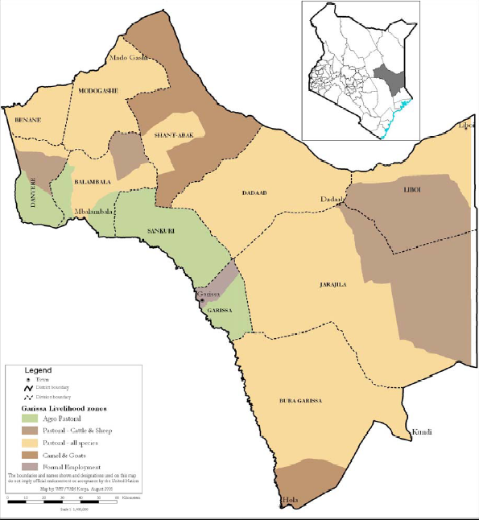
Position and size: Garissa, one of the districts of the North Easter Province of Kenya covering an area of 34,387.7 Km². The district is located between Tana River to the West and Ijara to the South at latitude of 0º 58’ North and 1º 30’ South and longitudes 38º 34’East and 41º 05’. Garissa is divided into 12 administrative divisions.
Population
Garissa has a population of 190,062 occupying 32, 118 households in an area of 5,588 Sq Km. It has a population density of 34 persons.
 | Male | Female | Total | HHs | Area in Sq Kms | Density
Garissa | 101,202 | 88,860 | 190,062 | 32,118 | 5,588.7 | 34
Source: 2009: National Census, KNBS
Climate
The district is generally dry and hot most of the year. Temperatures range between 20ºC to 38ºC. The district had bimodal types of rainfall: the long rains (March to April) and short rains (October to December). The average annual rainfall is 320mm.
Topography
The district is low lying with altitudes ranging between 70m -400m above sea level. River Tana, which runs along the Western boundary, is of the district is the only permanent river. The soils range from sandstone, dark clays in some patches, to alluvial (white and red sand) soils along the Tana River basin. The white and red sand soils are found in Balambala Division where the terrain is relatively uneven and well drained. The soils hold no water but support vegetation which remains green long after the rains. The rest of the district had sandy soils that support scattered shrubs and grassland. The alluvial soils occur along the shores of river Tana and along the Lagha valleys. The soils are very fertile and can support increased agricultural production using irrigation.
The district has a lot of groundwater potential along the Merti aquifer stretching from Shant Abaq Division to Jarajilla Division. Along the aquifer, the water is fresh but some parts of Jarajilla have saline water. The northern and central parts of the district have no underground water potential and therefore cannot support human habitation during the dry seasons.
Vegetation
The vegetation in the area has been utilized for firewood/ charcoal burning leaving the area vulnerable to wind erosion, which may lead to desertification in the near future.
Settlement Patterns
The district population is concentrated in small pockets surrounding water points and market centers. These are areas where basic services like hospitals, schools, health facilities and commercial activities are found. Population cluster also coincide with the location of sub-locations headquarters. The major towns also attract large proportions especially Garissa town and the surrounding areas.
The rest of the population are nomadic and shift their livestock in search for water and pasture.
Livelihood
The main source of livelihood in the district is nomadic pastoralism. The environment is fragile given the low vegetation cover; this calls for sustainable use of natural resources to avoid desertification.

Appendix 2: Garissa District –“Population and Household Distribution by Socio-economic Characteristics “Source: 2009 Kenya Population Census,
Population aged 5years and above by sex, activity status
Garissa District | Total | Employed | Seeking work/ No work available | Economically inactive | Unclassified
Male | 85,820 | 32,731 | 19,830 | 22,304 | 10,955
Female | 75,952 | 16,016 | 16,145 | 33,489 | 10,392
Total | 161,772 | 48,747 | 35,975 | 55,300 | 21,257

Households by main type of roofing material for the main dwelling unit
Garissa District | Corrugated iron sheets | Tiles | Concrete | Asbestos sheets | Grass | Makuti | Tin | Mud/dung | Other | total
Rural | 391 | 79 | 11 | 36 | 8,982 | 1,656 | 10 | 12 | 12 | 11,189
Urban | 15,671 | 331 | 72 | 740 | 2,407 | 1,134 | 47 | 177 | 56 | 20,635

Households by main type of wall material for the main dwelling unit
Garissa District | stone | Brick/ block | Mud/wood | Mud/cement | Wood only | Corrugated iron sheets | Grass /reeds | Tin | other | Total
Rural | 88 | 108 | 1,031 | 428 | 2,881 | 32 | 6,594 | 12 | 15 | 11,189
Urban | 3,627 | 10,677 | 2,780 | 1,522 | 212 | 144 | 1,582 | 38 | 53 | 20,635

Households by main type of floor material for the main dwelling unit
Garissa District | Cement | Tiles | wood | Earth | Other | Total
Rural | 277 | 6 | 26 | 10,838 | 42 | 11,189
Urban | 14,707 | 268 | 123 | 5,449 | 88 | 20,635

Households by main sources of water
Garissa District | Pond/ dam | Lake | Stream | Spring/ well/ borehole | Piped into dwelling | Piped | Jabia/ rain/ harvested | Water vendor | Other | Total
Rural | 506 | 57 | 4,672 | 4,513 | 93 | 237 | 55 | 823 | 233 | 11,189
Urban | 68 | 37 | 744 | 325 | 2,354 | 16,756 | 26 | 506 | 113 | 20,929

Households by main source of human waste disposal
Garissa District | Total | Mail sewer | Septic tank | Cess pool | VIP Pit latrine | Pit latrine covered/ uncovered | Bucket | Bush | Other
Rural | 11,189 | - | 5 | 13 | 134 | 973 | 9 | 10,002 | 54
Urban | 20,929 | 964 | 664 | 71 | 1,758 | 15,258 | 94 | 2,039 | 81

Population by sex and main type of disability
Garissa District | Visual | Hearing | Speech | Physical / self care | Mental | Other | None | Total
Male | 447 | 356 | 355 | 659 | 333 | 33 | 97,999 | 100,182
Female | 435 | 319 | 269 | 609 | 237 | 28 | 86,721 | 88,618
Total | 882 | 675 | 624 | 1,268 | 570 | 61 | 184,720 | 188,800

Appendix 3: Village * [Q3.01 Source of drinking water most often used by HH?] Crosstabulation

Count
 |  | [Q3.01 Source of drinking water most often used by HH?] |  |  |  |  |  |  |  |  |  |  | Total
 |  | Piped water into house | Piped water to yard/ plot of the house | Public tap/ standpipe | Borehole | Protected dug well | Unprotected dug well | Unprotected spring | Rainwater collection | Cart with small tank/ drum | Surface water (river, dam, lake etc | Other | Total
Village | Dolowyen | 0 | 0 | 0 | 3 | 5 | 0 | 0 | 0 | 0 | 10 | 0 | 18
Village | Jarirot | 0 | 1 | 5 | 0 | 0 | 0 | 0 | 2 | 0 | 8 | 0 | 16
Village | Bantich | 0 | 0 | 0 | 2 | 6 | 5 | 1 | 0 | 0 | 4 | 0 | 18
Village | Duley | 0 | 0 | 0 | 3 | 12 | 0 | 0 | 1 | 0 | 1 | 0 | 17
Village | Sambul | 2 | 13 | 0 | 0 | 0 | 0 | 0 | 0 | 0 | 0 | 1 | 16
Village | Kasha | 0 | 0 | 3 | 0 | 1 | 3 | 2 | 0 | 0 | 9 | 0 | 18
Village | Ohia | 1 | 0 | 0 | 2 | 0 | 5 | 0 | 0 | 1 | 8 | 0 | 19
Village | Bulaifin | 1 | 13 | 3 | 0 | 0 | 3 | 0 | 0 | 0 | 5 | 3 | 28
Village | Jarajara | 0 | 0 | 0 | 0 | 3 | 0 | 0 | 0 | 0 | 15 | 0 | 18
Village | Bula Mzuri | 0 | 11 | 7 | 0 | 0 | 0 | 0 | 0 | 0 | 0 | 0 | 18
Village | Bula Game | 1 | 2 | 0 | 0 | 0 | 1 | 0 | 0 | 0 | 0 | 0 | 4
Village | Bula College | 0 | 7 | 1 | 0 | 0 | 0 | 0 | 1 | 0 | 0 | 1 | 10
Village | Bora Argi | 2 | 16 | 9 | 0 | 0 | 1 | 0 | 0 | 0 | 1 | 3 | 22
Village | Modika | 0 | 0 | 0 | 0 | 0 | 6 | 0 | 0 | 0 | 8 | 3 | 17
Village | Makaliba | 0 | 4 | 0 | 0 | 0 | 13 | 0 | 0 | 1 | 16 | 0 | 34
Village | Hadley | 0 | 0 | 0 | 0 | 0 | 12 | 0 | 0 | 0 | 12 | 0 | 24
Village | Libalhow | 0 | 2 | 6 | 2 | 0 | 2 | 1 | 1 | 0 | 19 | 3 | 36
Village | Saka Junction | 0 | 0 | 0 | 0 | 0 | 9 | 0 | 0 | 0 | 9 | 0 | 18
Village | Isadek | 3 | 14 | 0 | 0 | 0 | 0 | 0 | 0 | 0 | 0 | 0 | 17
Village | Dolomide | 0 | 0 | 0 | 0 | 0 | 0 | 0 | 3 | 0 | 15 | 0 | 18
Village | Karakora | 0 | 0 | 9 | 1 | 1 | 2 | 1 | 1 | 0 | 5 | 0 | 20
Village | Mbalambala | 2 | 10 | 1 | 0 | 0 | 0 | 0 | 0 | 0 | 1 | 0 | 14
Village | Ashadin | 0 | 0 | 0 | 0 | 1 | 0 | 0 | 0 | 0 | 3 | 0 | 4
Total |  | 12 | 93 | 44 | 13 | 29 | 64 | 5 | 9 | 2 | 149 | 14 | 434

Village * [Q3.02 Distance to the main drinking water source during the rainy season] Crosstabulation
Count
 |  | [Q3.02 Distance to the main drinking water source during the rainy season] |  |  |  |  |  |  |  |  | Total
 |  | On premises | Less than 100m | Betwn 100m-500m | Betw half-1km | betw 1-2km | betw 2-5km | Betw 5-10km | Betw 10-20km | More than 20 km | Total
Village | Dolowyen | 0 | 2 | 4 | 1 | 7 | 2 | 0 | 1 | 0 | 17
Village | Jarirot | 1 | 7 | 3 | 0 | 1 | 5 | 0 | 0 | 0 | 17
Village | Bantich | 0 | 0 | 6 | 8 | 3 | 1 | 0 | 0 | 0 | 18
Village | Duley | 0 | 1 | 6 | 6 | 4 | 0 | 0 | 0 | 0 | 17
Village | Sambul | 5 | 11 | 0 | 0 | 0 | 0 | 0 | 0 | 0 | 16
Village | Ohia | 0 | 2 | 0 | 1 | 1 | 0 | 0 | 0 | 0 | 4
Village | Kasha | 0 | 5 | 3 | 2 | 2 | 0 | 5 | 0 | 0 | 17
Village | Ohia | 0 | 5 | 1 | 0 | 8 | 0 | 0 | 1 | 0 | 15
Village | Bulaifin | 3 | 13 | 1 | 5 | 5 | 2 | 0 | 0 | 0 | 29
Village | Jarajara | 0 | 3 | 7 | 3 | 5 | 0 | 0 | 0 | 0 | 18
Village | Bula Mzuri | 3 | 12 | 3 | 0 | 0 | 0 | 0 | 0 | 0 | 18
Village | Bula B | 0 | 0 | 0 | 0 | 1 | 0 | 0 | 0 | 0 | 1
Village | Bula Game | 2 | 1 | 0 | 0 | 0 | 0 | 0 | 0 | 0 | 3
Village | Bula College | 2 | 6 | 2 | 0 | 0 | 0 | 0 | 0 | 0 | 10
Village | Bora Argi | 3 | 15 | 0 | 3 | 1 | 0 | 0 | 0 | 0 | 22
Village | Bolagy | 1 | 8 | 0 | 0 | 0 | 1 | 0 | 0 | 0 | 10
Village | Modika | 0 | 0 | 0 | 3 | 4 | 3 | 6 | 0 | 1 | 17
Village | Makaliba | 0 | 9 | 1 | 0 | 10 | 9 | 1 | 4 | 0 | 34
Village | Hadley | 0 | 2 | 6 | 4 | 11 | 0 | 1 | 0 | 0 | 24
Village | Libalhow | 0 | 6 | 1 | 13 | 8 | 3 | 2 | 0 | 3 | 36
Village | Saka Junction | 0 | 8 | 4 | 4 | 2 | 0 | 0 | 0 | 0 | 18
Village | Isadek | 5 | 12 | 0 | 0 | 0 | 0 | 0 | 0 | 0 | 17
Village | Dolomide | 0 | 1 | 1 | 2 | 11 | 3 | 0 | 0 | 0 | 18
Village | Karakora | 1 | 3 | 2 | 2 | 10 | 2 | 0 | 0 | 0 | 20
Village | Mbalambala | 2 | 11 | 0 | 0 | 1 | 0 | 0 | 0 | 0 | 14
Village | Ashadin | 0 | 0 | 0 | 0 | 3 | 1 | 0 | 0 | 0 | 4
Total |  | 28 | 143 | 51 | 57 | 98 | 32 | 15 | 6 | 4 | 434

Appendix 4: Household Survey Questionnaire

The Greater Horn of Africa countries include: Ethiopia, Sudan, Kenya, Eritrea, Somalia, Djibouti and Tanzania
Prof. Hardin, Tragedy of the Commons

