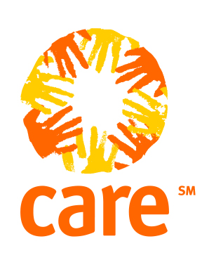

IMPROVED HOUSEHOLD LIVELIHOOD SECURITY PROJECT

PROGRESS REPORT: February- March 2005

Teresa Kamara Leo Roozendaal
Tel: (404)-979-9177 CARE Sudan Country Director
Fax: (404)-589-2627 Tel: (249)-465056
E-mail: kamara@care.org E-mail: leo@sdn.care.org
CARE 151 Ellis Street CARE Street 55 Khartoum 2
Atlanta-Georgia USA P.O. Box 2702 Khartoum Sudan

Background

Unity State is potentially a very rich area in southern Sudan located in the south west of the country. It falls within the Sudd, swampy and stagnant land. It is the second most populous southern state after Northern Bahr Gazal. It has four provinces: Rubkona which harbours Bentiu, Mayom, Pariang and Leer. The dominant tribes are the Nuer mainly in Rubkona, Leer and Mayom while the Dinkas are in Pariang and Abiemnom provinces. The total population of the state is estimated at 1,560,000 persons according to Unicef statistics. Besides the Nuer and Dinkas, other tribes like the Shilluk and Arab tribes from the north are in the state either as traders, working officials or nomads with their cattle during the dry season.

CARE has been in Unity State since 1998 doing interventions in different fields like feeding programs for malnourished children, pregnant, and lactating mothers, food distribution, (PHC) health project, water and sanitation, civil society strengthening and conflict resolutions (peace building).

With the Comprehensive Peace Agreement (CPA) signed in January 2005, CARE International in Sudan shifted its program base from basic service delivery to recovery projects. As per usual, CARE works through local partners including Government of Sudan (GoS), International Displaced Persons (IDP) communities, and Community Based Organizations (CBOs) so as to obtain sustainable results.

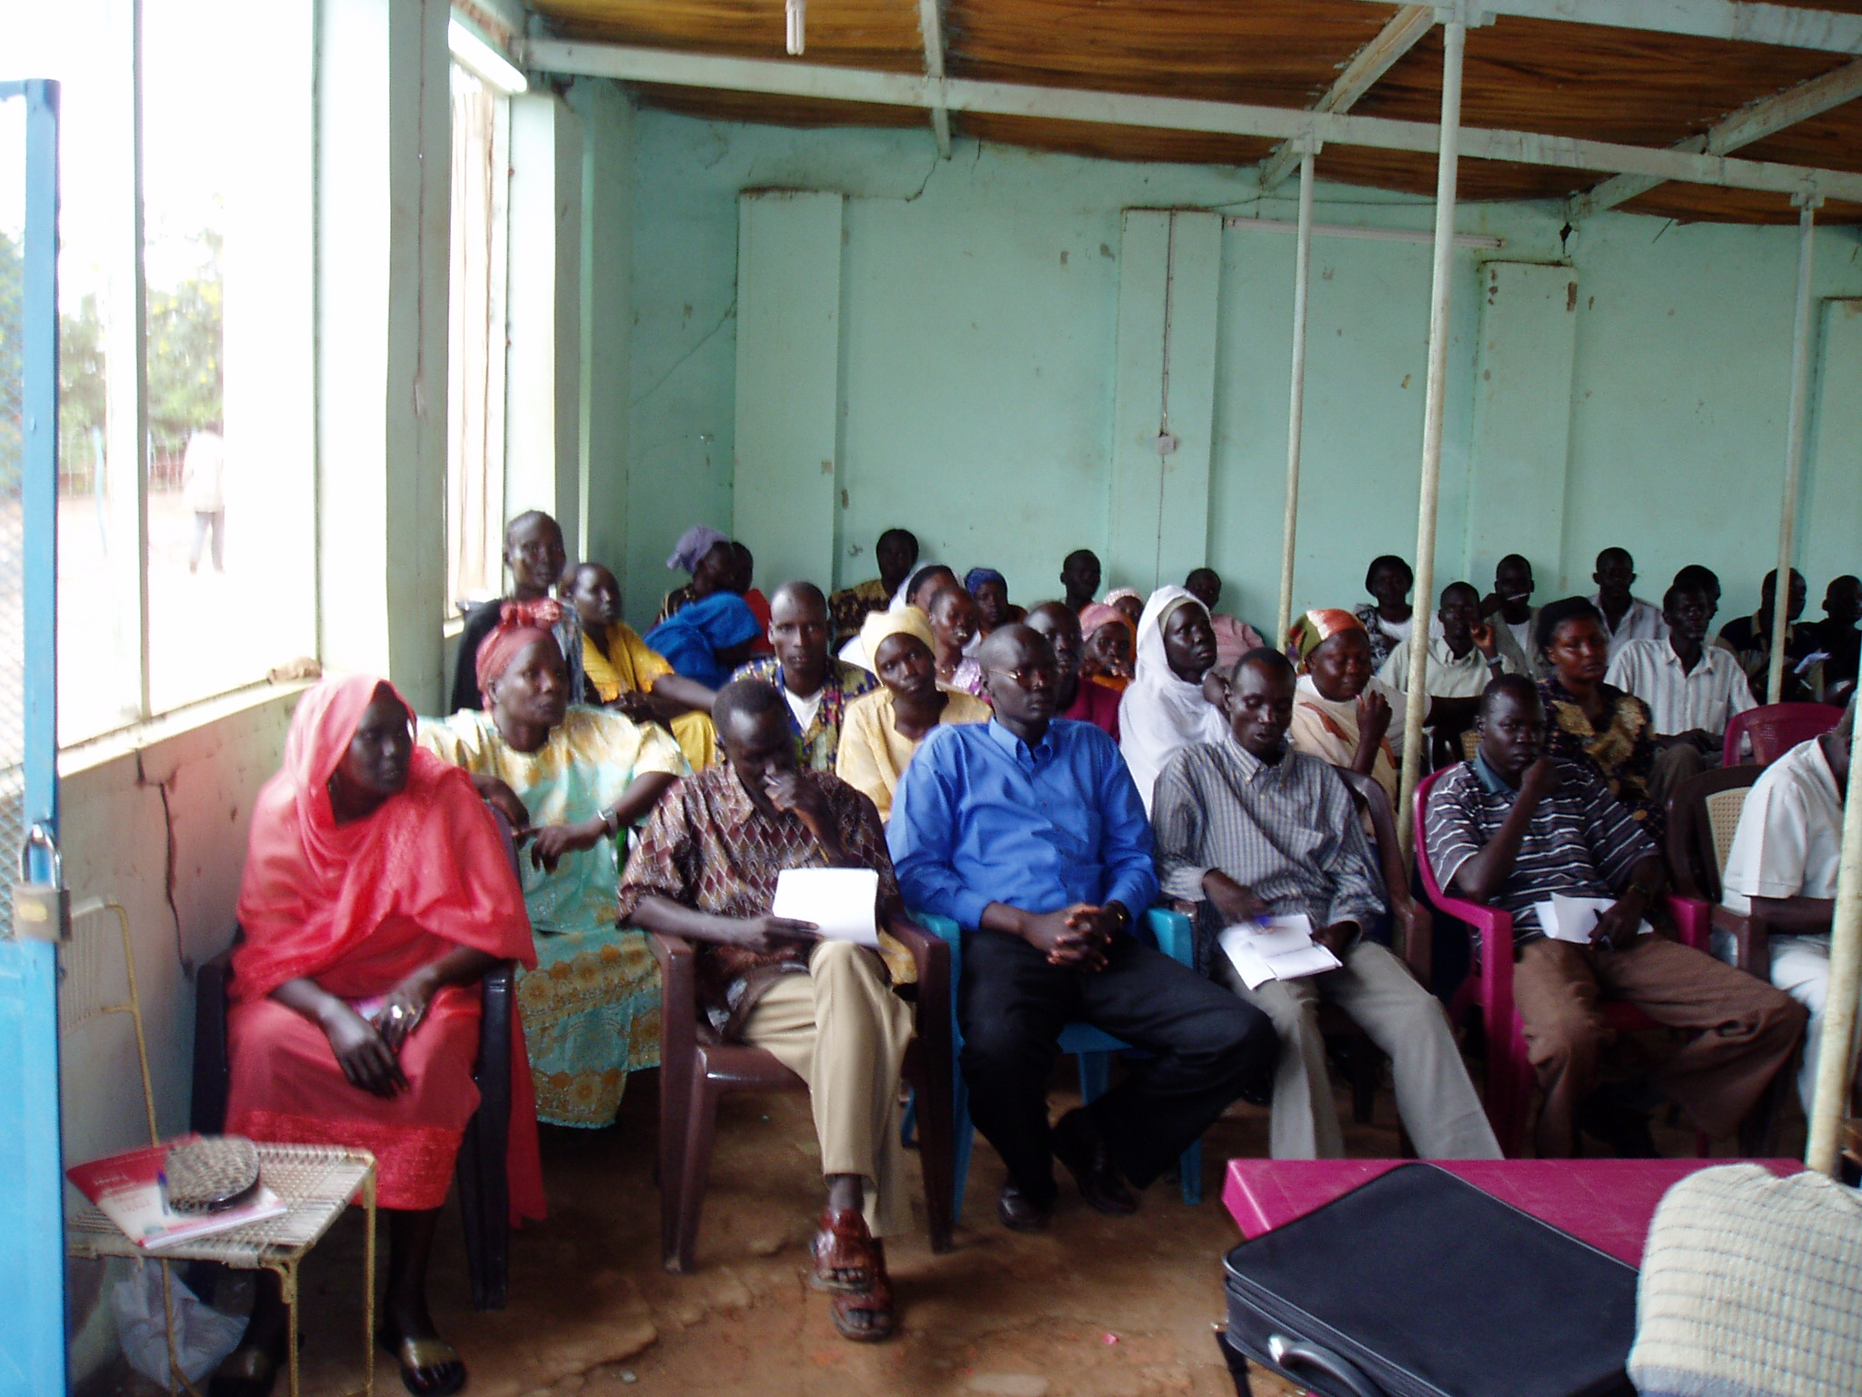
CBO members attending orientation sessions in Rubkona on conflict resolutions strategies.

The first phase of this project focused on peace building and capacity building of local partners. Peace building activities aim to bring about peaceful coexistence between different ethnic groups including IDPs returnees and residence through the implementation of joint activities, thus establishing the condition to promote livelihood security.

The project deals specifically with identifying and informing key partners and NGOs of the new strategy which CARE is undertaking in addressing issues of sustainability. A key principle of CARE strategy is to respect and support decisions of IDPs in a post conflict Sudan based on informed choices.

Objective 1:
5,442 resident and returnee households in Unity State living in war-effected areas have improved (levels of sustainable income) livelihood coping mechanisms through the provision of capacity building, and inputs for small business enterprises.

Agricultural Activities
During February 2005, CARE staff and representatives from the State Ministry of Agriculture, Fisheries, and Forestry (SMoA) met in the office of the Director General to discuss the new livelihood project to be undertaken by CARE in Unity State. From this introduction meeting, all parties involved “bought-in” to the idea and methodology planned. From the meeting, the Ministry of Agriculture guaranteed full support in all components of the project, including the allocation of land for agricultural activities.

During the meeting, CARE highlighted that the aims of this project is to improve the livelihood coping mechanisms of the communities in Unity. The Ministry of Agriculture highlighted that they would expect CARE to jointly implement the project together with the community groups. CARE took this opportunity to discuss in details the concept of Village Development Committees (VDCs) and that this would be a main output of the project to ensure sustainability. CARE highlighted that the VDCs would include both men and women and people from different ages. This was well received by all present at the meeting.

During March CARE began field assessments with the SMoA, after all necessary steps and information had been finalized in the following areas: Rubkona locality, Mayom locality, Pariang locality, Mirmir, Rubkuai Nhialdiu. The assessments were completed by the following officials in area within the localities for eight days:

Assessments in the four localities
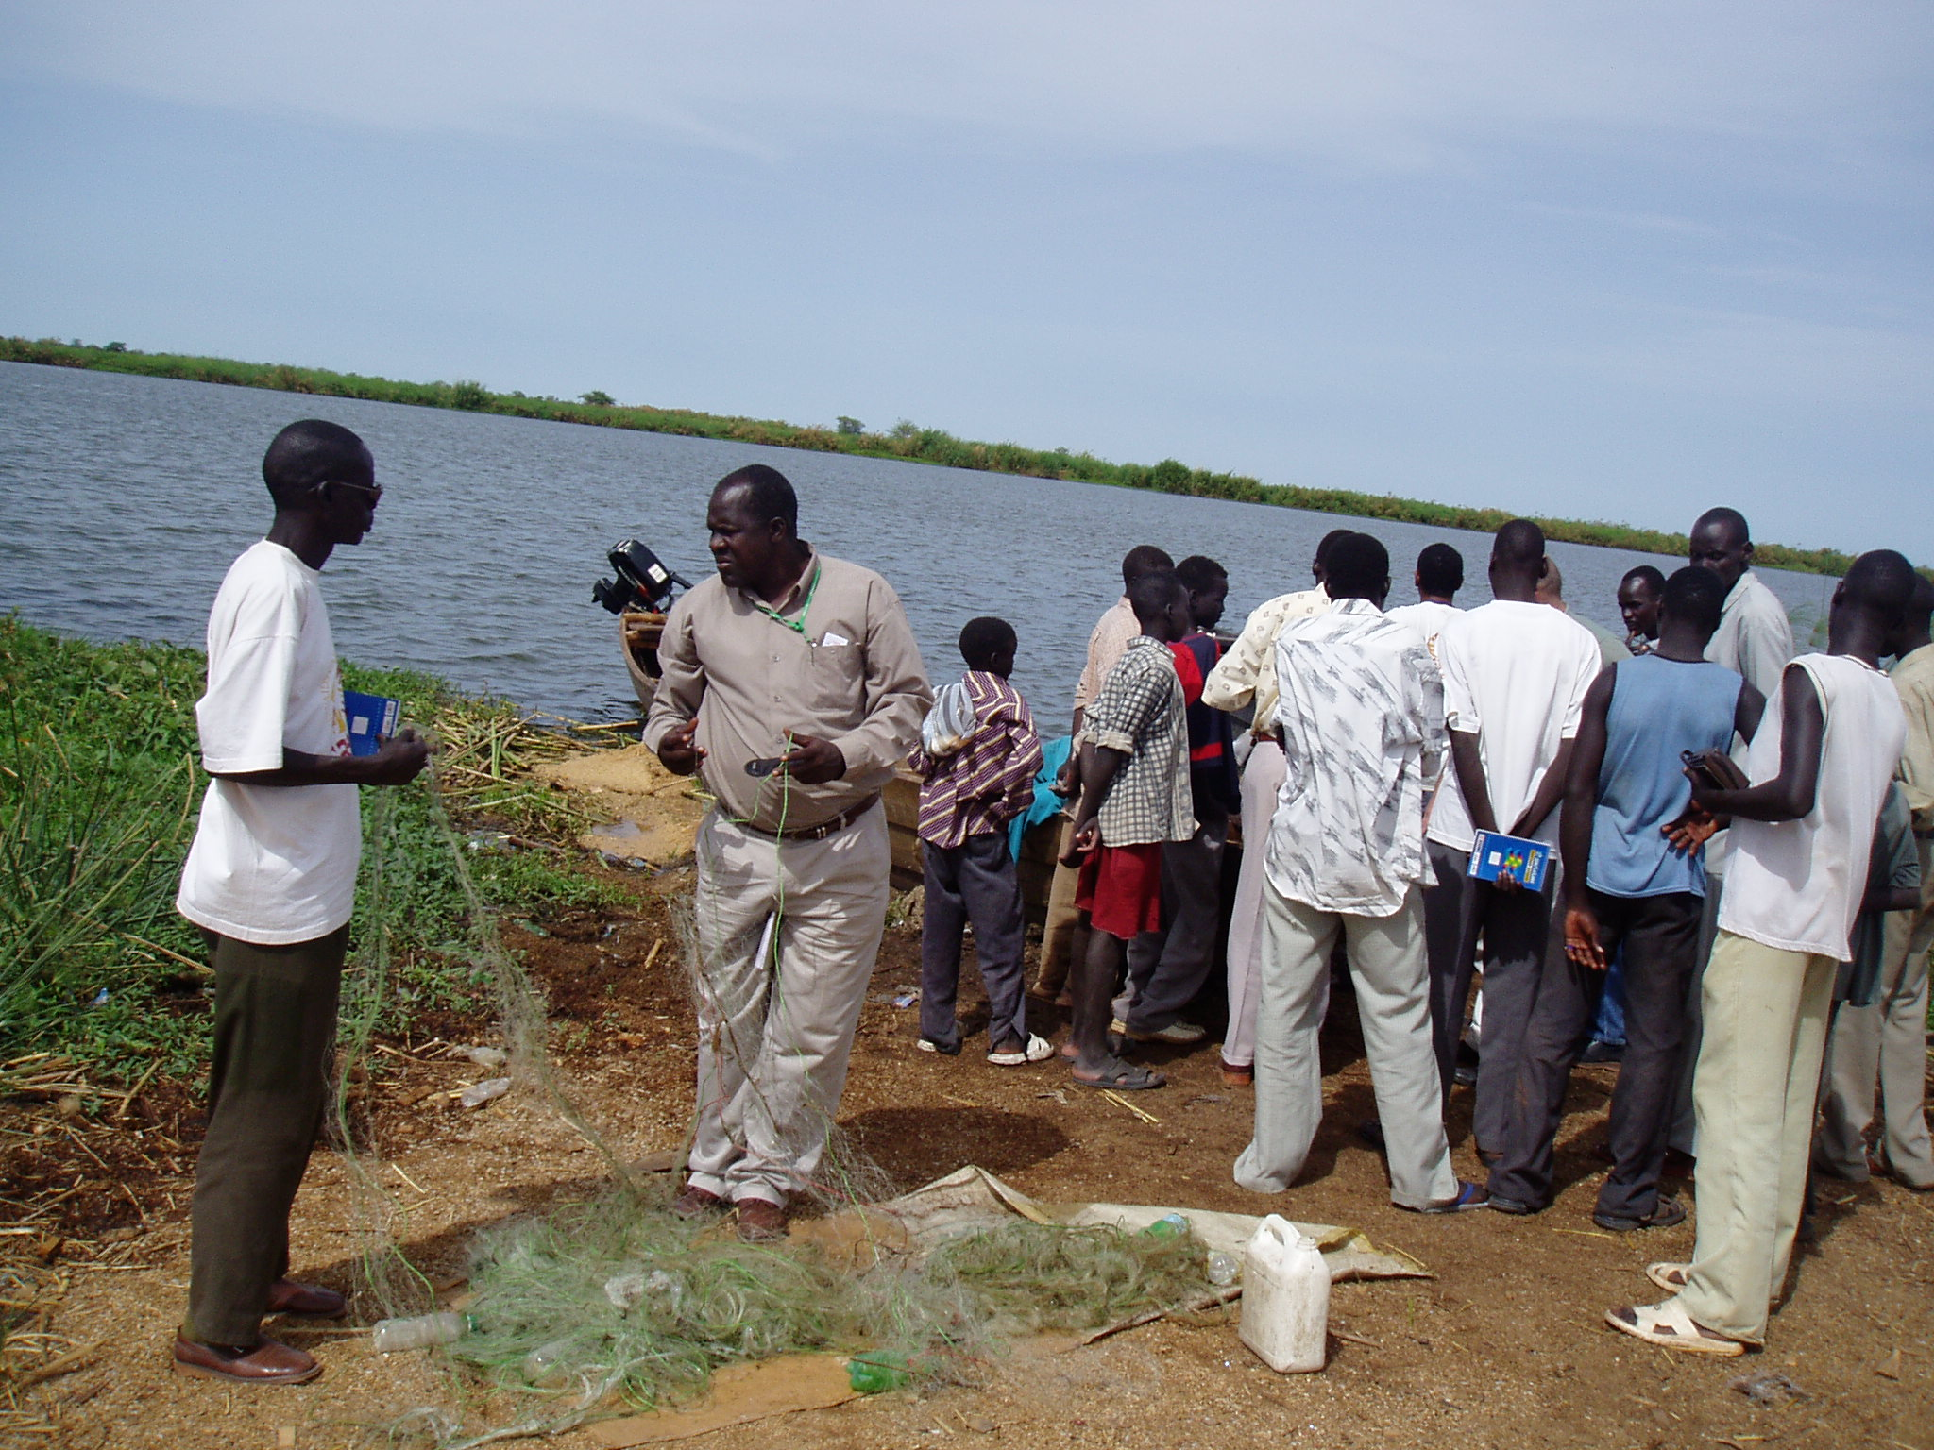
Assessment team in Manga fishing site Feb 2005 CARE staff with SMoA

- Agriculture Extension Agent
- Fisheries technician
- Forestry officer (Ranger)
- CARE Project manager, peace building officer and the Extension Agent
- Two representatives from each locality
- Two chiefs each from various localities

Objective for conducting the assessment
- General briefing to the localities about the coming livelihood project.
- Identifying suitable arable land for agriculture cultivation
- Meet with community leaders (Chiefs) to determine ancestral land issues to avoid land disputes
- Identifying fishing areas/sites suitable including number of registered fishermen
- Identify within the locality the number of skilled carpenters

The areas proposed for the agricultural activities are to be:
- Government land, not owned by individuals to avoid land disputes
- Areas accessible to the communities
- Areas declared free from land mines
- Areas suitable for cultivation (arable)

Note: Assessments are available for distribution

Objective 2
Improve general food security situation for approximately 10,000 household in Unity State through increased provision of agricultural goods and services.

Land allocation (SMoA ) for agricultural activities
CARE requested an approval of fourteen thousand feddans of arable land to be distributed for returnees, IDPs, and residents so as to cultivate field and vegetable crops. This land was approved and distributed accordingly to various localities. Each locality has four administrative units with land allocations as follows:

Locality | Number of  feddans | Number of  administrative units
Rubkona | 3000 | 4
Pariang | 3000 | 4
Leer | 3000 | 2
Mayom | 3000 | 4
Abiemnom | 2000 | 1

Problems encountered in the distribution of land
- Abiemnom falls under Mayom and arguments over giving it more than other areas
- Suitable lands are distant from residential areas and are still mined
- Most returnees were not registered during the distribution of land
- One and half feddans each household is not enough to cultivate all types of crop
The MoA in a meeting, strongly agreed to support CARE. They agreed to give advice and personnel from their department to the project since CARE involved them in the planning stage of the project. In exchange for their support, CARE facilitated MoA staff movement in areas where CARE operates projects in order to allow SMoA staff to visit the requested sites and provide the promised support. CARE requested the SMoA to avail and maintain their tractors to assist in cultivation of both field and vegetable crops. CARE will support the procurement of spare parts.

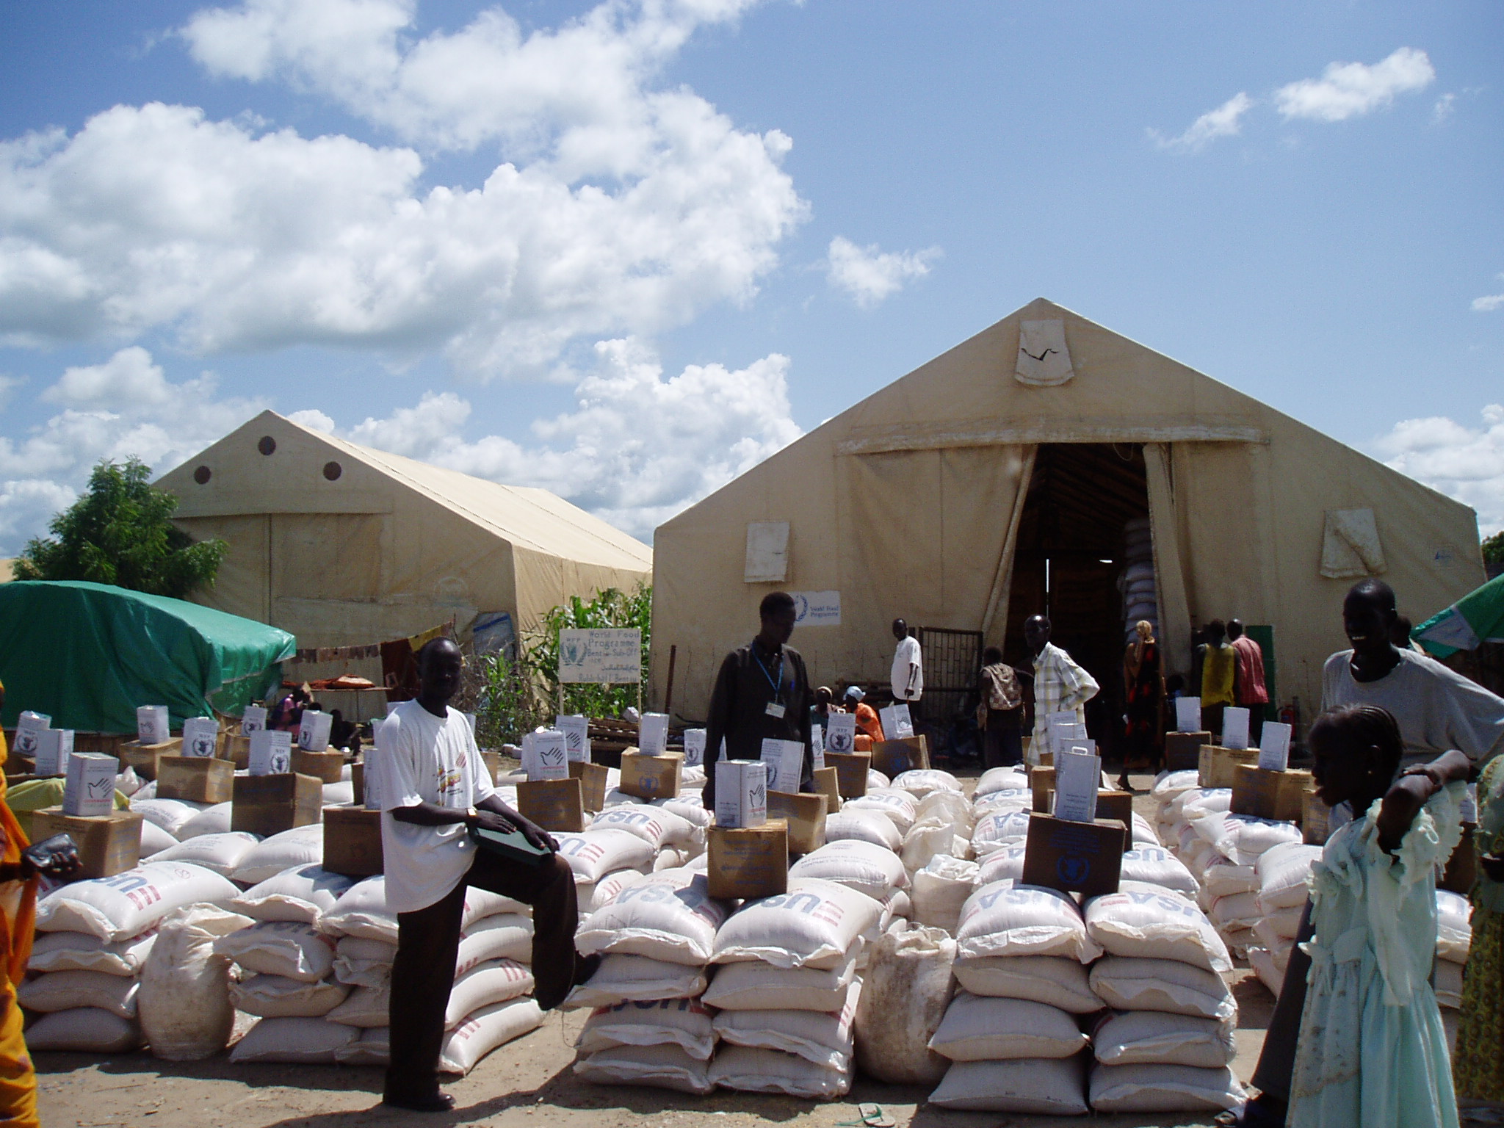
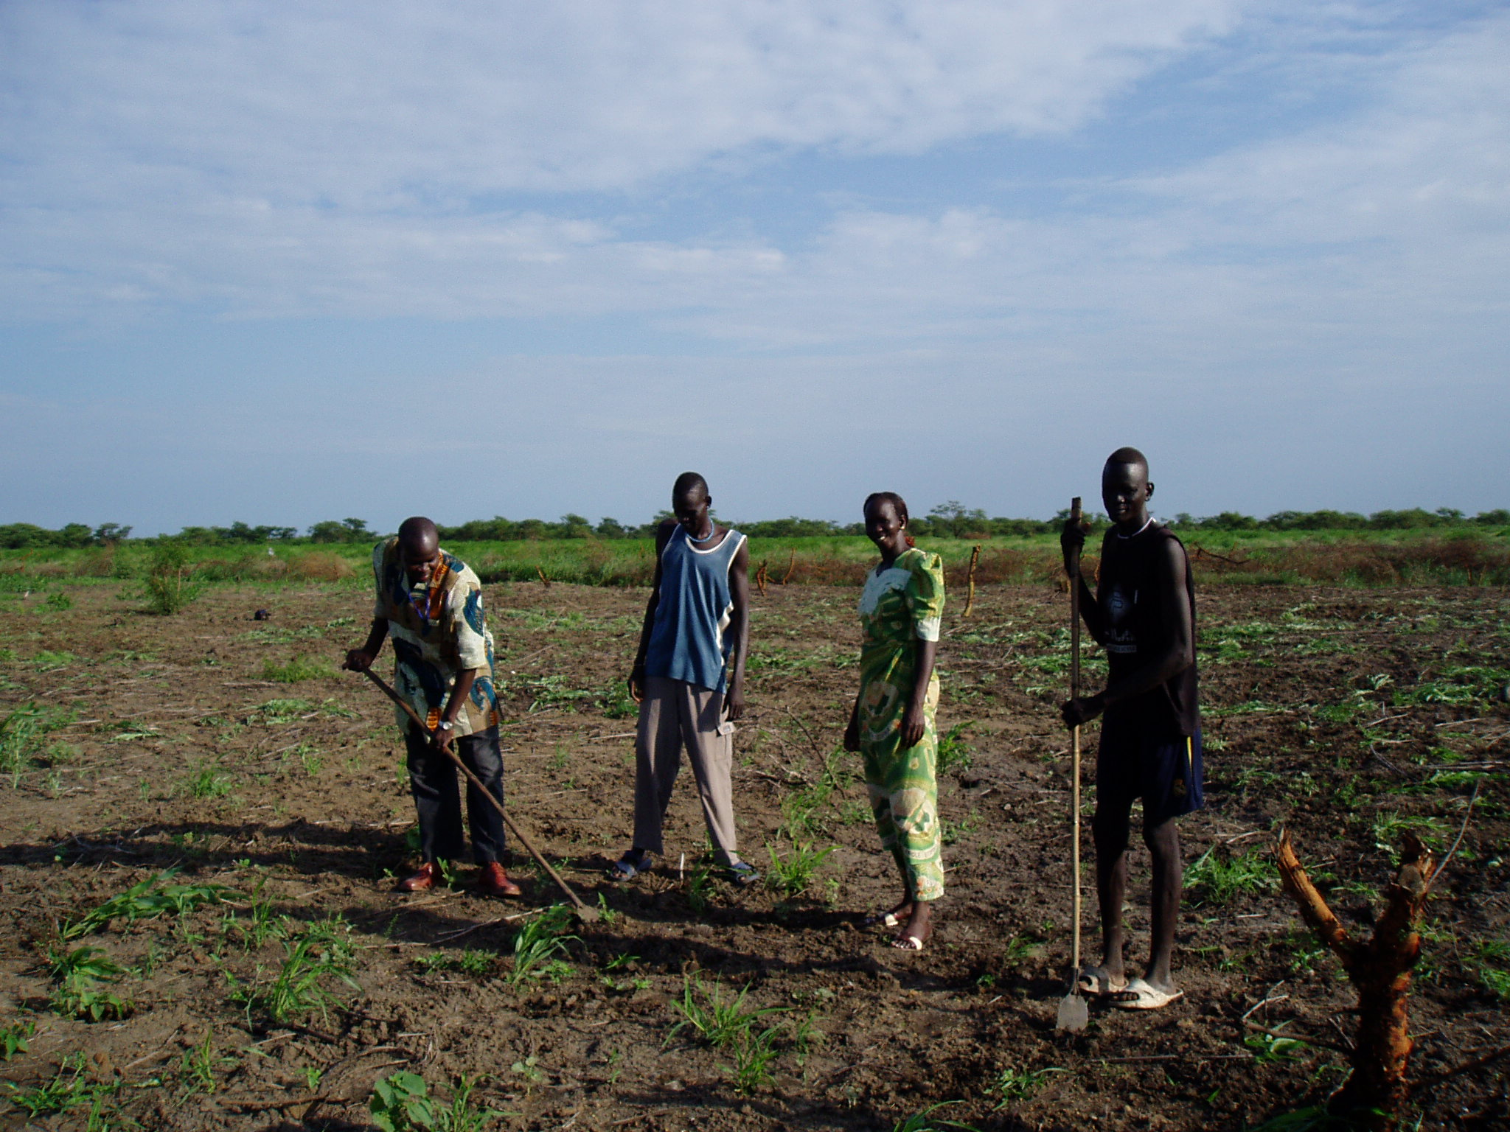
Food distribution point at Bentiu town (Need to move from service delivery to livelihood coping mechanism.) CARE is explaining to the communities that time has come to move away from service delivery to self reliance through sustainable agriculture (Copping mechanism). One of the distribution centers in Bentiu town at a CARE food distribution point.

Table indicating areas visited by CARE and SMoA staff during assessment mission
Locality | Administrative Units | Areas proposed
Rubkona | Rubkona unit | Nyabol
Rubkona | Bentiu unit | Boiya, Wongbuor
Rubkona | Nhialdiu unit | Biel, Shomorow, Dourong
Rubkona | Kuach unit | Kwer bang, Leichang
Pariang | Pariang unit | Pankual, Agentok, kamagon
Pariang | Tor unit | Dongulanga, Panluk, Akoy
Pariang | Mankuo
Pariang | Biu | Patendieng, agarak, kegkuol ,Fadiar
Leer | Mirmir | Maper,Reire,Fangaak
Mayom | Mayom | Parial, Keic
Mayom | Mankein | Panyal,Jekijal,Mana
Mayom | Abiemnom | Agongebek, Rubmayar, Bangbang
Mayom | Wankay | Mankap, Yocyoc, Macar

Conclusion
This first report covers mainly assessments of the target areas for intervention and contacts with the key people to identify potential areas and needs. However with the assistance of the partner SMoA, land was provided for allocation and for farming. Contacts were made with the local community leaders to agree on the land allocation in order to avoid issues of conflict over land. The second phase of the project will deal with distribution of land, seeds and tools including training for farmers and fishermen in managing this implementation process.

