Participatory Rural Adaptation Pilot in Response to Climate Change in Tajikistan

Project Implementation Plan (PIP)

October 2005

TABLE OF CONTENTS

1 INTRODUCTION 5
1.1 Context and Rationale 5
1.2 Tajikistan Environmental Context 6
1.3 Varzob District of Tajikistan 13
1.3.1 Socio-economic Context 13
1.3.2 Biophysical Condition 16
1.3.3 Institutional Context 19
1.4 CARE Tajikistan’s Work in Varzob District 20
1.4.1 Disaster Preparedness Action Plan Tajikistan (DipacT) 20
1.4.2 Varzob Highland Food Security and Capacity Building Project (VHFS) 21
1.5 Programming Context 22
1.5.1 CIDA’s Draft Country Development Programming Framework for Tajikistan 22
1.5.2 CARE International’s Unifying Framework for Poverty Eradication and Social Justice …………………………………………………………………………………………..22
1.5.3 CARE Tajikistan’s Long Range Strategic Plan (2002 – 2006) 24

2 PROJECT DESIGN 24
2.1 Project Development Methodology 24
2.2 Project Site Selection Process 25
2.3 Project Target Groups 26
2.4 The Logical Framework 27
2.5 Cross-cutting Themes: Gender and Environment 33
2.5.1 Gender Strategy 33
2.5.2 Environmental Strategy 34
2.6 Sustainability 34

3 Implementation Approach 35
3.1 Information Collection and Analysis (WBS 100) 37
3.1.1 Vulnerability Assessment (WBS 110, Outputs 8 and 9) 37
3.1.2 District-Level Workshop (WBS 120, Output 10) 37
3.1.3 Identification of Potential Coping Strategies (WBS 130, Output 3) 37
3.1.4 Institutional Analysis (WBS 140, Output 6) 38
3.2 Work with Community Groups (WBS 200) 38
3.2.1 Training for Community Groups (WBS 210, Output 4) 38
3.2.2 Establishment of Field Trials for Adaptation Strategies (WBS 220, Output 12) 39
3.3 Engagement of Local Government (WBS 300) 39
3.3.1 Training for Jamoat Members (WBS 310, Output 5) 39
3.3.2 Incorporation of vulnerability issues into Jamoat planning process (WBS 320, Output 1) 39
3.4 Creating Linkages 39
3.4.1 Adaptation Advisory Group (WBS 410, Output 5) 39
3.4.2 Development of Advocacy Strategy (WBS 420, Output 7) 39
3.4.3 Adaptation Workshop (WBS 430, Output 2) 40
3.5 Life of Project Work Plan 40

4 PROJECT MANAGEMENT 45
4.1 Management Approach and Structure 45
4.2 Roles and Responsibilities of the Implementing Partners 46
4.2.1 CARE Canada 46
4.2.2 CARE Tajikistan 46
4.2.3 CIDA 47
4.3 Adaptation Advisory Group 47
4.4 Risk Management Strategy 48

5 PROJECT MONITORING AND REPORTING 50
5.1 Monitoring and Evaluation Methodology 50
5.2 Performance Indicators 50
5.3 Performance Reporting 55

6 Project Financial Information 56
6.1 Revised Life of Project Budget 56
6.2 CARE’s Contribution 58
6.3 Procurement 59

7 REFERENCES 67

LIST OF TABLES

Table 1: | Average Number of Animals Owned by Households in Varzob District
Table 2: | Logical Framework Analysis
Table 3: | Work Plan for the Inception Phase (April 2005 to January 2007)
Table 4: | Performance Measurement Framework
Table 5: | Performance Reporting Framework
Table 6: | Revised Life-of-Project Budget (Revised 14 September 2005)
Table 7: | Materials and Equipment Received as In-Kind Contributions

LIST OF FIGURES

Figure 1 | Map of Tajikistan
Figure 2 | Climate Zones Found in Tajikistan
Figure 3 | Dynamics of Mean Annual Surface Temperature During 1961-1990.
Figure 4 | Deviation of Air Temperature from Normal Value in 2000
Figure 5 | Dynamics of Annual Precipitation During 1961-1990
Figure 6 | Deviation of Precipitation from Normal Value in 2000
Figure 7 | Projected Degradation of Glaciers by 2050s
Figure 8 | Administrative Divisions of Tajikistan and Original Proposed Project Sites
Figure 9 | Map Showing Location of Varzob District and Proposed Project Sites
Figure 10 | Change in Annual Runoff by 2050
Figure 11 | Work Breakdown Structure
Figure 12 | Unifying Framework for Eradication of Poverty and Social Justice
Figure 13 | Organogram of the ACCT Project

LIST OF ACRONYMS

AAG Adaptation Advisory Group
ACCT Adaptation to Climate Change in Tajikistan
ACD Assistant Country Director
CBO Community-Based Organization
CD Country Director
CEAA Canadian Environmental Assessment Act
CIDA Canadian International Development Agency
CIS Commonwealth of Independent States
CoF Conference of Parties
DipacT Disaster Preparedness Action Plan Tajikistan (a CARE Tajikistan project)
DM&E Design, Monitoring and Evaluation
GEF Global Environmental Facility
GHG Green House Gas
HH Household
IPCC Intergovernmental Panel on Climate Change
KAB Knowledge, Attitude and Behaviour
LFA Logical Framework Analysis
LRSP Long Range Strategic Plan
NAPA National Adaptation Plan of Action
NGO Non-Governmental Organization
ODI Overseas Development Institute
PIP Project Implementation Plan
RRS Rayons of Republican Subordination
RVCC Reducing Vulnerability to Climate Change
SOM Somoni, national currency of Tajikistan
TORs Terms of Reference
UNDP United Nations Development Fund
UNFCCC United Nations Framework Convention on Climate Change
VHFSP Varzob Highlands Food Security and Capacity Building Project (a CARE Tajikistan Project)

GLOSSARY OF TAJIK TERMS

Kishlak
ETC

INTRODUCTION

Context and Rationale

Climate change occurs amid numerous social and natural transformations. Understanding and anticipating the consequences of climate change, therefore, requires knowledge about the interactions of climate change and other stresses and about the resilience and vulnerability of human–environment systems that experience them.

It is recognized that adaptation to climate change is as important as the reduction of Green House Gas (GHG) emissions. Communities are vulnerable when their livelihood systems are sensitive to climate change and they lack supportive institutions and networks. An effective response to climate change lies with the rural communities themselves by building their awareness of the impacts of climatic change and improving their capacity to respond over the long-term. By enabling them to effectively and pro-actively take “adaptive” action, the direct negative impact of climate change can be lessened.

As the Inter-governmental Panel on Climate Change (IPCC) notes, there is a direct link between climate change and vulnerability – “it is established…that climate change, mainly through increased extremes and temporal/spatial shifts, will worsen food security” (IPCC, 2000). The report also argues that “poverty limits adaptive capabilities” of communities. Smit el al., 2000 (IPCC, 2000) further notes that adaptation is often the result of interactions between climate and other factors:

“Adaptation varies not only with respect to their climatic stimuli but also with respect to other, non-climate conditions, sometimes called the intervening conditions, which serve to influence the sensitivity of systems and the nature of their adjustments. For example, a series of droughts may have similar impacts on crop yields in two regions, but differing economic and institutional arrangements in the two regions may well result in quite differing impacts on farmers and hence in quite different adaptive responses, both in the short term and long-term.”

Smit et al., (2000) have proposed an adaptation process for mitigating the impacts of climate change. The first step in the process is to characterize “adaptation to what”. While it is widely recognized that climate change has impacted on Tajikistan with a marked increase in temperature over the last 75 years and increased extreme weather patterns resulting in natural calamities such as drought, floods, flash floods and mudslides, the knowledge of how farmers cope with these extreme patterns and what mechanisms are in place to assist farmers to respond to these calamities and recover from the effects of these calamities, is not generally understood and/or systematically characterized. With the agricultural sector in Tajikistan accounting for 60 percent of employment and with over 70 percent of the population living in rural areas, providing means for farmers and farming communities to adapt to climate change becomes critical.

Current environmental problems that are expected to be exacerbated by climate change include: land degradation further reducing the already limited amount of arable land; salinity and/or waterlogging due to floods or poor water use; soil erosion and reduction of soil fertility; and deforestation both for fuel wood consumption at the household level and for expansion of arable land. All of these affect a household’s ability to cope with and quickly recover from climate related environmental stimuli. Household vulnerability is further amplified because of inadequate local capacity as well as lack of institutional mechanisms for support. This is even more the case in a situation where the government is unable to assist its own population due to acute lack of resources and more importantly, the capacity to link environmental or climatic changes to vulnerability of the poor. Enhancing farmers’ own capacity and that of their local institutions to adapt and innovate to mitigate the impacts of climate change are the first line of defence.

The second step in the adaptation process is to identify “who or what adapts”. Since poor and marginal farming households in Tajikistan are the most vulnerable to climate change and are least able to cope with or recover quickly from its effects, there is a need for planned adaptation in the social and economic systems such that communities are able to consciously undertake measures that will reduce their vulnerability. Blaikei et al. (2000) argues that households that have access to information, resources and social networks are less vulnerable and better able to cope with environmental hazards. IPCC Paper 18 suggests that activities required for the enhancement of adaptive capacity are essentially the same that promote sustainable development and equity. ODI (2003) recommends that successful adaptation to climate change depends upon:

  - meaningful participation of communities in identifying and developing adaptation plans,
  - local institutional arrangements,
  - availability of information and finances,
  - information exchange and technological change, and
  - adaptive capacity of local institutions as well as communities.

Each stakeholder reacts to climate change differently and climate change modeling data has revealed that the effects of climate change are not homogenous even within relatively limited geographical confines. As a result, the impact of climate change is characterized by important variances that cannot be translated into a general response strategy. Facilitating organization of all stakeholders (households, community-based organizations (CBOs), NGOs and government institutions) to understand constraints and opportunities is important, as well as developing a support network to improve local adaptive capacity. In the context of Tajikistan, anticipatory and precautionary adaptation is more effective and less costly than forced, last minute, emergency adaptation or rehabilitation which Tajikistan goes through on a regular basis.

Tajikistan Environmental Context

Tajikistan is a small country of 143,100 square kilometres located in Central Asia, lying between 36˚40’ to 41˚05’ north latitude and 67˚31’ to 75˚14’ east longitude (Figure 1).

It is a country dominated by mountains: 93 percent of the country is mountainous, with about half of the country situated at 3,000 meters or higher. Tajikistan is considered to be the main glacier center of Central Asia, with glaciers covering 6 percent of the country’s area. Glaciers regulate river flow and climate. Tajikistan’s rivers are the main sources of water for the Aral Sea. There are around 1,300 lakes throughout Tajikistan, with the majority of them less than 1 square kilometre in size.

The population of Tajikistan was 6.127 million according to the 2000 census. More than 70 percent of the population is rural, with over 60 percent of the population dependent on agriculture.

The two major exports are aluminum and cotton, which are grown on irrigated plains.

Figure 1: Map of Tajikistan

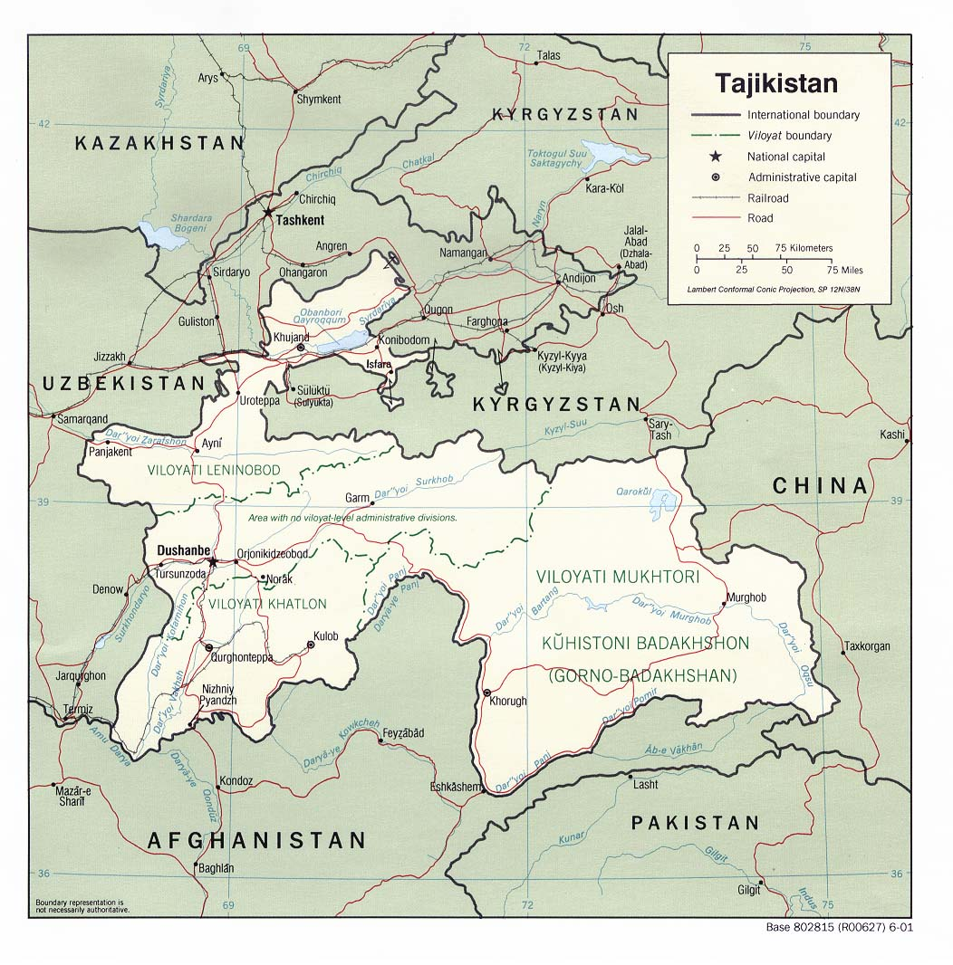
Source: Downloaded from http:// www.lib.utexas.edu/maps/commonwealth/tajikistan_pol01.jpg

There are seven climate zones within the country, ranging from subtropical to areas with perpetual frost in mountain ranges and cool summers in valleys (Figure 2).

Climatic data collected in the country over the past 75 to 100 years indicate a steady temperature increase. Local and regional temperature has increased on average from +0.2ºC (degrees Celsius) to +1.3ºC over the last 50 - 75 years. These “average” increases are accompanied by increased exposure to extreme weather events. The average national temperature increased by +1˚C to +2˚C between 1931 and 1960. In 2000, variance from the mean averaged +1.5º C to +3.2º C (State of the Environment - Tajikistan 2000).

Figure 2: Climate zones found in Tajikistan

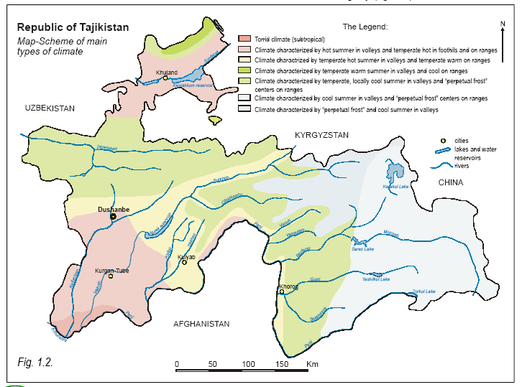

Figure 3 shows air temperature changes during the period 1961 to 1990. Due to widespread economic decline followed by civil unrest, the level and frequency of meteorological observations recorded in Tajikistan since the 1990s decreased considerably. Nevertheless, according to the Meteorological Service of Tajikistan, the 1990s appear to be the warmest decade throughout the period of instrumental observations in Tajikistan. Available observational evidence indicates that changes in climate, particularly abrupt increases and decreases in temperature, have already affected a diverse set of physical and biological systems in Tajikistan. For example, in 2000 observed increases in temperature ranged from +0.3⁰ C in the mountains to +1.8⁰ C on the plains (refer to Figure 4). Examples of observed changes include shrinkage of glaciers, thawing of permafrost, lengthening of growing seasons, altitudinal shifts of plant and animal ranges, decline of some plant and animal populations, and earlier flowering of trees, emergence of insects, and egg-laying in birds. At the same time, the Meteorological Service of Tajikistan recorded lower than normal temperatures in the range of -0.7⁰C to -0.9⁰C in some mountainous regions at altitudes of 3,000 meters and above. To humans, such changes may appear minimal and almost trivial. However, for many species of plants and animals, such increases can be disastrous if they are already at the edge of their tolerance level.
Figure 3: Dynamics of mean annual surface temperature during 1961-1990.

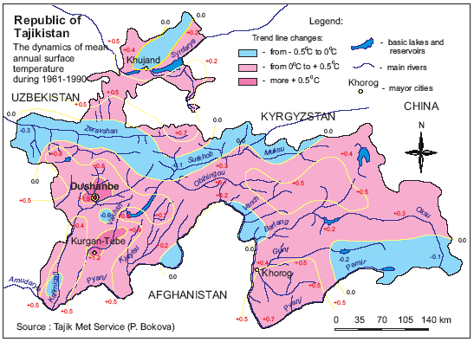

Figure 4: Deviation of air temperature from normal value in 2000

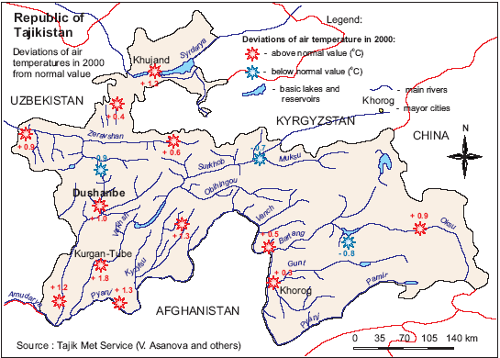

A direct consequence of climate variability is droughts and flooding, which result in a high level of food insecurity among the poor farmers. With over 70 percent of the population living in rural areas, agriculture accounts for 60 percent of employment. The civil wars, decaying infrastructure, poor agricultural practices and severe consecutive droughts have reduced Tajikistan’s population of 6 million to living in poverty and high levels of food insecurity. Tajikistan has fertile soil and varied climate, which makes the country suitable for a wide range of farming systems. Because mountains cover 93 percent of the territory, arable land is scarce - only 0.14 hectares per capita. Although irrigation systems cover 85 percent of the arable land, these are ineffective due to frequent breakdowns and limited supply of water resulting from recurrent droughts and floods. Despite recent heavy investment in rehabilitation of irrigation infrastructure, the overall water use efficiency is about 40 percent. During the period 1961-1990, a reduction in the amount of annual precipitation of 1-20 percent was observed within the mountains of Central Tajikistan (the location of the Participatory Rural Adaptation Pilot in Response to Climate Change in Tajikistan), as well as in the valleys of southwest and northern Tajikistan, the foothills of the Turkestan range and high-altitude areas of Eastern Pamir, (refer to Figure 5). In the foothills and mountains of the Khatlon Region, the reduction in precipitation averaged between 6-22 percent.

Figure 5: Dynamics of annual precipitation during 1961-1990

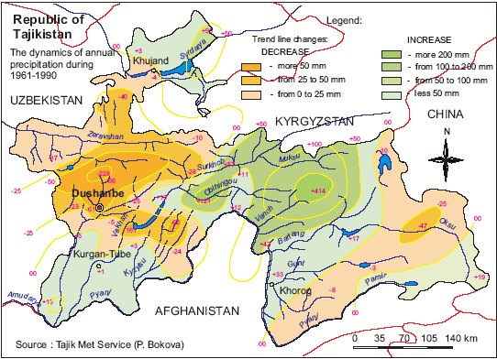

Figure 6, produced by the Meteorological Service of Tajikistan, shows a widespread decrease in precipitation in 2000 throughout Tajikistan (with one exception in the far eastern portion of the country) ranging from 4 to 44 mm. According to the same Meteorological Service of Tajikistan, in 2001, average rainfall was only 44 percent of the national average. The crops not destroyed by the drought were unfit for human consumption and could only be used as fodder. The drought almost completely wiped out Tajikistan's crops, including its main staple food, wheat. The severity of food insecurity was reflected by a survey conducted by Action Against Hunger in 2000 that found 41 percent of children chronically malnourished and anaemic.

Figure 6: Deviation of precipitation from normal value in 2000.

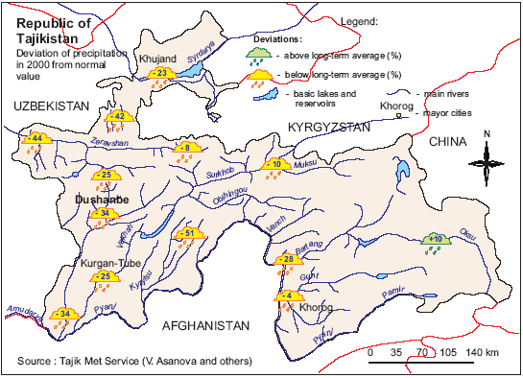

Endemic animals and plants in Tajikistan are being impacted by unsustainable human economic activity, particularly in the rural areas, due to poverty that is being aggravated by climate change and climate variability. The unregulated pasturing of cattle has prompted widespread soil erosion and decreased the productivity of local pastures. According to the National Report of the Republic of Tajikistan to Combat Desertification (2002), all pastures are subject to medium-to-heavy erosion: 89% of summer, 97% of winter and 87% of spring-fall pastures are eroded and affected by desertification. Large scale felling of valuable juniper, walnut, birch and pistachio forests has dramatically shrunk the forest cover within the country. Annual forest destruction as a result of illegal logging, cattle grazing and natural disasters is estimated at 5,000 to 10,000 m³, which is 1.5 to 3 times greater than the rate of natural increment and forest renewal (Environmental Performance Review, Tajikistan, 2004). A similar situation exists with the famous tugai forests, whose area has shrunk catastrophically due to human activity. The loss of biodiversity is equally dismal – over the past 50 years three animal and 16 plant species have died out in Tajikistan – partially because of the inability of local institutions to respond to poverty resulting from environmental degradation and climate change and climate variability.

As a result of projected increases in global surface temperatures, Tajikistan may lose thousands of small glaciers by 2050 (refer to Figure 7). Scholars predict that the area of Tajikistan’s glaciers will shrink by 20 percent and the ice volume will decrease by 25 percent. This is a considerable loss since Tajikistan’s glaciers currently cover an area of 8,000 square kilometres. Climate change is implicated in causing numerous avalanches, landslides and mudslides in Tajikistan. There is also increasing evidence of diseases that are atypical for this region, such as tropical malaria (Biologist Negmatullo Safarov, Biodiversity and Biosafety National Focal Point).

According to the World Bank, each year mountainous Tajikistan experiences around 50,000 landslides, some 5,000 tremors and earthquakes, and hundreds of avalanches and mudflows. Between 1991 and 2001 over 66,000 people were made homeless by natural disasters. During the first nine months of 2002 alone, 200,000 people were affected by 65 small and mid-scale natural disasters (Asian Development Bank, 2003). In 2003 the Tajik government registered more than 120 floods, avalanches, mudslides and landslides and 14 earthquakes. These natural disasters destroyed or damaged more than 9,000 houses. In 2004 Tajikistan asked for US $21 million worth of assistance to deal with the damage caused by natural disasters. The 2004 floods and mudslides caused by torrential rains destroyed bridges, roads, parts of vital infrastructure and damaged water supply systems, leaving 400,000 people without access to safe drinking water in the capital city Dushanbe, and considerably affecting Penjikent, Ayni and Varzob Districts and parts of Moskovski and Vosei Districts. In July 2005 rapid temperature increase on top of heavy rains during the previous two months caused the water levels to rise in the main rivers of Tajikistan. This resulted in numerous floods and mudflows affecting the infrastructure and livelihoods of several districts.

Figure 7. Projected degradation of glaciers by 2050s.

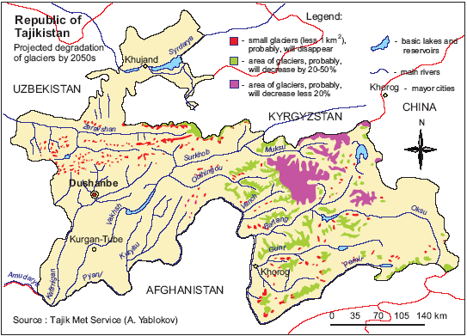

Varzob District of Tajikistan

Socio-economic Context
Varzob District, part of Rayons of Republican Subordination (RRS), is a disadvantaged part of Tajikistan (refer to Figure 9). With a population of 56,000 residents (male – 44.9 percent, female – 55.1 percent), Varzob is located near the capital city (Dushanbe) and is heavily dependent on agricultural production for economic livelihoods. Unlike the cotton-producing areas of Tajikistan, economic and political attention to Varzob has not been high, as the standard products in the district - fruit, vegetables and livestock - do not generate hard currency and are for local market consumption only. At the same time, a multitude of factors result in chronic food insecurity of a substantial part of the population. Some problems are common to all regions of Tajikistan, such as the collapse of the centralized production and market systems, dissolution of state-run farms, lack of maintenance of agricultural infrastructure including irrigation systems, lack of availability of and access to quality inputs and lack of non-farming income opportunities. However, as a district in which no export crops, such as cotton, are produced, Varzob District has largely been neglected by state authorities in the past. This practice continues to date, as Varzob District still does not receive sufficient government attention and assistance to support agriculture activities. While in the past, the District’s relative proximity to the capital city, Dushanbe, provided for some non-agricultural income, the recent demise of the industrial sector has contributed to alarming levels of unemployment.

According to the 2002 Poverty Reduction Monitoring Survey (PRMS), more than 45 percent of households are large households with 7 or more members and 23.8 percent are households consisting of two or more married couples with or without children. Average household size, based on the PRMS data, is 6.6 persons country wide, with 5.42 persons in urban and 7.22 persons in rural areas. According to the CARE Tajikistan Food and Economic Security in Tajikistan (FEST) Final Evaluation Report 2005, average family/household size for Varzob District is 8.1 persons.

Based on the PRMS data, average monthly income per household member was 12.6
Somonis (SOM) with 18.0 SOM in urban areas and 10.6 SOM in rural areas. Highest income was recorded in Dushanbe (22.2 SOM). In the RRS, which includes Varzob District, average income per capita in 2002 was 10.1 SOM. Also, according to the PRMS data, due to high levels of unemployment and inability to support families, 13.4 percent of the RRS households reported that members of their household leave for jobs in other countries. Based on discussions with residents of Varzob District and the CARE staff working in communities of the District, the situation has not changed much.

CARE’s assessments have revealed that the basic needs of the great majority of Varzob District residents are not met, especially those communities situated in the remote highland areas that suffer from lack of road access for up to five months/year. Although the livelihoods of the majority of Varzob District citizens are largely characterised by agriculture, for most households the crop yields for home consumption and/or the marketing of small surpluses do not suffice to economically sustain themselves. According to CARE’s baseline survey conducted in Varzob District in April 2002, the income derived from agricultural activities is estimated to cover only 20 percent of all household needs, including food, clothing, and house repairs, as well as educational and medical services.

Farming provides the main income of the target population, with 80% of households basing their livelihoods on income in this sector. The dependency on agricultural income, especially in the mountainous communities, and the subsequent need to exploit natural resources for crop and livestock production, add to the already existing levels of soil erosion. The diversity of existing agricultural activities in the proposed project area stems to a great extent from the climatic situation, which is strongly influenced by the varying elevation of land within the chosen Jamoats – from 900 m above sea level up to 2.700 m. One example is the vast area of summer pasture, up to 70.000 ha, which is part of the highland areas of one of the project Jamoats. The vegetation period in the highland areas is short and usually stretches from May until the end of September, allowing only one harvest a year as opposed to two or even three harvests – if irrigated – in the lowland areas, such as the neighbouring Rudaki District.

At present, the yield of crops cultivated on private as well as leased land is much lower than what could be achieved under the existing climatic and pedological conditions. Cereals, such as barley and wheat often yield less than one ton/hectare (ha); oil crops, such as flax, usually render a yield of 200-300 kg/ha. A very important source of production for most households is kitchen gardens, which usually vary in size between 200- 800 m², as well as the so-called “Presidential land” of around 500-2000 m²/household. If sufficient water is available, different varieties of vegetables can be grown by the farmers. Under proper management, this land can often suffice to cover most of the respective household’s needs, however due to traditional management and the low quality of seeds and other inputs, production at present covers 60% or less of household needs.

Very often low yields in Jamaots located at higher elevation fail to ensure food security of households and/or to provide for surpluses which could be marketed in return for cash to satisfy non-food household needs. Shortage of adequate food leads to malnutrition and deteriorating health conditions, especially so during the winter time, when many villages are isolated for several months.

At the same time in Jamoats located at lower elevation, for example in Jamoat Chorbogh, the climate provides ideal conditions for the production of various fruits, such as apples, apricots, cherries, almonds, plums, persimmons, pistachios and walnuts. Such fruit trees are often planted in kitchen gardens, but also frequently on slopes. In addition to these fruits, grapes are cultivated in Chorbogh (1.200 ha). These vineyards had originally been maintained by kolkhozes (Soviet era collective farms), but have recently been subdivided into smaller plots and been allocated on lease arrangements to peasant farmers. Each farmer now cultivates between 1 and 5 ha. These vineyards thus provide livelihoods for about 650 families.

Since ancient times, Tajikistan has been inhabited by nomads who grazed their animals on the country’s vast pastures. This century-old tradition has been carried over to the present and still provides many villagers with a considerable part of their income. In Varzob District alone, there is about 70.000 ha of this pasture land, which was formerly farmed by kolchozes but is now public land and is generally free for everybody’s use. Each community has its own grazing areas. During Soviet times, large herds were kept under controlled grazing and adequate service was provided by the state veterinarian service. Unfortunately during the first years of independence, the numbers of animals was seriously decimated due to uncontrolled slaughter which occured because of insecurity over ownership as well as the lack of jurisdiction. At present, veterinarian or any other agriculture related extension services barely exist. The following table provides informaton on average number of animals owned by households in Varzob District (CARE Tajikistan Food and Economic Security in Tajikistan (FEST) Final Evaluation Report 2005).

Table 1: Average number of animals owned by households in Varzob District

Animal Type | Average number per household
Bull | 0.19
Calf | 1.45
Cow | 1.88
Goat | 3.75
Sheep | 2.52
Horse | 0.06
Donkey | 0.40
Rabbit | 0.03
Chicken | 0.99
Duck | 0.03
Turkey | 0.00

Before and during the Soviet era, bee-keeping was an important economic activity throughout the District. Until independence, a state farm in Ziddi Jamoat specialised in honey production and maintained about 1.000 bee hives. Like most others, this state farm was dismantled, and at present only about 90 beehives are left under private ownership. All over the designated project area, the highland pastures with their herbal plants provide excellent habitat for bee-keeping. Honey produced in this area is considered to have medicinal value and fetches premium prices at local markets. In the past, bee-hives were transported to more temperate areas during the winter time, where bees could survive on wild flowers and crops. After indepence in the early 1990s this transport system broke down and sugar-feeding in the highland areas became impossible due to a lack of financial resources: 90 percent of the bee families died.

Sustainable rural livelihoods require sustainable management of natural resources. This is especially true in such delicate environments as the designated project area. In Varzob District, crops are usually planted on rain-fed slopes, thus giving way to heavy run-off and subsequent erosion during spring, when rainfall is abundant and run-off is exacerbated by the melting snow. While during the Soviet era grazing was prohibited on sloping plots, since independence uncontrolled grazing and general overgrazing on areas close to the villages have resulted in severe damage of natural vegetation and subsequent erosion. Firewood collection by the local population which does not have adequate access to other fuels further exacerbates the problem. All over Varzob District erosion is substantial. On many sites, dramatic linear erosion can be observed and mud slides frequently destroy agricultural plots and even homesteads. These phenomena are present in all of the targeted Jamoats.

Biophysical Condition
The project will operate at three different altitudes within the territory of three Jamoats (Ziddi, Dehmalik and/or Chorbogh) in Varzob District. The district is located along the Gissar mountain range of the Pamiro-Alay Mountains of Central Asia, which run through west Tajikistan and southeast Uzbekistan. The project area lies within two climatic zones (refer to Figure 2): the higher elevations are described as having temperate, locally cool summers in the valleys and ‘perpetual frost’ centres in the ranges. The lower elevations are described as having temperate hot summers in the valleys and being temperate warm in the ranges. Due to large variations in altitude and aspect, this area is characterized by a wide range of micro-environments.
Varzob District covers an area of approximately 1,656 km². The Varzob River and its numerous tributaries provide the main source of drinking water supply to Dushanbe. Pollution generated upstream by domestic and industrial waste waters effects quality of drinking and irrigation water in the riparian communities and Dushanbe. Intense precipitation and rapid snow melt often cause considerable economic damage and loss of human lives. For example, heavy rainfall in July 2004 triggered severe flooding, mudflows and landslides in several areas in Tajikistan. Destruction was most severe in Varzob District where, aside from landslides and mudflows, flooding resulted in heavy damage of the existing infrastructure. CARE deployed a disaster assessment team, which assessed the needs and vulnerabilities of the people affected by the floods. In addition to the physical destruction, the floods seriously affected water supply and water quality in Dushanbe, with as many as two thirds of the population being affected.

Figure 9: Map showing location of Varzob District and the proposed project sites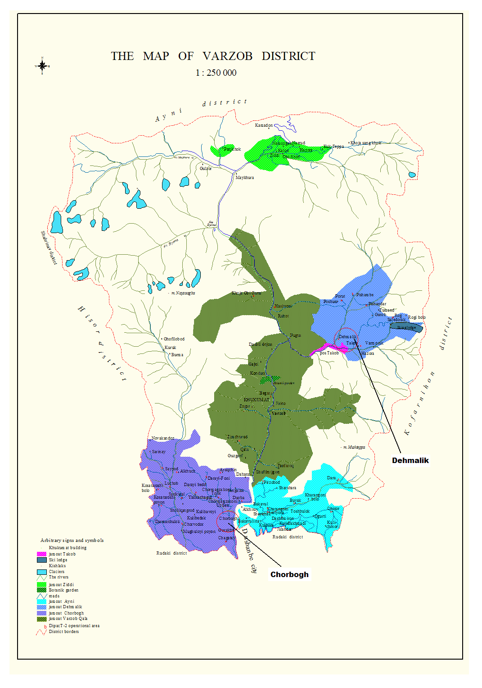
Ziddi

According to a July 15, 2004 CARE Assessment report, some of the impacts of the 2004 flood were as follows:
- The Varzob River swept away parts of the main road connecting Dushanbe to the northern city of Khujand, along the Dushanbe-Anzob-Istaravshan route. Along a 30 km stretch between Hushyori village and the Siama River, the road was impassable in several parts. Aside from the river sweeping away parts of the main road, debris left by landslides and mudflows blocked the route. Reports on the number of vehicles trapped varied, from 100 to 600 cars and trucks.
- Dehmalik was isolated. The bridge located in Takob leading to Dehmalik was destroyed. Six other bridges in Dehmalik Jamoat collapsed. In Varzob-Kala, two bridges were damaged and were declared not passable to vehicles.
- 10 km of pipelines were destroyed
- 20 km of power lines were destroyed, leaving villagers without electricity
- 100 heads of livestock were lost in Ziddi, Takob, Dehmalik and Varzob-Kala Jamoats
- 50 hectares of gardens, kitchen gardens, and cropland were washed away by the floods
- 30 houses were destroyed in Ziddi Jamoat
- 2 persons sustained serious injury

According to Figure 10, generated by the Meteorological Service of Tajikistan, the rainfall pattern in Varzob District may change drastically in the near future. Rainfall, and therefore runoff, may decrease by over 20mm/year and thereby severely affect both quality and quantity of water resources in the ACCT Project area.

Figure 10: Projected change in annual runoff by 2050.
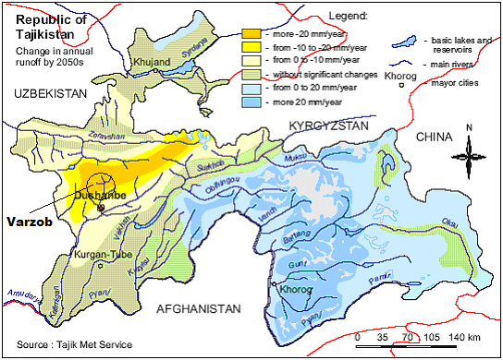

It is also expected that by losing many small glaciers the ACCT project area will experience considerable alterations in the stream flow of the Varzob River and its tributaries. Some tributaries may completely dry out leaving nearby communities without their only source of water for drinking water and for irrigation (refer to Figure 7).

Institutional Context

Administratively, Tajikistan is divided into 4 administrative units known as Oblasts, with each Oblast governed by an Oblast Kukumat (council). The Oblasts are divided into 58 districts, with each district governed by a district government known as a District Hukumat. Each district is divided into sub-districts, known as Jamoats. There are approximately 500 Jamoats in the country. Within each Jamoat there are a number of villages known as kishlaks, each consisting of between 10 to 100 households. Each kishlak has its own village authority. Within larger kishlaks, there may be between 4 to 10 well defined neighbourhoods or communities, known as makhalas.

The Hukumats have the same committees as the central government. All members of the Hukumat administration are selected by the central government, and are not always from the district that they are appointed to. Chairs of Hukumats are changed irregularly, between 6 months and 10+ years. Thirty (30) percent of the positions within the Hukumat administration (including leaders and deputies) are reserved for women.

Jamoats are managed by local councils that are referred to simply as Jamoats. The Chairs of Jamoats (local councils) are appointed by Hukumats, with the rest of the Jamoat council elected by local residents. The Jamoat council varies in size from less than 10 persons to over 40 persons. Each kishlak within a Jamoat has 1 to 5 delegates on the Jamoat council; depending on the population size of the kishlak (delegates from each kishlak include the chairperson of the kishlak and the leaders of the makhalas within the kishlak). Each Jamoat should have at least 30 percent of its positions filled by women, but since it is difficult to find qualified women, representation tends to be less than 30 percent. Jamoats are the lowest tier of formal government. Decisions are made based on open voting and simple majority. Jamoats employ on average 10 individuals.

Hukumats request that Jamoat local plans and budgets for the following year be submitted by the end of November of the current year. Local plans and budgets for the following year usually include the following budget lines:

- School renovation and purchase of school equipment (July);
- Tree planting (March, October);
- Land related activities (ploughing, planting, harvesting) (March-May, September - October);
- Draft (April, September).

According to the Dekhmalik Jamoat ex-chair, Jamoats usually receive around 50 percent of their requested amounts which is just enough to cover salaries of civil servants (Jamoat employees and teachers) and limited renovation of schools.

Jamoats (local councils) are charged with the following powers:
- to approve the local budget, submitted to them by the chairman, and report on its execution;
- to report on long-term social and economic development programs and on general plans and regulations governing land development;
- to establish local taxes, fees and duties and stipulate privileges for local taxes, fees and payments allocated to the local budget according to legislation;
- to approve the appointment of the chairman and deputies, dismiss the chairman or deputies from office and review reports of their activities;
- to approve the chairman’s decisions in cases stipulated by law;
- to approve or amend the council agenda and provisions on standing and other commissions;
- to establish standing and temporary commissions and review reports on their activities;
- to certify newly elected council members, terminate their powers or consent to their criminal prosecution if they violate the law;
- to review reports from the heads of directorates, committees, departments and other divisions of the local administration;
- to approve the necessary expenditures for council activities;
- to approve regulations establishing courses of disciplinary action for administrative infractions;
- to address initiatives or inquiries made by council members;
- to establish administrative and supervisory committees, a commission on juvenile delinquents and other commissions or approve them upon the recommendation of the chairman;
- to decide upon issuing local loans and bonds or holding lotteries;
- to revoke any decisions of the chairman or subordinate councils that contradict Tajik legislation.

Also, Jamoats and their chairpersons are responsible for local issues such as: issuing birth and death certificates; organizing national, cultural and religious celebrations; arranging funerals; collecting utility fees; providing humanitarian assistance; and, organizing small-scale civil works (cleaning canals, planting trees and rehabilitating schools, etc.). They assist with the collection of irrigation and other water-use fees and mediate local disputes, including those over water access and use. Because of this traditional role, they are natural partners of project-related programs and tasks (Ilolov et al, 2001).

At the kishlak (village) level, the local government structure, known as a village authority, consists of a chairperson (kishlak rais, may be a male or a female) who is elected in a general assembly of residents to act on a voluntary basis. The chairperson supervises the organization of springtime fieldwork, the harvesting and processing of crops and the distribution of humanitarian aid and micro-loans. A council of elders, which includes all citizens over seventy-five years of age, may summon the chairperson to report on village activities. Villagers help the chairperson with his/her daily needs, for instance caring for his/her livestock. The chairperson works in close cooperation with the Jamoat and Raion chairmen.

Makhalas (neighbourhoods within kishlaks) are non-formal institutions. Elders, always male, are elected by the community to settle local disputes.

CARE Tajikistan’s Work in Varzob District

Disaster Preparedness Action Plan Tajikistan (DipacT)

DipacT-3, initiated in September 2005 with funding by the European Commission (EC), is designed to contribute to reducing risks by preparing vulnerable populations in the areas most affected by recurrent natural hazards. The specific objective of DipacT-3 is to better protect community-based organizations (CBOs) and schools located in villages in Varzob, Vahkdat and Yovon Districts from disasters that are continuously affecting them, through sustained, appropriate and effective disaster preparedness and mitigation activities.

Previous stages of the current project - DipacT and DipacT-2 - have increased tremendously community awareness about various hazards that exist in their locality, their vulnerabilities and also their capacities in dealing with disasters. During DipacT-3, the capacities of the CBOs, kishlaks and schools to sustain small-scale mitigation projects, community endowment funds, awareness-raising and preparedness activities beyond the project life will be further enhanced. The project will assist selected CBOs in terms of disaster preparedness and mitigation activities through targeted trainings and awareness raising activities. The project also intends to implement small-scale mitigation projects that will incorporate community cost-matching, maintenance measures and cost-recovery mechanisms that will promote project sustainability. Also, the project will closely coordinate activities with local authorities, Jamoats and the Hukumat (District government). This coordination will allow local authorities to assist and respond to the needs of the CBOs, kishlaks and schools, and create potential for activity replication. DipacT-3 also intends to expand its focus to include school teachers, school children and other youth groups through wider community participation in disaster awareness activities.

Varzob Highland Food Security and Capacity Building Project (VHFS)

This three year (2003-2006) CARE project funded by the European Commission implements activities to support food security in a manner consistent with national food security strategies. Although the Republic of Tajikistan has yet to establish a proper food security strategy on a national level, the Poverty Reduction Strategy Paper (PRSP) includes all major components of such a strategy.

The main objectives of the VHFS are:
- Sustainable increase of household food security through raising agricultural production and productivity, improving food preservation and processing and the appropriate management of natural resources;
- Sustainable increase in non-farming income through the expansion of income generating activities (IGA); and,
- Enhanced capacity of the target population to address development issues and to effectively participate in planning and management of community development projects.

According to the second Mid Term Evaluation Report – VHFS Project of CARE Tajikistan – August 2005, in order to attain the project’s objectives, a holistic approach is undertaken that does not only tackle issues related to agricultural production (field crops, horticulture, livestock, irrigation, apiary management, natural resource management, etc.) but also includes activities related to food preservation and processing, agricultural marketing, income generation from non-farming activities and institutional capacity building to address development issues.

Both DipacT-3 and VHFS are implemented in Varzob District. Subsequently, DipacT-3, VHFS and the Participatory Rural Adaptation Pilot in Response to Climate Change in Tajikistan will develop synergies and work to create a larger impact on the CBOs, community groups in selected kishlaks, selected Jamoats and the Hukumat of Varzob District. By integrating disaster risk reduction and increased household food security into their development agenda, target community groups, kishlaks and Jamoats will be better equipped to protect development activities from the impacts of natural disasters, climate variability and change, and unsustainable land use practices.

Programming Context

CIDA’s Draft Country Development Programming Framework for Tajikistan
CIDA has published a Discussion Draft Country Development Programming Framework (CDPF) for Tajikistan. This document identifies two major areas of focus for CIDA’s work in Tajikistan, as identified in the country’s Poverty Reduction Strategy Paper (PRSP): water resource management and agriculture. The ACCT Project will focus its vulnerability reduction efforts in these areas, focusing on the micro level, specifically farmers and Jamoats.

CARE International’s Unifying Framework for Poverty Eradication and Social Justice

CARE International’s Unifying Framework for Poverty Eradication and Social Justice is developed around three outcomes that ensure that projects/programmes address underlying causes from both a needs- and rights-based perspective (refer to Figure 11):
- Improving social positions: Supporting people’s efforts to take control of their lives and fulfill their rights, responsibilities and aspirations. Promoting people’s efforts to improve social inequity so that people can live a life of dignity without discrimination.
- Improving human conditions: Supporting efforts to ensure that people’s basic needs are met, which in turn improves livelihood security, and ensures that future generations will have these opportunities as well.
- Creating a sound enabling environment: Promoting sound and equitable governance systems – public (government), private, civic and social institutions – that promote equity, justice and livelihood security for all.

The ACCT Project will address some of the key intermediate outcomes that are necessary to achieve the upper-level development outcomes, as identified in Figure 11 below, namely:
- Improvement of social positions/social equity: gender equity will be promoted by ensuring that project interventions meet the self-identified needs of both males and females, including both landowners and the landless; trainings will address the rights and responsibilities of service providers, as well as project beneficiaries; organizational capacity of community groups and local NGOs will be strengthened via active participation in the development of this project and trainings held.

- Improvement in human conditions/increased opportunities: vulnerability to the impacts of climate change will be reduced by identifying and promoting alternative livelihood options that are sustainable under changing climatic conditions, resulting in improved sustainable livelihoods and improved income and assets. The project may advocate for landless beneficiaries to have access to state owned pasture lands or to Presidential lands (depending on the findings of the project’s vulnerability assessment). Presidential lands consist of irrigated and non-irrigated lands from collective farms that must pay an obligatory tax. Jamoats prepare lists of persons who have requested access to the state pasture lands or to Presidential lands, and recommends to the District Hukumat who should be given access to the lands. The District Hukumat approves who the land will be allocated to.

- Enabling environment: sound environmental stewardship will be promoted via an awareness campaign focused on raising awareness on the causes and effects of climate change and possible adaptation strategies that increase people’s capacity to cope with the impacts of climate change and are environmentally sound. Civil society (i.e., community organizations and local NGOs) will be empowered via their active participation in the development and implementation of this project. Questions of governance will be addressed directly through work with Jamoats - the government body closest to the ground. Jamoats, whose administration tends to be staffed by persons from the locality, represent a critical link between the central government and local communities. Developing the planning capacity (problem identification, longer-term problem solving, etc.) of the Jamoats will make a contribution toward improving their abilities to provide for and respond to the needs of those communities over whom they are supposed to have nominal authority. The ACCT Project will establish linkages with these projects so that the ACCT Project can build upon the experiences of these projects and design a program for the Jamoats that complements the training Jamoats have already received.

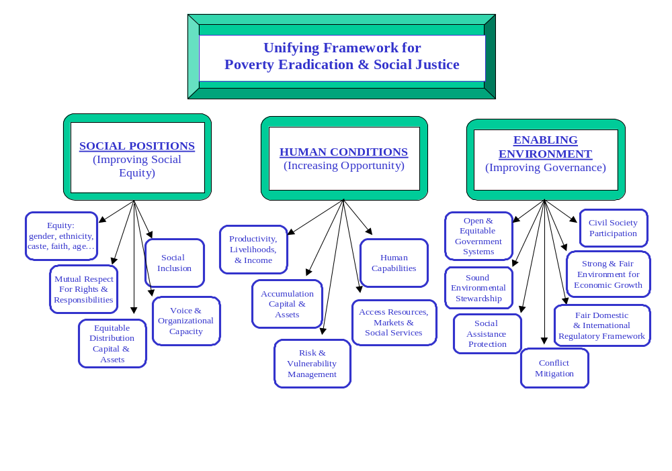
Figure 11: Unifying framework for poverty eradication and social justice

CARE Tajikistan’s Long Range Strategic Plan (2002 – 2006)

This project integrates well into CARE Tajikistan’s 2002 to 2006 Long Range Strategic Plan (LRSP):
- The ACCT Project’s proposed working area of 2 or 3 selected Jamoats within the Rayons of Republican Subordination (RRS), particularly rural, hillside, rain-fed populations, is within the country office’s targeted focus areas.

- The ACCT Project’s proposed direct beneficiaries include target groups as identified in the LRSP: female-headed households, daily wage earners (i.e., laborers who have unreliable sources of income from work that provides no benefits) and marginalized farmers (i.e., farmers who have little land, few agricultural inputs and are unable to provide for their family’s basic needs).

- The 3 strategic approaches as identified in the LRSP to identify and confront the underlying causes of poverty and marginalization, closely match with the ACCT Project’s proposed methodology:
  - To reduce the vulnerability of the target population through integrated approaches that address the underlying causes of poverty.
  - To strengthen organizational capacity to implement high-quality, effective programs that improve target beneficiaries’ lives in a sustainable manner.
  - To strengthen partnerships at all levels to achieve sustainable development.
To achieve the above, project efforts will focus on: initiation of advocacy at local, regional and national levels, partnerships (with civil society organizations and national research organizations), capacity building (of civil society organizations, of government institutions and of community based organizations), gender equity (ensuring that gender-appropriate adaptation measures are considered), promoting household livelihood security, and using a rights-based approach. Additional details on the project’s methodology are included in Section 4.

- The ACCT Project will work on both program strategies identified in the LRSP:
  - Social development strategies that help to create an environment in which basic needs are met so that healthy families have the opportunity to work toward a productive future. Sectoral interventions in the ACCT Project may include: food/nutrition, health, water/sanitation and energy/fuel (interventions are dependent upon the findings of the vulnerability assessment – refer to Section 2.5).
  - Sustainable economic development strategies that allow for development of economic opportunities, resulting in stable and less vulnerable households. Sectoral interventions in the ACCT Project may include: agriculture (promotion of sustainable agriculture practices in the face of climate change), micro-enterprise development, alternative energy and fuel, and advocacy in areas such as access to Presidential land (as previously mentioned, the selection of interventions is dependent upon the results of the vulnerability assessment to be conducted by the project).

PROJECT DESIGN

Project Development Methodology

On the basis of a proposal submitted in late 2003 and revised in July 2004, the Canadian International Development Agency agreed to support CARE Canada in undertaking a project to address the challenge of how best to increase the adaptive capacity of communities and local institutions to respond to climate change and resulting environmental disasters in selected Jamoats of Tajikistan.

A Canadian consultant was hired to work with the newly hired Project Manager of the ACCT Project and a locally recruited technical advisor,to develop the Project Implementation Plan. The project design has benefited from the lessons learned by CARE in implementing the Reducing Vulnerability to Climate Change (RVCC) Project in Bangladesh. The consultant undertook a three-week mission in August 2005 to develop the implementation plan.

The key activities undertaken during this design mission were:

- A workshop during which the consultant presented an overview of climate change as well as the lessons learned from the RVCC Project in Bangladesh, and the Project Manager for the ACCT Project presented the implications of climate change for Tajikistan;
- Field visits to proposed project sites;
- Meetings with relevant government and civil society stakeholders;
- Review of relevant documents; and
- Workshop on Vulnerability Assessment Tool;
- Field testing and refinement of Vulnerability Assessment Tool.

Project Site Selection Process

Originally CARE selected three districts – Hissor, Vahdat and Varzob (refer to Figure 8) – that the project would work in, based on the following criteria:
- Areas represent three different climate zones (in reality, the areas only represent two climate zones)
- Areas have significant environmental problems and are exhibiting the impacts of climate variability
- Presence of successful and interested community based organizations (CBOs) to undertake project activities
- Located next to protected nature reserve areas

A working group consisting of the ACCT Project Manager, a Canadian consultant and a locally recruited technical advisor (Project Technical Advisor), visited some of the originally proposed sites and reviewed the selection criteria.
It was decided that an integrated watershed approach, in which all project sites are situated within the same watershed but at different altitudes, was the most relevant approach to use. The watershed approach is holistic – it considers how changes and human activities at the higher elevations of the watershed impact on kishlaks (villages) in the lower elevations of the watershed. By focusing on one watershed that covers 2 climate zones, the project can make local residents aware of the interdependence of kishlaks located within the same watershed, and identify possible coping strategies for various altitudes that are complementary.

Figure 8: Administrative divisions of Tajikistan and original proposed project sites
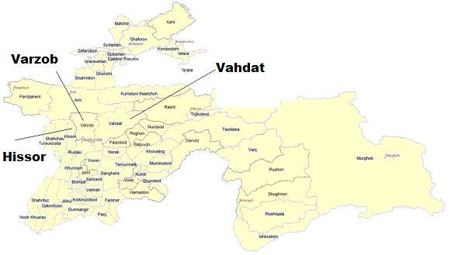

Final selection of a watershed was based on the following:
- Importance of the watershed as a main source of potable and irrigation water for communities and the capital city Dushanbe
- Variety of agriculture activities being undertaken in the watershed (farming, kitchen gardens, pastures)
- The watershed covers two climate zones
- Kishlaks (villages) are situated in three different altitude ranges
- Different vulnerability contexts (villages located on higher elevations are generally considered to be more vulnerable than villages located on plains especially in terms of livelihood and general well-being)
- Area severely affected by natural disasters (flood in 2004 and/or drought in 2000 and 2001)
- Road accessible (at least for most of the year)
- CARE Tajikistan has good working relations established with the region level government (Oblast)
- Presence of other CARE projects in the area, especially established and functioning CBOs (given the short time frame of the project, it is not viable to form new community groups to work with the project. Instead, the ACCT Project will work with existing community groups)

Based on the revised criteria, the working group recommended Varzob District as the most suitable area to pilot the project’s activities in this phase. CARE Tajikistan is currently working in 8 Jamoats within Varzob District, and three of these have been targeted for the ACCT Project.

Project Target Groups

The target beneficiaries for the project include poor rural people living in Varzob District, in particular: female-headed households, daily wage earners and marginalized farmers.

Direct project beneficiaries at the community level will include members and families of three community groups in 3 different kishlaks in Ziddi, Dehmalik and Chorbogh Jamoats; and the members of the Jamoat councils of Ziddi, Dehmalik and Chorbogh. As well, approximately 25,000 individuals that live in the selected Jamoats (Ziddi–5,400, Dekhmalik-4,675 and Chorbogh-16,036) will indirectly benefit through strengthened local governance and improved access to services. Other indirect beneficiaries will include: local NGOs selected to work with the project; the State Committee for Environmental Protection and Forestry; the Climate Change Center of the Agency of Hydrometeorology; the remaining 5 Jamoat councils within Varzob District; and other community groups participating in CARE projects in the district; all of whom will benefit through sharing of information and resources on livelihoods and climate risks.

Based on this, the total direct and indirect beneficiaries of the project are estimated to be 30 000.

The Logical Framework

The ACCT Project has been designed to pilot innovative approaches to assess the vulnerability of communities to environmental degradation and climate variability and change, and to reduce vulnerability by developing adaptive capacity at the community level.

Within the climate change community, several definitions of adaptation have been proposed. The definitions of adaptation used by this project include:

“Adaptation involves adjustments to enhance the viability of social and economic activities and to reduce their vulnerability to climate, including its current variability and extreme events as well as longer term climate change”. (Smit, 1993, as quoted in Huq et al, 1999)
and
“Adaptation to climate is the process through which people reduce the adverse effects of climate on their health and well-being and take advantage of the opportunities that their climatic environment provides.” (Burton, 1992, as quoted in Huq et al, 1999)

CIDA’s approach to Results-Based Management was used in the designing of the project, and the development of logical connections between planned activities and intended results.

The goal of the ACCT Project is:

To strengthen institutional and technical capacities of three selected Jamoats in Tajikistan to effectively respond and adapt to adverse effects of climate change.

This project has been designed to assist Tajikistan to adapt to the adverse impacts of climate change via the promotion of sustainable livelihoods and the building of local capacity to advocate on climate change issues.

By increasing people’s ability to cope with current environmental conditions, it is assumed that the ability of people to adapt to climate change will be improved.

The project’s objective then is:

To improve the ability of local institutions to understand, use and disseminate climate change information in order to build local capacity to adapt to the impacts of climate change to improve livelihoods.

The expected project outcomes are:
- Strengthened adaptive and innovative capacities of men and women to develop sustainable livelihood approaches in response to identified vulnerabilities due to climate change.

- Increased capacity of men and women from local institutions to network, collect and disseminate information related to climate change and to advocate with the government on climate change-related vulnerabilities.

- Enhanced knowledge and awareness of the potential impacts of climate change and possible adaptation plans at the community and local levels.

The principal project impacts that the project hopes to achieve in the long term are:

- Men and women from selected vulnerable communities understand and are better able to respond to adverse climate change effects.

- Local community groups, NGOs and government institutions are sensitized to the need for strategic interventions to enhance gender sensitive adaptation to climate change for vulnerable communities.

The project’s logical framework is shown in Table 2. The LFA lays out the project’s central logic, linking proposed activities to outputs and outcomes, all of which will contribute to achieving the impacts noted above. Slight revisions have been made to the LFA from what is presented in the Contribution Agreement. Explanation of these changes is provided below:

  - “Agencies/partners” were replaced with “institutions” and “CBOs/farmer research committees” were replaced with “community groups” to reflect planned implementation approach and terminology used in Tajikistani context.
  - HLS Tool changed to be called “Vulnerability Assessment Tool” for clarity.
  - Impact 1: word “Tajik” was removed to avoid confusion regarding the target groups.
  - Outcome Indicator 1: changed to improve clarity for monitoring.
  - Outcome Indicators 3 and 4: added households to reflect household approach to implementing adaptation strategies.
  - Output 1: changed to be more results-oriented.
  - Output 3: implementation of strategies taken out and added as separate output (Output 12) for monitoring purposes.
  - Output 4: “households” replaced with members to clarify work with Jamoats vs. work with community groups.
  - Output 5: changed to reflect diverse membership of AAG.
  - CA Output 6: removed as role of AAG has been defined.
  - Output 7: revised to reflect more realistic goal on advocacy (based on experience in Bangladesh)
  - Output 9: added facilitators as most important target for training on VA Tool.
  - Output 10: specified “district-level” for clarity.
  - Output 11: changed to reflect emphasis on facilitating access to services as opposed to providing services.
  - Output 12: added as mentioned above.
  - Output-level indicators have been revised to reflect monitoring and evaluation plan.

Table 2: Logical Framework Analysis (Revised October 2005)

Country/Region: Tajikistan/Central Asia |  | Project No. Z020363
Project Title: Participatory Rural Adaptation Pilot in Response to Climate Change in Tajikistan (ACCT Project)
Narrative Summary | Expected Results | Performance Measurement | Assumptions/Risk Indicators
Goal:  To strengthen institutional and technical capacities of three selected Jamoats in Tajikistan to effectively respond and adapt to adverse effects of climate change. | Impacts:  - Men and women from selected vulnerable communities understand and are better able to respond to adverse climate change effects.  - Local community groups, NGOs and government institutions are sensitized to the need for strategic interventions to enhance gender sensitive adaptation to climate change for vulnerable communities. | Indicators:  Level of understanding of climate change in local leaders and institutions, disaggregated by gender.  Climate change and adaptation issues are incorporated in decision-making at the local level. | - GoT and communities have the time, capacity and orientation to consider climate change implications in their decisions.  Risk: Medium.
Objective:  To improve the ability of local institutions to understand, use and disseminate information in order to build local capacity to adapt to impacts of climate change and to improve livelihoods. | Outcomes:  - Strengthened adaptive and innovative capacities of men and women to develop sustainable livelihood approaches in response to identified vulnerabilities due to climate change.  - Increased capacity of men and women from local institutions to network, collect and disseminate information related to climate change and to advocate with the government on climate change-related vulnerabilities.  - Enhanced knowledge and awareness of the potential impacts of climate change and possible adaptation strategies at the community and local levels. | Indicators:  - # of women and men/households from targeted communities that test and adopt new practices to sustain their livelihoods.  - Extent to which communities are sensitive to the socio-economic and environmental impacts of climate change.  - # of men and women/households actively engaged in finding solutions to local problems that result from climate change.  - #/quality of knowledge and practices provided by local institutions.  - Extent of communities’ ability to plan and implement advocacy campaigns on climate change issues.  - Extent to which local institutions provide timely and accurate information. | Assumptions/Risks:  - New ideas and technological packages exist that the project can link communities to (medium).  - Accurate information on potential impact of climate change exists (medium).  - Community groups/NGOs have the influence and status and skills to effect change at the government and community level (low).  - Local institutions are willing to share and disseminate information (low).
Resources/Activities:  - Project Adaptation Workshop  - Establishment of Adaptation Advisory Group  - Vulnerability Assessment Tool  - Social Organization and Capacity Building.  - Training programs.  - Participatory Technology Development.  - Monitoring and Evaluation. | Outputs:  - Three Jamoats incorporate identified climate-related vulnerability issues into local planning processes. | Indicators:  - Identified Jamoat priorities are linked to climate issues through a participatory process.  - # of local plans incorporating priority issues identified in Vulnerability Assessment. | Assumptions/Risks:  - Identified institutions are willing to put time and effort into the project.  - Participation of communities is not affected by severe natural disasters.  - Stakeholders are able to reach consensus on adoption of community-based research extension management systems.  - Government allows communities to mount advocacy campaigns and is open to receive local level input.  - Ineffectiveness of GoT may hinder implementation.  - Some targeted communities may not be accessible for up to three months during the winter.
 | - In collaboration with State Committee for Environment Protection and Forestry, a climate change and adaptation workshop conducted involving community leaders, community organizations, NGOs, government service providers and local government staff from three selected Jamoats. | - Quality of workshop report.  - Level of participation by local organizations disaggregated by gender.  - Linkages are established and maintained between research/government institutions and community groups/Jamoats.
 | - Adaptation response focusing on livelihood strategies for 50 households in three Jamoats identified. | - #/type/quality of adaptation options identified by communities.
 | - Trainings on adaptation processes and planning completed and disseminated to men and women members of three Jamoats. | - # of trainings provided.  - Extent of participation disaggregated by gender.  - Quality of training and the relevance of climate change/adaptation issues incorporated.
 | - An Adaptation Advisory Group (AAG) involving representatives of relevant government institutions, local government staff, community leaders and agricultural research institutions established. | - Level of participation in AAG by relevant institutions.  - Meeting minutes.
 | - An institutional analysis and training needs assessment of NGOs and governmental institutions completed. | - Institutional analysis report.  - Key actors and potential partners identified.  - Knowledge/service gaps and opportunities identified.
 | - At least one key policy issue is identified and dialogue initiated with relevant government institutions | - Advocacy issue identified based on Vulnerability Assessment.  - Desired government actions elaborated.
 | - CARE Vulnerability Assessment Tool modified and tested in three Jamoats. | - AAG approves tool.  - Number of FGDs held.  - Number of female and male participants in FGDs.  - User-friendly tool/methodology developed and documented.
 | - Training of facilitators, local institutions and community leaders conducted on Vulnerability Assessment Tool. | - #/type/quality of training on tool.  - Extent of participation disaggregated by gender.  - Quality of facilitation of VAs.
 | - Vulnerability Assessment data analyzed and discussed in a district-level workshop. | - Key vulnerability issues and well-being indicators identified for target communities.  - #/type/quality of training on problem identification, diagnosis and prioritization.
 | - Training programs on technologies responding to identified vulnerabilities accessed/developed. | - Analysis of relevant government services and gaps in access.  - #/relevance of training programs available to project participants from NGOs or government service providers.  - Target individuals (men and women) have new livelihoods skills.
 | - Community groups implement identified adaptation strategies. | - Field trials established.  - # of men and women participating.

Cross-cutting Themes: Gender and Environment

CIDA policy requires all executing agencies to consider gender and environmental impacts as crosscutting issues in the design of CIDA-funded projects.

Gender Strategy

Women in Tajikistan play an important role in agriculture, yet they remain excluded from the use of more advanced technology such as improved seeds and agricultural machinery. They plant on less fertile soils, have smaller plots than men, and have less access to services than men. The social power structure provides more support to men: there is an absence of supporting networks and institutions that could give marginalized households and individuals, particularly women, the voice they need.

Women (and children) are more vulnerable to natural disasters such as floods and droughts due to their lack of mobility, lack of resources to cope with the situation, poorer health status, and lack of access to information.

In times of crisis, women bear the responsibility of maintaining the family and providing the daily essentials. As environmental degradation increases, women’s workload and worries increase, i.e., longer distances to collect fuelwood, less food to feed the family as soil fertility decreases, or kitchen gardens are swept away during floods. As family income/production decreases, there is less money for education, with girls taken out of school before boys.

CARE International’s experience suggests that males and females view adaptation to climate change differently. For example, a vulnerability assessment conducted in Bangladesh showed a sharp contrast in selected adaptation measures – females chose relief while males chose rehabilitation as their immediate priority adaptation measure. Females gave greater importance to health, housing and potable water while males gave importance to income and food security.

CARE, as a principle, integrates gender into all of its programs. CARE Tajikistan’s Long Range Strategic Plan (2002-2006) identified a number of vulnerable groups that it is targeting, including female-headed households, marginalized farmers (agricultural workers with access to less than one hectare of land, no or poor irrigation, saline or waterlogged land, or rain-fed hillside land) many of whom are females, and daily wage earners.

Building upon the experience of CARE Tajikistan in implementing a number of projects, as well as experience gained by the adaptation to climate change project implemented in Bangladesh, the ACCT Project will use a number of strategies to promote gender equity:
- At least 50% of the participants involved in the adaptation activities will be female.
- Activities will be designed to work within social and religious restrictions:
  - Separate focus groups will be held for women and men.
  - Learning and training sessions for women will be held in locations where women feel comfortable and at times that do not conflict with women’s responsibilities in the home.
  - Female staff will facilitate sessions for female groups whenever possible.
- The special needs/interests of women will be considered:
  - Additional trainings will be provided to female Jamoat members
  - Raising women’s knowledge of climate interactions can strengthen their role in the distribution of traditional knowledge.
- At the organizational level:
  - Responsibility for addressing gender issues will be included in the job descriptions of partner staff assigned to work with the project.
  - Child care costs will be reimbursed for project staff attending workshops and trainings.
  - All data collected will be gender disaggregated and analyzed by gender.

Environmental Strategy

CIDA’s Policy for Environmental Sustainability highlights the important links between poverty and the environment. The ACCT Project aims to reduce the environmental vulnerability of target communities in Varzob District. Serious environmental problems are threatening the livelihood security of rural households in the project area. These environmental problems include: heavy rainfall with associated flooding, avalanches and mudslides; lack of rainfall resulting in drought; lack of potable water, resulting in high incidence of water-borne diseases, including diarrhea, typhoid and cholera; scarcity of fuel for cooking and heating, resulting in severe deforestation, burning of dung for fuel and landslides due to soils no longer being stable due to lack of forest cover; declining fertility of pasture lands due to overgrazing and slow decrease in temperatures and increasing rainfall.

The consideration of the potential impacts of this project on the environment, and of the potential impacts of the environment on the project, will be a priority in implementation of the ACCT Project. The project will attempt to identify and mitigate risks to the success of the interventions, and will analyze the environmental sustainability of all proposed adaptation strategies before they are promoted to the communities. If project or partner staff do not have the expertise to determine if activities are sustainable, expert advice will be sought from the country’s research organizations.

CIDA is required under the Canadian Environmental Assessment Act (CEAA) to consider whether a CIDA-funded project requires an Environmental Impact Assessment. In turn, CIDA requires all executing agencies to screen proposed projects to determine whether they require assessments of their environmental impact.

Projects are only subject to CEAA regulations if they consist of “any proposed construction, operation, modification, decommissioning, abandonment or other such undertaking in relations to a physical work or structure”.

At the time of preparation of this document (August/September 2005), it is not anticipated that any project activities will involve construction or modification of a physical work. Rather, activities are expected to be focused on developing the capacity of communities and households to diagnose, analyze, test and adapt appropriate technologies to minimize the impact of climate change. As such, Part A, Section 2, of the Contribution Agreement states, “An environmental assessment is not required for this Project under the Canadian Environmental Assessment Act”.

However, if the project decides, in response to vulnerabilities expressed by target beneficiaries, to construct a physical structure, such as a river-training work or lined canal to divert a potential mudflow, then an environmental screening may be required. Once activities to be undertaken by the project are finalized, the project manager will consult with CIDA to verify if an environmental screening is required.

Sustainability

The project will build the capacity of community groups and Jamoats to identify vulnerabilities and to develop appropriate solutions to selected vulnerabilities. The project will also develop the capacity of local institutions (Jamoats) to support their constituents, and will help ensure that the communities’ real concerns are incorporated into local development plans prepared by the Jamoats. Facilitation of access to government/NGO services for project participants will help them to cope in the longer term.

Efforts will be made to link Jamoats with other donor organizations. Donor organizations will be invited to attend workshops organized by the project, as well as to become members of a Tajikistan Climate Change Donor Group. Two of the functions of the Climate Change Donor Group will be to keep donors informed of climate change initiatives being considered or undertaken within Tajikistan, and to identify possible sources of funding for initiatives that are beyond the scope of the ACCT Project – including initiatives that Jamoats identify was being critical for their areas.

Project staff will be pro-active in promoting close integration among all CARE projects working within the project area. Staff from other CARE projects will be invited to attend trainings and workshops conducted by the ACCT Project. Information on the project will be shared with other senior CARE staff during regular staff meetings. As a result of the initiative shown by the project staff, a 2-day workshop was held in early September 2005, during which the sharing of staff among CARE projects was discussed as one means of increasing coordination and dissemination of information.

This 16-month long project is considered to be pilot, during which the project’s methodology will be developed and field tested. The lessons learned during this phase will be used to scale up the approach to a larger target area.

Implementation Approach

This project seeks to increase understanding of the links between livelihood security and climate variability and change, particularly in rural areas and on agricultural activities. This will be achieved by working with community groups to identify appropriate, low-cost techniques which can be introduced at the farm level, and by working with local government councils to incorporate identified climate-related vulnerabilities into planning processes. The project will strive for an integrated approach to implementation in order to achieve the desired outcomes. It is expected that a replicable model for reducing vulnerability will be developed that can be scaled up by local NGOs and government institutions.

Figure X below presents the Work Breakdown Structure for the Project.

Figure X: Work Breakdown Structure
Goal: To strengthen institutional and technical capacities of three selected Jamoats in Tajikistan to effectively respond and adapt to adverse effects of climate change
Objective: To improve the ability of local institutions to understand, use and disseminate information in order to build local capacity to adapt to impacts of climate change and to improve livelihoods.
WBS 100
Information Collection and Analysis
WBS 200
Work with Community Groups
WBS 300
Engagement of Local Government
WBS 400
Creating Linkages
WBS 500
Project Management
110 Vulnerability Assessment (Outputs 8 and 9)

120 District-Level Workshop
(Output 10)

130 Identification of Potential Coping Strategies
(Output 3)

140 Institutional Analysis
(Output 6)
210 Facilitation/ development of training
(Output 11)

220 Adaptation strategies field tested
(Output 12)
310 Training for Jamoat Members (Output 4)

320 Incorporation of vulnerability issues into Jamoat planning processes
(Output 1)
410 Establishment of Adaptation Advisory Group (AAG)
(Output 5)

420 Development of Advocacy Strategy
(Output 7)

430 Adaptation Workshop
(Output 2)
510 Project Staffing

520 Monitoring and Evaluation

530 Documentation

540 Exit Strategy

550 Reporting

Information Collection and Analysis (WBS 100)

The activities and outputs under this area focus on gathering information and providing analysis to facilitate the development of appropriate strategies for engaging stakeholders and increasing coping capacity.

Vulnerability Assessment (WBS 110, Outputs 8 and 9)

In order to determine what local people feel vulnerable to and to identify potential coping strategies, the project will undertake a vulnerability assessment. Although CARE Tajikistan has collected a lot of information on livelihood strategies for the project area, information is lacking on the types of climate-related vulnerabilities local people face, or how they cope with them.

The objectives of the vulnerability assessment are to:
- Identify the vulnerability contexts that local people feel most vulnerable to;
- Relate the vulnerability contexts to community well-being; and
- Obtain preliminary information on general coping strategies currently being employed by community members to deal with identified vulnerability contexts.

A vulnerability assessment tool developed for the Reducing Vulnerability to Climate Change (RVCC) Project implemented by CARE in Bangladesh was modified and field tested with six focus groups (two male and four female) in the project area. After the tool is modified on the basis of these field tests, training will be held for facilitators on how to use the tool. The tool will then be used to conduct vulnerability assessments with approximately 18 focus groups: 3 kishlaks (villages) in each of 3 selected Jamoats, 1 male and 1 female group per kishlak.

Once analysis of the data is completed, a report will be drafted to document the process and findings. The preliminary findings will be taken back to the target communities for validation before finalization of the report.

District-Level Workshop (WBS 120, Output 10)

The findings of the Vulnerability Assessment will be presented in a district-level workshop. This workshop is intended to communicate the priority areas of vulnerability in the target communities to government and NGO representatives up to the district level. There will be opportunities for feedback and discussion of the findings, and the feedback provided will be incorporated into the final Vulnerability Assessment Report.

Identification of Potential Coping Strategies (WBS 130, Output 3)

Based on the results of the Vulnerability Assessment, priority vulnerability contexts and indicators of well-being will be identified for the three target kishlaks. The project team will research adaptation strategies to address the identified areas of vulnerability. This may involve consultation with research organizations, government service providers, other NGOs, and community people.

Once an inventory of potential coping strategies is developed, the strategies will be analyzed to determine their social, technical and environmental feasibility for the target communities. Those strategies found to be feasible will be presented to the community groups, and a participatory selection process will be undertaken to select strategies for each group to focus on.

Institutional Analysis (WBS 140, Output 6)
An institutional analysis will be undertaken to identify the key actors for the ACCT Project’s target issues. This process will involve research into governmental, non-governmental and civil society organizations who may present opportunities for collaboration on the project issues. Consultations will be undertaken to determine the interest and potential level of engagement of these organizations. Analysis of gaps and opportunities will be included in the Institutional Analysis Report.

Work with Community Groups (WBS 200)

Efforts under this component will focus on improving adaptive capacities of rural men and women, using a group-based approach aimed at making households aware of new livelihood strategies that address current concerns and will be sustainable in the longer term.

While some farmers in the target area may be aware of changing weather patterns, ex. rise in temperatures, increasing occurrence of floods or drought, there is a general lack of awareness of how weather is being affected by climate change. There is even less awareness of the links between current environmental problems and crop failure and climate change, either as a contributing cause of these present problems or as a factor that will exacerbate them further.

Given the short timeframe for the project, it is not realistic to initiate group formation in the rural areas and associated training on institutional capacity building. Therefore, the project will work with active community groups (commonly known as women’s groups, community-based organizations, water users’ associations or farmers’ associations) that CARE has worked with during other projects and developed trust and working relationships with at both the community and Jamoat level. Community groups in the target Jamoats will be invited to submit expressions of interest to work with the project, and the three participant groups will be selected based on selection criteria to be developed by the project team.

Training for Community Groups (WBS 210, Output 4)

The potential coping strategies identified (Output 3) will be presented to the community groups, and a participatory process undertaken to select the most appropriate for their specific context. Once the community groups have identified which coping strategies they would like to pursue, the project will seek to provide them with the necessary training for successful implementation of the strategies. The project will first explore training and services available from government and/or NGO service providers, and will work to facilitate access to appropriate training opportunities for project participants. If no appropriate training is available, the project will work to develop training programs that will meet the needs of the participants. This may involve service delivery contracts with other organizations/institutions for delivery of training programs and development of training materials.

Group-based training sessions will be offered to the three participating community groups to develop the necessary skills and knowledge to implement the identified coping strategies. Training topics may include: links between climate and livelihoods, village mapping, site selection, and technical training on adaptation strategies.

Establishment of Field Trials for Adaptation Strategies (WBS 220, Output 12)
Following skills development training for beneficiaries, the project will facilitate access to the necessary resources, technical assistance and support from government service providers and/or other organizations or projects. This will create an ongoing relationship between the project participants and other institutions which will extend beyond the life of the project. In addition, the project team will offer ongoing support and mentoring to the community groups.

Field trials will be established to test the adaptation strategies selected by the community groups. Progress will be monitored by the project team, and experiences and lessons will be documented.

Engagement of Local Government (WBS 300)

High-level government agencies/institutions have awareness of climate change issues through the development of the 1st Phase National Communications Plan and the preparation of the Tajikistan National Action Plan for Climate Change Mitigation.

Training for Jamoat Members (WBS 310, Output 5)

I AM NOT CLEAR ON THE APPROACH HERE – PLEASE EXPLAIN

Incorporation of vulnerability issues into Jamoat planning process (WBS 320, Output 1)
SAME COMMENT AS ABOVE

Creating Linkages

It is widely understood that local-level actions require a supportive policy and institutional environment for long-term success. The ACCT Project will attempt to create linkages with key actors on climate-related vulnerability in an effort to create a wider movement on the issue, and to link local-level vulnerabilities with priorities at local, district and national levels.

Adaptation Advisory Group (WBS 410, Output 5)

The purpose of the Adaptation Advisory Group (AAG) will be to provide advice and guidance to the project on project strategy and programme implementation, and to communicate the learnings from the project to other relevant organizations in Tajikistan. The AAG will meet quarterly to receive updates on the project and to provide strategic and technical direction.

Development of Advocacy Strategy (WBS 420, Output 7)
Governments are being encouraged to develop long-term adaptation plans. However, if the adaptation needs of the poor are not properly accounted for in official planning exercises, there is a danger that existing local adaptive capacities could be undermined.

Many national government institutions are aware of the problems that climate change poses, but are poorly informed of the day-to-day realities that poor and vulnerable communities face. Information at the national level is slow to reach local levels. Information from the local level rarely reaches the national level. By building the capacity of local institutions, it is expected that they can advocate with government institutions on vulnerability issues, closing the gap in information and knowledge between government levels and the rural communities.

An important contribution that the project can make, both within Tajikistan and without, is to share lessons learned on how vulnerable people are being affected by climate variability and change and how they are coping. The lessons learned will be shared with the national community via the Adaptation Advisory Group and through a national workshop (see below).

At the same time, the project will analyze the gaps and opportunities in existing government policy and programs, and will identify actions that will support the local-level initiatives being undertaken. This will be combined with information from the Institutional Analysis (Output 6) to develop an Advocacy Strategy, which will be documented in a form that is usable by local NGOs and institutions.

Adaptation Workshop (WBS 430, Output 2)
At the end of the project, a workshop will be held in collaboration with the State Committee for Environmental Protection and Forestry. The workshop will present the results of the Vulnerability Assessment and the results achieved with the selected adaptation strategies, and will identify policy issues that need consideration to support local-level efforts.

Life of Project Work Plan

The project will be implemented over a 16 month period, from April 1, 2005 to July 31, 2005.
Table 3 below provides a detailed breakdown of activities planned by outcome by quarter, over the life of the project. Quarter 1 is from April to June 2005, which also corresponds with the first quarter of CIDA’s Fiscal Year 2005-2006.

Table 3: ACCT Project Work Plan (April 2005 to July 2006)
PLEASE REVIEW AND CORRECT TIMELINES – SOME GOT LOST/MOVED
Also please ensure that this is based on original 16 month timeline

 | Activities | 2005 |  |  |  |  | 2006
 | Activities | Q1 | Q2 |  | Q3 |  | Q4 | Q5 | Q6 | Q7
 | Activities | Apr-June |  | July-Sept | Oct-Dec | Jan-Mar |  | Apr-June | July-Sept | Oct-Dec
WBS 100: Information Collection and Analysis

110 | Vulnerability Assessment (Outputs 8 and 9)
111 | Vulnerability Assessment Tool modified, field tested and refined.
112 | Facilitators trained in use of Vulnerability Assessment Tool.
112 | Vulnerability assessment conducted.
113 | Data analyzed and report prepared
114 | Findings verified in target communities.
120 | District-Level Workshop (Output 10)
121 | Plan workshop, book venue and send invitations.
122 | Hold workshop.
123 | Report on findings of workshop.
120 | Identification of Potential Coping Strategies (Output 3)
121 | Verify sources of expertise (ex. Local NGOs, government institutions, research institutions, other CARE Projects) and levels of support (training materials, technical, financial, in-kind) available for each adaptation strategy.
122 | Analysis of coping strategies for technical, social and environmental feasibility.
123 | Selection of potential coping strategies for specific communities based on identified vulnerability contexts.
130 | Institutional Analysis (Output 6)
131 | Identify key actors relating to climate change and vulnerability.
132 | Consultation with identified actors.
133 | Preparation of Institutional Analysis Report.
WBS 200: Work with Community Groups

210 | Facilitation/development of training for Community Groups (Output 11)
211 | Community identification of coping strategies to implement.
212 | Identification of available training and services available from government service providers.
213 | Development of training materials/programs to meet identified gaps.
214 | Group-based sessions held with community groups in 3 selected kishlaks.
220 | Adaptation Strategies field tested (Output 12)
221 | Facilitate access for project participants to technical assistance and support from government service providers and/or other organizations/projects.
222 | Adaptation strategies implemented (i.e., demo plots/field trials established)
223 | Monitor progress of implementation of adaptation strategies
WBS 300: Engagement of Local Government
310 | Training for Jamoat Members (Output 4)
311 | Development of training program for Jamoat members???.
312 | Training held. PLEASE FILL IN
320 | Incorporation of vulnerability issues into Jamoat planning processes (Output 1)
 | NEED TO FILL IN PROCESS HERE
WBS 400: Creating Linkages
410 | Establishment of an Adaptation Advisory Group (AAG) (Output 6)
311 | Develop Terms of Reference.
312 | Invite selected persons to be members.
313 | Quarterly meetings of AAG.
421 | Identify key actors.
422 | Consultations.
423 | Finalize report.
420 | Development of Advocacy Strategy (Output 7)
421 | Analysis of gaps and opportunities.
422 | Consultation with potential allies.
423 | Identification of appropriate actions.
424 | Documentation of strategy.
430 | Adaptation Workshop (Output 2)
431 | Plan workshop, book venue and send invitations.
432 | Hold workshop.
433 | Incorporate workshop findings into Final Report and Lessons Learned Report.
WBS 500: Project Management

510 | Project staffing
511 | Recruitment of local Project Manager, locally-recruited technical advisor, administrative assistant, driver
512 | Recruitment of field monitors
513 | Organize training for project staff as per needs (facilitation skills, communication skills, monitoring and evaluation, report writing).
520 | Monitoring and Evaluation
521 | Conduct Vulnerability Assessment and Knowledge, Attitudes and Behaviour (KAB) survey.
522 | Review of baseline data collected by other CARE projects working within same Jamoats/villages.
523 | Develop and implement baseline survey tool(s).
524 | End of project surveys/evaluations.
530 | Documentation
531 | Vulnerability Assessment Report
532 | KAB Report
533 | Institutional Analysis Report
534 | Advocacy Strategy Document
535 | Adaptation Workshop Report
536 | Lessons Learned Report
540 | Exit Strategy
541 | Develop strategy.
550 | Reporting
551 | Preparation and submission of draft Project Implementation Plan to CIDA by Sept. 15th 2005
552 | Preparation and submission of summary (quarterly) narrative reports and quarterly financial reports within 45 days of end of Q1, Q3, Q5
553 | Preparation and submission of semi-annual report within 45 days of end of Q2
554 | Preparation and submission of annual report within 45 days of end of Q4
555 | Preparation and submission of final project report (narrative and financial) by Dec. 15th 2006

PROJECT MANAGEMENT

Management Approach and Structure

CARE Canada will manage implementation of this project through its partnership with CARE Tajikistan. CARE Canada will be responsible for overall project development and management, contract management for international consultants, financial management and reporting, narrative/progress reporting and liaison with CIDA. CARE Canada is responsible for bearing potential liabilities with respect to agreed contractual obligations. Project implementation will be managed in-country by CARE Tajikistan.

The project will be managed by a small team (Figure 12). A project manager began work in July 2005. He reports directly to the Assistant Country Director – Program. A locally-recruited technical advisor with a strong background in environmental policy, in particular policy related to climate change, was hired in August 2005 to work closely with the Project Manager on technical issues.

The project has a full-time driver. A Project Assistant reported to the project in late August. A monitoring and evaluation assistant will work full time on the project, eventually reducing her time to 50%. All staff is based in Dushanbe.

Figure 12: Organogram of the ACCT Project

ACD / Program

Technical Adviser
(50 percent)
Project Manager
DM&E Manager (10 percent)

Project Assistant

DM&E Assistant

Field Monitors (2)
1 full-time
1 part-time

None of the NGOs interested in working with the project have extensive experience in working with community organizations or have experience working in the target area. In addition, they have a limited number of staff that can speak Tajik. Given the above limitations, and the fact that the project timeline is so short, existing CARE staff may be assigned to work on the ACCT Project and be shared with other CARE projects (i.e., staff would work 50% of the time on the ACCT Project and 50% of the time on another CARE project). This arrangement would enable the project to tap into field monitors’ knowledge of local conditions, contacts already established within the communities and with the Jamoats, and encourage cross-fertilization among CARE projects that have activities complementary to those of this project. In particular, the promotion of physical infrastructure by the Disaster Preparedness Action Plan Tajikistan (DipacT) Project to mitigate the impacts of natural disasters, and the research being done by the Varzob Highlands Food Security and Capacity Building Project (VHFS), are expected to be complementary to this project’s activities.

Service delivery contracts will be signed with local organizations or individuals as necessary for specific tasks, such as developing and testing training materials, and preparation of technical guidelines ex. how to stabilize slopes using trees, grass and/or agricultural crops.

Roles and Responsibilities of the Implementing Partners

CARE Canada

CARE Canada will be responsible for the successful management and implementation of the project as follows:
- Overseeing and implementing the project in keeping with the project description and the results framework identified in the Contribution Agreement and further refined in this document;
- Ensuring that the results-based performance review framework is used to monitor and assess progress toward achievement of project results and report on the achievement of progress toward planned results;
- Preparing and submitting to CIDA the progress reports, financial reports and other documents as outlined in Appendix E;
- Receiving, managing and disbursing the funds provided by CIDA as agreed upon in the Contribution Agreement document;
- Recommending corrective action to the implementation of the project as appropriate;
- Liaising with CIDA, the relevant Canadian Post in Almaty and others as required;
- Participating in project evaluations, performance reviews and audits, as required;
- Responding to feedback and changes in direction to the implementation of the project as directed by CIDA, the relevant Canadian Post, and others as required; and
- Acknowledging CIDA’s contribution to the project in any publication, press releases, websites, presentations or other means.

CARE Tajikistan

CARE Tajikistan will be responsible for the successful implementation of the project as follows:
- Overseeing and implementing in-country aspects of the project, including organizing and directing project activities as directed by CARE Canada, in keeping with the project description and the results framework identified in the Contribution Agreement and further refined in this document;
- Cooperating with CARE Canada in preparation of the required reporting within the specified timeframes;
- Organizing and acting as a point of contact and direction for training, capacity building, awareness raising and other implementation aspects of the project with project partners;
- Liaising with Government authorities and other relevant stakeholders;
- Monitoring macro-environmental changes and recommending corrective action to project goals and objectives to CARE Canada as appropriate; and
- Acknowledging CIDA’s contribution to the project in any publication, press releases, websites, presentations or other means.

CIDA

CIDA, via its headquarters in Ottawa, Canada and via the Canadian Embassy based in Almaty, will:
- Provide the necessary funding for its portion of the project and ensure that funds are used in accordance with the project description and results framework identified in the Contribution Agreement and further refined in this document;
- Review, comment on and approve the project documents, including the progress reports, financial reports, annual reports and the final report;
- Monitor the implementation and strategic direction of the project;
- Recommend changes in direction to the implementation of the project as appropriate;
- Commission performance reviews, evaluations and audits as required;
- Liaise with the Organization, the Canadian Embassy in Almaty, project partners and others, as required; and
- Take such action as may be necessary to amend the Contribution Agreement, if needed.

Role of Adaptation Advisory Group

As described in Section 3.4.1, an Adaptation Advisory Group (AAG) will be established to provide the project with strategic and technical advice during implementation. The committee will meet quarterly. The meetings will be coordinated with the production of project summary narrative reports (also referred to as quarterly reports), with the quarterly reports circulated to committee members at least 1 week prior to meetings. Since the quarterly report is due 45 days after the end of a quarter, the committee meetings will be tentatively scheduled for the last week of November 2005, February 2006, May 2006 and August 2006.

Composition of the advisory committee may include:
- Becky Myton, CARE Assistant Country Director
- Guillaume Legros, 1st Secretary, Canadian Embassy, Almaty
- Begmurod Ubaidovich Mahmadaliev, Director, Agency on Hydrometeorology
- Abdullo A. Madaminov, Deputy Head of Dept. of Ecology and Plant Resources, Institute of Botany
- Aliev Samardin, Director, Ministry of Health
- A representative from one of the donor organizations active in climate change
- Bahtiyor Rasykov, Project Manager, ACCT Project (chairperson)
- Nino Nadiradze, Technical Advisor, ACCT Project (secretary)

Committee members will not receive remuneration for their involvement. Travel and lodging costs will be covered by the project in accordance with CARE Tajikistan's policies.

Risk Management Strategy

The major risks identified with this project are outlined in the Logical Framework Analysis. The following risk management strategies will be undertaken during the life of the project:

Expected Impacts: Men and women from selected Tajik vulnerable communities understand and are better able to respond to adverse climate change effects; and local community groups, NGOs and government institutions are sensitized to the need for strategic interventions to enhance gender sensitive adaptation to climate change for vulnerable communities.

Risk: Community members, local NGOs and government institutions may not have the time, capacity or orientation to consider climate change implications in their decisions.

Risk Rating: Medium. Government capacity in Tajikistan is limited. Community capacity to respond is less than its capacity to understand and plan for climate change.

Risk Management Strategy: CARE experience suggests that with appropriate capacity development, communities and local government institutions are willing to and do respond to initiatives.

Expected Outcome 1: Strengthened adaptive and innovative capacity of men and women to develop sustainable livelihood approaches in response to identified vulnerabilities due to climate change.

Risk: New ideas and technological packages may not exist that the project can link communities with.

Risk Rating: Medium. Although government institutions and research organizations are engaged in the development of technologies, the capacity of these institutions to transfer their knowledge and establish field demonstrations is weak.

Risk Management Strategy: CARE will work closely with relevant government institutions and research organizations to develop appropriate training materials, arrange for direct transfer of technology and/or field testing of technologies with targeted communities. As well, representatives of various government institutions and research organizations will be invited to be members of the project’s Adaptation Advisory Group.

Expected Outcome 2: Increased capacity of men and women from local institutions to network, collect and disseminate information related to climate change and to advocate with the government on climate change related vulnerabilities.

Risk: Accurate information on the potential impacts of climate change may not exist.

Risk Rating: Medium. Global Climate Models that are fairly accurate in other countries in documenting past changes in the climate and predicting future changes, are less reliable in Tajikistan due to the country’s rugged topography, variable elevations and aspects.

Risk Management Strategy: The project approach will be based on the assumption that reducing vulnerability to current environmental conditions will increase coping capacity for longer term climate impacts. Information on current vulnerability will be obtained through the Vulnerability Assessment.

Risk: Government institutions and local NGOs may not be willing to share and disseminate information.

Risk Rating: Low-medium. Initial discussions held with various government institutions and NGOs have all been positive. CARE has received assurances of full collaboration for dissemination of available information. However, centralized decision-making within the government could slow down dissemination.

Risk Management Strategy: The project will assist in the dissemination of the information and establishment of field trials to test technologies as required. As previously stated, representatives of various government institutions and research organizations will be invited to be members of the project’s Adaptation Advisory Group.

Expected Outcome 3: Enhanced knowledge and awareness of the potential impacts of climate change and possible adaptation plans at the community and local levels.

Risk: Project activities may have difficulty competing with other demands on the Jamoats and community groups.

Risk Rating: Medium. Needs are high but resources are limited.

Risk Management Strategy: The ACCT Project will build upon synergies established between Jamoats and community groups by other CARE projects working in the area, and will link climate-related vulnerability to existing priorities and planning processes. The project will assist the Jamoats and community groups to identify possible sources of funding over and above the national government for implementation of adaptation plans.

Risk: Community groups and local NGOs may not have the influence, status and skills to affect change at the local government (Jamoat) and community level.

Risk Rating: Medium. Although climate change has been announced as a governmental priority, the capacity and funding of the government (both local and national) is limited.

Risk Management Strategy: Training sessions will be held with Jamoats and community groups, during which information on climate change will be shared, as well as the results of the vulnerability assessments. Jamoats will be encouraged to incorporate climate-related vulnerability into their development plans, and will be linked with donors to secure funding for initiatives not funded by government.

Risks at the Output Level and Risk Management Strategies:

Risk: Participation of community groups may be affected by the occurrence of natural disasters such as severe flooding or mudflows.

Risk Rating: Medium. The project area suffered severe flooding in 2004 which destroyed a number of houses and kitchen gardens, as well as destroyed bridges and extensive portions of major access roads.

Risk Management Strategy: In the event of a natural disaster, project activities will be suspended and efforts focused to assist participants in need. Project activities will recommence as soon as feasible. In the event of severe flooding, project outputs may not be fully achieved.

Risk: Project activities may have difficulty competing with other demands on Jamoats and community groups.

Risk Rating: Medium. The project area is highly vulnerable to climate change and is already suffering from the impacts of climate change. Local people have expressed interest in learning new adaptation strategies. Local NGOs have expressed their interest in working with the project. Relevant government institutions have stated their willingness to support the project.

Risk Management Strategy: Adaptation strategies promoted by the project will be in direct response to community concerns identified during the vulnerability assessment.

Risk: National government institutions may not be receptive to a dialogue initiated by community groups, NGOs and Jamoats.

Risk Rating: Low to Medium. Tajik society is hierarchical and traditionally is top-down.

Risk Management Strategy: Discussions with national-level actors indicates that there is strong interest in working with CARE. There is increasing awareness among senior government officials that climate change is impacting Tajikistan, and that additional funding sources may become available to tackle issues related to climate change.

PROJECT MoNITORING AND REPORTING

Monitoring and Evaluation Methodology

A design, monitoring and evaluation (DM&E) assistant who is currently working with CARE Tajikistan’s Design, Monitoring and Evaluation Unit, will provide DM&E support to the ACCT project. She will work 100% of the time with the project initially, then reduce her time to 50%.

Performance will be measured using participatory monitoring and evaluation methods, including:

- As previously described, a vulnerability assessment will be conducted during the second and third quarters of the project to determine which vulnerability contexts related to climate change people are facing, in order that project activities focus on these vulnerabilities.

- A KAB (Knowledge, attitude and behaviour) survey will be conducted for the purpose of assessing changes over the life of the project in participants’ knowledge, attitudes and behaviour around the theme of sustainable livelihoods in the context of climate change. The KAB survey will be repeated at the end of this project in order to determine how successful the project activities have been in improving awareness and changing people’s behaviour.

Performance Indicators

Refer to Table 4 below for a summary of indicators, data sources and collection methods.

Table 4: Performance Measurement Framework

Expected Results | Performance Indicators | Data Sources | Collection Methods | Frequency
Impacts:  Men and women from selected vulnerable communities understand and are better able to respond to adverse climate change effects.  Local community groups, NGOs and government institutions are sensitized to the need for strategic interventions to enhance gender sensitive adaptation to climate change for vulnerable communities. | Level of understanding of climate change by communities, local leaders and institutions, disaggregated by gender.  Climate change and adaptation issues are incorporated in decision-making at the local level. | Project evaluation  Jamoat development plans; project evaluation | KAB survey  KAB survey;  Document review | Beginning and end of project  Beginning and end of project
Outcomes:  1. Strengthened adaptive and innovative capacities of men and women to develop sustainable livelihood approaches in response to identified vulnerabilities due to climate change.  2. Increased capacity of men and women from local institutions to network, collect and disseminate information related to climate change and to advocate with the government on climate change-related vulnerabilities.  3. Enhanced knowledge and awareness of the potential impacts of climate change and preparation of adaptation plans at the community levels. | - # of women and men from targeted communities that test and adopt new practices to sustain their livelihoods.  - Extent of communities that are sensitive to the socio-economic and environmental impacts of climate change.  - # of men and women actively engaged in finding solutions to local problems that result from climate change.  - #/quality of knowledge and practices provided by local institutions.  - Extent of communities’ ability to plan and implement advocacy campaigns on climate change issues  - Extent to which local organizations provide timely and accurate information | Project evaluation  Project evaluation  Project evaluation  Project evaluation  Project evaluation  Project evaluation | KAB survey;  Community group records; field monitoring  KAB survey;  Document review  Document review;  Focus Group Discussions; field monitoring  Document review;  KAB survey  Document review;  Focus Group Discussions  Focus Group Discussions | Beginning and end of project  Beginning and end of project  End of project  End of project  End of project  End of project
Outputs:  - Three Jamoats incorporate identified climate-related vulnerability issues into community planning processes. | - Identified Jamoat priorities are linked to climate issues through a participatory process.  - # of local plans incorporating priority issues identified in Vulnerability Assessment. | Selected Jamoats | Meeting minutes/workshop reports | End of project
- In collaboration with the State Committee for Environment Protection and Forestry, a climate change and adaptation workshop conducted involving community leaders, community organizations, NGOs, government service providers and local government staff from two selected Jamoats. | - Quality of workshop report.  - Level of participation by local organizations disaggregated by gender.  - Linkages are established and maintained between research/government institutions and community groups/Jamoats. | Project evaluation | Review of workshop report; meeting minutes | End of project
- Adaptation response focusing on livelihood strategies for 50 households in three Jamoats identified. | - #/type/quality of adaptation options identified by communities. | Project evaluation | Review of workshop report; meeting minutes | End of project
- Trainings on adaptation processes and planning completed and disseminated to men and women members of three Jamoats. | - # of trainings provided.  - Extent of participation disaggregated by gender.  - Quality of training and the relevance of climate change/adaptation issues incorporated. | Project evaluation | Participation sheets for training sessions; training evaluation forms | Quarterly
- An Adaptation Advisory Group (AAG) involving representatives of relevant government institutions, local government staff, community leaders and agricultural research institutions established. | - Level of participation in AAG by relevant institutions.  - Meeting minutes. | Project evaluation | Review of meeting minutes and participants list | Quarterly
- An institutional analysis and training needs assessment of NGOs and governmental institutions completed. | - Institutional analysis report.  - Key actors and potential partners identified.  - Knowledge/service gaps and opportunities identified. | Project evaluation | Review of report
- At least one key policy issue is identified and dialogue initiated with relevant government institutions. | - Advocacy issue identified based on Vulnerability Assessment.  - Desired government actions elaborated. | Project evaluation | Review of strategy document
- CARE Vulnerability Assessment Tool modified and tested in three Jamoats. | - AAG approves tool.  - Number of FGDs held.  - Number of female and male participants in FGDs.  - User-friendly tool/methodology developed and documented. | Project evaluation | Review of meeting minutes; review of tool
- Training of facilitators, local institutions and community leaders conducted on Vulnerability Assessment Tool. | - #/type/quality of training on tool.  - Extent of participation disaggregated by gender.  - Quality of facilitation of VAs. | Project evaluation | Training evaluation forms; review of VA report
- Vulnerability Assessment data analyzed and discussed in a regional workshop. | - Key vulnerability issues and well-being indicators identified for target communities.  - #/type/quality of training on problem identification, diagnosis and prioritization. | Project evaluation | Review of Vulnerability Assessment Report
- Training programs on technologies responding to identified vulnerabilities accessed/developed. | - Analysis of relevant government services and gaps in access.  - #/relevance of training programs available to project participants from NGOs or government service providers.  - Target individuals (men and women) have new livelihoods skills. | Project evaluation | Training participant lists and evaluation forms; inventory of training programs available
- Community groups implement identified adaptation strategies. | - Field trials established.  - # of men and women participating. | Project evaluation | Field monitoring
Inputs: Can. $250,000 | Compliance with CIDA contract  Resources delivered on time, within budget |  | Document review | Quarterly

Performance Reporting

CARE Tajikistan will comply with all contractual reporting requirements. Assignment of reporting responsibilities, report recipients and the reporting schedule are detailed in Table 5 below.

Table 5: Performance Reporting Framework

Report | Content Areas | Responsible | Recipients | Schedule
Initial budgetary Forecast | Request for advance, cash flow requirements for remaining fiscal quarters in current fiscal year, and the first quarter of the following fiscal year | Finance Dept. of CARE Tajikistan | CARE Canada (CARE Canada will review and forward to CIDA) | Prior to approval of the project
Initial Work Plan | Project context, analysis of performance and risk, project management and organization, major project components and key milestones and budget for the year, communications strategy | Project Manager | CARE Canada (CARE Canada will review and forward to CIDA) | Initial work plan due in September 2005, 2nd work plan due March 2006
Second Budgetary Forecast | Request for advance and revised cash flow requirements for remaining fiscal quarters in current fiscal year, and first quarter of the following fiscal year | Project Manager, Finance Dept. of CARE Tajikistan | CARE Canada (CARE Canada will review and forward to CIDA) | September 2005, as part of Initial Work Plan
Summary Narrative Reports | Short narrative summary of progress of project over last 3 month period, incl. activities undertaken and outputs achieved. Explanations for variances greater than 10% in budget line items. | Project Manager | CARE Canada (CARE Canada will review and forward to CIDA) | Within 45 days from end of quarter
Quarterly Financial Reports | Planned to actual disbursements for the quarter, explanation of variance, updated forecast for remaining fiscal quarters of current fiscal year and first quarter of following fiscal year | Project Manager, Finance Dept. of CARE Tajikistan | CARE Canada (CARE Canada will review and forward to CIDA) | Within 45 days from end of quarter, together with Summary or Semi-annual Narrative Reports
Semi-annual Narrative Report | Variances between planned and actual activities, problems and difficulties encountered, major changes in project, variances in expenditures , planned activities for next quarter, integration of women in activities, progress towards results | Project Manager | CARE Canada (CARE Canada will review and forward to CIDA) | Within 45 days from end of fiscal year and each six months thereafter
Annual Workplan Update | Narrative review of the accomplishments against the milestones planned in the initial workplan, variances in activities, variances in expenditures, milestones for each activity for coming year | Project Manager | CARE Canada (CARE Canada will review and forward to CIDA) | Within 45 days of end of fiscal year, together with Semi-annual Narrative Report and Annual Financial Report
Annual Financial Report | Comparison between forecast expenditures for year just completed and actual expenditures for year just completed, forecast for coming fiscal year, financial contribution of Canadian and recipient partners to the project during the year | Project Manager, Finance Dept. of CARE Tajikistan | CARE Canada (CARE Canada will review and forward to CIDA) | Within 45 days of end of fiscal year, together with quarterly Financial Report, semi-annual Narrative Report and Annual Workplan Update
Final Narrative Report | Background and purpose of project, summary of project description, analytical review of project, original budget forecast versus actual disbursements, in-kind contributions and CARE’s contributions | Project Manager | CARE Canada (CARE Canada will review and forward to CIDA) | Within 45 days from termination of project activities, i.e., by 15 Dec 06, together with Final Financial Report
Final Financial Report | Actual disbursements by line item versus budgetary estimates, request of payment of final amount due by CIDA or return of undisbursed accountable advances | Project Manager, Finance Dept. of CARE Tajikistan | CARE Canada (CARE Canada will review and forward to CIDA) | Within 45 days from termination of project activities, i.e., by 15 Dec 06, together with Final Narrative Report
Technical Coopera-tion Reporting | CIDA Form 9P and Form 9B | Project Manager | CARE Canada (CARE Canada will review and forward to CIDA) | By 31 Jan. 2006

Project Financial Information

Revised Life of Project Budget

Table 6 below provides a revised budget for the life of the project. The budget has been revised based on the following:

Activity 1

Under Technical Consultancy:

National Consultants – we will have to hire independent experts such as Kayumov, an expert from a forestry department, or in any other relevant field

Under Materials and Equipment:

Fixtures and Furniture: increased to 1000 CAD for equipment and software

Under Operating Expenses

Training: increased to 500 CAD to build capacity to understand and participate in awareness raising activities and improve English skills of the project staff

Under Travel Costs

Travel, meals, accommodation for 2 (changed from 1) int’l trips – changed to 2320 CAD
Also, due to a sharp increase of oil prices, accommodation and other relevant services, international trips have become more expensive.

Activity 2

Under Technical Consultancy:

National Consultants – we will have to hire independent experts such as Kayumov, an expert from a forestry department, or in any other relevant field

Under Operating Expenses

Training: increased to 500 CAD to build capacity to understand mechanisms and importance of advocacy and improve English skills of the project staff

Under Travel Costs

Travel, meals, accommodation for 2 changed to 1800 CAD
The change is due to a sharp increase of oil prices accommodation and other relevant services, international trips have become more expensive.

Activity 3

Under Technical Consultancy:

National Consultants – we will have to hire independent experts such as Kayumov, an expert from a forestry department, or in any other relevant field

Under Materials and Equipment:

Materials, Equipment for Activities: increased to 7000 CAD. This increase will allow to spend more funds on implementation of the CC adaptation activities.

Under Operating Expenses

Training: increased to 1000 CAD to gain and improve knowledge on different adaptation methods within the country or overseas and improve English skills of the project staff

Under Travel Costs

Travel, meals, accommodation for 2 international trips–changed to 2134 CAD
This change is due to a sharp increase of oil prices accommodation and other relevant services, international trips have become more expensive.

Activity 4

Under Materials and Equipment:

Fixtures and Furniture: increased to 1000 CAD for equipment and software

Under Operating Expenses

Training: increased to 1000 CAD to gain knowledge (within the country or overseas) and build capacity to understand and conduct vulnerability assessments and improve English skills of the project staff

Under Travel Costs

Travel, meals, accommodation for 2 int’l trips – changed to 2126 CAD
The change is due to a sharp increase of oil prices accommodation and other relevant services, international trips have become more expensive.

Activity 5

Under national staff salaries/benefits

Trainers Monitors decrease from 28800 to 14400 CAD. Since the project is going to focus on one area (Varzob District) instead of originally planned 3. The project decided to hire 1 monitor (at 100% of his/her time) and 1 (50% of his/her time).

Program assistant will be working at 100%. Salary has not changed.

DM&E assistant will work: 7 months at 100% and the remaining 9 months at 50% of her time. (explanation is provided in the PIP)

DM&E Manager: added at 100/month for 16 months

CARE’s Contribution

The ACCT Project is receiving a cost-match of $23,400 CAD from other CARE projects operating within the project area, as explained below.

To insure complementarity and coordination with other CARE activities in Tajikistan, the ACCT project will be closely working with Disaster Preparedness Action Plan Tajikistan (DipacT) and Varzob Highlands Food Security and Capacity Building Project (VHFSP) as well as with CBOs and community groups established by these and other CARE projects active in the region.

Both DipacT and VHFSP are implementing a number of infrastructures (bridges, reinforcement of river banks, rehabilitation of irrigation ditches, mitigation of slope erosion, etc.) in Varzob District that is helping to improve quality of life and use of farmland and kitchen gardens. In some cases, investments are being made in the form of a grant to CBOs. After rehabilitation, the CBOs manage the grants by themselves and are fully responsible for further investments. These types of activities undertaken by DipacT and VHFSP are directly relevant to the ACCT Project, i.e., activities related to improving people’s capacity to cope with climate change.

For example, if the selected kishlaks of the ACCT Project choose erosion of slopes as one of their major vulnerabilities, the ACCP Project will be able to capitalize on the experience of the VHFSP and DipacT Projects in working on erosion mitigation programs. The ACCT Project will also benefit from DipacT’s ability to conduct awareness and preparedness training and funding opportunities for small anti-erosion activities, and VHFSP’s activities in slope stabilization through terracing and tree planting. At the same time, the ACCT Project will be able to invest in activities outside of DipacT’s and VHFSP’s scope of work. Based on discussions with the DipacT and VHFSP management, the projects spend on average 7,800 CAD per project per kishlak. Since the ACCT Project plans to work directly with 3 kishlaks, a contribution of 23,400 CAD has been estimated as a cost-match from other CARE projects.

In addition to the above $23,400, there is an in-kind contribution by the beneficiaries in the 3 targeted kishlaks in the form of tools and labour that totals $1,198.44 CAN:
- Average of 3 hand tools/household X 8 SOM/tool = 24 SOM /HH (household)
- Value of tools = 50 HHs X 24 SOM/HH = 1200 SOM / 3.2 = 375 USD X 1.3
= 487.50 CAD
- Average daily wage for labour is 7 SOM
- Estimate an average of 5 days labour/HH for establishment and maintenance of each demo plot/field trial
- Labour contribution = 50 HHs x 5 days labour/HH x 7 SOM/day = 1750 SOM / 3.2 = 546.88 USD X 1.3 = 710.94 CAD

Procurement

Table 7 below lists all materials and equipment received as in-kind contributions to the project as of August 31st 2005. Savings were realized by the contribution of equipment and furniture previously used by other CARE projects. No materials or equipment were procured as of August 31st 2005.

Table 6: Revised life-of-project budget (revised 14 September 2005)

Budget Line Items |  | Basis of Calculation | CIDA Contribution | CARE Contribution | CARE Cost-match/in-kind | TOTAL
 |  |  | CAD | CAD | CARE Cost-match/in-kind | CAD
Activity # 1 - Climate Change Awareness raising and capacity development
1. Technical Consultancy |  | International Consultant @553 /day x 5.25 days based on 1 trip = 2903.25 (CIDA contributing 30% of 2903.25 = 871.) | 871 | 2032 |  | 2903
 |  | International Consultant @553 /day x 5.25 days based on 1 trip = 2903.25 (CIDA contributing 30% of 2903.25 = 871) | 871 | 2032 |  | 2903
 |  | Technical Advisor @ 350.71/day over 3 month period based on 21.67 workdays per month = 350.71 x maximum 35 workdays over 3 months = 12275. | 12275 |  |  | 12275
 |  | Fees to a local NGO(s) | 6445 | 2500 |  | 8945
 |  | National Consultants | 2000 |  |  | 2000
 |  | Sub-total: | 22462 | 6564 | 0 | 29026
2. Materials & Equipment
Fixtures and Furniture: |  | Includes: desks, chairs, filing cabinets, computer, printer, photocopier | 1000 |  | 490 | 1490
Vehicles and Truck Rentals: |  | Includes: 1 Vehicle @ 175/month X 16 months X 1 no. | 2800 |  | 500 | 3300
Materials, Equip for Activities: |  | Includes: workshop materials, publications, equipment for Training to communities | 5000 | 0 |  | 5000
 |  | Sub-total: | 8800 | 0 | 990 | 9790
3. Operating Expenses
Transport Operating Costs: |  | Includes: Fuel and spares for 16 months (1 vehicle - 25%) | 2533 |  |  | 2533
Rent and Maintenance: |  | Includes: office rents, maintenance, utilities etc. | 800 |  |  | 800
Training: |  | Includes: Staff training plus materials | 500 |  |  | 500
Other Costs: |  | Includes: Stationary, Communications, Insurance, Banking and main office operating costs | 3500 |  |  | 3500
 |  | Sub-total: | 7333 | 0 | 0 | 7333
4. Travel Costs |  | Includes: Travel, meals, accommodation for 2 Int'l trips (25%) | 2320 |  |  | 2320
 |  | Domestic travel, Per diem for local staff, etc. | 600 |  |  | 600
 |  | Sub-total: | 2920 | 0 | 0 | 2920
 |  | TOTAL ACTIVITY # 1 | 41515 | 6564 | 990 | 49069
Activity # 2- Strengthening Institutional linkages and advocacy
1. Technical Consultancy |  | International Consultant @553 /day x 5.25 days based on 1 trip = 2903.25 (CIDA contributing 30% of 2903.25 = 871.) | 871 | 2032 |  | 2903
 |  | International Consultant @553 /day x 5.25 days based on 1 trip = 2903.25 (CIDA contributing 30% of 2903.25 = 871) | 871 | 2032 |  | 2903
 |  | Technical Advisor @ 350.71/day over 3 month period based on 21.67 workdays per month = 350.71 x maximum 35 workdays over 3 months = 12275. | 12275 |  |  | 12275
 |  | National Consultants | 2000 |  |  | 2000
 |  | Sub-total: | 16017 | 4064 | 0 | 20081
2. Materials & Equipment
Fixtures and Furniture: |  | Includes: desks, chairs, filing cabinets, computer, printer, photocopier | 500 | 0 | 490 | 990
Vehicles and Truck Rentals: |  | Includes: 1 Vehicle @ 175/month X 16 months X 1 no. | 2800 | 0 | 500 | 3300
Materials, Equip for Activities: |  | Includes: workshop materials, publications, equipment | 5000 | 0 |  | 5000
 |  | Sub-total: | 8300 | 0 | 990 | 9290
3. Operating Expenses
Transport Operating Costs: |  | Includes: Fuel and spares for 16 months (1 vehicle - 25%) | 2533 |  |  | 2533
Rent and Maintenance: |  | Includes: office rents, maintenance., utilities etc. | 800 |  |  | 800
Training: |  | Includes: Staff training plus materials | 500 |  |  | 500
Other Costs: |  | Includes: Stationary, Communications, Insurance, Banking and main office operating costs | 3500 |  |  | 3500
 |  | Sub-total: | 7333 | 0 | 0 | 7333
4. Travel Costs |  | Includes: Travel, meals, accommodation for 2 Int'l trips (25%) | 1800 | 0 |  | 1800
 |  | Domestic travel Per diem for local staff etc. | 600 | 0 |  | 600
 |  | Sub-total: | 2400 | 0 |  | 2400
 |  | TOTAL ACTIVITY # 2 | 34050 | 4064 | 990 | 39104
Activity # 3 - Participatory Technology Development
1. Technical Consultancy |  | International Consultant @553 /day x 5.25 days based on 1 trip = 2903.25 (CIDA contributing 30% of 2903.25 = 871.) | 871 | 2032 |  | 2903
 |  | International Consultant @553 /day x 5.25 days based on 1 trip = 2903.25 (CIDA contributing 30% of 2903.25 = 871) | 871 | 2032 |  | 2903
 |  | Technical Advisor @ 350.71/day over 3 month period based on 21.67 workdays per month = 350.71 x maximum 35 workdays over 3 months = 12275. | 12275 |  |  | 12275
 |  | National Consultants | 2000 |  |  | 2000
 |  | Sub-total: | 16017 | 4064 | 0 | 20081
2. Materials & Equipment
Fixtures and Furniture: |  | Includes: desks, chairs, filing cabinets, computer, printer, photocopier | 500 | 0 | 490 | 990
Vehicles and Truck Rentals: |  | Includes: 1 Vehicle @ 175/month X 16 months X 1 no. | 2800 | 0 | 500 | 3300
Materials, Equip for Activities: |  | Includes: workshop materials, publications, equipment (including agriculture hand tools from community ) | 7000 | 0 | 24598 | 31598
 |  | Sub-total: | 10300 | 0 | 25588 | 35888
3. Operating Expenses
Transport Operating Costs: |  | Includes: Fuel and spares for 16 months (1 vehicle - 25%) | 2533 |  |  | 2533
Rent and Maintenance: |  | Includes: office rents, maintenance., utilities etc. | 800 |  |  | 800
Training: |  | Includes: Staff training plus materials | 1000 |  |  | 1000
Other Costs: |  | Includes: Stationary, Communications, Insurance, Banking and main office operating costs | 3500 |  |  | 3500
 |  | Sub-total: | 7833 | 0 | 0 | 7833
4. Travel Costs |  | Includes: Travel, meals, accommodation for 2 Int'l trips (25%) | 2134 | 0 |  | 2134
 |  | Domestic travel Per diem for local staff etc. | 600 | 0 |  | 600
 |  | Sub-total: | 2734 | 0 | 0 | 2734
 |  | TOTAL ACTIVITY # 3 | 36884 | 4064 | 25588 | 66536
Activity # 4 - Development of Vulnerability Assessment Framework
1. Technical Consultancy |  | International Consultant @553 /day x 5.25 days based on 1 trip = 2903.25 (CIDA contributing 30% of 2903.25 = 726.) | 871 | 2032 | 0 | 2903
 |  | International Consultant @553 /day x 5.25 days based on 1 trip = 2903.25 (CIDA contributing 30% of 2903.25 = 726) | 871 | 2032 | 0 | 2903
 |  | Technical Advisor @ 350.71/day over 3 month period based on 21.67 workdays per month = 350.71 x maximum 40 workdays over 3 months = 12275. | 12275 |  | 0 | 12275
 |  | Sub-total: | 14017 | 4064 | 0 | 18081
2. Materials & Equipment
Fixtures and Furniture: |  | Includes: desks, chairs, filing cabinets, computer, printer, photocopier | 1000 |  | 490 | 1490
Vehicles and Truck Rentals: |  | Includes: 1 Vehicle @ 175/month X 16 months X 1 no. | 2800 |  | 500 | 3300
Materials, Equip for Activities: |  | Includes: workshop materials, publications, equipment and training materials for community trainings | 5000 | 0 |  | 5000
 |  | Sub-total: | 8800 | 0 | 990 | 9790
3. Operating Expenses
Transport Operating Costs: |  | Includes: Fuel and spares for 16 months (1 vehicle - 25%) | 2533 |  |  | 2533
Rent and Maintenance: |  | Includes: office rents, maintenance., utilities etc. | 800 |  |  | 800
Training: |  | Includes: Staff training plus materials | 1000 |  |  | 1000
Other Costs: |  | Includes: Stationary, Communications, Insurance, Banking and main office operating costs | 3500 |  |  | 3500
 |  | Sub-total: | 7833 | 0 | 0 | 7833
4. Travel Costs |  | Includes: Travel, meals, accommodation for 2 Int'l trips (25%) | 2126 | 0 |  | 2126
 |  | Domestic travel, Per diem for local staff etc. | 600 | 0 |  | 600
 |  | Sub-total: | 2726 | 0 | 0 | 2726
 |  | TOTAL ACTIVITY # 4 | 33376 | 4064 | 990 | 38430
Activity # 5 - Project management in Dushanbe
International Staff Salaries/benefits:
 |  | Country Director @520/month X 16 months (5%only) | 4160 | 4160 |  | 8320
 |  | ACD Program @ 450/month x 16 months (5% only) | 7200 |  |  | 7200
 |  | ACD Program Support @ 420/month X 16 months (5% only) | 3360 | 3360 |  | 6720
 |  | Finance Controller @ 315 /month X 16 months (5% only) | 2520 | 2520 |  | 5040
International Staff Allowances |  | 37% of Basic Salaries | 6379 | 3715 |  | 10094
National Staff Salaries/benefits:
 |  | Project Manager @960 /month X 16 months | 15360 | 0 |  | 15360
 |  | Driver 385 /month X 16 months | 6160 | 0 |  | 6160
 |  | Trainers Monitors @ 600/month X 16 months X 1,5 persons | 14400 | 0 |  | 14400
 |  | Project Assistant @ 300X 16 months | 4800 | 4800 |  | 9600
 |  | DM&E Assistant @300 X 16 months | 3450 | 4800 |  | 8250
 |  | Program Manager @ 100 /month X 16 months (10% only) | 1600 | 0 |  | 1600
 |  | DM&E Manager @ 100 X 16 months (10%only) | 1600 |  |  | 1600
 |  | Main Office Program Support Staff @ 400/month X 16 months (2% only) | 6400 | 0 |  | 6400
National Staff Allowances |  | 9% of Basic Salaries | 0 | 5703 |  | 5703
 |  | TOTAL ACTIVITY #5 | 77389 | 29058 | 0 | 106447
CARE CANADA overhead (12 % of CIDA's share of CARE Canada's eligible project costs) |  |  | 26,786 |  |  | 26,786
 |  | GRAND TOTAL OF ALL ACTIVITIES: | 250000 | 47814 | 28558 | 326370

Table 7: Materials and equipment received as in-kind contributions

Description of Item | No. | In US $ |  | In CDN $
Description of Item | No. | Unit Cost | Total Cost | Unit Cost | Total Cost
Table with 2 drawers | TJK-416 | 11.67 | 11.67 | 15.17 | 15.17
Table with 2 drawers | TE-44 | 15.50 | 15.50 | 20.15 | 20.15
Table with 2 drawers | TJK-280 | 0 | 0 | 0 | 0
Swivel armchair (2) | ChA-24 ChA28 | 0 | 0 | 0 | 0
Chair | CH-191 | 11.70 | 11.70 | 15.21 | 15.21
Telephone | Tph-10 | 0 | 0 | 0 | 0
Filling cabinet with 4 drawers | TJK-484 | 44.00 | 44.00 | 57.20 | 57.20
Book case | TJK-250 | 0 | 0 | 0 | 0
Computer | TJK-477 | 173.00 | 173.00 | 224.90 | 224.90
Monitor | TJK-477a
Computer | TJK-148 | 0 | 0 | 0 | 0
Monitor | TJK-396a | 21.00 | 21.00 | 27.30 | 27.30
UPS | TJK46 | 0 | 0 | 0 | 0
Oil radiator | OR-33 | 1.00 | 1.00 | 1.30 | 1.30
Stabilizer | STB 4 | 20.00 | 20.00 | 2.60 | 2.60
Printer | TJK-793 | 554.00 | 554.00 | 720.00 | 720.00
Computer | TJK-710 | 526.80 | 526.80 | 684.84 | 684.84
Monitor | TJK-710
UPS | TJK-712 | 87.50 | 87.50 | 113.75 | 113.75
Swivel armchair | Cha-41 | 20.60 | 20.60 | 26.78 | 26.78
Table with 2 drawers | TE-54 | 20.60 | 20.60 | 26.78 | 26.78
Russian JEEP/UAZ-31514 | TJK-597/  V-23 | 1,537.50 | 1,537.50 | 1,998.75 | 1,998.75
Total Value |  | 3,044.87 | 3,044.87 | 3,958.33 | 3,958.33

Note: All costs are depreciated (current) value.
Exchange rate used is USD 1.00 = CAN 1.30

REFERENCES

Asian Development Bank (2003). Summary of Country Environmental Conditions: Tajikistan. Dushanbe, Tajikistan.

Asian Development Bank (2005). Japan Fund for Poverty Reduction: Tajikistan Poverty Reduction Project: 2004 Annual Report (JFPR 9008-TAJ).

CARE Bangladesh (2002). Project Implementation Plan for the Reducing Vulnerability to Climate Change (RVCC) Project, a CIDA-funded project. Khulna, Bangladesh.

CARE Bangladesh (2003). Report of a Community Level Vulnerability Assessment conducted in Southwest Bangladesh. A report prepared under the Reducing Vulnerability to Climate Change Project. Khulna, Bangladesh.

CARE Canada and CARE International in Tajikistan (2003). Participatory Rural Adaptation Pilot in Response to Climate Change in Tajikistan. Project proposal submitted to Central and Eastern Europe Branch of CIDA. Revised July 2004.

CARE Deutschland and CARE Tajikistan (2002). Food Security Programme NGO 2002. Grant Application Form. Dushanbe. Tajikistan

CARE Deutschland, CARE Tajikistan and the European Community (2005). Mid Term Evaluation Report Varzob Highland Food Security Project. Dushanbe. Tajikistan

CARE International (2004). Moving CARE’s Programming Forward: Summary Paper of the Unifying Framework for Poverty Eradiation and Social Justice, and Underlying Causes of Poverty. Atlanta, USA.

CARE Nederland and CARE Tajikistan (2005). Disaster Preparedness Action Plan Tajikistan (DipacT-3). Dushanbe. Tajikistan

CARE Tajikistan (2002). CARE Tajikistan Long Range Strategic Plan: 2002 – 2006. Dushanbe, Tajikistan.

CARE Tajikistan (2004). CARE in Tajikistan: Assessment Report. Dushanbe, Tajikistan.

CIDA (2001). A Results Approach to Developing the Implementation Plan. Ottawa, Canada.

CIDA (2004). Country Development Programming Framework: 2004-8 for Tajikistan. Ottawa, Canada.

CIDA (2005). Environment Handbook for Community Development Initiatives. Ottawa, Canada.

CIDA (undated). The Canada Climate Change Development Fund Monitoring and Reporting Framework Guide. Ottawa, Canada.

Government of Tajikistan (2000). State of the Environment. Dushanbe, Tajikistan.

Huq, S., Z Karm, M. Asaduzzaman and F. Mahtab (Eds.) (1999). Vulnerability and Adaptation to Climate Change for Bangladesh. Kluwer Academic Publishers, The Netherlands.

Lolos, M., Khudoiyev, M. (2001). Local Government in Tajikistan. lgi.osi.hu/publications/2001/84/Ch11-Tadjikistan.pdf

Intergovernmental Panel on Climate Change (2001). IPCC Third Assessment Report: Climate Change 2001.

Ministry for Nature Protection of the Republic of Tajikistan (2003). The First National Communication of the Republic of Tajikistan. Prepared under the United Nations Framework Convention on Climate Change, by the Main Administration on Hydrometeorology and Environmental Monitoring. Dushanbe, Tajikistan.

Ministry for Nature Protection of the Republic of Tajikistan (2003). National Action Plan for Climate Change Mitigation. Prepared by the Main Administration on Hydrometeorology and Environmental Pollution Monitoring, Ministry for Nature Protection of the Republic of Tajikistan. Dushanbe, Tajikistan.

ODI (2003). Poverty Reduction, Equity and Climate Change Challenges for Global Governance. ODI Natural Resource Perspective. United Kingdom.

SAFE Development Group (2005). The Reducing Vulnerability to Climate Change (RVCC) Project: Reflecting on Lessons Learned. A report prepared for the RVCC Project. Dhaka, Bangladesh.

Smit, B., I. Burton, R.J.T. Klein and J. Wandel (2000). IPCC Working Group Paper 18, Adaptation to Climate Change in the Context of Sustainable Development and Equity. Downloaded from http://www.grida.no/climate/ipcc_tar/wg2/pdf/wg2TARchap18.pdf.

Smit, Barry (2004). CIDA Monitoring Mission Report. Report prepared for CIDA on the Reducing Vulnerability to Climate Change Project implemented by CARE Canada in Bangladesh, highlighting lessons learned. Guelph, Canada.

State Committee on the Republic of Tajikistan for Land Management (2002). National Report of the Republic of Tajikistan to Combat Desertification. Dushanbe, Tajikistan.

State Statistical Committee of the Republic of Tajikistan and Asian Development Bank (2003). 2002 Poverty Reduction Monitoring Survey (PRMS). Dushanbe, Tajikistan.

UNDP/GEF (2003). Biodiversity Conservation and Sustainable Development of the Gissar Mountains in Tajikistan. A proposal submitted to GEF. Approval pending as of August 2005.

UNDP (2005). Moving Mountains: The UN Appeal for Tajikistan, 2005. Downloaded from http://www.MovingMountains/UNAppeal2005Eng.

Weiss, Eric (2005). Final Evaluation Report of Food and Economic Security in Tajikistan (FEST). Report prepared for CARE Tajikistan.

World Bank (2003?). Poverty and Climate Change: Reducing the Vulnerability of the Poor Through Adaptation. MediaCompany, Berlin, Germany.

Locally, the project is more commonly referred to as the Adaptation to Climate Change in Tajikistan (ACCT) Project
Locally, the project is more commonly referred to as the ACCT Project - Adaptation to Climate Change in Tajikistan Project.
CARE’s assessments have shown that in Chorbogh, Dekhmalik and Ziddi Jamoats, presidential land of 180 ha, 118 ha and 90 ha respectively, have so far been allocated to individual farmers.
The 4 Oblasts are: Sogd (in the north), Rayons of Republican Subordination (RRS, located in the center of the country), Khatlong (in the south) and Mountain Badahshan (in the east)
The PIP was developed using the methodology recommended in A Results Approach to Developing the Implementation Plan, CIDA, March 2001.
Defined as laborers who have unreliable sources of income from work that provides no benefits.
Farmers who have little land, few agricultural inputs and are unable to provide for their family’s basic needs
There are 58 districts in Tajikistan, sub-divided into 500+ Jamoats, or sub-districts
Note that because of male migration to Russia for employment, it may not be possible to conduct male focus group discussions in all of the selected communities.
The design, monitoring and evaluation assistant will share her time between the ACCT Project and the GEF Biodiversity Project, once the GEF Project is approved and begins implementation.
SOM = Somoni, the national currency. 3.2 Somonis = US $1.00

