 Evaluation e-Library (EeL) cover page

Name of document | TZA - TUMA UMA KEMP 08-06
Full title | FINAL EVALUATION OF TUMA UMA PROJECT AND KEMP
Acronym/PN | TUMA UMA and KEMP
Country | Tanzania
Date of report | August 2006
Dates of project | 2004 - 2006
Evaluator(s) | B.K.Kaale; S. M. Mwakifwamba and A. Furaha
External? | Yes
Language | English
Donor(s) | DANIDA
Scope | Projects (2)
Type of report | final evaluation
Length of report | 63 pages
Sector(s) | Livelihood security, ANR
Brief abstract (description of project) | CARE International - Tanzania is implementing the Tunza Mazingira Uongeze Mapato – Care for the environment while increasing your income project (TUMAUMA) and the Kigoma Environmental Management Project (KEMP) that are dealing with improvement of livelihood security and sustainable management of natural resource respectively in Kigoma region. (p.1)
Goal(s) | TUMA UMA: sustainably improved food security, economic livelihood and social status of 20,000 farmers in five villages in Kigoma District, to improve the profitability of their land and decrease the rate of deforestation.  KEMP: Initially to address issues related to natural resources management in 8 villages in Kasulu surrounding Mtabila, Muyovosi and Nyarugusu refugee camps; in 2004 the project expanded its area of operation to 13 villages in Kasulu district and in 6 villages of Kigoma rural district. (p.1)
Objectives | TUMA UMA:  - Informed male and female farmers continuously and sustainably improve profitability of agricultural production (with three defined outputs).  - Empowered farming households are strengthening their efficiency, effectiveness and negotiating power (with two defined outputs).  KEMP:  - Tanzanian host communities take active role in planning and management of their own and refugees’ use of natural resources in economically viable and environmentally sound manner.  - Tanzanian host communities and refugees take active measures to reduce wood consumption and replenish wood resources.  - Refugees and implementing agencies within the camps utilise woodland and water resources effectively and sustainably, and in accordance with Tanzanian natural resources laws.  - Men and women in six villages save money for investment in natural resources and other entrepreneurial activities through a project-promoted savings and credit scheme. (p.20)
Evaluation Methodology | A participatory method was used for conducting the final evaluation. It involved literature review, consultations, development of questionnaires and Logical Framework, consideration of common aspects for monitoring and evaluation, field visits, data analysis, preparation and presentation of draft report to the client for comments and improvements and submission of final report that incorporated comments received from the client and other stakeholders. (p.3)
Results (evidence/ data) presented? | Within text
Summary of lessons learned (evaluation findings) | - Working in partnership needs clear understanding of roles and responsibility for each partner. Equal participation of the partners in all stages of the project implementation and decisions encourages transparency and good governance.  - Farmers learn and adopt quickly when they see and share experiences within themselves. Use of farmer field schools and cross-visits in the project sites facilitated adoption of project interventions.  - Social economic baseline survey data is a pre-requisite for evaluating impact of a project.  - Social capital is high when people work together in groups. (p. vi)
Observations
Additional details for meta-evaluation:
Contribution to MDG(s)? | 1a:Income / 1b:Hunger / 7a:Environment
Address main UCP “interim outcomes”? | Access to and distribution of environmental resources
Were goals/objectives achieved? | 2=somewhat (However, the duration of the projects was rather short hence the need to extend their span to a second phase. (p. vii))
ToR included? | Yes, Annex 1
Reference to CI Program Principles? | No
Reference to CARE / other standards? | No
Participatory evaluation methods? | Yes (p.3)
Baseline? | No (see p.17)
Evaluation design | Post-test only (no baseline, no comparison group) [evaluators were aware that at least pre-post-test should be done (p. v)]
Comment



CARE TANZANIA

FINAL EVALUATION OF TUMA UMA PROJECT
AND KEMP

Prepared by
B.K.Kaale; S. M. Mwakifwamba and A. Furaha (Consultants)
August, 2006
TABLE OF CONTENTS

ACKNOWLEDGEMENTS iii
ACRONYMS AND ABBREVIATIONS iv
EXECUTIVE SUMMARY v
1. INTRODUCTION 1
1.1 Brief description of the project 1
1.1.1 TUMA UMA 1
1.1.2 KEMP 1
2. METHODOLOGY 3
2.1 Literature review 3
2.2 Consultations 3
2.3 Development of questionnaires 3
2.4 Field visits 3
2.5 Data analysis and preparation of draft and final report 4
2.6 Presentation format 4
3. TUMAUMA PROJECT 5
3.1 Development Objective 5
3.2 Immediate objectives 5
3.3 Institutional arrangements 5
3.4 Extent to which the development objective and immediate objectives of TUMA-UMA were achieved 6
3.4.1 Project monitoring and evaluation plan 6
3.4.2 Analysis of annual implementation achievements against targets (2004 - 2006) 6
3.4.3 Analysis on the extent of gender and community participation 11
3.4.4 Strength and weaknesses on project partnership and institutional arrangements 14
3.4.5 Effectiveness of progressive project monitoring and evaluation 15
3.5 Main challenges the project has experienced 18
3.6 Sustainability of the project interventions 18
3.7 Lessons learnt 19
3.8 Proposals to sustain the project interventions 19
4. KIGOMA ENVIRONMET MANAGEMENT POJECT (KEMP) 20
4.1 Development Objective 20
4.2 Immediate objectives 20
4.3 Institutional arrangements 21
4.4 Extent to which the development objective and immediate objectives of KEMP were achieved 21
4.4.1 Project monitoring and evaluation plan 21
4.4.2 Analysis of annual implementation achievements against targets (2004 - 2006) 21
4.4.3 Analysis on the extent of gender and community participation 31
4.4.4 Strength and weaknesses on project partnership and institutional arrangements 31
4.4.5 Effectiveness of progressive project monitoring/evaluation 32
4.5 Main challenges the project has experienced 33
4.6 Extent to which the interventions/results/impact are sustainable 33
4.7 Lessons Learnt 34
4.8 Proposals to sustain the project interventions (The Way Forward) 34
5. CONCLUSIONS AND RECOMMENDATIONS 36
5.1 TUMA UMA 36
5.2 KIGOMA ENVIRONMET MANAGEMENT PROJECT (KEMP) 37
ANNEXES 38
Annex 1 Terms of Reference for the Final Evaluation of TUMA UMA and KEMP projects 38
Annex 2 References consulted 41
Annex 3. List of Government and NGO officials contacted 45
Annex 4. Names of Villagers Contacted 48

ACKNOWLEDGEMENTS

The final evaluation team would like to sincerely thank CARE Tanzania for providing the financial and logistic support, which enabled the evaluation to be conducted. Cooperation and continuous support from TUMA UMA Project officials, namely: Mr. Rutaihwa L. (Project Manager) Mr. Mango C (Field Officer Sustainable Agriculture), Mr. Ngate R (Assistant Project Manager) and Mr. Mathias N.(Driver) are deeply appreciated.

Various officials from KEMP namely: Mr. Majani R. (Project Manager), Mr. Alex Njahani ((Project Officer Research, M&E), Mr. Kavumuli P (Project Officer Natural Resources Management), Mr. Limu S.(Administrator), Mr. Majura R. (Field officer) Ms. Mushi J (Field Officer) and Mr Alex S. (Driver) provided technical support and participated periodically in the field in conducting the evaluation. We are grateful to all the officials for their timely support.

We are also very thankful to CARE Tanzania officials, Dr. Nick Southern (Tanzania Country Director), Mr. Balaram Thapa (Director of Programmes), Mr. Musokwa (Administrative Manager) and Mr. Hezron M. (Procurement Officer) for their continuous support and provision of guidance on the initial planning and implementation of the final evaluation.

In Kigoma region the final evaluation team received generous assistant from various officials of the Kigoma Regional Secretariat, Kigoma and Kasulu District Councils and NGOs. We are very thankful to their valuable and timely assistance.

Officials from the Ministry of Natural Resources and Tourism -Forestry and Beekeeping Division Headquarters and from Ministry of Agriculture and Food Security provided background information and participated in discussions. We are grateful to their timely assistance.

The success of this study is greatly attributed to active participation of village government officials, village environmental committee members and Savings and Credit scheme members in Kazuramimba, Pamila, Matendo, Mgombe, Buhoro and Basanza. We are greatly indebted to all.

ACRONYMS AND ABBREVIATIONS

AOP Annual Operational Plan
AWPs Annual Work Plans
BPRM Bureau for Population Refugee and Migration
CBFM Community Based Forest Management
DALDO District Agriculture and Livestock Development Officer
DANIDA Danish International Development Agency
EG Environmental Guide
FET Final Evaluation Team
FF Farmer facilitator
FFS Farmer Field School
FOSA Field Officer for Sustainable Agriculture
I.O Intermediate Objective
KEMP Kigoma Environmental Management Project
LRSP Long Range Strategic Plan
LUP Land Use Plans
M&E Monitoring and Evaluation
MDGs Millennium Development Goals
MMD Mata Masu Dubara
MOU Memorandum Of Understanding
NGO Non Governmental Organization
NSGRP National Strategy for Growth and Reduction of Poverty
PIRs Project Implementation Reports
PMEP Participatory monitoring and Evaluation
RED Royal Danish Embassy
S&C Savings and Credit
TOR Terms of Reference
TUMAUMA Tunza Mazingira Uongeze Kipato
USA United States of America
VEC Village Environmental Committee
VEO Village Executive Officer
VFO Village Field Officer
VFR Village Forest Reserve

EXECUTIVE SUMMARY

BACKGROUND FOR THE EVALUATION
The purpose of the final evaluation was to assess the extent to which the TUMA UMA and KEMP projects have achieved their objectives and determine how their interventions/results can be sustained beyond the project tenure. A participatory methodology was used for conducting the final evaluation. It involved literature review, consultations, development of questionnaires, field visits, data analysis, preparation and presentation of draft and final reports.

COMMON ASPECTS FOR TUMA UMA AND KEMP
Project monitoring and evaluation plan
TUMA-UMA and KEMP did not prepare monitoring and evaluation plans at their initial stage of implementing the projects. Most of the outputs in the project documents were stated in qualitative terms hence difficult to evaluate quantitatively. Nonetheless, quarterly and annual reports had quantitative data of implementation achievements for the different project activities.

Data desegregations by gender were adequately covered in quarterly progress reports. Nonetheless socio-economic data on the participating communities with respect to age, education and wealth ranking were not collected. Availability of these data could enhance evaluation on how certain activities of the project are having real impact on women’s, youth and men’s lives.

Effectiveness of progressive project monitoring and evaluation
TUMA-UMA and KEMP effectiveness in project M&E was considered by the final evaluation team to be weak. The underlying causes of weakness were:
- None development of comprehensive Project Monitoring and Evaluation Plan (PMEP) as proposed by the project document
- Lack of baseline survey data on the project area.
- Non-desegregation of project data on the basis of age, education and wealth ranking.
- Lack of periodic extension services appraisal to assess satisfaction of the farmers with the services provided by the projects.

Sustainability
Sustainability of both TUMA-UMA and KEMP project interventions was considered to be good due to the following facts:
- The projects are helping local communities to improve their livelihood through improved agricultural crops production and wise use of their natural resources.
- The projects have initiated savings and credit groups for income generation through awareness creation and education to local communities.
- The projects are in line with local community and government socio-economic development priorities on poverty reduction and sustainable agriculture.
- The projects are building local capacities in villages for establishing community based extension service through training and use of VEC and local facilitators for conducting extension services.

Main lessons learnt in the two projects include:
- Working in partnership needs clear understanding of roles and responsibility for each partner. Equal participation of the partners in all stages of the project implementation and decisions encourages transparency and good governance.
- Farmers learn and adopt quickly when they see and share experiences within themselves. Use of farmer field schools and cross-visits in the project sites facilitated adoption of project interventions.
- Social economic baseline survey data is a pre-requisite for evaluating impact of a project.
- Social capital is high when people work together in groups.

Strength
The main institutional strength of the two projects is that they are based on community participation with multi sectoral cooperation with relevant stakeholders. They are also in line with overall National Vision, Strategies, MDGs and relevant sector policies.

Weaknesses
The main weakness of the two projects was lack of transparency on the utilisation of project funds to stakeholders.

SPECIFIC ASPECTS TO TUMA-UMA
Comments on TUMA-UMA annual implementation achievements against targets for the period 2004 – 2006 based on the project immediate objectives are highlighted.
Immediate objective 1. Informed male and female farmers continuously and sustainably improve profitability of agricultural production. Significant achievements were attained in spite of the relatively short duration of the project interventions with an average ranking of 90%. However, the output of managing and developing effective performance of district staff was poor with an average achievement ranking of 19%.

Immediate objective 2: Empowered farming households are strengthening their efficiency, effectiveness and negotiating power. Over 2,300 farmers were reached. During field visits, most of the farmers contacted confirmed that they have attained improvements in agricultural production due to TUMA-UMA interventions.

The main challenges of the TUMA-UMA project were:
- The use of Farmer facilitators with no defined TOR and incentive packages.
- Limited proven field research for the introduced new agricultural crops.
- Un-ability to control and influence work performance of the government employees (VFOs) in conducting effective village extension services.

SPECIFIC ASPECTS FOR KEMP
Comments on KEMP annual implementation achievements against targets for the period 2004 – 2006 based on the project immediate objectives are highlighted.
Immediate objective 1. Tanzanian host communities take an active role in planning and management of their own and refugees’ use of area natural resources in economically viable and environmentally sound manner. On average, implementation achievement was around 77%. However VEC participatory patrol system was poor with average achievement ranking of 19%. KEMP facilitated villagers in the 19 target villages to develop natural resources by-laws and guidelines with aim of protecting natural resources in the villages.

Immediate objective 2: Tanzanian host communities and refugees take active measures to reduce wood consumption and replenish wood resources. Overall achievement was good with an average ranking of 75%. The total number trained and using energy saving stoves by June 2006 were 7,456 households for Tanzanian community and 24,962 for refugees. By December 2005 total of 474,236 trees were planted with average field survival rate of 69 percent.

Intermediate Objective 3: Refugees, and implementing agencies within the camps, utilize woodland and water resources efficiently and sustainably and in accordance with Tanzanian natural resources laws. Average achievement was 92%.

Intermediate Objective 4: Men and women in 19 villages save money for investment in natural resources. Saving and credit schemes were successfully introduced to all the targeted 19 villages. More than 2,393 members organized in 82 groups are benefiting by getting loans. Savings has risen from zero Tanzanian shillings by January –2004 to TZS. 68,136,511 by June 2006.

GENERAL CONCLUSIONS AND RECOMMENDATIONS
Achievement of the Developmental Objective
TUMA UMA and KEMP have contributed positively in achieving their development objectives by improving food security, conservation of natural resources, tree planting, economic livelihood and social status of farmers in the project areas. However, the duration of the projects was rather short hence the need to extend their span to a second phase.

Institutional arrangements
Use of FFs and VECs for extension services at village level is very effective. However, it is recommended to prepare comprehensive TORs and incentive packages to the FFs and VECs.

Project monitoring and evaluation plan
TUMA-UMA and KEMP attained significant implementation achievements in the field. Nonetheless, the project staffs were weak in conducting regular monitoring and evaluation as they had no comprehensive monitoring and evaluation plans. It is therefore recommended to provide periodic training to the project staff in M&E skills.

Women and men in the project villages showed an increasing willingness to join savings and credit groups. It was also observed that the S&C schemes provided effective entry point to other rural development initiatives such as HIV/AIDS and awareness raising in environmental conservation. It is recommended to intensify the S&C initiatives. The projects have attained remarkable successes in gender mainstreaming with high sustainability rate of the project interventions.

1. INTRODUCTION

1.1 Brief description of the project

CARE International - Tanzania is implementing the Tunza Mazingira Uongeze Mapato – Care for the environment while increasing your income project (TUMAUMA) and the Kigoma Environmental Management Project (KEMP) that are dealing with improvement of livelihood security and sustainable management of natural resource respectively in Kigoma region (Figure 1).

1.1.1 TUMA UMA
The TUMA UMA project is one of three projects in Kigoma District financed by a special grant from the Danish Government to assist Refugee-Affected Areas in Tanzania. Its development objective is sustainably improved food security, economic livelihood and social status of farmers in five villages in Kigoma District. The main target group of the project is 20,000 persons in five villages (Nyanganga, Kazuramimba, Kalenge, Matendo and Pamila), who are being assisted to improve the profitability of their land and decrease the rate of deforestation. A community managed extension service, responsive to farmers’ needs has been established and managed; new agricultural technologies have been introduced, developed and tested by farmers in collaboration with extension workers.

Through project interventions, informed male and female farmers will continuously and sustainably improve the profitability of agricultural production. Farmers will strengthen their efficiency and effectiveness through cooperation in groups and improve their negotiating power in marketing and participatory processes.

This will be achieved by establishing a community based extension service, which will engage farmers in a learning process and allow them to improve productivity, soil fertility, crop storage and labour efficiency. The extension service will also improve farmers’ skills in attaining information and marketing of agricultural crops to enable them to make informed choices on crop diversification, marketing and timing of sales.
This process will involve strengthening of the social capital of Kigoma farmers’ through group building and a process of social mobilisation – a critical step to actively engage farmers in solving their problems. The Phase I of Danish funds ended by June 2006 and probably Phase II starts by July 2006.

1.1.2 KEMP
KEMP started operating in Kibondo and Kasulu districts back in 1997 in refuge relief operations, initially to address the natural resources needs of refugees. From 1999 the project with support from the Bureau for Population Refugee and Migration (BPRM) (USA) went a step further to work with the local community in the refugee-affected areas. Kibondo district was left to be attended by another local NGO, REDESO, and CARE International concentrated its activities in Kigoma and Kasulu. Initially the program targeted to address issues related to natural resources management and involved only 8 villages in Kasulu surrounding Mtabila, Muyovosi and Nyarugusu refugee camps. In January 2004 the project expanded its area of operation to 13 villages in Kasulu district and in 6 villages of Kigoma rural district with financial support from DANIDA.

Figure 1 Map of Tanzania showing Kigoma and Kasulu Districts

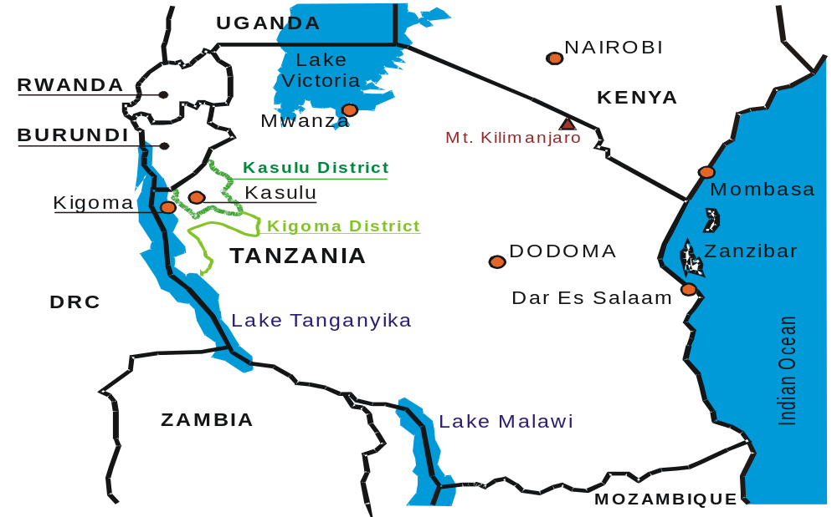1.2 Background for the evaluation

The purpose of the final evaluation was to assess the extent to which the TUMA UMA and KEMP projects have achieved their objectives and determine how their interventions/results can be sustained beyond the project tenure.

Based on the terms of reference (Annex 1) specifically the evaluation aimed at:
- Establishing the extent to which the objectives of the projects have been achieved. (In villages surrounding Refugee camps and in other local community areas).
- Identifying the challenges the projects have faced.
- Assessing the extent to which the interventions/results/impact are sustainable
- Outline the lessons learnt with regard to design and implementation arrangements of projects concerning sustainable livelihoods in the context of natural resource management.
- Drawing up lessons learnt, paying particular attention to the dynamics involved in securing equitable share of responsibilities, rights and benefits relating to natural resource management, sustainable agriculture, economic development and gender issues in community participation; the roles and voices of the vulnerable groups, MMD Savings and Credit model’s effectiveness in supporting sustainable livelihoods and natural resource management.
- Establishing and proposing what needs to be done to sustain the projects’ interventions/impacts.

2. METHODOLOGY

A participatory method was used for conducting the final evaluation. It involved literature review, consultations, development of questionnaires and Logical Framework, consideration of common aspects for monitoring and evaluation, field visits, data analysis, preparation and presentation of draft report to the client for comments and improvements and submission of final report that incorporated comments received from the client and other stakeholders. Key aspects covered are highlighted.

2.1 Literature review

Intensive review of project documents and other relevant literature was conducted to enhance understanding of the project, identify its main strength, weaknesses, opportunities and challenges. This included reviewing sector policies, development strategies and legal instruments linked to the Project development goal to establish the multi-sectoral linkages of the project with other sectors dealing with sustainable agriculture and natural resources management, income generating and poverty reduction (Annex 2 has a list of, TUMA UMA, KEMP and National Policies and Strategies references consulted).

2.2 Consultations

Consultations were made with Project staff, relevant stakeholders and villagers to clarify and share experiences learned from the literature review and field visits. (Annex 3 has a list of Government and NGOs officials contacted and Annex 4 a list of villagers contacted).

2.3 Development of questionnaires

In collaboration with TUMA-UMA and KEMP project staff, some guiding questionnaires were developed specifically for TUMA-UMA and KEMP to enhance collection of relevant information and data from project stakeholders and local communities.

2.4 Field visits

Field visits were conducted to 3 representative sample villages out of the 5 villages covered by the TUMA UMA project representing 60% of the project areas. Villages visited were Kazuramimba, Pamila and Matendo.

In addition 3 villages out of the 19 villages and 2 refugee camps out of the 5 camps covered by KEMP were visited. Names of visited villages were: Mugombe, Basanza and Buhoro. Refugee camps visited were: Mtabila and Muyovosi. Selection of the sites visited were jointly discussed and agreed by project staff and relevant stakeholders to enhance sharing of field experiences and cover a realistic study sample areas. In collaboration with TUMA –UMA and KEMP project staff a detailed schedule for field visits was prepared and it was agreed to make pre-appointments to officials and community groups to be visited. The field visits were conducted from 9th to 16th July 2006.

Participatory discussions with stakeholders were free, democratic and gender sensitive during field visits. Rule of thumb during discussions was that there was no teacher/pupil relationship as such every one in the discussion group had something to contribute to the process of accelerating participatory conservation of sustainable natural resources, improvement of food security, livelihoods and social status. Main objective was to encourage stakeholders to learn from their own experiences and to gauge stakeholders’ satisfaction on the contribution of the project to improvement of their livelihoods and poverty reduction. Since agreement by group consensus is usually the key factor in enhancing changes to a community, participatory discussions provided an opportunity to stakeholders to reach a consensus on future strategies for sustaining the project.

2.5 Data analysis and preparation of draft and final report

Data analysis and preparation of first draft report were made after the field visits. The first draft report was circulated to project stakeholders for comments. Later a final report was prepared taking into account comments and suggestions received from the project stakeholders.

2.6 Presentation format

In the field, TUMA UMA and KEMP are implemented separately with different project documents and management. To enhance clarity, analysis and findings of the two projects are presented as follows: section 3 covers TUMAUMA and Section 4 covers KEMP. While the other sections covers both projects.

3. TUMAUMA PROJECT

3.1 Development Objective

The development objective of TUMA UMA is “Sustainably improved food security and economic livelihood and social status of 5 villages in Kigoma District”

The development objective recognises that poverty is a multi dimensional issue, which cannot be reduced by focussing on one single aspect of it. Improved food security will allow farmers to concentrate on needs other than the most basic. Increased access to cash and economic security will allow them to meet needs like school fees, health expenses, improvement of housing standards, etc. However, poverty also has a structural dimension. The poor and marginalized have a limited say in local policy issues that concern their livelihoods and social status. Confidence is often very important for active participation of individuals in the development of their own lives and community. The overall objective will be evaluated by using indicators on poverty, food security, environmental degradation, and local decision making processes.

3.2 Immediate objectives

The TUMA UMA project had two immediate objectives namely:
- Informed male and female farmers continuously and sustainably improve profitability of agricultural production (with three defined out).
- Empowered farming households are strengthening their efficiency, effectiveness and negotiating power (with two defined outputs).

3.3 Institutional arrangements

CARE International - Tanzania has the overall responsibility for the project implementation with a manager and supporting staff stationed at Kigoma town. According to the initial project document, the manager was to be supported by a Programme Coordinator who will be responsible for supporting and providing administrative and financial oversight of the two DANIDA funded projects (TUMA UMA & KEMP). TUMA UMA officials reported that the programme coordinator worked for only a short period with the project.

The CARE Tanzania Country Office is providing technical, administrative and financial support services to the project and monitoring its success. CARE is also responsible to build the capacity of its local partner particularly in the fields of report writing, computer skills, management and organisational development.

Kigoma District Council officials in particular Agricultural Extension Officers are collaborating with TUMA-UMA in implementing field activities. However, there is no formal written Memorandum of Understanding (MOU) between CARE and Kigoma District Council on their specific responsibilities and resource sharing in implementing the project.

3.4 Extent to which the development objective and immediate objectives of TUMA-UMA were achieved

3.4.1 Project monitoring and evaluation plan
A monitoring and evaluation plan for the project was not prepared at its initial preparation stage. Most of the outputs in the project document were stated in qualitative terms hence difficult to evaluate quantitatively. Nonetheless, quarterly and annual reports indicated targets and achievements for activities implemented that were used for evaluating the project.

3.4.2 Analysis of annual implementation achievements against targets (2004 - 2006)
Quarterly and annual implementation progress reports were used to analyse annual implementation achievements against targets for the period 2004 – 2006 (Table 1). Observations during field visits and discussions with stakeholders were also used to substantiate the reported achievements. Attained achievements and key observations are highlighted.

Immediate objective 1. Informed male and female farmers continuously and sustainably improve profitability of agricultural production

It had three outputs namely:
- Establish and maintain community management extension service responsive to farmers needs.
- Introduce, testing and developing new agricultural technologies
- Effective performance management of district staff developed.

Based on analysis in table 1, achievements for output (i) was very successful with an average ranking of 119%; for output (ii) achievement was satisfactory with average ranking of 61% and for output (iii) achievement was poor with average ranking of 19%. Most of the quarterly progress reports indicated that performance of district extension workers (VFOs) was unsatisfactory.

The project involved and trained a total of 56 farmers intensively to become extension agents – Farmer Facilitators (FF) – within their own and neighbouring communities. This training and coaching is building capacity within the community to allow farmers (male and female) access useful services when they need them rather than having to rely on the public extension services, the Village Field Officers (VFOs) of the district agricultural department only. However, the FF are not working in isolation but collaborating with the VFOs.

The project document states that the achievement of the Immediate objective I (one) will be measured by evaluating profitability of agriculture (net profit per unit of land, profit margin) and marketing strategies farmers use. By evaluating profitability the project will be able to evaluate both, increase in production and improved marketing and price margins.

Significant achievements were attained in spite of the relatively short duration of the project interventions. During field visits, most of the farmers contacted confirmed that they have attained improvements in agricultural production due to TUMA-UMA interventions. For example at Matendo village Mr. Msia Erasto reported that before TUMA-UMA interventions he was getting two bags of maize (of 100kgs) per acre. With TUMA-UMA interventions that included advice on spacing, use of quality seeds, use of organic manure, timely and frequent weeding enabled him to harvest 7 bags of maize from the same field (one acre). On the other hand Mr. Filbert Kilayogele from the same village cultivated soya beans a new crop that was introduced by TUMA-UMA. He managed to harvest 5 bags from one acre plot, but the quality of the crop was reported to be poor. Out of the 5 bags, only 2 were graded as acceptable quality for sale. Nonetheless Mr. Filbert complained that he had no market for his 2 bags of soya beans.

Improvements of agricultural production yields were also reported at Kazuramimba village due to TUMA-UMA interventions. For example Ms. Tatu Abdalla reported that prior to TUMA-UMA interventions she was getting 2 bags of maize (100 kg/bag) per acre. With TUMA-UMA interventions, in 2005 season she got 4 bags and in 2006 season she got 5 bags of maize from the same acre. Similarly Ms. Hidaya Maulidi, in the same village reported that she used to harvest 1 bag of beans (90 kg) from her one acre plot. With project interventions in 2005 and 2006 farming seasons she got 2 bags and 3 bags of beans respectively.

Villagers consulted at Kazuramimba, Pamila and Matendo reported that the project has introduced improved banana farming with supply of improved banana suckers to farmers. For example mama Fedha in Kazuramimba village had planted 50 banana stems of improved variety supplied by the project that were observed to perform well with good hopes of getting a bumper crop in the near future (See photo). Shortage of the improved banana variety suckers was reported to be a limiting factor for wider banana cultivation in the villages visited.

Mama fedha banana stems
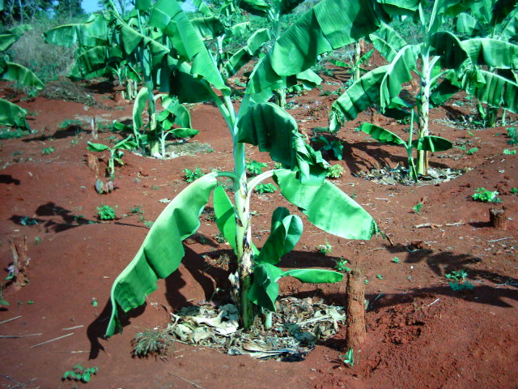

Immediate objective 2: Empowered farming households are strengthening their efficiency, effectiveness and negotiating power

It had two outputs namely:
- Farmers are capable of making informed choices on crop diversification, marketing and timing of sales through improved access to information and knowledge about agricultural marketing.

- Active farmer groups and associations established, formalised and linked up with each other.

Based on data in table 1 substantial achievements were reported reaching over 2,300 farmers. However, a record showing names of the farmers reached with some indication on gender, age, education level, wealth ranking and their villages of origin were not available. Such a record could have enhanced follow-up and assessment of the project impact to individual farmers.
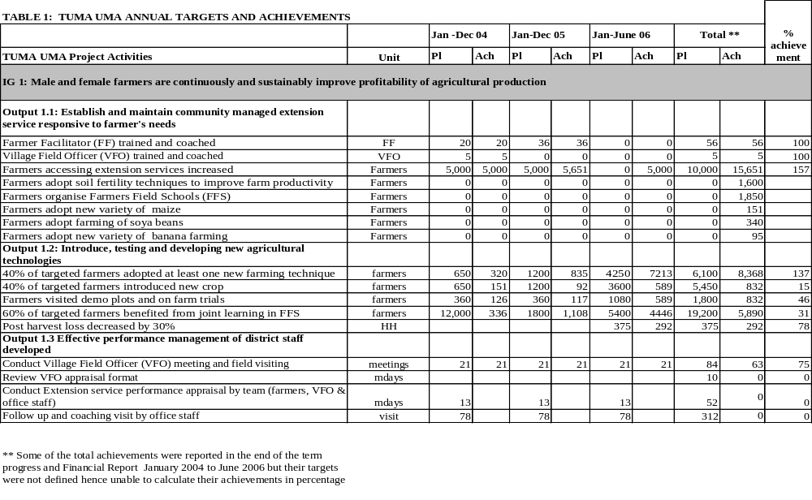

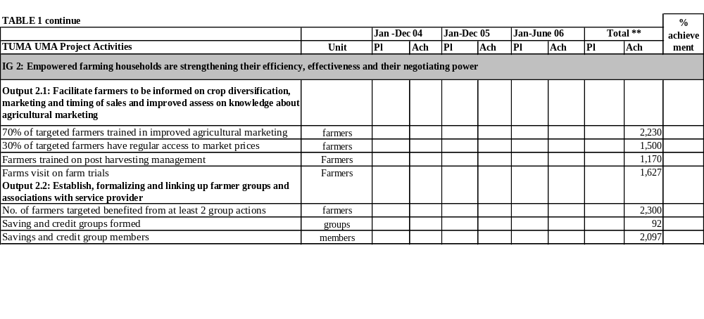

3.4.3 Analysis on the extent of gender and community participation
Data desegregations by gender were adequately covered in quarterly progress reports. However, project annual reports were rather silent on gender aspects hence not reflecting the true field situation.

Socio-economic data on the participating communities with respect to age, education and wealth ranking were not collected. Availability of these data could enhance evaluation on how certain activities of the project are having real impact on women’s, youth and men’s lives, rather than the current practice of counting and reporting numbers of those participating communities in a holistic form. Wealth ranking will also help to illustrate which income group is the project assisting, the rich or poor?

The final evaluation team collaborated with the project management to review and extract data on gender involvement for different project activities of which the results are summarised in Table 2 and Figure 2. Based on table 2 women involvement in the overall project accounted for around 55 percent.

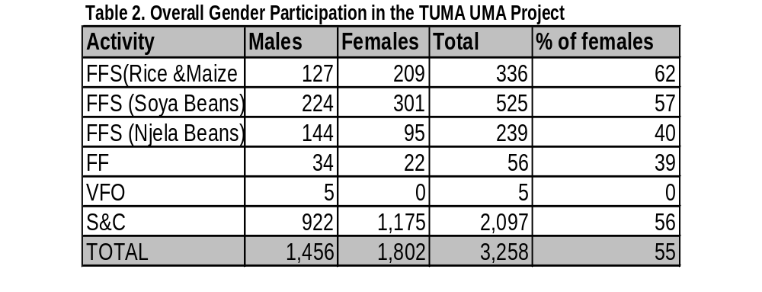

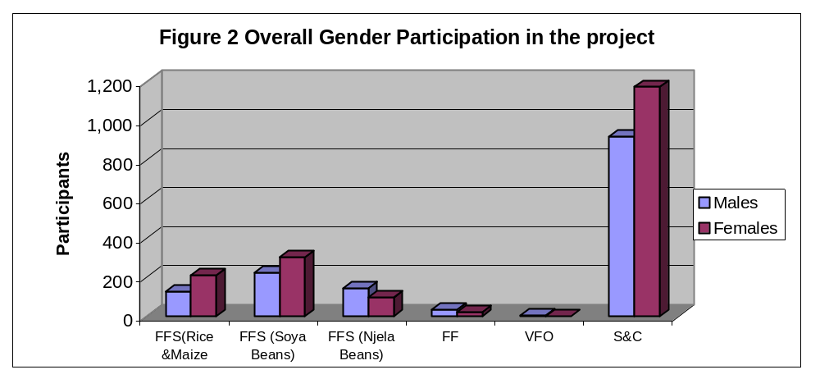

The final evaluation team also collected data on gender and age group coverage for participants who attended the final evaluation meeting at three villages namely: Kazuramimba, Matendo and Pamila villages. In overall, women participants accounted for 67% (Table 3 and Figure 3).

With respect to age, results showed that people in the age group 40-49 dominated, accounting for 35% at Matendo and 41% at Pamila village out of the total participants who attended the meetings. The second group were people in the age group 30-39 years that accounted for 29% at Matendo and 32% at Pamila village (Figure 4 to 7).
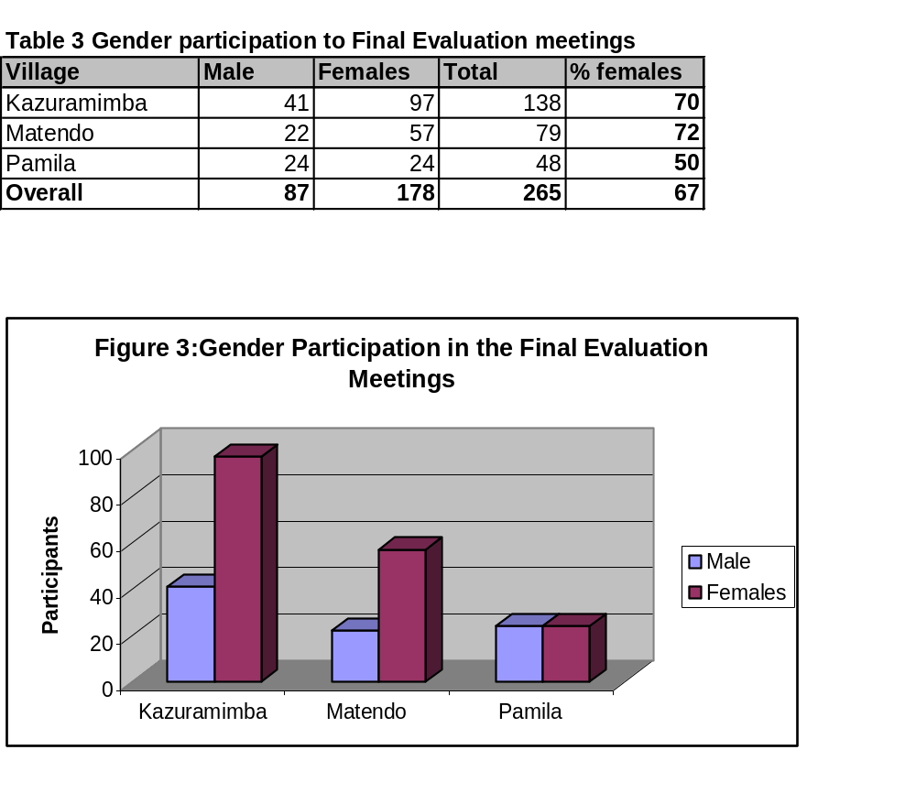

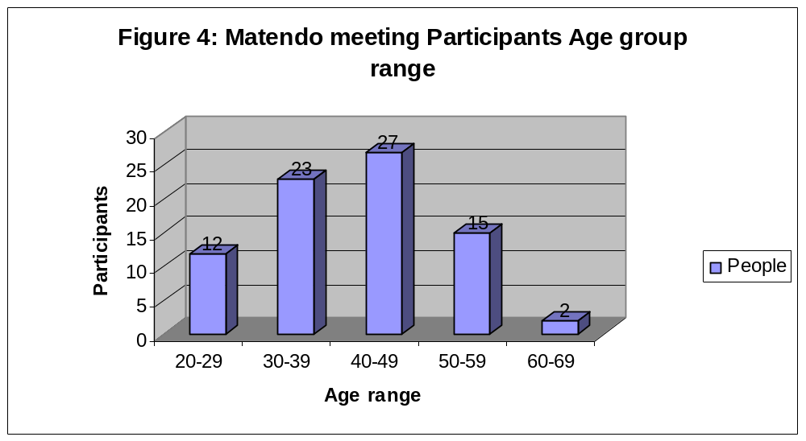

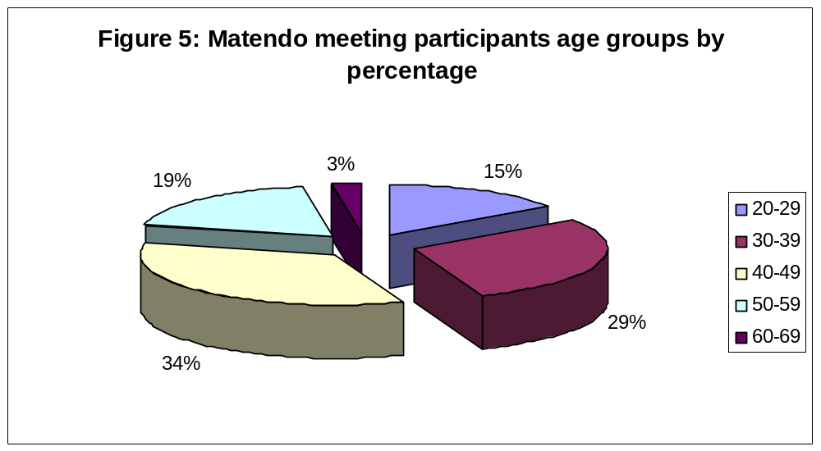

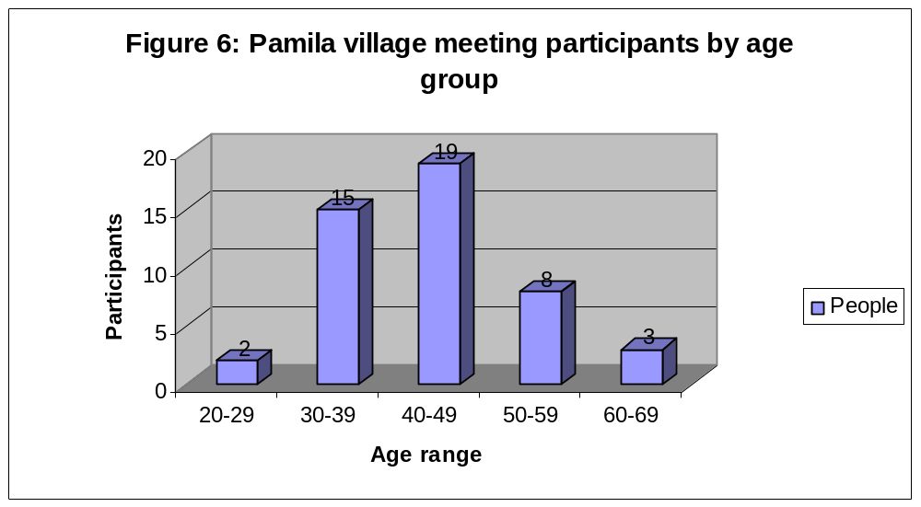

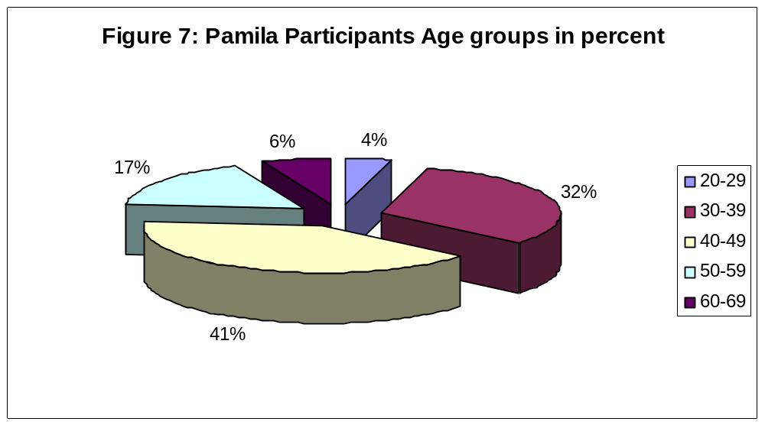

3.4.4 Strength and weaknesses on project partnership and institutional arrangements
Strength
The main institutional strength of the project is that it is based on community participation with multi sectoral cooperation with relevant stakeholders. Review of National Strategies and relevant Sector Policies (Annex2) confirmed that the project vision, development objective and immediate objectives are in line with the overall national strategies, MDGs and sector policies with the emphasis to poverty reduction, improvement of community livelihoods and sustainable environmental conservation. As such, the project implementation strategy is enhancing opportunities for multi-sectoral cooperation.

Weaknesses
The main weakness of the project was the strategy of using Farmer Facilitators (FF) to conduct extension services to fellow farmers with no specific working terms of reference and remuneration scheme in the pilot phase. As a result the FFs are serving the project at their own costs, while Village Field Officers (VFOs) working at the same village level are paid salaries by the government and the project is providing them with additional top up of TZS 30,000 per month and a provision of a bicycle. This weakness was reported in almost all the quarterly reports but it is not yet solved.

Various project reports, studies and discussions held with villagers during the final evaluation field visits confirmed that FF were very instrumental in project interventions but they are demoralised by the lack of incentives. On the other hand, there was a general consensus from villagers that the contributions’ of VFOs in project implementation was insignificant. For example during the final evaluation team meeting at Pamila, villagers reported that the VFO had not provided extension services in their village for several months. Surprisingly the VFO who was also present in the meeting did not comment on the complaint raised. Villagers reported with concern that most VFOs are paid for filling a position in their village and not a function while FFs are working for free. It was proposed to prepare clear TORs for the FFs and VFOs, with a comprehensive monitoring and evaluating strategy of their inputs to the project implementation.

Undefined partnership with the Kigoma District Council mainly with respect to field extension was a weakness that was reported in quarterly progress reports. Partnership is defined as “A mutually beneficial alliance between organisations where roles and responsibilities are clearly defined. Partnerships are based on a shared vision regarding the objectives of the work undertaken together. Joint contributions of resources, shared control of information and planning are key characteristics of successful partnership”

District officials consulted indicated the TUMA-UMA project is not transparent on funds used for implementing the project. Village government leaders consulted also reported that they had no clue of the amount of money spent by the project in their villages hence weakening effective partnership and good governance. The project management reported that their financial reports were for CARE-TZ headquarters and donors.

3.4.5 Effectiveness of progressive project monitoring and evaluation

The effectiveness of progressive TUMA UMA monitoring and evaluation (M&E) was analysed by considering the: project management understanding the concept of M&E as an implementation tool; applying M&E results to project planning and consideration of key monitoring and evaluation components for effective project management.

Understanding the concept of M&E as an implementation tool
Effectiveness of progressive project monitoring and evaluation is based on the project management understanding on the importance of monitoring and evaluation as an implementation tool. Project monitoring and evaluation is “the collection and management of information to be analysed and used for the regular and periodic assessment of a project’s or programme’s relevance, performance, efficiency and impact in the context of its stated objectives”. A project’s M&E system is a subset of the overall “management information system” and it is concerned specifically with assessing achievement of a project’s objectives.

Monitoring refers to the regular, ongoing collection, analysis and use of information within the project. Evaluation, on the other hand, is the formal, periodic assessment of available information usually involving key stakeholders within and outside the project. Project M&E is about assessing a project’s performance against its stated objectives covering development objective, intermediate objectives, outputs, activities, annual work plans and assumptions. The primary objective of project M&E is to assist the project and its partners to implement the project effectively through progressive evaluation of project implementation strengths and weaknesses. Developing an annual work-plan is the most appropriate and convenient way to produce a completed list of detailed activities to be performed each year within the activities outlined in the project log-frame.

It is also important to monitor the critical assumptions that relate to the project’s strategy, the operating context (e.g. government policy), or the contributions of project collaborators that were envisaged at the project design stage as being critical to the success of the project. As a project proceeds it is important to check that the assumptions were, firstly, realistic and, secondly, that they remain valid.

Experience has shown that output level assumptions should be reviewed annually in order to flag out key achievements and problems. Key issues to be considered will include the development of new legislation to support policies relevant to the implementation of the project. Consideration should also be made on the validity of the TUMA UMA two immediate objectives which are: informed male and female farmers continuously and sustainably improve profitability of agricultural production and empowered farming households are strengthening their efficiency, effectiveness and negotiating power.

Applying M&E results to project planning
The main purpose of the M&E system is to guide the project planning process such that the project is both more successful and more cost effective in realising its objectives. Implementation experience has demonstrated the importance of adopting a flexible; learning approach to project management and it is the M&E system that largely provides the necessary information to facilitate adaptive management. Assuming that the project adopts an adaptive management style, which encourages staff at all levels to critically review progress achieved and modify project working strategies and plans accordingly, project planning can not be achieved without effective M&E system. Monitoring and evaluation has to cover quarterly and annual reports followed with project annual planning workshop for the next financial year.

Evaluation Components
In evaluation, the emphasis is on five main general components namely; efficiency, effectiveness, impact, relevance and sustainability. Together they represent the most important points to be taken into consideration when doing monitoring and evaluation.

Ranking of TUMA UMA Monitoring and Evaluation Effectiveness
Taking into account the M&E highlights described above, the effectiveness of TUMA UMA project M&E was considered by the final evaluation team to be weak. The underlying causes of weakness were:
- None development of comprehensive Project Monitoring and Evaluation Plan (PMEP) as proposed by the project document.
- Lack of baseline survey data on the project area.
- Non-desegregation of project data on the basis of age, education and wealth ranking.
- Lack of periodic extension services appraisal to assess satisfaction of the farmers with the services provided by the project.

Specific key weaknesses in TUMA-UMA project monitoring and evaluation are highlighted.

Weakness in monitoring and reporting project efficiency
Efficiency of project is the measure of the outputs of the project, qualitative or quantitative in relation to the total resource inputs. In other words, it is a measure on how economically the various inputs of the project are converted into outputs.

TUMA UMA progress implementation reports reviewed, and discussion with various project staff did not show a component of monitoring the project efficiency at activity level. Annual progress and financial reports provided blanket statements of total amount spent for the project in that year per output that contained various activities without analytical breakdown to indicate the project efficiency at activity level.

Lack of an updated tool to monitor effectiveness of the project
Effectiveness of a project measures the extent to which project objectives and its outputs have been achieved or can be expected to be achieved. Assessing effectiveness presupposes that the project objectives and expected outputs have been unambiguously and operationally defined so as to make verification possible. As indicated earlier, TUMA UMA project had no PMEP hence lacking a tool for monitoring the project effectiveness. Nonetheless, the field visits confirmed that TUMA-UMA had significant achievements.

Lack of baseline survey data for assessing impact of the project
The concept of impact is far broader as it includes both positive and negative consequences whether these are foreseen and expected or not. In assessing project impacts the point of departure must be the project purpose has been defined and the degree of effectiveness achieved. Then, which other effects whether negative or positive are expected or unforeseen – that have come about as a result of the project. These may be economic, social, political, technical or environmental effects.

Different impacts may appear at varying times; attention should be paid to both the short term and long term impacts of a project. TUMA UMA PROJECT had no baseline survey data to establish a bench mark for tracing changes and monitor its impact. Nonetheless field observations confirmed that on qualitative basis the impact of the project to the target community is high. Consulted villagers and other stakeholders confirmed that TUMA UMA has contributed to: raising awareness on improved agricultural crop production and successful formation of savings and credit schemes with active involvement of women.

Monitoring the project relevance
In monitoring terms, relevance is a tool to check whether the rationale behind a project is harmonised with priorities of the local community and society in question. It checks direction of the project in relation to its purpose and assessing societal changes that may have taken place while the project has been in operation, and asking to what degree this may alter the rationale for the project. Relevance is also a question of how well the project has succeeded in reaching the target groups, and whether it is directed towards areas to which the involved parties have given high priority. Periodical assessment of the project relevance was conducted on quarterly basis. Results confirmed that the project relevance is high, hence the need to extend its implementation duration.

3.5 Main challenges the project has experienced

The main challenges of the project are:
- Farmer facilitators, who are volunteers, started out with a high level of commitment to deliver extension services to their fellow farmers. However, they became discouraged after learning that the work required continuous daily long working hours with no defined incentives. As such, establishment of an effective community managed extension services in the 5 villages of Kigoma region is still a challenge.
- New agricultural crops like soya beans are introduced without comprehensive proven field trial research at the local sites also without defined and proven market for the crops. Farmers are therefore cultivating the introduced new crops at their own risk.
- Project management is experiencing difficulties to control the contribution of the government employed VFOs in conducting effective village extension services.

3.6 Sustainability of the project interventions

Project sustainability is an overall assessment of the extent to which the positive changes achieved as a result of the project can be expected to last after the project has been terminated. In many cases this is a question of the relation between the necessary use of local resources and how recipients view the project. Sustainability is the final test of project success.

Based on the final evaluation team field observations, discussions with local communities and various stakeholders, sustainability of many of the TUMA-UMA project interventions was considered to be good due to the following facts:
- It is helping local communities to improve their livelihood through improved agricultural crops production and wise use of their natural resources.
- It has initiated savings and credit groups for income generation through awareness creation and education to local communities.
- The project is in line with local community and government socio-economic development priorities on poverty reduction and sustainable agriculture.

3.7 Lessons learnt

Main lessons learnt are:
- Working in partnership needs clear understanding of roles and responsibility for each partner. Equal participation of the partners in all stages of the project implementation and decisions encourages transparency and good governance.
- Farmers learn and adopt quickly when they see and share experiences within themselves. Use of farmer field schools and cross-visits in the project sites facilitated adoption of project interventions.
- In spite of poverty, farmers can refuse to accept unrealistic prices for their crops. (This was the case for soya beans where farmers refused to accept low market prices offered by one buyer).
- There is limit of volunteerism in project implementation. Volunteers can only perform at a certain limit, as they are not paid.
- Social economic baseline survey data is a pre-requisite for evaluating impact of a project.
- Social capital is high when people work together in groups.

3.8 Proposals to sustain the project interventions (The way forward)

Key proposals are:
- The project should be extended for at least another 30 months to allow for realistic visualisation of the project development objective and immediate objectives.
- A social economic baseline survey for the project areas should be conducted to facilitate evaluation of its impact to poverty reduction and improvement of community livelihoods.
- Comprehensive and formal partnership strategy with different stakeholders involved in implementing the project should be developed and agreed upon by the partners.
- A comprehensive monitoring and evaluation plan for the project should be prepared and adopted as a pre-requisite management tool for the successful implementation of the project. In addition, the project staff should receive institutional capacity training in project monitoring, evaluation, analytical project report writing skills, gender and wealth mainstreaming.

4. KIGOMA ENVIRONMET MANAGEMENT POJECT (KEMP)

4.1 Development Objective

The development objective of KEMP is “The natural resources and income security of 70,000 Tanzanians improved in 19 villages while the natural resources needs of 220,000 refugees in 5 camps in Kasulu and Kigoma rural districts are met without compromising the integrity of the surrounding environment or the security of women and children (traditional firewood gatherers)”

This was meant to be achieved by making land and resource use plans in local Tanzanian communities with the participation of District land, agriculture and natural resources departments, village government, and affected community representatives. The project was further encouraging Tanzanian communities to grow, nurture and protect trees for reforestation of deforested areas and increase fuel wood supply. This entailed establishment of household nurseries, tree planting and establishment of woodlots. The project also assisted Tanzanian communities, and NGOs to utilize woodland and water resources efficiently and in a sustainable way. To improve resource utilization, that saves energy and encouraging regeneration of miombo woodland over the long term. Controlled and regulated harvesting (guided harvesting) of forest products was a central activity. In addition to the environmental benefits, guided harvesting was important for the protection of women and children from sexually abused gender violence.

Village covered by KEMP in Kasulu are; Nyamidaho, Mvugwe, Nyarugusu, Mwali, Buhoro, Shunga, Mugombe, Nyakitonto, Makere, Nyachenda, Kitagata, K’nkanda and Mvinza. In Kigoma are Kazuramimba, Basanza, Chakulu, Uvinza, Mwamila and Nyanganga. On the other hand refugee camps covered by the project were; Nyarugusu, Mtabila, Muyovosi, Lugufu I and Lugufu II.

4.2 Immediate objectives

The KEMP project had four immediate objectives namely:
- Tanzanian host communities take active role in planning and management of their own and refugees’ use of natural resources in economically viable and environmentally sound manner.
- Tanzanian host communities and refugees take active measures to reduce wood consumption and replenish wood resources.
- Refugees and implementing agencies within the camps utilise woodland and water resources effectively and sustainably, and in accordance with Tanzanian natural resources laws.
- Men and women in six villages save money for investment in natural resources and other entrepreneurial activities through a project-promoted savings and credit scheme.

4.3 Institutional arrangements

CARE International - Tanzania had the overall responsibility for project implementation, which was done in close collaboration with district government departments and was focused also on capacity building of the local leaders (Village government and Village Environmental Committee) in the communities and local people in general. Natural resources were taken care of or managed by the community either on individual or group basis hence minimization of tragedy of commons on resource management. The implementation of the activities of the project was monitored through quarterly project implementation reports.

Kasulu and Kigoma district officials in particular District Natural Resources officers from both districts were collaborating with KEMP in implementing project activities.

Periodic surveys for effect level changes as well as changes related to environmental aspects were carried out using a combination of participatory methods. The ecological monitoring unit was responsible for monitoring the state of forests and forest consumption levels. Field officers reported on the implementation of the project activities including tree planting, trainings, energy saving technologies and land use planning. The information was passed to the project management to be consolidated in Project Implementation Report (PIR).

The Project Manager and CARE Tanzania accountants monitored project expenditure monthly and prepared reports to The Royal Danish Embassy (RDE) according to DANIDA regulations.

4.4 Extent to which the development objective and immediate objectives of KEMP were achieved

4.4.1 Project monitoring and evaluation plan
A monitoring and evaluation plan for the project was not prepared at its initial preparation stage. Outputs in the project document were stated in qualitative terms hence difficult to evaluate quantitatively. Quarterly and annual implementation reports were presented. However, copies of annual work plans were not available despite repeated requests by the FET during preparation of the inception report and field visits, hence it was difficult to compare and check reported annual achievements against annual work plans.

4.4.2 Analysis of annual implementation achievements against targets (2004 - 2006)
Quarterly and annual implementation progress reports were used to analyse annual implementation achievements against targets for the period 2004 – 2006 (Table 4). Observations during field visits and discussions with stakeholders were also used to substantiate the reported achievements. Attained achievements for the project immediate objectives (I.O) and its outputs are highlighted.

Immediate objective 1. Tanzanian host communities take an active role in planning and management of their own and refugees’ use of area natural resources in economically viable and environmentally sound manner.

It had four outputs namely:
- Community-based Forest Management Plans (CBFM), land use plans, and natural resources by-laws and guidelines developed
- Conflicts over resource use between refugees and nearby TZ communities discussed and resolutions made
- Village Environmental Committees (VECs) patrol system maintained
- Profitable and environmentally sustainable beekeeping undertaken

Based on analysis in table 4 and project reports, the project has made a number of achievements both in camps and communities surrounding the camps for output (i) achievement was very successful with an average ranking of 100%, where it managed to prepare land use plans and by-laws for all 19 villages as well as identification of VFR for many villages and establishment of functional village environmental Committees in all villages (Table 4); for output (ii) achievement was satisfactory with average ranking of 60% and for output (iii) achievement was poor with average ranking of 19%, while for output (iv) achievement was good with average ranking of 70%.

Under this immediate objective, the project also facilitated conflict resolution between refugees and host communities and helped them establish mechanisms for dialogue, resulting in improved cooperation for natural resources management. To a certain extent this was achieved in other villages surrounding the refugee camps, but was not the case for Buhoro village where the refugees cleared the village forest reserve, they used to come at night despite the conflict resolution agreed upon with host communities.

Under this immediate objective in output three (iii) there was a provision sub-granting program whereby community groups, cooperatives or even district offices would build incentives for conservation by providing financial resources for natural resources management or economically profitable and environmentally sound activities. But the sub-grants were not provided to the stakeholders as intended by the project during the design, hence only 22% of sub-grants were provided to District Beekeeping staff to provide technical training to local beekeepers; and to District Natural Resources office for funding demarcation of community forest reserves.

KEMP facilitated development of natural resources by-laws and guidelines with aim of protecting natural resources in 19 villages. However, by end of July 2006, the district council had not yet approved the by-laws

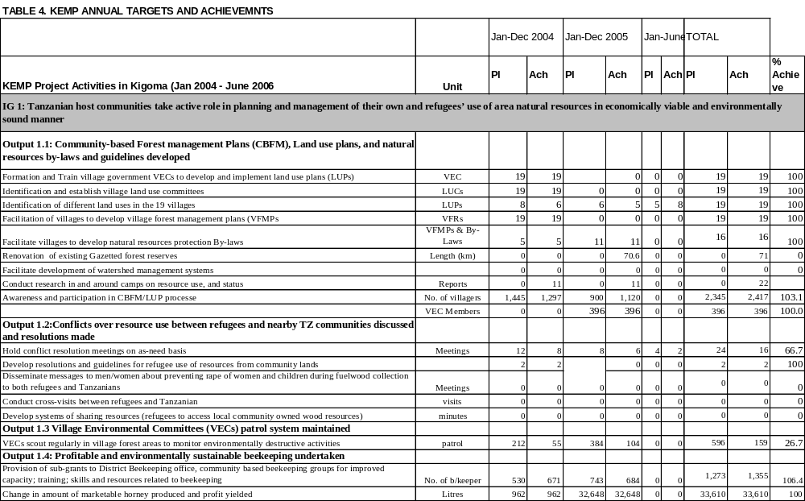
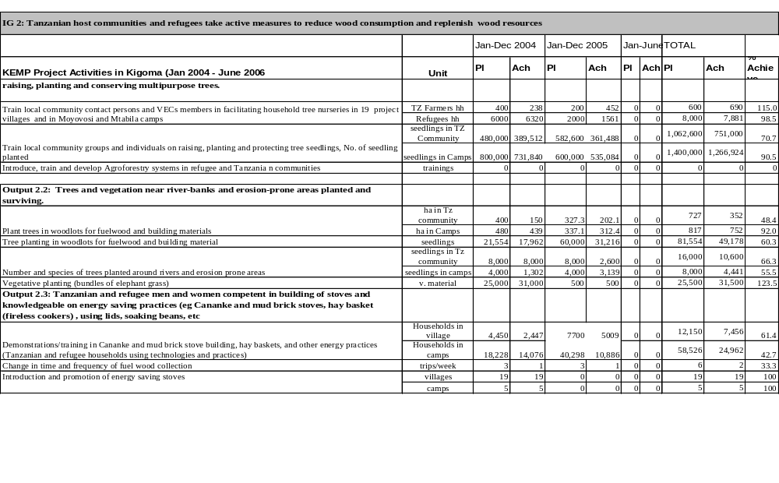

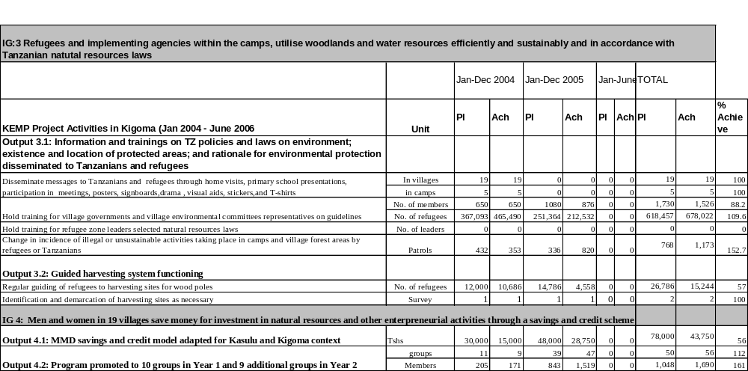

No facilitation of the development of watershed management systems was witnessed in project intervention despite being in the project design document and was one of the activities in the immediate objective I.

The project has done good monitoring of resources by conducting research in and around camps on resource use, and status which provide an insight of the ecological performance as a result of refugees’ impacts and the project intervention to reduce the impacts. Some of the researches conducted are; stove coverage survey, tree survival assessment, cultivation survey, livestock survey, wood intake survey, gap identification to Environmental Guide (EG) and VEC assessment with emphasis to gender balance (Table 5).

Table 5: Village Environmental Committee (VEC) Composition by Gender

VILLAGE | MALE | FEMALE | TOTAL
Buhoro | 12 | 12 | 24
Mgombe | 15 | 5 | 20
Shunga | 18 | 6 | 24
Nyakitonto | 18 | 6 | 24
Nyachenda | 12 | 8 | 20
Kitagata | 15 | 5 | 20
Mwali | 12 | 6 | 18
Makere | 17 | 7 | 24
Nyamidaho | 18 | 5 | 23
Mvugwe | 14 | 8 | 22
Nyarugusu | 10 | 6 | 16
Kagerankanda | 12 | 4 | 16
Mvinza | 10 | 6 | 16
Basanza | 18 | 4 | 22
Chakulu | 13 | 7 | 20
Uvinza | 14 | 5 | 19
Mwamila | 16 | 9 | 25
Kazuramimba | 17 | 8 | 25
Nyanganga | 10 | 8 | 18
Total | 271 | 125 | 396

Immediate objective 2: Tanzanian host communities and refugees take active measures to reduce wood consumption and replenish wood resources

It had three outputs namely:
- Local communities and refugees have necessary knowledge and resources for raising and planting trees.
- Trees and vegetation around watersheds, river-banks and erosion-prone areas planted and surviving.
- Tanzanian and refugee men and women competent in building of stoves and knowledgeable on energy saving practices (e.g. Cananke and mud brick stoves, haybasket (fireless cookers), using lids and soaking beans.

Based on analysis in table 4, achievements in implementing I.O two was good with an average ranking of 75%. This immediate objective was addressing the firewood shortage through reducing energy consumption and supplementing the natural firewood supply through tree planting. Also the project promoted energy saving technologies and practices in Mtabila, Nyarugusu, Lugufu I and Lugufu II camps, as well as villages surrounding the refugee camps in Kasulu and Kigoma rural districts.

The project trained Tanzanians men and women in building energy saving stoves like Cananke (mud stove), burnt brick stove and haybasket. The total number trained and using energy saving stoves by June 2006 were 7,456 households for Tanzanian community and 24,962 for refugees. KEMP further trained Tanzanian local communities around camps in energy saving practices such as use of lids, soaking grains and beans, double pot cooking, use tenderisers, fire management like smearing and drying firewood. More emphasis was put on training village environmental committee members and influential persons to enable them train others. A total of 396 VEC members were trained in the project area.

Cananke mud firewood stove at Mtabila Refugee Camp
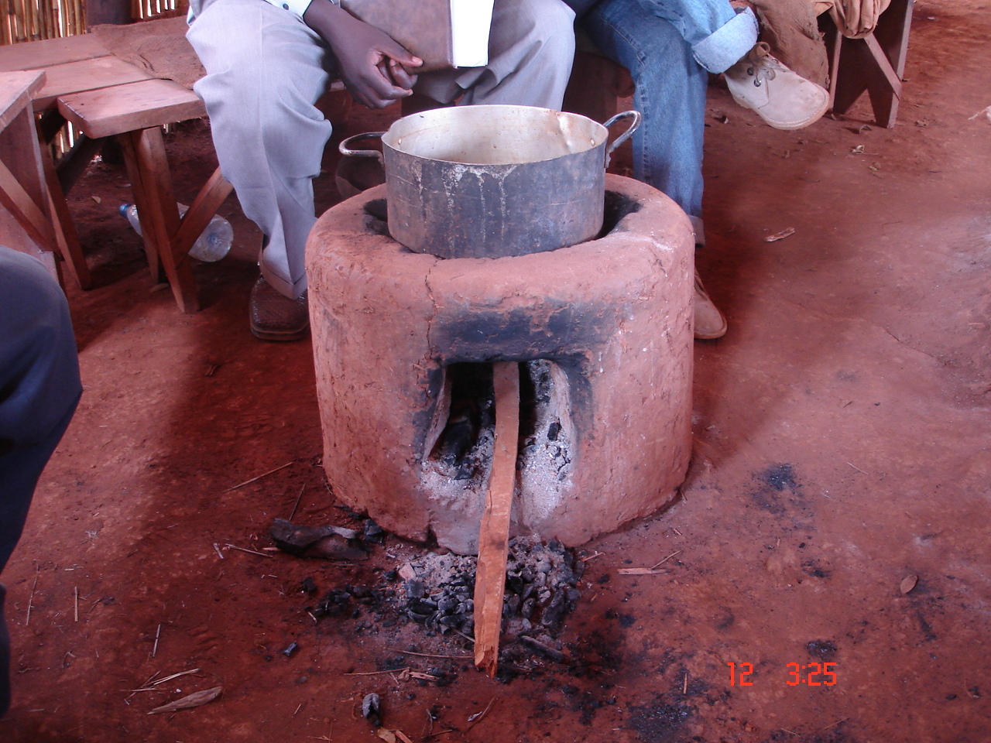

Wood intake in Refugee Camps
Following the wood intake assessment conducted in 2003 and October 2005, total wood volume that entered in the camps show some significant improvement, i.e., there was a reduction trend due to the project intervention on all camps. Especially due to introduction of improved firewood cook stove, mud bricks technology and guiding principle for firewood collection (Table 6).

Table 6 KEMP Impact on wood intake in the camps
 | Site | 2003 (Kg/day) | 2005 (kg/day) | Difference | % change
1 | Mtabila | 30,789 | 32,712 | -1,923 | -6.24
2 | Nyarugusu | 24,918 | 16,679 | 8,239 | 33.06
3 | Lugufu I | 29,035 | 14,773 | 14,263 | 49.12
4 | Lugufu II | 25,612 | 16,162 | 9,450 | 36.90

Tree Planting in Refugee Camps
KEMP trained and encouraged tree planting in forest degraded areas through development of nurseries at individual, household and group levels in the 5 refugee camps to enhance availability of firewood close to the camps. It was reported that due to firewood scarcity especially for Muyovosi and Mtabila camps women walk for up to 8 hours per trip to fetch firewood. Reported tree planting achievements by December 2005 were 474,236 with average field survival rate of 69 percent (Table 7).

During field visit at Mtabila refugee camp the final evaluation team observed remarkable tree planting successes for controlling gully erosion and in farmland on agro-forestry practices. Efforts were made to encourage planting of fast growing trees species that could be harvested for firewood within 2-3 years and for poles within 5-6 years.

Table 7: Trees planted against survived in Mtabila and Moyovosi camps
Camp | Household plots |  |  | Open area
Camp | Planted | Survived | %age | Planted | Survived | %age
Moyovosi | 135,283 | 86,254 | 63.8 | 203,068 | 133,050 | 65.5
Mtabila | 151,653 | 110,929 | 73.1 | 211,357 | 154,003 | 72.9
Total | 286,936 | 197,183 | 68.7 | 414,425 | 287,053 | 69.3
Average for both camps |  |  | 69.0
Source; CARE 2005

Tree Planting in Tanzanian Communities
During project implementation KEMP in 2004-2006 successfully established tree planting blocks in 6 villages namely: Buhoro, Nyakitonto, Shunga, Mugombe, Nyanganga and Kazuramimba. Total number of trees planted for the 2 years were 463,979, with an average survival rate of 60 percent for all six villages (Table 8). In addition, villagers are advised to encourage natural regeneration of trees in their farm lands and village forests.

Table 8: Tree planted against survived in six villages
Village | Household plots |  |  | Block farms
 | Planted | Survived | %age | Planted | Survived | %age
Buhoro | 11,549 | 9,846 | 85.25 | 128,226 | 83,955 | 65.47
Nyakitonto | 11,217 | 7,589 | 67.66 | 27,600 | 15,975 | 57.88
Shunga | 26,645 | 19,843 | 74.47 | 5,905 | 3,710 | 62.83
Mugombe | 4,904 | 3,002 | 61.22 | 69,773 | 23,263 | 33.34
Nyanganga | 10,454 | 9,280 | 88.77 | 0 | 0 | 0
Kazuramimba | 11,098 | 8,682 | 78.23 | 0 | 0 | 0
Total | 75,867 | 58,242 | 76.77 | 231,504 | 126,903 | 54.82
Average for all 6 villages |  |  | 60.24
Source; KEMP 2005

Active tree planting
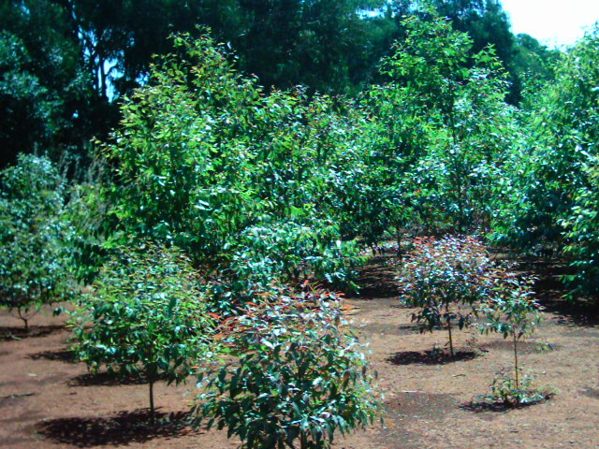

Intermediate Objective 3: Refugees, and implementing agencies within the camps, utilize woodland and water resources efficiently and sustainably and in accordance with Tanzanian natural resources laws

It had two outputs namely:
- Information and trainings on TZ laws on environment; existence and location of protected areas; and rationale for environmental protection disseminated to Tanzanians and refugees
- Guided harvesting system functioning

Based on analysis in table 4 and project reports, the project has made a number of achievements both in camps and communities surrounding the camps. For output (i) achievement was very successful with an average ranking of 92%, and for output (ii) achievement was also successful with an average ranking of 78%

KEMP in 2004-2006 focused on awareness raising campaigns in 19 villages through various methods. Where by 396 VEC member were facilitated to conduct awareness campaigns in primary schools, religious institutions, home visits, discussions with village leaders, on-site environmental guidance meetings with KEMP staff, and refugee leaders and groups. Also other 2,417 villagers were given awareness and participated in CBFM/LUP process. Methods used included participation in village government and village environmental committees meetings, posters and signboards. These approaches had proven to be effective and have reduced the level of environmental destructive activities in refugee camps. During the field visit the final evaluation team observed signboards with different environmental management messages, which were distributed to all villages bordering the reserves. The messages were about protection and conservation of forest, wildlife and other forest inhabitants.

Training the village governments and environmental committees was also done on selected Tanzanian natural resources laws, e.g., forest policy and laws, land policy and laws, beekeeping policy, environmental policy etc. However, no notes or curriculum used for training was provided to the final evaluation for assessing the contents of the trainings.

Intermediate Objective 4: Men and women in 19 villages save money for investment in natural

It had two outputs namely:
- MMD savings and credit model adapted for Kasulu and Kigoma districts context
- Program promoted to 10 groups in Year 1 and 9 additional groups in Year 2

Based on analysis in table 4 and project reports, the project has made a number of achievements in 19 village communities surrounding the camps for both two outputs. For example output (i) achievement was satisfactory with average ranking of 56% and for output (ii) was very successful with an average ranking of 137%.

In the efforts to alleviate income poverty the saving and credit scheme has been introduced to all 19 villages. More than 2,393 members organized in 82 groups are benefiting by getting loans. Savings has risen from zero Tanzanian shillings by January –2004 to TZS. 68,136,511 by June 2006. The loans has assisted community members to diversify the economic activities and augment incomes, monitoring reports depicts that out of people engaged in business who took loans from the scheme between January and December 2005, 31% of them were new entrepreneurs, and majority were women (61%). Therefore, this I.O has addressed the developmental goal of giving priority and empowering women and youth during the project intervention.

Villagers interviewed in Buhoro, Basanza and Mugombe were very happy with the intervention, but requested the project to train them on small business entrepreneurship. It was also revealed that some villagers were scared of taking loans because they had no defined business to do with the money hence lacking confidence of being able to repay back the loans.

4.4.3 Analysis on the extent of gender and community participation

Analysis of the KEMP implementation progress reports confirmed that women are involved in all project activities although at different levels. Women representations in different project activities were: CBFM/LUP process (26%), beekeeping activities (21%), savings and credit activities (61%), vegetable gardening (67%) and VEC (32%) (Table 9). Discussion held with savings and credit groups during the final evaluation field visit revealed that a number of women involved in the scheme had improved their living standards. However, the youth group is not referred to specifically in all progress reports.

Table 9 Analysis on Gender and community participation

Activity | Male | Female | Total | % Female
Awareness & participation in CBFM / LUP process | 834 | 286 | 1,120 | 26
Participation in Beekeeping activities | 534 | 143 | 674 | 21
Savings and Credit activities | 931 | 1,464 | 2,393 | 61
Village Environmental Committee | 271 | 125 | 396 | 32
Vegetable gardening (in Camps) | 1,645 | 3,693 | 5,483 | 67

Disaggregation of data on women and men is being recorded. Less so is data disaggregation by age, education, wealth or youth. It is advisable to consider more in depth case studies on how project activities are having a real impact on women’s and youth wealth creation and empowerment.

4.4.4 Strength and weaknesses on project partnership and institutional arrangements

Strength
The main institutional strength of the project is that it is based on community participation with multi sectoral cooperation with relevant stakeholders. The project vision, development objective and immediate objectives are in line with overall national strategies and sector policies with emphasis to poverty reduction, improvement of community livelihoods and sustainable environmental conservation. As such, the project implementation strategy is enhancing opportunities for multi-sectoral cooperation.

Weaknesses

- Some institutional organisation weaknesses were reported by stakeholders. Majority of the District officials consulted indicated that KEMP is not transparent on funds used for implementing the project. Village leaders (Village Governments and VECs) reported that they had no clue of the amount of money spent by the project in their villages hence weakening effective partnership and good governance. The project management reported that their financial reports were for CARE-TZ headquarters and donors but they were also accessible to other stakeholders on request.

4.4.5 Effectiveness of progressive project monitoring/evaluation

The effectiveness of progressive KEMP monitoring and evaluation (M&E) was analysed by considering the: project management understanding the concept of M&E as an implementation tool; applying M&E results to project planning and consideration of key monitoring and evaluation components for effective project management.

Ranking of KEMP Monitoring and Evaluation Effectiveness
Taking into account the M&E highlights described above (Section 3.4.5), the effectiveness of KEMP M&E was considered by the final evaluation team to be weak. The underlying causes of weakness were:
- None development of comprehensive Project Monitoring and Evaluation Plan (PMEP)
- None preparation of comprehensive annual work plans (AWPs).
- Lack of baseline survey data on the project area.

It should be noted that the FET repeatedly requested for the above reports, during preparation of the evaluation and during the field visits in Kigoma region but failed to get copies. However, the project management commented on the first draft report that the reports cited above exists at least in draft form.

Specific key weaknesses in KEMP monitoring and evaluation are highlighted.
Weakness in monitoring and reporting project efficiency
KEMP progress implementation reports reviewed, and discussion with various project staff did not show a component of monitoring the project efficiency at activity level. Annual progress and financial reports provided blanket statements of total amount budgeted and spent for the project in that year per output that contained various activities without analytical breakdown to indicate the project efficiency at activity level.

Lack of an updated tool to monitor effectiveness of the project
As outlined above, KEMP had no PMEP and defined AWPs. Tools for monitoring the project effectiveness were therefore lacking. Nonetheless, the field visits confirmed that KEMP had significant achievements, especially on public awareness on environment and natural resources conservation, tree planting in both camps and local communities, introduction of improved firewood cook stove and S&C scheme.

Lack of baseline survey data for assessing impact of the project
As indicated earlier, KEMP had no baseline survey data to establish a benchmark for tracing changes and monitor its impact. Nonetheless field observations confirmed that on qualitative basis the impact of the project to the target community is high. Consulted villagers and other stakeholders confirmed that KEMP has contributed to: raising awareness on environmental conservation, establishment of village forests and by-laws, development of land use plans and successful introduction of savings and credit schemes with active involvement of women in all 19 villages.

Monitoring the project relevance
Periodical assessment of the project relevance was conducted on quarterly basis. Results confirmed that the project relevance is high, hence the need to extend its implementation duration.

4.5 Main challenges the project has experienced
Challenges faced by the project includes:
- Some of the community members and stakeholders working with CARE have high expectations of personal gains from the project instead of community gains.

- The project experienced difficulties to enhance effective guiding of refugees to accepted firewood harvesting sites as demand of firewood was higher than the supply potential with no provision of alternative sources of energy for refugees cooking.

- Low financial position of majority of Kasulu farmers limits their participation in the Savings and credit schemes introduced.

- Lack of business skills has scared people to borrow money from the Saving and Credit schemes due to fear of failing to return the borrowed money.

- The 90 days set for initial payback of Savings and Credit loans is rather short for income activities related to farming and beekeeping that takes a longer period to mature.

- Some villagers and refugees have developed high dependency syndrome hoping that the project will spoon feed them by covering costs of all project activities even those activities that could be implemented by the villagers and refugees on participatory efforts i.e., raising of tree seedlings.

4.6 Extent to which the interventions/results/impact are sustainable

Sustainability rate of the project interventions were rated to be high as they are improving livelihood through environmental protection and management by involving and empowering the community through training and income generating activities such as beekeeping and savings and credit activities.

The idea of establishing VEC through the entry point of village government, and the training and use of local facilitators for training their fellow villagers on tree planting, S&C, vegetable growing and improved stoves will enable the project interventions to be sustainable even after the project end. The establishment of S&C network will cement further the S&C groups hence making them sustainable.

The project brought about social capital between the communities in the project areas through communal involvement in various project interventions in groups, especially in S&C activities. In so doing the villagers are united and look at each other as relatives.

4.7 Lessons Learnt
Main lessons learnt were:
- Working in partnership needs clear understanding of roles and responsibility for each partner. Equal participation of the partners in all stages of the implementation and decisions encourages transparency and more ownership.

- Tanzanian and refugees’ communities learn and adopt quickly when they see and share experiences.

- Tanzanian and refugees communities are eager to plant fast growing trees species for production of firewood and building poles.

- Progressive institutional capacity building to the local community through training of VEC and other village members on tree growing, environmental conservation and S&C schemes will instil the sense of ownership and empowerment of the community in sustaining the project initiatives.

- Adoption of the improved firewood stoves in both Tanzanian and refugee’s communities was high due to scarcity of firewood.

- KEMP initiatives of conducting conflict resolution meetings between refugees and Tanzanian communities enhance good living and working co-operations between the two communities.

Proposals to sustain the project interventions (The Way Forward)

KEMP provide enabling environment to local communities to improve their livelihood and environmental conservation. At the end of the project the local community through their own initiatives will continue to implement KEMP activities that have direct benefits to them and within their capacity. Activities that villagers indicated they will continue to implement include: beekeeping, creation and conservation of village forest reserves through CBFM and continue with Savings and Credit initiated by KEMP and networking to enhance sharing of sustainable livelihood and conservation experiences. KEMP should also educate the communities to reduce the dependence syndrome, especially on tree planting activities because they depend on the project for provision of all materials for establishment of tree nurseries. This may result into un-sustainability of the activity after the project closure.

Extension of the project to second phase will also intensify achievement of the project developmental objective. The objective is still valid and in line with Tanzania National Strategy for Growth and Reduction of Poverty (NSGRP), Tanzania Development Vision 2025 and the Millennium Development Goals (MDGs). As such extension of the project will provide an opportunity of realising many of the positive impacts of the project that are currently at infancy stage.

During the field visit it was observed that more community/village members are increasingly willing to join savings and credit groups. Therefore, these popular savings and credit groups could also be used as an entry point to other disciplines such as HIV/AIDS and conservation awareness rising, because the disease has direct impacts on communities’ daily lives.

Other key proposals are:
- The project should be extended for at least another 30 months to allow for realistic visualisation of the project development objective and immediate objectives.

- A social economic baseline survey for the project areas should be conducted to facilitate evaluation of its impact to poverty reduction and improvement of community livelihoods.

- Comprehensive and formal partnership strategy with different stakeholders involved in implementing the project should be developed and agreed upon by the partners.

- A comprehensive monitoring and evaluation plan for the project should be prepared and adopted as a pre-requisite management tool for the successful implementation of the project.

5. CONCLUSIONS AND RECOMMENDATIONS

The main conclusions and recommendations from the Final Evaluation are highlighted. In order to avoid repetition, each conclusion is followed with its recommendation and comments where applicable. The conclusion and recommendation have been also separated into two sections, for TUMA-UMA and KEMP projects respectively.

5.1 TUMA UMA

Achievement of the Developmental Objective
The TUMA UMA project has contributed positively in achieving its development objective by improving food security, economic livelihood and social status of farmers in five villages in Kigoma District. However, the duration of the project was rather short hence the need to extend the project span,

Institutional arrangements
Use of FFs for extension services at village level is very effective. However, it is recommended to prepare comprehensive TORs and model of incentives to the FFs.

Institutional linkage between District Officials and CARE was low due to lack of a formal Memorandum of Understanding (MOU) between the two parties. It is recommended to prepare a comprehensive MOU in the future.

Project monitoring and evaluation plan
The project attained significant achievements in the field. Nonetheless it was weak in conducting regular monitoring and evaluation. It is recommended to train project staff in M&E skills.

Savings and credit schemes are providing good entry points for active groups formations. It is recommended to intensify the ongoing initiatives but with some emphasis in reaching the poorer section of the community.

The project has attained remarkable successes in gender mainstreaming. It is recommended to strengthen the initiative by collecting socio-economic data related to target groups’ age, education and wealth ranking.

Sustainability of many of the TUMA-UMA project interventions was considered to be good because: it is helping local communities to improve their livelihood through improved agricultural crops production and wise use of their natural resources, it has initiated savings and credit groups for income generation through awareness creation and education to local communities, and the project is in line with local community and government socio-economic development priorities on poverty reduction and sustainable agriculture. It is therefore recommended to extend the span of the project to enhance provision of successful field best practices.

5.2 KIGOMA ENVIRONMET MANAGEMENT PROJECT (KEMP)

Achievement of the development objective
In general terms, KEMP contributed positively in achieving the development objective by changing community attitudes from negative to positive environmental conservation through participatory forest management efforts. Improvement of community was also attained but on a small scale through the starting of saving and credit schemes. Remarkable tree planting efforts were observed in both camps and Tanzanian communities, as well as taking into consideration of women participation in all activities. However, due to short duration of the project it was not possible to fully realize the achievement of the project development objective.

Institutional arrangements
District Natural Resource Officers, Village Government Officials, and VEC members from Kasulu and Kigoma districts collaborated with KEMP in implementing the project. However, transparency in sharing project financial reports with stakeholders’ was reported to be weak. It is recommended to intensify sharing of project reports to enhance good governance.

Project monitoring and evaluation plan
In the field KEMP attained remarkable successes. However, its staffs were weak in conducting regular monitoring and evaluation of the project activities as they had no comprehensive monitoring and evaluation plans. It is recommended to provide periodic training to project staff in M&E skills to enhance adaptive management of the project

Both women and men in the project villages showed an increasing willingness to join savings and credit groups. It was also observed that the S&C schemes provided effective entry point to other rural development initiatives such as HIV/AIDS and environmental conservation awareness rising. It is recommended to intensify the S&C initiatives.

ANNEXES

Annex 1 Terms of Reference for the Final Evaluation of TUMA UMA and KEMP projects

1. Name of Activity: Final Evaluation – TUMAUMA/KEMP

2. BACKGROUND

CARE international in Kigoma region is implementing activities through TUMAUMA, which is a livelihood security project, and KEMP (a natural resource management project). KEMP started operating in Kibondo and Kasulu districts back in 1997 in refuge relief operations, initially to address the natural resources needs of refugees. From 1999 the project with support from the Bureau for Population Refugee and Migration (BPRM) (USA) went a step further to work with the local community in the refugee-affected areas. Kibondo district was left to be attended by another local NGO, REDESO, and CARE concentrated its activities in Kigoma and Kasulu. Initially the program targeted to address issues related to natural resources management and involved only 8 villages in Kasulu surrounding Mtabila, Muyovosi and Nyarugusu refugee camps. In January 2004 the project expanded its area of operation to 13 villages in Kasulu district and in 9 villages of Kigoma rural district with financial support from DANIDA. The project targeted to improve host community income security and ensure the natural resources needs of both refugees and host communities are sustainably met The Phase I of Danish funds will end by June 2006 and probably phase II starts by July 2006.

3. THE PURPOSE OF FINAL EVALUATION

The purpose of the final evaluation is to assess the extent to which the projects have achieved their objectives and determine how their interventions/results can be sustained beyond the project tenure.

4. THE OBJECTIVES OF FINAL EVALUATION

Specifically the evaluation will aim to:
- Establish the extent to which the objectives of the projects have been achieved. (In villages surrounding Refugee camps and in other local community areas).
- Identify the challenges the projects have faced.
- Assess the extent to which the interventions/results/impact are sustainable
- Outline the lessons learnt with regard to design and implementation arrangements of projects concerning sustainable livelihoods in the context of natural resource management.
- Establish and propose what needs to be done to sustain the projects’ interventions/impacts.
5. TASKS
The consultants among other things will carry out the following tasks.
- Review all relevant documents to gain an understanding of the document design and implementation issues
- Consult with project implementation partners for information about partnership and institutional arrangements and lessons learnt
- Develop instruments to enable collection and analysis of data
- Gather information from all relevant stakeholders
- Gather relevant information from the projects.
- Analyze the data
- Draw up lessons learnt, paying particular attention to the dynamics involved in securing equitable share of responsibilities, rights and benefits relating to natural resource management, sustainable agriculture, economic development and gender issues in community participation; the roles and voices of the vulnerable groups, MMD Savings and Credit model’s effectiveness in supporting sustainable livelihoods and natural resource management.
- Produce and present an evaluation report.

6. ACTIVITIES
The appointed Consultant will be required to develop an activity plan and methodology to be agreed by the implementing partners before embarking on fieldwork. However for the purpose of tendering the Consultant is required to submit a list of activities as part of her/his technical proposal based on these TOR and the selected methodology.

7. OUTPUTS
The consultant is expected to produce a detailed report responding to the above terms, including lessons learnt and recommendations for future or similar programs. The report will be presented in two steps as prescribed below:
  - Draft findings and recommendations should be presented as a power point presentation to a stakeholders’ workshop for their input on a scheduled date.
  - A final report not exceeding 50 pages incorporating the stakeholders’ input should be submitted both as hard and soft copies within 5 days of the draft presentation. The final report should be submitted in four spiral bound copies and the soft copy should be in MS Word sent as email attachment or on flash disk (to be returned to the consultant upon copying).

8 BUDGET
There is a set budget for the exercise, and this will serve as ceiling against which the prospective Consultants will negotiate. The Consultants are required to submit a budget based on their activity plan and resources required. The winner of the tender will subsequently negotiate the fee with CARE.

9 TIME FRAME
The consultancy is envisaged to take 22 consulting days within the period beginning the June 5th, 2006 ending June 26 ^{th.}
Tentative schedule
TASK | OUTPUT | No. OF DAYS
Reviewing and agreeing on TOR with CARE TZ, KEMP and TUMAUMA Projects and Partners | - Agreed TOR  - Contract letter | 1
Review of projects document and other relevant literature | Information of design, implementation arrangements, and implementation results | 3
Consultation with CARE and MYP staff | Information of implementation arrangements including views on efficacy and lessons learnt | 2
Development of study instruments and testing (if necessary) | Study instruments (e.g. questionnaire, interview guides, etc | 2
Field work | Field data | 7
Data analysis and preparation of draft | Draft report and proposal for way forward | 4
Presentation of draft report to stakeholders’ workshop | Stakeholders input into the report and proposal for the way forward | 1
Finalization of report | Final report and concept note for the future of Kigoma Program interventions after present phase | 2
Total |  | 22

10. PROPOSED COMPOSITION OF CONSULTANCY TEAM

A lead consultant will be a Tanzanian with extensive experience in conducting end-of-project evaluation/reviews and knowledgeable in natural resource management including forest conservation policies, acts and regulations, savings and credit, and sustainable agriculture. S/he should have at least an MSc in Forest Management/Conservation/Economics and a good knowledge in forest management issues in Tanzania. S/he should also have experience in leading high caliber consulting teams.
A Tanzanian consultant with good experience in working on issues of social development in rural or poor sub-urban environment. Should have a good knowledge of micro-enterprise development in Tanzania.
The team will work with CARE’s TUMAUMA and KEMP Project Managers and one representative from each of the other partner funding agencies
The Government will be represented by the Districts Forest officers and DALDOs of Kasulu and Kigoma districts.

Annex 2 References consulted

TUMA UMA References
TUMA UMA. 2006. End of term progress and financial report. Reporting period: January 2004 to june 2006. CARE International in Tanzania.
TUMA UMA. 2005. Project Implementation Annual Report. CARE International in Tanzania.
TUMA UMA. 2005. Annual Progress and Financial Report. Reporting Period July/2005 to December/2005. CARE International in Tanzania.
TUMA UMA. 2005. Project Implementation Report. January – March 2005. CARE International in Tanzania.
Peham. A. 2005. TUMA UMA Participatory Review. CARE Kigoma Programme.

TUMA UMA. 2004. Annual Progress and Financial Report. January 2004 – December 2004. CARE International in Tanzania.
TUMA UMA. 2004. Project Implementation Annual Report. CARE International in Tanzania.
TUMA UMA. 2004. Project Implementation Report. October – December 2004. CARE International in Tanzania.
TUMA UMA. 2004. Project Implementation Report. July – September 2004. CARE International in Tanzania.
TUMA UMA. 2004. Project Implementation Report. January – June 2004. CARE International in Tanzania.
DANIDA. 2003. Dashish Support Refugee-Affected Areas, 2003 – 2005, Tanzania. TUMA UMA Project, Kigoma District. Danish Ministry of Foreign Affaires.

KEMP References
KEMP. 2004. Project Implementation Progress Report, July – September 2004. CARE International in Tanzania.
KEMP. 2004. Project Implementation Progress Report, April – June 2004. CARE International.
KEMP. 2004. Project Implementation Progress Report, October - December 2004. CARE International.
KEMP. 2004. KEMP Kigoma District. Annual Progress and Financial Report. January – December 2004. CARE International.
KEMP. 2004. KEMP Kasulu District. Annual Progress and financial Report. January – December 2004. CARE International.
KEMP. 2005. KEMP Kigoma District. Annual Progress Report. January – December 2005. CARE International.
KEMP. 2005. KEMP Kasulu District. Annual Progress and Financial Report. January – December 2005. CARE International.
KEMP. 2005. KEMP Kigoma District. Annual Progress and financial Report. January – December 2005. CARE International.

DANIDA. 2003. Danish Support to Refugee-Affected Areas, 2003 – 2005, Tanzania. Kasulu Environmental Management Project. Danish Ministry of foreign Affaires.
CARE. 2003. A Proposal for Funding for the Kigoma Environmental Management Project. Submitted to the Royal Danish Embassy Dare s salaam. CARE International in Tanzania.
CARE. 2005. Project Progress Report, Fourth Quarter November 2004 – January 2005. Including brief annual Progress Report February 2004 – January 2005. CARE International Tanzania.
DANIDA. 2003. Danish Support to Refugee-Affected Areas, 2003 – 2005, Tanzania. Kigoma Environmental Management Project. Danish Ministry of Foreign Affaires.
KEMP. 2004. Program Report Covering BPRM Funded Activities between February 2003 – January 2004. CARE International in Tanzania.
Yanda, P. Z. and Pallangyo, N. 2005. Evaluation and Benchmark Survey of KEMP Project in Kasulu and Kigoma Districts. CARE International in Tanzania.
KEMP. 2005. Survey Report on Eroded Area in Refugee Camps of Kasulu and Kigoma Rural Districts, Kigoma Region Tanzania. CARE International in Tanzania.
KEMP. 2005. Report on Effect of Firewood Collection Using Bicycles and Trucks in Mtabila and Moyovosi Camps. CARE International in Tanzania.
KEMP. 2005. Livestock Assessment Report For Lugufu I And Lugufu II Refugee Camps, Kigoma District. CARE International in Tanzania.
KEMP. 2005. Report for Harvesting Site and Regeneration Assessment. CARE International in Tanzania.
KEMP. 2005. Tree Survival Assessment Report Conducted at Mtabila and Muyovosi Refugee Camps, and Buhoro, Shunga, Nyakitonto, Mugombe, Kazuramimba and Nyanganga Villages in Kasulu and Kigoma Districts. CARE International in Tanzania.
KEMP. 2004. Livestock Assessment Report for Lugufu I And Lugufu II Refugee Camps, Kigoma District. CARE International in Tanzania.
KEMP. 2006. Assessment Report on Environmental Destruction in Mtabila and Moyovosi Camps in Kasulu District, Kigoma Region Tanzania. CARE International in Tanzania.
KEMP. 2005. Wood Intake Survey Report for Refugees Camps in Kasulu and Kigoma Rural Districts Kigoma Region Tanzania. CARE International in Tanzania.

KEMP. 2005. Household Energy Consumption Report for Refugees Camps in Kasulu and Kigoma Rural Districts Kigoma Region Tanzania. CARE International in Tanzania.
KEMP. 2005. Crop Cultivation Survey Report for Refugees Camps in Kasulu and Kigoma Rural Districts Kigoma Region Tanzania. CARE International in Tanzania.
KEMP. 2005. Trees Inventory Report in Mtabila and Moyovosi Camps Kasulu District. CARE International in Tanzania.
KEMP. 2005. Gap Identification (Knowledge Assessment) to Environmental Guides and Village Environmental Committee Members Report. CARE International in Tanzania.
KEMP. 2005. Survey Report on Stove Coverage and Use in Project Villages of Kasulu and Kigoma Rural Districts, Kigoma Region Tanzania. CARE International in Tanzania.
KEMP. 2004. Survey Report on Stove Coverage and Use in Refugee Camps and Tanzanian Villages of Kasulu and Kigoma Rural Districts, Kigoma Region Tanzania. CARE International in Tanzania.
KEMP. 2004. Institutions and Brewing Energy Consumption Survey Report for Refugees Camps; Nyarugusu, Lugufu I, Lugufu II, Mtabila and Moyovosi Camps. CARE International in Tanzania.
KEMP. 2004. Crop Cultivation Survey in Nyarugusu, Lugufu I, Lugufu II, Moyovosi and Mtabila Refugee Camps. Kasulu And Kigoma Rural Districts. CARE International in Tanzania.
KEMP. 2004. Household Energy Consumption Survey In Refugee Camps Kasulu & Kigoma Rural Districts. CARE International in Tanzania.
KEMP. 2004. Tree Survival Assessment in Mtabila and Moyovosi Camps in Kasulu District. CARE International in Tanzania.
KEMP. 2004. Survey Report on Stove Coverage and Use in Refugee Camps and Tanzanian Villages of Kasulu and Kigoma Rural Districts, Kigoma Region Tanzania. CARE International in Tanzania.
KEMP. 2004. Wood Intake Survey Report for Refugees Camps in Kasulu and Kigoma Rural Districts Kigoma Region Tanzania. CARE International in Tanzania.
KEMP. 2004. Assessment Report on Eroded Area in Refugee Camps of Kasulu and Kigoma Rural Districts, Kigoma Region Tanzania. CARE International in Tanzania.
KEMP. 2004. Forest Resource Assessment For Kagerankanda Road Harvesting Site. CARE International in Tanzania.

KEMP. 2004. Report on Mud-Brick Shelter in Refugee Camps of Kasulu and Kigoma Rural Districts, Kigoma Region Tanzania. CARE International in Tanzania.

NATIONAL STRATEGIES AND SECTOR POLICIES REVIEWED
MEM. 2003. National Energy Policy. Ministry of Energy and Minerals. Government Printers, Dar es Salaam, United Republic of Tanzania.
Ministry Education and Culture. 1995. National Education and Training Policy. Dar es Salaam, United Republic of Tanzania
Ministry of Agriculture and Livestock. 1997. Agriculture and Livestock Policy. Government Printers, Dar es Salaam, United Republic of Tanzania.
Ministry of Community Development Women Affairs and Children. 1996. National Community Development Policy. Government Printers, Dar es Salaam, United Republic of Tanzania.
Ministry of Community Development Women Affairs and Children. 2003. Kitita Cha Teknolojia Sahihi zinazopatikana Tanzania. Government Printers, Dar es Salaam, United Republic of Tanzania.
Ministry of Community Development Women Affairs and Children. 2000. National Policy on Women Development and Gender. Government Printers, Dar es Salaam, United Republic of Tanzania.
Ministry of Health. 2003. Health Sector Strategic Plan 2003-2010. Dar es Salaam,
United Republic of Tanzania
Ministry of Health. 2003. National Health Policy. Dar es Salaam, United Republic ofTanzania
Ministry of Industry and Trade. 1996. Sustainable Industrial Development Policy – SIDP (1996 – 2020). Dar es Salaam, United Republic of Tanzania.
Ministry of Industry and Trade. 2003. National Trade Policy. Dar es Salaam, United Republic of Tanzania
Ministry of Industry and Trade. 2005. Small and Medium Enterprise Development Policy . Dar es Salaam, United Republic of Tanzania
Ministry of Transport and Communication. 2003. National Information and Communications Technology Policy. Dar es Salaam, United Republic of Tanzania.
Ministry of Transport and Communication. 2003. National Transport Policy. Dar es Salaam, United Republic of Tanzania.
Ministry of Water and Livestock Development. 2002. National Water Policy. Dar es
salaam, United Republic of Tanzania
Ministry of Works. 1996. National Construction Industry Policy. Dar es Salaam, United Republic of Tanzania
MLHSD. 1997. National Land Policy. Ministry of Lands, Human Settlements and Development. Government Printers, Dar es Salaam, United Republic of Tanzania.
MNRT. 1998. National Forest Policy. Ministry of Natural Resources and Tourism. Government Printers, Dar es Salaam, United Republic of Tanzania.
MNRT. 1998. National Beekeeping Policy. Ministry of Natural Resources and Tourism. Government Printers, Dar es Salaam, United Republic of Tanzania.
MNRT. 1998. The Wildlife Policy of Tanzania. Ministry of Natural Resources and Tourism. Government Printers, Dar es Salaam, United Republic of Tanzania.
URT. 1999. The Tanzania Development Vision 2025. Government Printers, Dar es
Salaam, United Republic of Tanzania.
URT. 2002. Household Budget Survey 2000/01. National Bureau of Statistics, President’s Office, Planning and Privatization. Dar es Salaam, Tanzania.
URT. 2003. Tanzania Census: 2002 Population and Housing Census General Report. Central Census Office, National Bureau of Statistics, President’s Office, Planning and Privatization. Dar es Salaam, Tanzania.
URT. 2005. National Strategy for Growth and Poverty Reduction. President’s Office, Ministry of Planning, Economic and Empowerment. Dar es salaam, Tanzania
VPO. 1997. National Environment Policy. Government of the United Republic of Tanzania, Vice President’s Office, Dar es Salaam, Tanzania.
VPO. 1998. The National Poverty Eradication Strategy. Vice President’s Office, Dar es Salaam, United Republic of Tanzania.
VPO. 2000. Poverty Reduction Strategic Paper. Government of the United Republic of Tanzania, Vice President’s Office, Dar es Salaam, Tanzania.

Annex 3. List of Government and NGO officials contacted

NAME | DESIGNATION | EMAIL – PHONE
REGIONAL OFFICE
Halima Y. Kasungu | Regional Commissioner – Kigoma | halimakasungu@yahoo.com 0784 369797
Orata Michael Dr; | Regional Livestock Advisor Kigoma
Peter Mnunduma | Regional Trade Advisor | petermnunduma@yahoo.com
Pasian Magere | Agricultural Adviser
UN AGENCIES KIGOMA
Laizer Raphael Laishiro | FAO – National Project Coordinator –Agricultural Component | raphaellaizer@yahoo.co.uk 0784 659204
Michael Okio | WFP Finance and Administrative Assistance | Michael.okio@wfp.org
Penina Sangiwa | WFP Programme Assistant | Penina.sangiwa@wfp.org
KIGOMA DISTRICT
Henty Orauya Clemens | District Commissioner – Kigoma | orauyaclem@hotmail.com 0731 262608 or 0744 266804
Kweka | Ag. District Executive Director – Kigoma
Filbert Itanisa | DANIDA Coordinator
Alex Butoto Paulo | Agriculture District Coordinator (FAO Project) | kigomadistrict@yahoo.com  0282802268 or 0784 824265
Dickson D. Maruchu | DALDO – Kigoma Vijijini
TANESCO
Shigela | TANESCO Regional Manager – Kigoma | rmkigoma@tanesco.co.tz, shigela20042003@yahoo.com
Charles Edward Masanja | TANESCO Plant operation manager | c.edward@tanesco.co.tz

NAME |  | DESIGNATION | EMAIL – PHONE
NGOS
Mulaga Lukondo |  | Executive Secretary CARITAS – Kigoma | caritaskg@mwanza.online.com  28 280 3657 0r 0746 617751
 |  | CARE International Tanzania
Dr. Hamimu Hongo |  | Director FELISA | hahimuh@yahoo.com  0784 406688  028 2804904
Donald R. Orota |  | Chief Engineer – FELISA | drovotta@yahoo.com  0713 652222
KASULU DISTRICT
 | District Commissioner Kasulu
Hadriani Kayombo. | District Executive Director – Kasulu |  | Hadrianik1@yahoo.com,kasulucouncil@yahoo.com  0713 293575 0r 0784 310176
Sadock Masinde | District Accountant |  | masindesado@yahoo.com 0787163950
Amos Lenganya | Planning officer |  | 0746581238
Odiliva Kasindi Thadeo | District Statistical Officer |  | 0743039487
Bugulim. S. | Senior Assistant Fisheries Officer – Box 97 Kasulu |  | 0713 260583
Godfery A. Mahendeka | Senior Assistant Forest Officer Box 97 Kasulu
Tresphory A.J. Kapondo | Assistant Forest Officer Box 97 Kasulu
Fransis Kaloza Bukuru | Assistant Fisheries Officer Box 97 Kasulu
Dr. Michael Mwandri | District Medical Officer – Box 54 Kasulu |  | mwari@yahoo.com  028 – 2810324
Venance B. Mweko | Kasulu Hospial Administrator |  | 0713 252050
Elfrida Abel | Principal Kabanga Teachers College Box 265 Kasulu |  | 028 2810660 or 0784 466531
Alphonce J. Mbonigabha | Principal Kasulu Teachers College Box 3 Kasulu |  | kasulutc@yahoo.co.uk  028 2810018, 0r 0717 426781 Residence 028 2810234
Shayo J.C. | Tutor Kasulu Teachers College |  | 0713 312167 or 0784 312167

NAME | DESIGNATION | EMAIL – PHONE
Sr. Henriette Mavakure | Matron | Kabanga School of Nursing Box 42 Kasulu 0717 637363 or 028 2810344
Dr. Nuru | Medical Officer | kabangahospital@bushlink.co.tz 0784 823 803
Brother Theo Call | Engineer Kabanga Roman Catholic | P.O Box 42 Kasulu or Box 71 Kigoma
REFUGEE CAMP
Eyembe B. X. | Assistant Camp Commender Mtabila Camp
Richard Majula | CARE Field Officer – Mtabila Camp | mwombemajura@yahoo.co.uk
Jasmin Mushi | Field Assistant Mtabila Camp | makomboj@yahoo.com
Kakeen Mashaka | Field Assistant Muyovosi Refugee Camp | hakeemkalunde@yahoo.co.uk  0787 912575
TUMAUMA OFFICIALS
Ladislaus M | Project Manager
Mango C. | Field Officer Sustainable Agriculture
Ngate R. | Project Officer Research, M&E
Mathias N. | Driver
KEMP OFFICIALS
Majani R. | Project Manager
Alex N. | Project Officer Research, M&E
Shabaan Wawa Limu | Administrator | CARE – Box 121 Kasulu
Majura R. | Field Officer
Mushi J. | Field Officer
Alex S. | Driver

Annex 4. Names of Villagers Contacted
A. TUMA UMA PROJECT VILLAGES

KAZURAMIMBA VILLAGE 10-07-2006
S/N | Name | Age | Sex | Designation | Education
 | Tausi Lugazama |  | F | MEMBER | n.a
 | Joyceline Joram |  | F | MEMBER | n.a
 | Tatu Abudara |  | F | MEMBER | n.a
 | Rukia Ally |  | F | MEMBER | n.a
 | Grace Hamis |  | F | MEMBER | n.a
 | Amisa Mlisho |  | F | MEMBER | n.a
 | Sijapata Saidi |  | F | MEMBER | n.a
 | Edisa Buliba |  | F | MEMBER | n.a
 | Yasinta Gervas |  | F | MEMBER | n.a
 | Asha Bakari |  | F | MEMBER | n.a
 | Habiba Kalumaze |  | F | MEMBER | n.a
 | Hadija Kassim |  | F | MEMBER | n.a
 | Mariam Mlisho |  | F | MEMBER | n.a
 | Zuena Kayegele |  | F | MEMBER | n.a
 | Maisala Mpumiye |  | F | MEMBER | n.a
 | Chausiku Yasin |  | F | MEMBER | n.a
 | Mailesi Ndiyunze |  | F | MEMBER | n.a
 | Joyceline Nzogera |  | F | MEMBER | n.a
 | Mwayaona Hussein |  | F | MEMBER | n.a
 | Yelusa Kayembe |  | F | MEMBER | n.a
 | Maria Dismas |  | F | MEMBER | n.a
 | Lekonia Maliatabu |  | F | SECRETARY | n.a
 | Adija Juma |  | F | MEMBER | n.a
 | Bestida Marko |  | F | MEMBER | n.a
 | Monica Edward |  | F | MEMBER | n.a
 | Melania Edward |  | F | MEMBER | n.a
 | Anatori Tebuye |  | F | MEMBER | n.a
 | Tausi Musa |  | F | MEMBER | n.a
 | Pendo Meshack |  | F | MEMBER | n.a
 | MwatanoYusufu |  | F | MEMBER | n.a
 | Tatu Hussein |  | F | MEMBER | n.a
 | Zaida Lutole |  | F | MEMBER | n.a
 | Hadhija Kizoya |  | F | MEMBER | n.a
 | Linas Ablallah |  | F | TREASURER | n.a
 | Veniza Andrea |  | F | SECRETARY | n.a
 | Fitina Rashid |  | F | MEMBER | n.a
 | Mariam Maulidi |  | F | MEMBER | n.a
 | Maisala Moris |  | F | MEMBER | n.a
 | Fatuma Kayamba |  | F | MEMBER | n.a
 | Florida Zeno |  | F | MEMBER | n.a

S/N | Name | Age | Sex | Designation | Education
 | Maua Vigelo |  | F | MEMBER | n.a
 | Halima Kweilusha |  | F | MEMBER | n.a
 | Misauda Vigelo |  | F | MEMBER | n.a
 | Amina Mugina |  | F | MEMBER | n.a
 | Hasia Rubaye |  | F | MEMBER | n.a
 | Hawa Hussein |  | F | MEMBER | n.a
 | Hidaya Maulid |  | F | MEMBER | n.a
 | Mukiwa Shigwa |  | F | MEMBER | n.a
 | Jonsi Mkoko |  | F | MEMBER | n.a
 | Fatuma Zuberi |  | F | MEMBER | n.a
 | Mwajemi Ally |  | F | MEMBER | n.a
 | Mwamvita |  | F | MEMBER | n.a
 | Amina |  | F | MEMBER | n.a
 | Sauda Yusufu |  | F | MEMBER | n.a
 | Stahimu Iddi |  | F | MEMBER | n.a
 | Chausiku Mutona |  | F | MEMBER | n.a
 | Joisi Mgina |  | F | MEMBER | n.a
 | Amina Iddi |  | F | MEMBER | n.a
 | Zena Juma |  | F | MEMBER | n.a
 | Siyajali Hussein |  | F | MEMBER | n.a
 | Edisa Buliba |  | F | MEMBER | n.a
 | Asia Salumu |  | F | MEMBER | n.a
 | Hawa Alfan |  | F | MEMBER | n.a
 | Andrea Simon |  | M | MEMBER | n.a
 | Ibrahim Mfanye |  | M | MEMBER | n.a
 | Jackson Jeremia |  | M | MEMBER | n.a
 | Yotamu Kahalawe |  | M | MEMBER | n.a
 | Kastori Kapacha |  | M | MEMBER | n.a
 | Eliaza Kagoma |  | M | MEMBER | n.a
 | Setti Boniface |  | M | MEMBER | n.a
 | Moris Mbiko |  | M | MEMBER | n.a
 | Hamis Samson |  | M | MEMBER | n.a
 | Fadhili Ramadhan |  | M | MEMBER | n.a
 | Issa Mvimba |  | M | MEMBER | n.a
 | Damas Mponya |  | M | MEMBER | n.a
 | Samson Ntonera |  | M | MEMBER | n.a
 | Salvatory Samson |  | M | MEMBER | n.a
 | HAMIMU Lukanka |  | M | MEMBER | n.a
 | SIMON LUKELEGWA |  | M | MEMBER | n.a
n.a- data not available

S/N | Name | Age | Sex | Designation | Education
80. | MAURIDI MAJALIWA |  | M | MEMBER | n.a
81. | JUMA HAMISI |  | M | MEMBER | n.a
82. | MUSSA NDAYAHANDE |  | M | MEMBER | n.a
83. | DANIEL SABUKURU |  | M | MEMBER | n.a
84. | SAULI MBONABUCHA |  | M | MEMBER | n.a
85. | JUMA IBRAHIMU |  | M | MEMBER | n.a
86. | YONA HITIRA |  | M | MEMBER | n.a
87. | LAZARO MUHUBIRA |  | M | MEMBER | n.a
88. | NUHU ISSA |  | M | MEMBER | n.a
89. | SAIDI KAMINONGO |  | M | MEMBER | n.a
90. | LOJAS AMONI |  | M | MEMBER | n.a
91. | ALAMU MPEPO |  | M | MEMBER | n.a
92. | JUMANNE MUSSA |  | M | MEMBER | n.a
93. | AYONI ZELUBABELI |  | M | MEMBER | n.a
94. | DANIEL MUHIBA |  | M | MEMBER | n.a
95. | EMMANUEL KENEDI |  | M | MEMBER | n.a
96. | JAKOBO KALOLI |  | M | MEMBER | n.a
97. | FREDRICK KANANDI |  | M | MEMBER | n.a
98. | PASKARI MICHAEL |  | M | MEMBER | n.a
99. | JOEL YUMVILA |  | M | MEMBER | n.a
100. | JOHN DAVID |  | M | MEMBER | n.a
101. | KASSIANO TUTU |  | M | MEMBER | n.a
102. | TOYI JAMES |  | F | MEMBER | n.a
103. | MAGRET YORAM |  | F | MEMBER | n.a
104. | MWAINE AMADI |  | F | MEMBER | n.a
105. | MAILES MUKUMBI |  | F | MEMBER | n.a
106. | JOYCE MWUYEKULE |  | F | MEMBER | n.a
107. | PELUSI ALMASI |  | F | MEMBER | n.a
108. | YUNIA LUTELEKEZA |  | F | MEMBER | n.a
109. | REHEMA IDDI |  | F | MEMBER | n.a
110. | ZABIBU YUSUFU |  | F | MEMBER | n.a
111. | PILI MRISHO |  | F | MEMBER | n.a
112. | SIJAFIKA MWAMEDI |  | F | MEMBER | n.a
113. | SHUKRANI ZUBERI |  | F | MEMBER | n.a
114. | ZAMANA HAMIS |  | F | MEMBER | n.a
115. | SAKINA IDDI |  | F | MEMBER | n.a
116. | RUKIA ALLY |  | F | MEMBER | n.a
117. | AGNESS SHINGILO |  | F | MEMBER | n.a
118. | FATUMA TUNGILAYO |  | F | MEMBER | n.a
119. | MARIAM SUNZU |  | F | MEMBER | n.a

S/N | Name | Age | Sex | Designation | Education
120. | MAISALA JUMA |  | F | MEMBER | n.a
121. | KEZIA AMOSI |  | F | MEMBER | n.a
122. | STAHIMILI JUMA |  | F | MEMBER | n.a
123. | HUSNA LAURAENT |  | F | MEMBER | n.a
124. | SOFIA BAZILIO |  | F | MEMBER | n.a
125. | ESTA ALFRED |  | F | MEMBER | n.a
126. | DEVOTA BAZILIO |  | F | MEMBER | n.a
127. | MAWAZO IDDI |  | F | MEMBER | n.a
128. | HAWA VENANSI |  | F | MEMBER | n.a
129. | ZUHURA IBRAHIM |  | F | MEMBER | n.a
130. | GELESIA ALFA |  | F | MEMBER | n.a
131. | ZUWENA AHAMADI |  | F | MEMBER | n.a
132. | AMINA MLISHO |  | F | MEMBER | n.a
133. | ZAINABU MUSTAFA |  | F | MEMBER | n.a
134. | EVEZINA RUTIBUKA |  | M | MEMBER | n.a
135. | CLEMENT SAMUEL |  | M | MEMBER | n.a
136. | DISMAS PASTORY |  | M | MEMBER | n.a
137. | TABIA JUMA |  | F | MEMBER | n.a
138 | ZAINA NTIBILINJWA |  | F | MEMBER | n.a

MATENDO VILLAGE 11/07/2006
S/N | Name | Age | Sex | Designation | Education
1 | MAGRET NKEYEMBE | F | 30 | SECRETARY | CLASS 7
2 | ANGELINA STEFANO | F | 37 | MEMBER | 0
3 | NOWERIAN STEFANO | F | 20 | MEMBER | 4
4 | PAULINA MULUBWA | F | 46 | CHAIR PERSON | 7
5 | WINFRIDA MANYULANE | F | 26 | MEMBER | 7
6 | PRISCA ELIAS | F | 35 | MEMBER | 7
7 | DAFROZA ALEXANDA | F | 23 | MEMBER | 7
8 | MERINAS BACHISHAKO | F | 49 | MEMBER | 4
9 | DENIZA BACHISHAKO | F | 45 | CHAIR PERSON | 4
10 | KELENI KABUTA | F | 60 | MEMBER | Nil
11 | TEREZIA JONAS | F | 35 | MEMBER | 7
12 | EDINA RAJABU | F | 27 | MEMBER | 7
13 | ANNA WILLIAM | F | 20 | MEMBER | Nil
14 | BERTHA KISANGANYA | F | 38 | MEMBER | Nil
15 | MERISTELA NSOGELA | F | 35 | MEMBER | 5
16 | SAFIA KALEMBE | F | 25 | MEMBER | Nil
17 | HELENA SHABANI | F | 45 | MEMBER | 7
18 | FATUMA KIZA | F | 54 | MEMBER | Nil
19 | ANNA JOEL | F | 40 | MEMBER | 7

S/N | Name | Age | Sex | Designation | Education
20 | MELISIANA MPENDA | F | 53 | MEMBER | Nil
21 | RENIA IBRAHIM | F | 45 | MEMBER | Nil
22 | NAOMI HOSEA | F | 50 | MEMBER | Nil
23 | ESTA MUSSA | F | 50 | MEMBER | Nil
24 | VAILETH MTEMBA | F | 45 | MEMBER | 7
25 | SEMENI OMARY | F | 20 | TRESURER | 7
26 | EDWINA WILLIAM | F | 55 | MEMBER | 6
27 | SOFIA KISIMBA | F | 55 | MEMBER | Nil
28 | STUMAI SHABANI | F | 32 | CHAIRPERSON | 7
29 | REOKADIA GOLAGOZA | F | 35 | MEMBER | 7
30 | SIMON LULIBHIKIYE | M | 45 | MEMBER | 7
31 | MIKAELI MUHINDWA | M | 42 | SECRETARY | 7
32 | UDILIA JANSON | F | 37 | MEMBER | 7
33 | RINASI MARIATABU | F | 80 | MEMBER | Nil
34 | JILIANI WITISON | F | 50 | MEMBER | Nil
35 | ESTA MPENUKE | F | 35 | MEMBER | 7
36 | ASHA MUSSA | F | 48 | MEMBER | 7
37 | JACKSON PAUL | M | 55 | MEMBER | 7
38 | FRORA KAMA | F | 37 | MEMBER | 7
39 | SITU IDDI | F | 29 | MEMBER | 7
40 | OLIVIA NCHIHIKI | F | 33 | MEMBER | 7
41 | LEONSIA NGEZEA | F | 34 | MEMBER | 7
42 | AGNES GAIKAMWE | F | 40 | MEMBER | 7
43 | EZENIA JOHN | F | 35 | MEMBER | 7
44 | EDWARD MATUMO | M | 55 | MEMBER
45 | PIUS EDWARD | M | 42 | MEMBER | 7
46 | ZEBEDAYO SABIBI | M | 46 | MEMBER | Nil
47 | SAIDI RUGALAMA | M | 51 | CHAIRMAN | 7
48 | FILBERT KIWAYOGEYE | M | 45 | MEMBER | Nil
49 | MARTIN LOLEGWA | M | 44 | CHAIRMAN | 7
50 | WILLIAM NDIMUCHAGA | M | 49 | TREASURER | FORM 1V
51 | MOSHI ATHUMANI | M | 40 | CHAIRPERSON | 7
52 | EMANUELI MATUMO | M | 46 | MEMBER | Nil
53 | WILISON LUTEBUKA | M | 58 | MEMBER | Nil
54 | JUMA IDDI | M | 25 | MEMBER | 7
55 | GERALD EVARIST | M | 42 | MEMBER | 7
56 | HAKUNA RUBRI | M | 42 | MEMBER | 7
57 | YOTHAM EDSON | M | 31 | MEMBER | 7
58 | SAROGE FRANCIS | F | 40 | MEMBER | Nil
59 | PERINA MTUMO | F | 45 | MEMBER | 7
60 | YOVITA PASKALI | F | 37 | TREASURER | 7
61 | REGINA JAPHET | F | 45 | MEMBER | Nil
62 | EVERINA JOEL | F | 52 | MEMBER | Nil

S/N | Name | Age | Sex | Designation | Education
63 | ELIZA HAMISI | F | 50 | MEMBER | Nil
64 | ELIZA YOHANA | F | 38 | TRESURER | Nil
65 | ASADIA BUTEME | F | 34 | MEMBER | 5
66 | JOISI LAZARO | F | 35 | TRESURER | 7
67 | MARIA MAMBO | F | 36 | FF | 7
68 | PERAJIA LAZARO | F | 32 | MEMBER | 7
69 | LUCY ERASTO | F | 25 | MEMBER | 7
70 | SALA RUBONDO | F | 27 | MEMBER | 7
71 | REGINA SUGWEJO | F | 43 | MEMBER | Nil
72 | VERINA NTUNGILAYO | F | 50 | MEMBER | Nil
73 | RUSIA KATABI | F | 40 | MEMBER | 7
74 | YAHAYA OMARY | M | 50 | MEMBER | 4
75 | KAMANA PATRICK | M | 30 | MEMBER | 7
76 | TENISON WILSON | M | 31 | MEMBER | 7
77 | ABDALLAH JAFARI | M | 43 | MEMBER | 7
78 | CECILIA MALIGABU | F | 27 | MEMBER | Nil
79 | ADAMU MILAMBO | M | 42 | MEMBER | 7

PAMILA VILLAGE 11/07/2006
S/N | Name | Age |  | Sex |  | Designation |  | Education
1 | AMRI MSAFIRI | M |  | 40 |  | FF |  | n.a
2 | ELIZABETH SANG’O | F |  | 44 |  | FF |  | n.a
3 | JEROME MARUSHA | M |  | 43 |  | FF |  | n.a
4 | PHILEMON MNYAVU | M |  | 40 |  | MEMBER |  | n.a
5 | MALAIKA NYABENDA | M |  | 46 |  | MEMBER |  | n.a
6 | ANNA KANUBO | F |  | 40 |  | MEMBER |  | n.a
7 | KENELAND ZANA | F |  | 34 |  | MEMBER |  | n.a
8 | SUZANA YUSUFU | F |  | 40 |  | MEMBER |  | n.a
9 | MAISALA NYAMWALA | F |  | 50 |  | MEMBER |  | n.a
10 | MARY MALIKI | F |  | 45 |  | MEMBER |  | n.a
11 | WINFRIDA EDWARD | F |  | 35 |  | MEMBER |  | n.a
12 | JUSILINI KOMBOLELA | F |  | 34 |  | MEMBER |  | n.a
13 | ODILIA ERNEST | F |  | 34 |  | MEMBER |  | n.a
14 | NEEMA NYAMILANGA | F |  | 28 |  | MEMBER |  | n.a
15 | SKOLA ELIAS | F |  | 35 |  | MEMBER |  | n.a
16 | SIWEMA JUMA | F |  | 32 |  | MEMBER |  | n.a
27 | ASIA YAHYA | F |  | 50 |  | MEMBER |  | n.a
18 | ANDREA MILEMBE | M |  | 60 |  | MEMBER |  | n.a
19 | P.B. MARUSHWA | M |  | 52 |  | MEMBER |  | n.a
20 | JUMANNE RUHAMBA | M |  | 0 |  | MEMBER |  | n.a
21 | SEBASTIAN MBEGA | M |  | 40 |  | MEMBER |  | n.a
22 | FRANCIS BAKOZA | M |  | 45 |  | MEMBER |  | n.a
23 | ALEX RUKOHOLA | M |  | 48 |  | MEMBER |  | n.a
24 | HAMISI MWAZI | M |  | 47 |  | MEMBER |  | n.a
25 | PHILEMON MABHABHA | M |  | 37 |  | MEMBER |  | n.a
26 | VENASI NENO | M |  | 62 |  | MEMBER |  | n.a
27 | GOD MABHABHA | M |  | 42 |  | MEMBER |  | n.a
28 | JUMANNE SHABANI | M |  | 32 |  | MEMBER |  | n.a
29 | PHILEMONI NYOGOTO | M |  | 30 |  | MEMBER |  | n.a
30 | PHILIPO NKIKA | M |  | 34 |  | MEMBER |  | n.a
31 | ABDU ADAM | M |  | 60 |  | MEMBER |  | n.a
32 | RAMADHAN KHALFAN | M |  | 45 |  | MEMBER |  | n.a
33 | MIKIDADI NASIBU | M |  | 55 |  | MEMBER |  | n.a
34 | RASHID | M |  | 52 |  | MEMBER |  | n.a
35 | PETRO CHRISTOPHER | M |  | 41 |  | MEMBER |  | n.a
36 | KURUDHU MAHAMUDU | F |  | 30 |  | MEMBER |  | n.a
37 | MAIMUNA KATOLE | F |  | 50 |  | MEMBER |  | n.a
38 | ASIA MWANDAGALO | F |  | 50 |  | MEMBER |  | n.a
39 | ANGELINA ELIAS | F |  | 40 |  | MEMBER |  | n.a
41 | ANNA KANUBO |  | F |  | 35 |  | MEMBER |  | n.a
42 | TATU RASHID |  | F |  | 45 |  | MEMBER |  | n.a
43 | ASIA MAZOBA |  | F |  | 30 |  | MEMBER |  | n.a
44 | REJENIA ESAU |  | F |  | 45 |  | MEMBER |  | n.a
45 | SIAMILI MAULIDI |  | F |  | 28 |  | MEMBER |  | n.a
46 | YASINTASEVELINA |  | F |  | 45 |  | MEMBER |  | n.a
47 | HAMIS G. HAMISI |  | M |  | 36 |  | MEMBER |  | n.a
48 | JUMANNE THABIT |  | M |  | 30 |  | MEMBER |  | n.a
49 | ASHURA JAFARY |  | F |  | 50 |  | MEMBER |  | n.a
n.a – data not available

B KEMP VILLAGES

MGOMBE VILLAGE 13/07/2006
S/N | Name | Age | Sex | Designation | Education
1 | DANFORD KAGABO | M | 40 | VILLAGE CHAIRPERSON | 7
2 | ABEL BALOBEGWA | M | 62 | VEC | 7
3 | RABANI BUDARA | M | 26 | VEC | n.a
4 | ENOS NDIYUNGUYE | M | 37 | MEMBER | n.a
5 | MATLIDA KAZUBA | F | 45 | MEMBER | n.a
6 | AGNES NDELEMA | F | 36 | MEMBER | n.a
7 | KEZIA PAULO | F | 35 | MEMBER | n.a
8 | FAUSTA WILLISON | F | 25 | TREASURER | n.a
9 | AGNES RICHARD | F | 26 | SECRETARY | n.a
10 | MANDE WILLIAM | M | 34 | MEMBER | n.a
11 | SADOCK JACKSON | M | 30 | MEMBER | n.a
12 | ATANAS MAGURUS | M | 36 | MEMBER | n.a
13 | PERAJIA FWATALI | F | 38 | MEMBER | n.a
14 | REGINA MWAKALAMBO | F | 28 | SAVING AND CREDIT FACILITATOR | 7

BUHORO VILLAGE 13/07/2006
S/N | Name | Age | Sex | Designation | Education
1. | YATANDUBYE BUKOKA | M | 58 | VEC | 7
2. | ELISIA JONAS | F | 33 | MEMBER | 7
3. | SKOLA CHUSE | F | 21 | MEMBER | 7
4. | JANETH KATOLE | F | 22 | MEMBER | 7

BASANZA VILLAGE 13/02006
S/N | Name | Age | Sex | Designation | Education
1. | ABDUL M. BUGOZO | M | 48 | VILLAGE CHAIRMAN | CLASS 7
2. | ALEX .P.MWIMBO | M | 35 | FACILITATOR | 7

