
CARE International in West Bank/Gaza

Participatory Evaluation of:

Palestinian Community Health Workers Capacity Building Project 2002-2004

Evaluation Report - Final

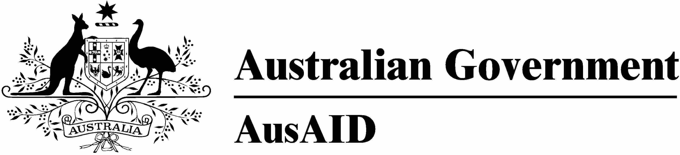
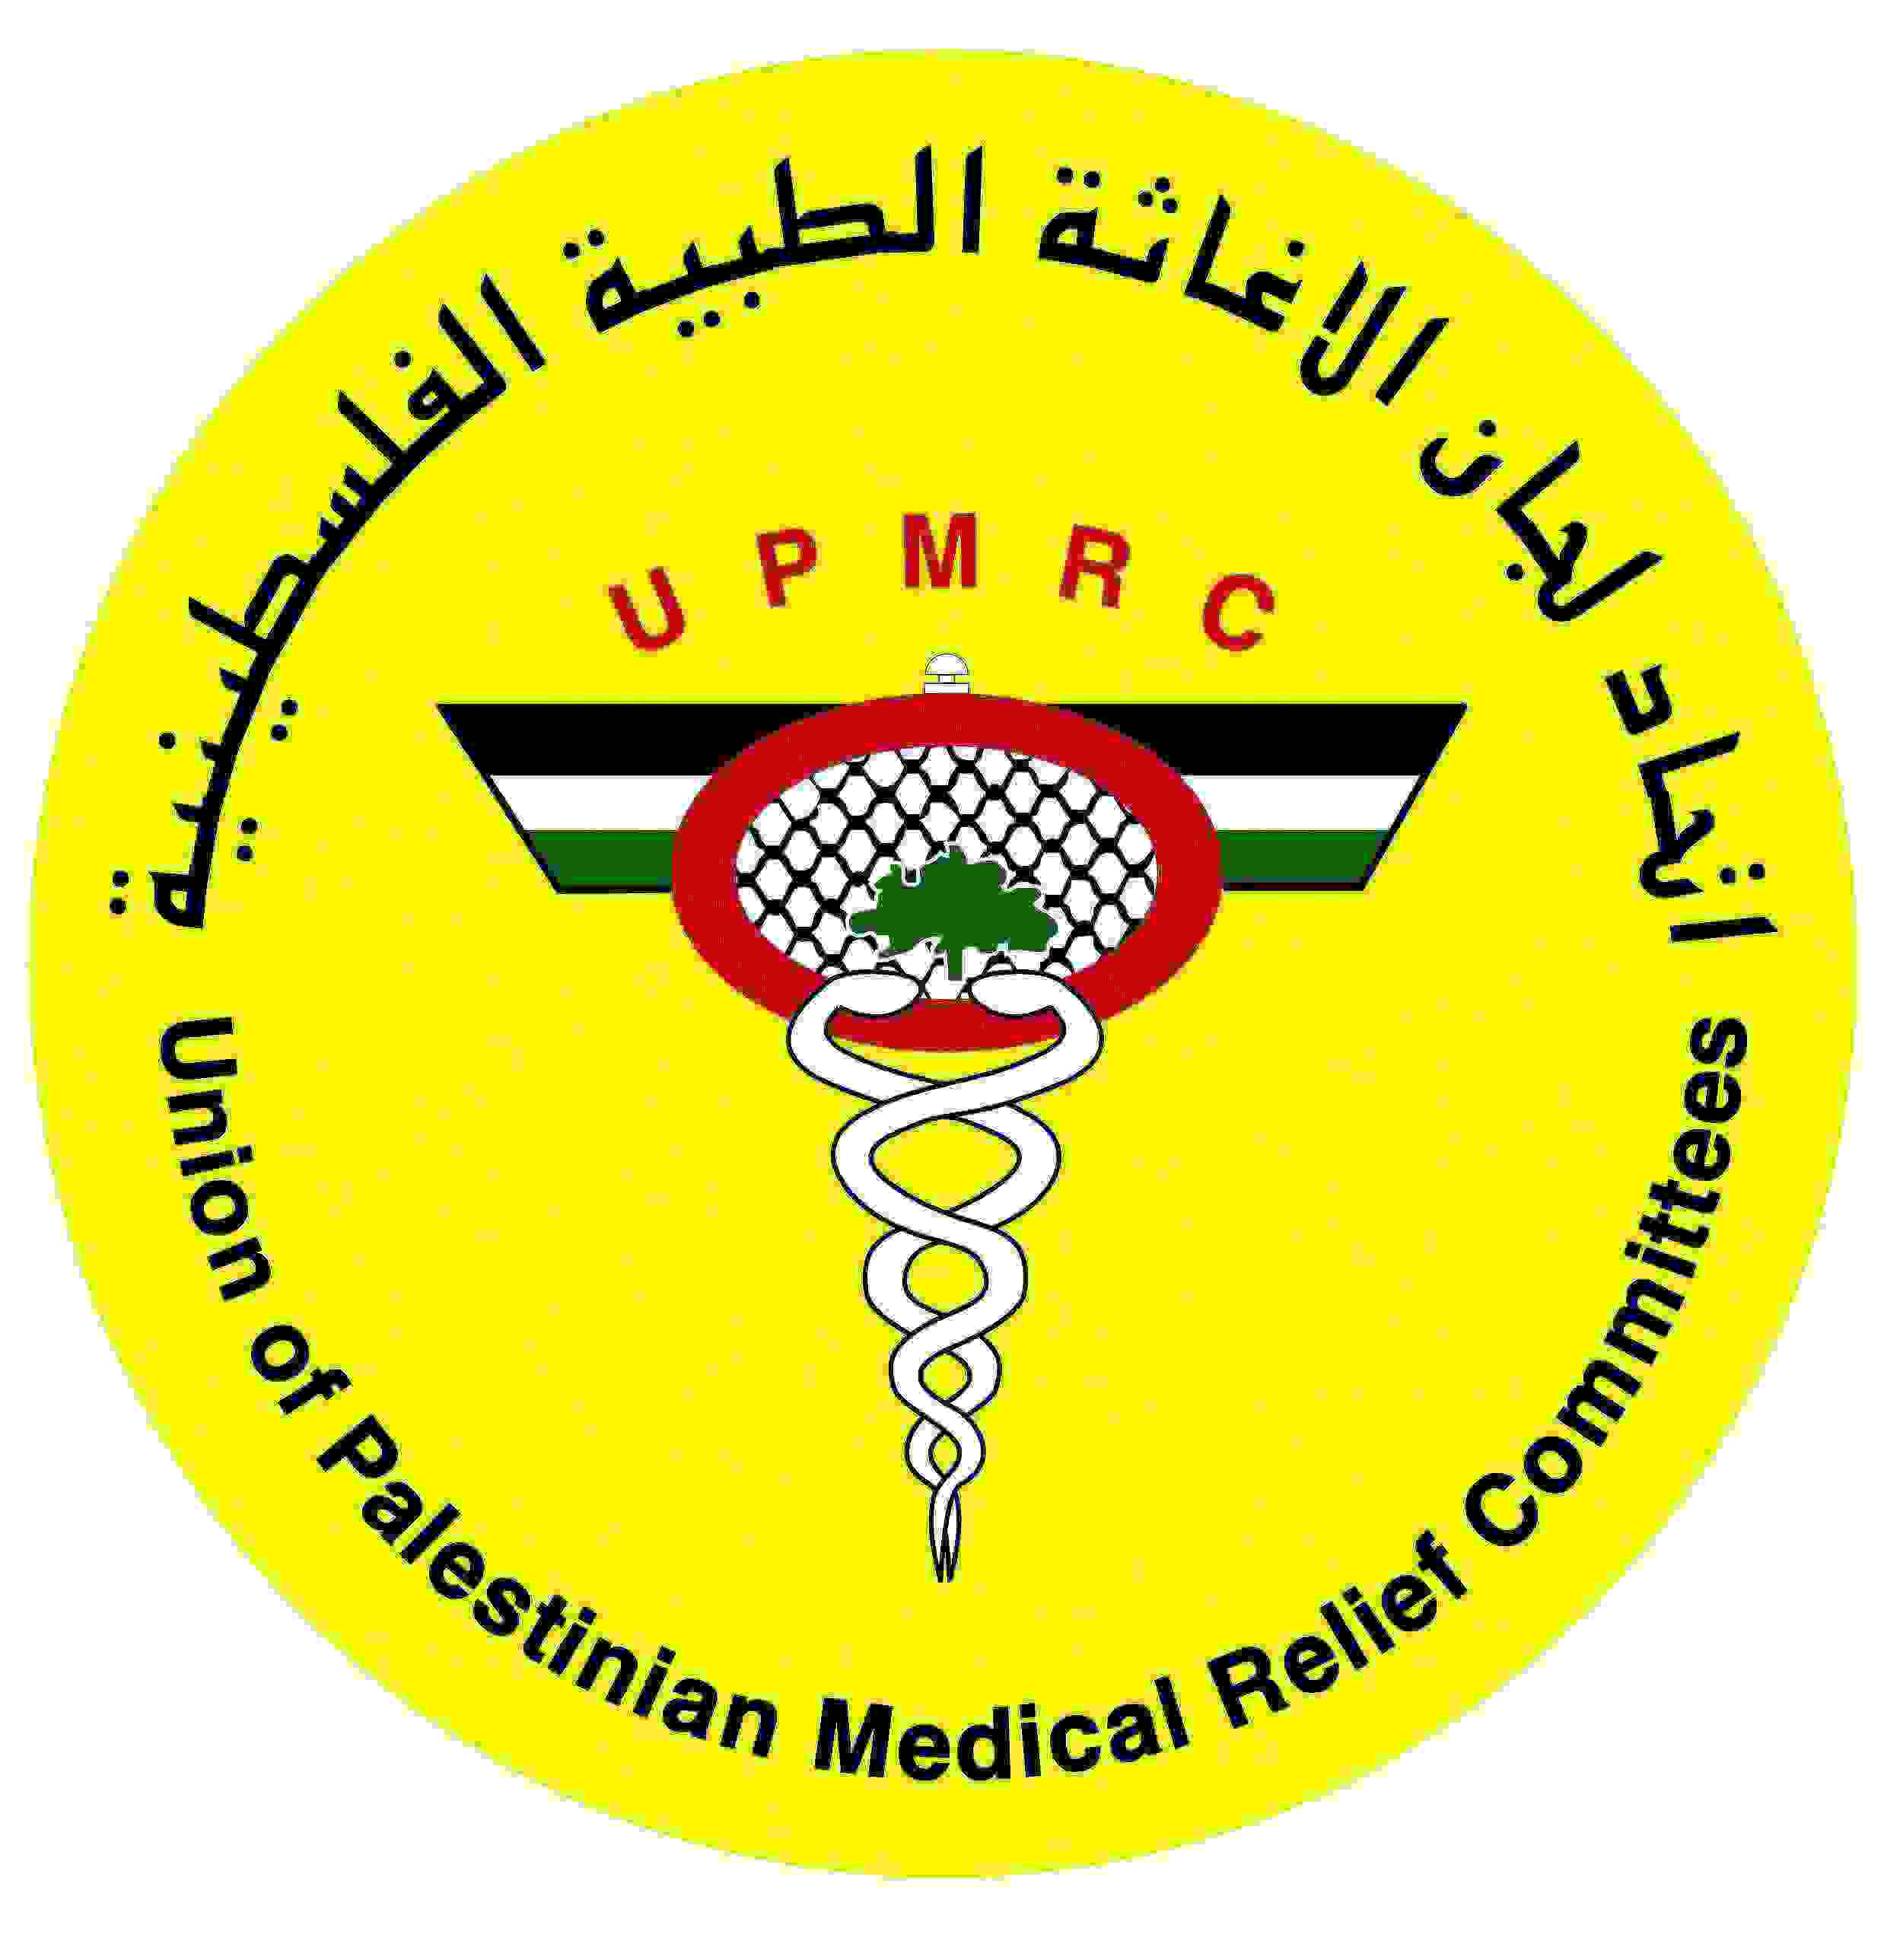
September 2004

Sponsored by: AusAid
Managed by: CARE West Bank/Gaza
Implemented by: CARE WB/G in partnership with UPMRC

Table of contents

Table of contents 1
Abbreviations 1
Acknowledgements 1
Background to the project 2
The training project 4
Training content 4
Training process 5
Post training 6
Work of the CHWs 9
Home visits 9
Community activities 10
CHW linkages 11
Recommendations 12
Annexes 14
1. Terms of reference/Scope of work 14
2. Programme of the evaluation and persons met 16
3. Methods of the evaluation – and prioritized topics 18
4. Partnership issues 19
5. Recommendations from the field 26
6. Opportunities analysis 29
7. Results of baseline & end-line project surveys 35

Abbreviations

AusAid Australian Aid to International Development
CARE Care and Relief Everywhere
CBR Community based rehabilitation worker
CHW Community Health Worker
CRS Catholic Relief Services.
EU European Union
GP General Practitioner
H/E Health education
HDIP Health, Development, Information and Policy Institute
MoH Ministry of Health
MoHE Ministry of Higher Education
MPH Master of Public Health
NGO Non-governmental organisation
PA Palestinian Authority
PHC Primary health care
UPMRC Union of Palestinian Medical Relief Committees
UWHC Union of Health Workers Committees
WB West Bank
WH Women’s Health

Acknowledgements
The Evaluation Team would like to briefly express their very sincere gratitude to all of the very kind people they met and talked with about this project. People were very generous with their time and ideas, and it was a real pleasure to share in their enthusiasm for their work and the benefits of this project. We thank you!

We also thank the senior management of CARE WB/G and UPMRC for their trust in a participatory process for this evaluation, and so generously making available the time of the core participants from each of their organisations.
September 2004
Ayman Shuaibi – CARE WB/G
Reem Miqdadi – UPMRC
Tom Barton – CRC

Background to the project

Context
The current political/military crisis has had a devastating effect on the economy and poverty levels in the West Bank and Gaza. Average household incomes have fallen dramatically, with almost half of all households having lost their sole source of employment. Household assets are being eroded, and at the time the project was designed, it was expected that very soon close to half of the total Palestinian population would be living below the poverty line (US$2 per day). Continuous military action before and during the project has led to the destruction of public infrastructure including water networks, public roads, electricity networks, factories, hotels and resorts.

The effect of this conflict on the Palestinian health sector extends far beyond the burden created by direct injuries. Physicians and nurses alike have often been unable to travel to their places of employment due to internal and external closures. Medical personnel, ambulances, and healthcare facilities have also come under attack. As such, access to health care has emerged as a major constraint to maintaining primary health care gains achieved in the decades before the Intifada.

Immediately prior to the second Intifada, health indicators for women and young children particularly, had greatly improved due to a variety of factors including effective private and public sector Primary Health Care (PHC) and Maternal Child Health (MCH) programs, as well as ample donor support. However, these gains were already being eroded during the early stages of the current conflict and there are indications that the longer the situation persists, the greater the health status setback. The current need for health assistance varies significantly by region and sub-population. Although a large proportion of Palestinian refugees have been assisted since the onset of the Intifada Al Aqsa, more than seventy-five per cent of rural villages have received no assistance.

Development needs/issues
Very large numbers of Israeli military checkpoints in West Bank and in the Gaza Strip, together with road blockades and the construction of a barrier wall have divided the Palestinian territories into hundreds of separate, isolated Bantustans. The reduction in health care access has created a need to decentralise health services for towns and villages throughout the West Bank and Gaza. As a result of access issues, healthcare in many rural communities is now exclusively in the hands of Community Health Workers or upgraded midwives, especially since doctors are also unable to make their usual visits due to mobility restrictions. These Community Health Workers are women, primarily from rural areas, who are selected in consultation with members of local committees and community leaders. Selection of CHWs is based on commitment, capacity and interest. The choice of female CHWs enables home visits for women and children, which would otherwise be infeasible in this cultural environment.

In many West Bank villages affected by internal and external closures, community health workers are the sole health care providers; in fact, they are frequently the main providers responsible for preventive, promotive, curative and emergency care. A number of donor organisations have sought to mitigate the devastating effects the Intifada Al Aqsa has had on the health of Palestinians, yet only very limited assistance has focused on community-level health workers, despite the crucial role they increasingly play.

Prior to the start of this project, health workers and the NGOs that train and support them identified an acute need to upgrade the skills of community health workers, particularly through training in basic medical emergency services, maternal and child health, psychosocial trauma counselling/social work, and chronic disease management. WHO identified the education of first responders and better-coordinated ambulance services as the two most important areas in need of development in terms of current emergency response.

How project proposed to address development needs/issues
CARE West Bank Gaza, in partnership with the Union of Palestinian Medical Relief Committees (UPMRC), designed this project in order to support community health workers during and beyond the present crisis. The project set out to partially redress the imbalance in health assistance since the outbreak of the Intifada al Aqsa, which has seen almost all aid go to supporting higher level personnel and strengthening medical facilities. In designing the project, CARE West Bank Gaza and UPRMRC were guided by the National Health Plan strategic objectives, which aim at strengthening human resources in identified areas of need and at utilizing the full potential of existing PHC services as an alternative to secondary health services.

CARE West Bank Gaza’s strategy of investing in Community Health Workers’ capacity was based on the knowledge that the Community Health Worker system in Palestine functioned well prior to the Intifida. The project proposed to build on the strengths of the Community Health Worker system and help it to meet the additional challenges which face Community Health Workers in isolated areas.

CARE West Bank Gaza and UPMRC formed a successful partnership three years prior to this project, during the implementation of the Pilot Health Project. This relationship provided the foundation for the present project. CARE West Bank Gaza’s international network and local knowledge, combined with UPMRC’s experience in providing professional health services and training for health personnel locally, offered significant advantages. UPMRC is one of the leading health organizations in Palestine, with over twenty years of experience. It has clinics throughout the West Bank and Gaza and provides health education programs for the general public as well as for medical personnel. It runs the leading training programme for CHWs and employs more of the trained CHWS around the country than any other agency, including the Ministry of Health.

Events during life of project affecting implementation
Due to major Israeli military incursions into the West Bank in April 2002, project implementation was delayed for four months. The work plan was revised, taking into consideration available resources, time lost, as well as safety for all. The project activities only started on August of that year. All project activities remained unchanged; what changed was the implementation schedule of the different activities.

In the last three months of the project, some new activities were approved; these included contracting 14 CHWs to support the trained CHWs in the clinics in order to conduct more home visits, also two reference/training books were re-printed in Arabic for use by CHWs and clinic staff. The project also provided the library in the CHW college with two computers and a server; this will help support the college to establish a resource centre that will be useful for all health providers. Some training materials were also purchased for the college to build their capacity to conduct good quality trainings.

The training project

Training content

Content covered in the training for this project
Topic | Details | Duration
Psychosocial health | Life skills and interpersonal communication skills, stress disorders, psychological factors and symptoms, child and adolescent diseases, methods of intervention, referral system | 14 days
Child health | Development phases, ARI, diarrhoea, breastfeeding and child nutrition, UTI | 10 days
Women health | ANC, pregnancy signs/phases and problems, high risk pregnancy and complications, safe delivery, emergency deliveries, PNC, post-partum health education | 7 days
Chronic diseases | Diabetes and hypertension | 4 days
First aid | Emergency management, cardiac and respiratory problems, foreign body, types of wounds, poisoning, fractures, casualty transport | 3 days
Rational drug use | General concepts, definitions, side effects and drug interactions, factors affecting drug abuse, antibiotic use, essential drug list, pharmacy management | 2 days

Outlines for the curricula of these components were set by different programmes at UPMRC (all except psychosocial, as there is no specific programme for it yet – so the Palestinian Counselling Centre was consulted for this component). The outlines were finalized by the staff of the Community Health College.

Results
While almost all of the content was praised by CHWs and others, for most of the stakeholders at different levels, the most useful content out of this package was the psychosocial component. Psychosocial health was a new topic for almost all CHWs, and it was presented in a concentrated course with value in its own right, rather than being just bits and pieces integrated into other subjects. As observed by the CHWs and their supervisors, the skills and process of sharing experiences in the training greatly contributed to their self-esteem and self-confidence to cope with psychosocial difficulties. Both communities and CHWs are living under chronically stressful conditions. CHWs reported that this content has proven useful in community and clinical working situations as well as helping in their personal lives.

Women’s health has been important issue as a large proportion of the services given by CHWs to women in the community are related to reproductive health and concerns. Women issues are sensitive in the Palestinian culture so it’s more comfortable to get the service from a female health worker.

During focus group discussions, the CHWs rated contents from the training in terms of relevance and importance for their work. They said that first is psychosocial issues, chronic diseases and women’s health the most important topics. They said that three of these areas are important to their current work, and worth repeating in any future refresher trainings.

Due to the current socio-political situation, with continuous curfews, closures, and recurrent invasions, accessibility to emergency care has been greatly affected. The CHWs and their respective communities have valued the training in first aid, and also recommend continuous refreshers in this area.

Child health was not rated as highly, but reasons for this are not clear and may need to be explored in the planning phase for any follow-on project. Management reports that it was intended as a combination of both refresher and some new material. It is possible that the detail topics were less useful (at least one focus group of CHWs complained of repetitiveness in the Child Health topics); it is also possible that the specific topics selected and presented were not as relevant to the work of the CHWs as were other topics. It could be related to two days of the content were addressing activities already being done by the CHWs (i.e., protocols that already exist and are in use – so the content was felt repetitive).

Voices: National NGO director, PHC clinic doctors, community, trainers, community leaders, donor representative, CHWs, UPMRC director, district manager, MoH director

Challenges and recommendations
Challenges | Recommendations
Good to have practical training, but want even more (voice of CHWs) | CHWs urged that future trainings include substantial practical, hands-on training.  Management urges that CHWs be more involved in helping select topics (which means more time will be needed for planning)
Psychosocial health is a new topic and the process of work afterwards has revealed more areas where information needs to be delivered | Need to elaborate and give more information on psychosocial health
There is a continuous need to update and improve CHWs skills in first aid | Periodic refresher training on first aid
CHWs want to conduct health training, e.g., on first aid, for various target groups in their communities in a more professional way to help cope with the ongoing emergency situation  Management says this was done, but by example and not practice through the continuous education program and training of students | Include planned ToT component, with the objective of further developing and improving the community teaching/training skills with the CHWs

Training process

Trainee selection
Equal chances were given to CHWs, old and new ones, in addition to CBR workers, while taking into consideration any kind of previous training the community based workers had participated in. Another point for selection was the relation of the training to job role of the community based worker, e.g., if she was working in a specific program. Also chances were given to CHWs from other organizations as part of emphasizing and enhancing the role of CHWs nationally. CHWs were given the opportunity to discuss who would participate from their clinic cohort, and to make the decision among themselves as a team. They considered past training, current roles, interest and experience.

There were six groups of trainees (and conducted in five locations) during the life of the project – with the locations selected partly to accommodate the physical distribution of CHWs, but strongly influenced by the evolving patterns of closures and restrictions on movement. There was one group in Gaza, one in the South WB, two in the middle WB, and two in the North WB.

The weaknesses of the selection were that CHWs from some other organizations, particularly the MoH, had only a middle school background which sometimes limited their literacy and capacity to rapidly grasp new training. The CBR workers also needed additional support, particularly when topics required medical or anatomical scientific background.

Trainers - selection and methods of training
Regarding the trainers, many of them were quite good, but some needed more strengthening, both in terms of methods and for specific knowledge.

Training materials
The CHWs report that during the post-training period, they have used the training materials that were distributed during the project as reference materials. They have used them to refresh their memory, and even to prepare for comprehensive exams.

Most of the training materials were translated or prepared in Arabic – which is the preferred language of the CHWs and their supervisors. It is worth noting, however, that this was a time-consuming process.

The medical kit distributed at the end of the training was so useful for the CHWs since they can use it at the clinic and in their communities.

Timing and location of training
Training was intensive, which was both good and bad. The intensity helped in concentrated learning, but sometimes meant that the CHWs were out of their communities for several days at a time. There were insufficient CHWs replacements available for the trainees from most of the clinics and this resulted in overload of work on the remaining staff and reducing some activities like some community activities. In addition, the unstable political situation included military incursions and strict curfews, leading to last minute changes in training schedules and further disruption of planned activity programmes at community and clinic level.

On the other hands there were some weaknesses during the preparations; there was not enough time to plan for the project, especially for curriculum development. The training venue was unsuitable in some places. And no graduation ceremony conducted.

Voices: District manager, NGO national director, UPMRC director, Clinic doctor, trainers, MoH director, CHWs,

Challenges and recommendations
Challenges | Recommendations
The partners involved with preparing the curriculum for training felt hurried by the timetable, particularly as it had to be adjusted in response to severe military incursions in most of the country. | More time for preparation
Some of the stakeholders, including CHWs and their supervisors felt that the duration of training was either too long or there was insufficient planning and organisation of alternative practitioners to maintain community and home-based services during the training period. | Ensure coverage in the clinics, either by having temporary replacements, or by not taking too many people from one clinic team at the same time
Up to the present time there has been no graduation, and the CHWs have expressed some disappointment about this. | Conduct a graduation ceremony at a suitable time, e.g., at 3-6 months post-training after CHWs have demonstrated adequate performance of post-training tasks as well as attending the training itself.

Post training

Specific post-training follow-up
There has been relatively little organized follow-up to the training. There was a plan for some structured follow-up, i.e., a systematic routine of observation during a proportion of home visits to ensure that the visits met a preset minimum standard of service/care. In reality, however, the proportion of visits mutually attended by CHW and supervisor (doctor) is less than 10% in most areas, and only happens with emergency cases. A constraint to this activity is that many of the supervisors for the CHWs are male doctors, and as such, their presence limits the nature of visits or topics that can be covered.

One trainer (first aid) informally challenges CHWs that were trained with questions about how they would handle various emergency situations, but has no routine follow up. One constraint is that the various trainers do not necessarily interact personally with all of their trainees on a routine basis after the training – due to work in different locations. Another constraint is that there has not been any development or adaptation of forms designed specifically for evaluation and monitoring of CHW performance after the training, i.e., assessing capabilities or competence with the newly acquired skills. Instead, there has been reliance on the routine monitoring forms and methods described below.

Although the basic training of CHWs is linked to specific post-training assignments, this strategy was not used with the present upgrade training. When this point was raised with the first aid trainer, he liked the idea of creating a special form for reporting on emergency cases, with copies of all such forms to come to him for review for a several month period after training.

Another constraint is that most of the supervisors, i.e., clinic doctors, were not included in the training – and therefore lacked details about the exact content of the training. This made it difficult for them to give specific feedback or to give feedback that was congruent with the messages delivered and skills taught in the trainings.

Routine monitoring
The clinic staff and doctors have been very supportive and appreciative of the CHWs after their training, and have continued with their routine monitoring activities that involve CHWs.

Forms –
Several different forms used in the UPMRC for tracking the various activities done inside and outside the clinic; for the CHW there are forms to monitor home visits and community activities, such as school health and health education activities. CHWs document and self-evaluate their own work using these forms, which are then reviewed and signed by the clinic doctors. After this, the forms are circulated upwards to the district managers. At this point, the data is sent to central level MIS unit, where it is extracted and shared with specific programmes for their monitoring and analysis, and sent back down to the district managers who are responsible for aggregating them into summary reports.

There is no special form for CHW supervision, particularly for their community-based activities, in either the UPMRC or the MoH. In addition there is no special form developed till now for psychosocial health activities. CHWs use forms for other activities to report on psychosocial activities. CHWs and doctors would like to have such special forms for the psychosocial health activities. Management reports that such forms are currently being developed by their new unit for psychosocial health.

Planning –
Planning is done in a participatory way; both doctors and CHWs are involved in weekly planning of activities. This process does include discussion about community and patient needs, and the team was informed that there is an annual planning process but was unable to see a copy during the time available in the field. Discussions with field staff did reveal considerable interest in how the process of home visitation could be linked more effectively to the annual planning cycle.

There is no clear routine, systematic on-site supervision for the home visit portion of the CHWs’ work. Supervisors do review the visit form and approve it or discuss it with the CHWs, but there is no routine of direct supervision during the time that the home visit is being done, e.g., for a specific percentage of home visits or a specific number of visits per week or month, although that is a welcome ideal expressed in the original proposal for this particular project. Doctors do some supervision during home visits from time to time, generally guided by the reported seriousness of the medical condition for the patient; with variation between the different clinics. The idea of developing and using certain criteria for supervision was welcomed by CHWs and supervisors, together with strategies for females to be the main supervisors of this particular task in respect of local cultural values.

Reports –
The UPMRC produces an annual report for the organization, built up out of reports from all the districts, which are in turn generated from data coming from the PHC clinic level. This report usually, although not always, includes some discussion of issues that affect the CHWs. There is also an annual report by the CHW college – the School for Community Health (SCH) which includes considerably more information about and for the interests of the CHWs.

Unstructured feedback –
The CHWs, PHC clinics and District Managers also rely on feedback from their ‘beneficiaries’, i.e., from the communities, schools, other NGOs as a way to monitor and evaluate the work of CHW. The limitation is that this feedback is unstructured and generated spontaneously by the beneficiaries rather than being gathered in any regular way, e.g., through client satisfaction surveys or community needs assessments. Regarding comments, virtually all of the direct feed back has been positive, mentioning good changes in the work and behaviour of CHWs during the past two years. There were no complaints related to the training project or performance afterwards in the past two years.

Perceptions and trust
There were very strong expressions of trust and approval for CHWs and their roles in the community, views that were enhanced by the training received in this project.
- Already, before this project, the CHWs had from the beginning been selected by their own community.
- The kinds of activities being implemented by CHWs are viewed by the communities as necessary and important to their people – helping them to live in good health during difficult times. The training in psychosocial issues particularly enhanced this aspect.
- The CHWs live in and participate in the own communities, going to weddings and funerals, helping in the schools, and visiting them in their homes. Here, the training in women and child health issues has been very important and raised the profile of the CHWs for the community.
- The CHWs are present around the clock and ready to help their people anytime and under any circumstances. Again, in this aspect, the first aid training has been particularly helpful.

CHW behaviour and support
The topics and curriculum of this training project helped to upgrade the knowledge and skills of CHWs in order to perform better in their communities. The information included was both a refresher course and provided new content. After the training, CHWs have felt more confident about their work and capacity to work independently when necessary. All of these factors have positively affected CHWs’ performance and made them eager to respond to community needs.

Training for the CHWs has resulted in better performance. They gained skills, knowledge and self-confidence; this strengthened the trust in these trained CHWs by the doctors inside and outside of the clinics. The CHWs learned the current protocols of the MoH for the conditions covered by the training, e.g., in child and women health, in first aid and emergency care, and for chronic diseases. Doctors became more confident to delegate responsibilities to CHWs because of their demonstrated understanding. CHWs valued the support of the doctors and they acknowledged the importance of the team framework in supporting their communities and their own work.

Supervisors described several ways that they support CHWs. One way is to send them to share in training, promoting work with team or family spirit. Another strategy is to conduct weekly meetings at the clinic for discussion about how the work is going and to do further planning. Psychological support for the CHW is given by the doctors and by the district managers. Sometimes the doctors help CHWs with transportation in the case of long distances. CHWs are able to discuss issues and problems with the clinic doctors and their regional supervisors, in order seek appropriate solutions. The clinic doctors make time available for debriefing sessions with CHWs. And, as seen in this project, they value continuing education for the CHWs and supported their attendance at the trainings.

Voices: Mayor, clinic supervisors, CHW, district managers, national NGO; CHW College director; doctor; community leaders, MoH directors, trainers, MPH programme at university.

Challenges and recommendations
Challenges | Recommendations
More understanding of the CHW role is needed, especially by other stakeholders (both NGO and MoH). | Sharing the report of this evaluation  Continue advocacy and support for networking among the CHWs and other community based health care workers (e.g., CBR workers)

Work of the CHWs

Home visits

Conditionalities
Many people have poor access to clinic services, caused by several factors such as:
- Elderly and infirm persons – difficulties of movement
- Persons in remote villages and isolated locations - Long distances, lack of transportation, closures and curfews
- Afraid of being diseased – stigma for some illnesses; also concerns about confidentiality.
- Unaware of symptoms
- Gender rules/roles – many reproductive health concerns, and very difficult in this cultural setting for women to discuss such issues with male doctors

For these reasons, home visits become a core activity of CHWs in the community.

CHWs are from the same community where they are working; this helps the supportive role of CHWs toward their communities.

Methods of work
CHWs do weekly planning for home visits together with the PHC team to prepare for the activity and determine which households are being to be visited.
Many different people are being visited during home visits such as: chronic disease patients, pregnant women, newly delivered women and their babies, old women
Many different health messages are being reviewed with the family members (sometimes with distribution of health education materials)

Voices: CHWs, clinic doctors, community leaders, MoH director, district managers

Challenges and recommendations:
Challenges | Recommendations
There is a shortage in the number of CHWs at certain clinics, leading to work overload at the clinic and hindering CHWs from conducting home visits in some days. | More CHW should be trained and hired for better home visit coverage (finances permitting).
Adolescents have many problems and their families may have problems dealing with them; | The adolescents should also be a target group for home visits, and support provided, including use of psychosocial communication strategies.
Although there are home visits in urban areas, the proportion of HV per CHW is much less than it is for CHWs working in/with rural clinics. | Better strategies/programmes need to be developed to ensure that home visits are also supported and carried out in urban areas
Unemployment of men was raised as an issue affecting home visits; when the men are in the home, it makes home visits for women health issues difficult. These are also households with an increased level of psychosocial stress. | There is need for developing a strategy to reach those women whose husbands don’t work.
Clinic doctors support home visit activity of CHWs, but sometimes have difficulty knowing how to go about supervising that activity. | Doctors need (and want) to have criteria and a system to supervise home visits with CHWs.

Community activities

Nature of the community work
Health education, school health and summer camps are routine community-based activities of the CHWs. They report that this training helped them gain information and improved skills for these parts of their work. They especially liked the communication skills and self confidence they got through the training. These changes helped the trained CHWs to do better coordination with other NGOs, Ministries, schools, and municipalities. Feedback from the different stakeholders like school principals, mayors and women leaders, district managers, other NGOs indicate the significant improvement in CHWs’ performance of community activities.

Access and distance
Closure, incursions and curfews have affected access to health services and to patients during and after the training. Urban areas have been particularly affected, with drastic declines in clinic visits for urban health facilities. People from rural areas who used to get services in the cities have often been unable to reach these centralised health services. As such, people became dependent on the PHC services in the rural areas. In some areas, patients walk for several Kms to reach the clinic and others drive as far as 25 Kms to bypass various barriers between their community and the “nearest” PHC clinic. CHWs also end up walking for up to 4-5 Kms to conduct a home visit. Most of the time, there is no means of transportation available for either patients or providers.

Despite all access problems, e.g., there were 60 days of full closure in Tulkarem during 2003, the staff of the PHC clinics have managed to reach their work close to 100% of the time. The fact that most of the CHWs are from the same communities where they work helps explain how they managed to work even in bad situations.

Health education materials
The CHWs received new H/E messages and materials during the training and post-training period. The community has appreciated these health education concerns and materials especially the ones for women health, child health, and chronic diseases. UPMRC develops H/E materials based on the expressed needs of community members and clinic workers, including CHWs. CHWs review the materials before distribution but more participation of CHWs in developing these materials could be useful.

Voices – trainers, district managers, CHWs, community leaders, national NGO representatives; national NGO director; clinic supervisor

Challenges and recommendations:
Challenges | Recommendations
CHWs have appreciated the handouts and training materials given during the course, but felt that they could be better organised to be more useful after the training. | Use a ring binder system that allows revised handouts to be inserted, and endeavour to do some editing for the training materials, possibly with a small team that includes some CHWs, striving for readability and capacity to be used as reference materials (indexing, etc.)

CHW linkages

Networking
The reality of CHW life and work in Palestine is one of relative isolation in mostly rural locations, settings that have become increasingly remote and delinked from each other as a result of the movement restrictions and physical barriers that have been put up in and around communities.

The training in this project brought together some groups of community-based health workers who had lacked clear understandings of each other’s roles, e.g., CHWs and CBR workers, as well as CHWs from different backgrounds and organizations. In this way, the training provided a good opportunity to network and share information and experiences. The training also helped to standardize concepts and ways of working among the trainees from the different settings and backgrounds. It helped to build a common language, unifying their perceptions and skills and reinforcing common approaches. The trainees valued this outcome and mentioned continuing to stay in contact with their peers after the training.

Another aspect of networking that was fostered by the training was the use of trainers from multiple organizations, thus linking the trainees to additional resources that they had not been familiar with before.

Voices: National programme manager, NGO national director, MoH director, MPH programme, district managers

Challenges and recommendations:
Challenges | Recommendations
There used to be a newsletter for CHWs in UPMRC, and CHWs were contributing to it. This newsletter was stopped, however, due to financial difficulties.  Management reports that a committee of CHWs is looking into how to reissue a newsletter. | Consider ways to restart the newsletter, but make it broader to reach CHWs and other community-based workers (CBR, counsellors, etc.) across the board in Palestine

Recommendations

Overall
Recommendations | Rationale
Follow-on proposal
- Create a proposal building on the locally identified needs, opportunities and recommendations of the present evaluation | Relevance - Need is there.  Support - Experience and positive signs from all partners  Expected outcomes  - Promote sustainability and further consolidation of achievements from the first project.  - Clear framework for a project to strengthen the work of CHWs, especially at quality and policy levels

Capacity building – training course
Recommendations | Rationale
Training content
- Psychosocial  - Chronic diseases (Non-communicable diseases)  - Women health, including breast feeding, safe delivery | Relevance - Clear issues of importance; need is high for these topics. There is evidence from the field, research to support this need. Psychosocial skills are very important to society; people in the community value and rate them highly. Psychosocial, genetic issues, women health issues, sexual health issues not well addressed by clinical services.  Support - Builds on existing staff investment; links with other efforts to improve skills and capacity of CHWs  Implementation - Discrete areas that can be addressed. Also include training process as well as content. Developing methods/curriculum would be a one-off activity  Expected outcomes:  - Better knowledge base.  - Expanded counselling skills and roles of the CHWs, with emphasis on home-based service capability
Trainees
- Include doctors as trainees in CHW training, e.g., for one module out of four, have doctors present as trainees together with CHWs in the training | Relevance – past experience with shared training of doctors and CHWs has been positive (UPMRC)  Support – enthusiasm for this approach among CHWs, doctors and supervisors  Expected outcomes:  - Enhance the preparation of physicians for supporting community work/workers  - Ensure common language and harmony  - To standardise messages conveyed to community and to improve teamwork
Trainers
- Include selected CHWs as co-trainers; upgrade their training skills as part of preparation for this activity | Relevance – correlating training to actual community situation through more grounding in practical realities. Promotion value  Support - Experience shows its value. Tested and proved to be correct  Expected outcomes:  - Motivation for CHW and others  - Enhanced respect for CHWs among stakeholders
CHW support
- Develop a system for post-training follow-up and support supervision of CHWs, including objectives, realistic indicators, protocols, strategy and forms | Relevance – continuing need to improve quality of health services (clinics and community). As a way of reaching quality assurance. High value and identified tool. Links with training, post-training, networks and policy  Implementation – multiple stakeholders to be consulted and involved in developing a participatory M&E system; develop specific indicators and milestones to be followed. Concrete, one-off activity; do-able  Support - Strong interest of all stakeholders, including CHWs, for ways to upgrade and improve the quality of community work  Expected outcomes:  - Improve sustainability of services  - Strengthened role of the CHW  - Better performance monitoring and evaluation; Enhanced quality assurance system for community work of the CHWs

Capacity building – institutional and policy level
Recommendations | Rationale
Annual community profiling
- Implement an annual ‘mini-survey’ related to HH quality of life (health and family/HH well-being) to be compiled locally into a community profile for use in generating an annual community health action plan | Relevance - Collection and analysis of information on communities very important. To be more knowledgeable about the community. Very valuable to local level. Supports broad view of health  Support - External contribution available. Strong support among stakeholders and partners for this idea  Implementation - One-off to develop, achievable  Expected outcomes  - Use of data for decision-making, i.e., evidence based prioritisation of health programmes  - Strengthened ties to community  - Improved services
Periodic and recurrent upgrading
- Regular continuing education, e.g., annual refresher training for increasing knowledge and upgrading skills | Relevance - Continuing education is necessary for certain topics, e.g., 1st Aid.  Support – interest of many persons to contribute as co-trainers in order to help with capacity building, upgrading skills of CHWs. Opportunity to expand resource pool of trainers and their links to the trainees  Implementation - Ensure equal chances for all CHWs  Expected outcomes:  - Improved capacity/competence of CHWs  - Enhanced pool of back-up resource persons  - Expanded reference materials relevant to CHWs  - Institutionalisation of value for continuing education
Human resources
- Developing a career ladder for CHWs | Relevance - Could increase quality of services, better sustainability  Implementation - Open avenues for further development without changing their career away from community orientation  Expected outcomes:  - Increased job satisfaction and interest  - Greater empowerment of women CHWs in their communities and professional lives
- Develop CHWs capable of being CHW supervisors and/or PHC clinic managers | Relevance - Builds on existing investments. Helps further institutionalise the CHW system  Support – there are already CHWs who are ‘natural leaders’ in virtually all of the PHC teams that have multiple CHWs; these leaders demonstrate strong organisational capacity but lack recognition and full empowerment for their administrative roles. The CHWs are committed to careers in health, many having worked for more than a decade. There are a few CHWs who have risen in the administrative channels of NGOs.  Implementation - Could develop curriculum, materials – not need on-going support  Expected outcomes  - Some PHC clinics with CHWs designated formally as clinic administrative managers and field CHWs supervisors
Networking
- Promote development of CHW “union”, “association” or “network” for CHWs; address all community-based health workers (CHWs from different provider groups, CBR workers, counsellors, etc.) | Relevance - Promote accreditation and legitimacy. There are existing networks that are largely inactive or do not address community based health worker concerns. This activity will lead to greater sustainability of CHWs work (improved support). It will strengthen capacity, sustainability, and improve systems. Will help with advocacy, empowerment of the CHW cadre, promotes sustainability  Support – CHWs and stakeholders were impressed with the enhanced networking achieved as a by-product of the first capacity building training (in 2003)  Implementation – promote advocacy with existing networks toward national policies that are supportive of CHWs and community based health system (links to quality assurance, career paths, and training)  Expected outcomes  - Improved advocacy capacity of CHWs  - Improved communication and support to/with CHWs

Annexes

1. Terms of reference/Scope of work
Evaluation of Community Health Workers Capacity Building Project
Background
CARE West Bank Gaza in partnership with the Union of Palestinian Medical Relief Committees (UPMRC) is implementing a project to support Community Health Workers (CHW). This project attempts to redress the imbalance in health assistance since the outbreak of Intifada al Aqsa due to the present crisis of Israeli restrictions of goods and peoples’ movements.
The main objective of this project is to fully utilize the existing Primary Health Care (PHC) services as an alternative to Secondary Health Care (SHC) services. This will be done through upgrading the skills of community health workers, providing technical assistance, equipment and materials and the rehabilitation of physical infrastructures.
This AusAID funded project started in April 2002, and to date succeeded in training 110 female community health workers on 1st Aid, child health, women health, chronic diseases, rational use of drugs and psychosocial health. In addition, the project produced and distributed health educational materials to cover all the training topics as a mechanism to raise awareness of communities on how to prevent, diagnose and deal with certain health problems. The two year project is expected to close end of July 2004. .
Upon the request of CARE WBG, Global Management Consulting Group (Global) concluded a baseline study (attached annex X) by March 2003. The study focused on the health knowledge and practices among the target communities as well as the health coverage in these areas. This was used as the base for the project activities, and intended to be used for end of project evaluation. The evaluation is expected to compare results and evaluate improvements introduced throughout this project.
Purpose:
- To evaluate the outcome of Community Health Workers Capacity Building Project on the targeted group of trained CHWs and the communities they serve.
  - To highlight the project’s main areas of success and failure.
  - To draw conclusions that will help improve implementation effectiveness and performance and to avoid problems in future projects
  - To measure the project’s relevance, effectiveness, and efficiency
  - To identify the project’s impact and sustainability
Methodology:
Guided by the OECD-DAC Evaluation Criteria (attached Annex XX); the consultant should propose an approach for conducting this evaluation. In doing so, the consultant should keep in mind the following:
- Involvement of CARE and Partner organization staff as team members in the evaluation if appropriate,
- Choose the appropriate set of data collection tools that could include:

- Household Survey
- Key informant interviews
- Focus group discussions
- Community group meeting
- Direct observations
- Case studies

- Conduct a training on the methods used in data collection
- Prior to arrival in-country the consultant will work closely with the project team, via email and phone if needed, to develop a detailed implementation plan that could include the following:
- Data sources and accessibility issues,
- Data collection instruments,
- Clarify roles and responsibilities of the participants and the external evaluator; logistical arrangements, timeframe, and data synthesis and analysis
- Determining the degree of participation by CARE and Partner staff.
Output:
- An evaluation report that does not exceed 50 pages plus annexes that includes:
- an executive summary (of no more than 3-4 pages);
- findings and recommendations;
- background and operating environment; and,
- annexes, which could include methodology, questionnaires, topic guides, etc.

The evaluator (consultant) will have the prime responsibility for the delivery of the final output; s/he will be at liberty in dividing the work among the different team members as deemed appropriate. After collecting feedback on the draft from the interviewees (and other stakeholders if appropriate) the consultant will retain the right of final editing of the report and expressing his/her views in an unbiased and independent manner.
Reference Group:
The purpose of the reference group is to provide guidance and assistance in making decisions regarding the methodology, timing of the evaluation and composition of the team. This will include facilitating, supervising and reviewing the evaluation teams’ work.
The Reference group will be composed of the following:
Ayman Mashni, Program Development, Design, Monitoring and Evaluation Manager will be coordinating the evaluation and reference group work.
Ayman Shuaibi Community Health Workers Capacity Building Project Manager who will take prime responsibility for facilitating the implementation of the evaluation.
Salam Kannan, Health Sector Coordinator who will provide guidance in making decisions regarding the evaluation including facilitating, supervising and reviewing the evaluation teams’ work.

2. Programme of the evaluation and persons met

Programme
Community health worker capacity building project - Action plan for the Evaluation
Day | date | Time | activity | location | Responsible
Wed | 11/8/2004 |  | Training for the core team | Care office/ Ramallah | Tom,Ayman,Reem,
Tur | 12/8/2004 | 9-12:30  12:30-1:30 | Training for the core team,  Lunch break  Meeting with UPMRC director general Dr Jihad Mishaal | Care office/ Ramallah  UPMRC | Tom,Ayman,Reem,
Fri | 13/8/2004 |  | Document review | Care office/ Ramallah | Tom,Ayman S.
Sat | 14/8/2004 | 9:00-10:30  10:45-11:45  1-2:30  3- | Document review  Interview with Dr. Ramlawi  Interview with Dr.Kamal Zeineh/UWHC  Document review | Care office/ Ramallah  UHWC office  CARE | Ayman, Tom  Ayman, Tom  Ayman, Tom  Ayman, Tom, Reem
Sun | 15/8/2004 | All day | Focus groups with CHWs and community, Interviews with supervisors, clinic district manager, women community leader, Mayor,CHW | Hebron/ Ithna clinic | Tom,Ayman,Reem
Mon | 16/8/2004 | All day | Focus groups with CHWs and community, Interviews with supervisors, CHW, Mayor, trainer | Jenin/ Maythalon clinic | Tom,Ayman,Reem
Tues | 17/8/2004 | 8:00-9:15  9:40-2:30  3- | Birzeit University/ICPH  Focus groups with CHWs and community, Interviews with supervisors, Mayor CHW  Document review | ICPH/ Ramallah  Ramallah/ 2 clinics  (Sinjel and Turmus Ayya) | Ayman, Tom  Ayman, Tom, Reem
Wed | 18/8/2004 | All day | Focus groups with CHWs and community; , Interviews with supervisors, CHW | Tulkarem | Ayman, Tom, Reem
Thu | 19/8/2004 | 10-11  1-2  2:30- | AusAID (Tawfiq Raad)  Dr.Malek/Maram  Documents review | Ramallah | Ayman, Tom  Ayman, Tom, Reem
Fri | 20/8/2004 | 8-2  2-3:30 | Document review,  Preparation of the data for the analysis.  Dr Mustafa Barghouti (hdip) | Ramallah | Ayman, Tom  Ayman, Tom, Reem
Sat | 21/8/2004 | 8:15-9:30  9:30- | Meetings with:  Womens Health director (wujdan Syam)  Data collection team debriefing, and data analysis | Ramallah | Ayman, Tom  Ayman, Tom, Reem
Sun | 22/8/2004 | 9:00- | Data collection team debriefing, and data analysis | Ramallah | Ayman, Tom, Reem  Ayman M
Mon | 23/8/2004 | 8-2  2-5 | Analysis  Sharing information with stakeholders. | Ramallah | Ayman, Tom, Reem
Tues | 24/8/2004 | 8-1 pm | Wrap up |  | Ayman, Tom, Reem

Persons met

Central level
UPMRC/PMRS
Dr. Jihad Mash’al Director
Dr. Abdullah Abu Sharara CHW College Director
Ms. Reem Miqdadi Training Co-ordinator
HDIP
Dr. Mustapha Barghouti Director
UWHC/WHC
Dr. Kamal Zeineh Health Manager
Marram Project
Dr. Malik Qutteneh Behaviour Change Communication, Senior Advisor
MoH
Dr. Asad Ramlawi Director of PHC and Preventive Medicine
Ms. Wijdan Syam Director General of Women Health Department
Institute for Community and Public Health, Birzeit University
Dr. Rana Al Khateeb Director of ICPH
Dr. Rita Giacaman Consultant/Researcher, ICPH
AusAid
Mr. Tawfiq Ra’ad Programme Manager
CARE West Bank/Gaza
Mr. Ayman Shuaibi Project Manager
Mr. Ayman Mashni Senior Programme Specialist

West Bank communities
Hebron
Dr. Othman Sabaha UPMRC, District Supervisor
Dr. Suhail Akabneh UPMRC, Ithna Clinic Doctor
Dr. Abed Jahshan UPMRC, Ithna Clinic Doctor
Ms. Abla Tmeze Women Community Leader, School Principal, Ithna
Mr. Jamal Tmeze Mayor of Ithna
Ms. Tahreer Albutran CHW, Ithna PHC Clinic
Ms. Taghreed Almasli CHW, Ithna PHC Clinic
Jenin
Dr. Waddah bane Odeh UPMRC, Maythaloon Clnic Manager
Ms. Hayfa Danibes UPMRC Staff Nurse, Women Health Trainer
Mr. Mustafa Rabayia Mayor of Maythaloon
Ms. Rana Abu Elkhair CHW, Maythaloon PHC Clinic
Ms. Siham Turkaman CHW, Maythaloon PHC Clinic
Ramallah
Dr. Daoud Abdeen UPMRC, District Manager
Dr. Shawkat Albakree UPMRC, Sinjel Clinic Doctor
Ms. Muneera Rabee CHW, Sinjel PHC Clinic
Mr. Hassan Awashreh Mayor of Sinjel
Tulkarem
Mr. Samih Othman UPMRC, District Supervisor
Mr. Oday Al Jalad First Aid Trainer, District Ambulance Driver
Ms. Intisar Abed Alraheem Women Community Leader, Tulkarem
Dr. Azam Mahmoud Community leader, member of physician association

3. Methods of the evaluation – and prioritized topics

Process of selection for locations and respondents in the evaluation:
Selection of sites for data collection was done upon coordination and discussion between the project manager and the project coordinator, with attention toward selecting different locations of project implementation. The sites selected were in the center WB, south WB, and north WB. It was agreed among the evaluation team and in consultation with the reference group that it would not add appreciable benefits to visit Gaza during the course of this particular evaluation. The household survey did collect information from Gaza and Gaza only represented 1/6th of the implementation of the project.

District managers were contacted to prepare the groups for focus group discussions, both from CHWs and the community, in addition to contacting a few community leaders for key informant interviews. CHWs who were trainees in the project are selected by the district managers and local coordinators who were there at the period of the project. Selection was made depending on the availability of CHWs at the time of data collection since all are willing to share and reflect their ideas.

Groups of women were selected by CHWs depending on the clinic information of the women having the PHC service, and the women were given an idea about the objective of the meeting and they made the choice if they would like to participate.

National level respondents were selected on the basis of being active stakeholders in the project, e.g., because they contributed or collaborated with the project during its lifetime or because they have a strong interest in the CHW cadre.

4. Partnership issues

Formal partners
UPMRC/PMRS – (Palestinian NGO)
Issue | Strengths | Constraints | Voice
Roles in CHW continuing education project
CHW curriculum for training | Contributed to designing the curriculum |  | UPMRC director  CHW training co-ordinator
Trainees | The majority of the trainees were doing community-based care in or from PHC clinics run by UPMRC,  A majority were graduates of the UPMRC training school for CHWs (most, but not all, of whom were working for UPMRC)  The second largest group of trainees were CBR workers, also trained and supported through UPMRC
Trainers | Provided some of the trainers for the trainings in this project
Training materials
Training venue | Some trainings conducted at the CHW college venue
Post-training support | Working context - PHC teams, continuity with communities, CHW supervisors, system of planning and self-monitoring of work
Partnering
Organisational involvement with CHW training
Criteria for selection of CHW | Woman of the village, nominated by the village  Graduate of secondary education (fully literate)  Age up to 30 years (but flexible) |  | UPMRC director
CHW training | Basic CHW training is provided on a cost-sharing basis, with substantial subsidy so minimal cost to the family or community |  | UPMRC director
CHW capacity | UPMRC CHWs are well qualified, but they need updating (like everyone) |  | MoH WH dept
CHW capacity | Able to pass the “State Comprehensive Exam” at the time of graduation with a better pass rate than Practical Nurses; during the last 2 years it has been a 100% success rate) |  | UPMRC and college directors
Qualitative aspects of CHW work in the organisation/agency
CHW roles | CHWs are key player in PHC; doctors and nurses are actually viewed as part of the support system for the community-based care, which is done mostly by the CHW |  | UPMRC director
CHW role | The core element of UPMRC work is the CHW;  There is always strong thinking toward their development |  | District supervisor
CHW roles | CHWs are the pillars of the UPMRC PHC clinics.  They are the ones who communicate with the communities |  | District supervisor
CHW roles | UPMRC CHWs are more powerful, organised and have approval of MoH and MoHE. |  | Programme manager
CHW roles | The UPMRC CHWs have more experience in comparison to the others |  | District supervisor
CHW support | Important that CHWs are:  Women  From the community  Hired for their job |  | MPH programme, Univ
CHW roles | UPMRC CHWs work in a structured system |  | Programme manager
Statistics (especially with relation to CHWs)
Distribution | UPMRC is working in more than 400 communities, linked to more than 25 health facilities of different levels |  | UPMRC director
CHW numbers | UPMRC has more than 100 fully qualified CHWs on staff (more than MoH) – total of 120 community based workers, which includes both CHWs and CBR workers. In addition, there are several CHWs who are working at administrative levels in the UPMRC. |  | Training co-ordinator
Enabling policies for CHWs and their work
CHW role | UPMRC has a written job description for CHWs |  | UPMRC director
CHW services during closures and emergencies | Organisation has an emergency plan  First – to PHC clinic  Second – to nearest health facility  Third – work from home (now has bag to implement this) |  | District supervisor
Other support to CHWs and community-based care
Physician training | Developed and implemented a training programme for newly hired doctors – orienting them to community medicine and how to work effectively with CHWs. The training includes primary health care concepts and using it, in home visits and community activities | Stopped the programme during the Intifada due to shift to emergency orientation | MPH programme, Univ.  UPMRC Director  HDIP
Support for CHWs | Services of NGOs are similar, but UPMRC is more available and sustainable |  | District supervisor
Organisation history since late 1970s | Three phases  Inception – voluntarism  Consolidating – building infrastructure  Advocacy – promoting systems, policies, protocols |  | UPMRC director
PHC services | UPMRC considers the financial situation of the patients (up to being free of charge for poorest patients) |  | Woman leader
PHC services | Services are good | Some tests and medications not available – for MoH insured patients | Community women  Mayor  District supervisor
Collaboration/co-operation with other agencies
Core funding | Has had funding from a portfolio of different donors | Donor support is dwindling (for all NGOs, not just PMRS), and hard to keep core activities going | HDIP
Co-operation | Working with 26 NGOs on the CBR programme  Includes some male CBR workers in Gaza |  | HDIP
Co-operation | UPMRC is a good, successful partner |  | Programme manager
Co-operation | Good cooperation with UPMRC to provide health services |  | Mayor
Co-operation | UPMRC is sub-contractor of MoH; and uses MoH policy for insured patients |  | District supervisor
Co-operation | Cooperation with other local NGOs (partnership project), there is training for doctors, nurses and CHWs through the project |  | College director
CHW roles |  | CHWs of other organisations (NGOs and MoH) generally have much less community and clinical responsibilities than those with UPMRC. | Clinic doctor
Sustainability |  | Community apprehensive at notion that UPMRC might ever stop services | Community women

CARE WB/G – (Contractor)
Issue | Strengths | Constraints | Voice
Reporting | Reports circulated regularly to Australia | Reports not formally circulated to local donor representative (though they are usually shared informally) | AusAid
Partnering | Has been good partnership with CARE.  They are flexible,  They give a sense of being partners, not supervisors  We feel that we are working for a common goal |  | HDIP
Other support | CARE obtained funding (ECHO, USAID) and has been implementing a parallel project for rational drug supply in the same regions of the country  They are providing drugs to NGO and MoH health facilities  This has improved drugs availability in the clinics  The project is expected to last for at least 6 more months and possibly get an extension |  | CHW  CARE programme officer
Other support | Increased presence of drugs (due to the drugs project) has led to an increase in patient loads |  | PHC clinic doctor
Other support | The drug supply project has also provided training on rational drug use for CHWs and other health care providers |  | CARE programme officer

AusAid – (Donor)
Issue | Strengths | Constraints | Voice
Co-operation | Good |  | UPMRC
Requirements |  | Have started using an ATC form; but is a ‘light’ version (compared to some other donors) | AusAid
Comments received about the project | Praise from different sources | No complaints | AusAid officer

Other stakeholders
Ministry of Health
Issue | Strengths | Constraints | Voice
Organisational involvement with CHW training
CHW training | EU supported continuing education for CHWs, especially in Hebron |  | MoH WH dept
CHW upgrade training | Some CHWs have been trained (in one project) to do vaccinations and proven ability to achieve adequate knowledge and skill |  | MoH PHC dept
Qualitative aspects of CHW work in the organisation/agency
Roles of CHWs |  | CHWs are not allowed to do vaccinations – due to fear of legal consequences | MoH PHC dept
Health plan | Developed a national health plan in 1995 that included a provision for CHWs as part of PHC at lower level health facilities | National plan still in place, and likely to be extended without change due to setbacks of the Intifada | MoH PHC dept
Statistics (especially with relation to CHWs)
PHC services | MoH has greatest number of health facilities  328/507 in WB  47/96 in Gaza |  | UPMRC director
Support for CHWs | Hired many CHWs under EU project – deployed in Hebron (60-70), Jenin (15) and Jericho (9) |  | MoH PHC dept
CHW presence | Currently, there are 12 CHWs (MRC qualified) working in Hebron on women health, under the FP society of Palestine | No CHWs with the MoH | MoH WH dept
CHWs | There are 24 CHWs in the WH programme in different locations | These CHWs need upgrading as it has been long since they had any refresher training | MoH WH dept
CHW presence |  | No MoH CHWs in the Tulkarem region, though it is an area extensively affected by wall-related separation | District supervisor
Enabling policies for CHWs and their work
Written health policies linked to CHW roles and status |  | Missing in the MoH or not followed even if present  Have to depend on personal influence with individuals | Programme manager
Job description for CHW | There is one in the MoH | Copy not available with head of PHC | MoH PHC dept
Job descriptions for health workers |  | No uniform job description for doctors or nurses in the MoH | MoH WH dept
Certification | Nurses and doctors have to qualify with a professional examination at graduation | There is no process of recertification for nurses and doctors (i.e., it is a license for life) | NGO manager
Chronic disease | Working on developing a programme | No policy or guidelines yet on chronic disease in the MoH | MoH PHC dept
CHW job description | MoH has consulted UPMRC for their CHW job description |  | MoH WH dept
Other support to CHWs and community-based care
Women health programme | Achievements of the women health programme, including their work with CHWs, has been praised internationally |  | MoH WH dept
Psychosocial care |  | Not a priority for the MoH | MoH WH dept
Support for CHWs |  | When EU project stopped,  MoH did not prioritise salaries for CHWs  Most of the CHWs were dropped by the MoH and they went out of service or joined other organisations | MoH WH dept
Supervision of CHWs |  | Not currently being done because MoH stopped supporting them after the EU project ended | MoH WH dept
Collaboration/co-operation with other agencies
Co-operation | Working with NGOs and private sector on the women health programme |  | MoH WH dept
Co-operation | Lower level rural clinics – many done together with MoH and NGOs |  | MoH PHC dept

UWHC/WHC
Issue | Strengths | Constraints | Voice
Organisational involvement with CHW training
CHW training |  | Have no training facility of own | NGO manager
CHW training |  | This training was the first organised/structured continuing education training for the CHWs of this organisation | NGO manager
Qualitative aspects of CHW work in the organisation/agency
CHW support | Now using fully qualified CHWs in hired positions | When started, using volunteers trained on the job | NGO manager
Male CHWs | Have used some men | Only as volunteers, not as full CHWs with training and employment | NGO manager
CHW roles | Operating health schools programme around Jerusalem with CHW support |  | NGO manager
Statistics (especially with relation to CHWs)
CHW numbers | Now employ at least 35 CHWs |  | NGO manager
PHC services | Operating 32 health units of different levels |  | NGO manager
Enabling policies for CHWs and their work
Job description | Has own job description for CHWs |  | NGO manager
Career ladder for CHWs |  | No career ladder | NGO manager

Save the Children
Issue | Strengths | Constraints | Voice
CHW numbers | There are 2-3 CHWs working with environmental health project  Main emphasis is field work |  | Mayor  Community women

MSF
Issue | Strengths | Constraints | Voice
CHW training | Did a one year training for CHWs,  Training course was repeated several times  Done in Hebron |  | MoH WH dept

Red Crescent
Issue | Strengths | Constraints | Voice
CHW training | Employs some of the CHWs that were trained in this training (Hebron) |  | District supervisor

MPH programme, Birzeit University
Issue | Strengths | Constraints | Voice
CHW curriculum for training | Contributed to review of the curriculum |  | MPH programme, Univ
CHW support | Observation that NGOs are providing structured system for supervision and follow-up | Is an important element in the success of the CHWs | MPH programme, Univ

Community
Issue | Strengths | Constraints | Voice
Support for CHWs | Municipality could support the CHWs in case of financial problems |  | Mayor
Support for CHWs |  | If UPMRC was ever obliged to go out of the village, then the PA should solve the problem | Mayor

History/time line of CHW training in Palestine
Issue | What done | Outcomes | Voice
CHW training
CHW training | In 1976-78 – CHW training first done by CRS and Bethlehem University | Failed for two reasons: CHWs were isolated and not working within/with any system  Trained mostly men – who left for other jobs | HDIP
CHW training | In 1981/82 - UPMRC started CHW training | Introduced a model of PHC to rural Palestine  Created a critical mass to influence health policy  IMR down from 100 to 20 | HDIP
CHW training | In 1988 - Training of CHWs at Al Quds university in two groups  In 1988 by UNICEF  Given 6 months (‘180’ days) of training  One time training for the CHWs, no routine updating | Salaries dependent on projects – numbers down when projects ended | MoH PHC dept  MoH WH dept
CHW training | In 1994 - UPMRC training for CHWs recognised and given award by UNESCO for adult education programme |  | UPMRC director
CHW training | In 1996 – CHW training by Spanish govt.  Given 6 months (‘180’ days) of training  One time training for the CHWs, no routine updating | Salaries dependent on projects – numbers down when projects ended | MoH PHC dept  MoH WH dept
CHW training | UPMRC training is 6 days per week for 40 weeks per year for two years = 480 training days |  | PHC training co-ordinator
CHW training | UPMRC has now trained 16 groups of CHWs | Up to date, there have been 246 CHWs graduated from the college. | UPMRC and college directors
Accreditation of CHWs
CHW accreditation | In 1998 (?) - Had to expand training to two years to get accredited – but it was a good thing |  | HDIP
CHW accreditation | In 2000 - The 2 year CHW training provided through the UPMRC has been officially recognised by the Ministry of Higher Education, and it grants an official diploma |  | UPMRC director  MPH programme, Univ.
CHW accreditation |  | Full accreditation as a ‘CHW’ career in the Palestine government civil service would require formal support by the Ministry of Labour, Ministry of Public Service and the Ministry of Health. | UPMRC director

5. Recommendations from the field
Recommendations | Voices
CHW training
Planning and preparation
- Use a good amount of time for planning if there is another training, especially for curriculum development | UPMRC director
- Systematic review of training curriculum to ensure relevance to real tasks of CHWs and needs of their communities | MPH programme, University
Training content
- Psychosocial | MoH, PHC dept; District supervisor; PHC GP/clinic doctor; NGO manager; CHW (all districts); MoH, Women Health dept
- Chronic diseases (Non-communicable diseases) | Women health tnr; MoH, PHC dept; NGO mgr; UPMRC dir; HDIP director
- Women health, including breast feeding, safe delivery | Women health trainer; District supervisor; MoH, Women Health
- Emergency care – emergency deliveries | First aid trainer; NGO manager; MoH, Women Health dept
- Child health | Women health trainer; District supervisor
- Emergency care – first aid for conflict related injuries (bullets, gas, etc.) | First aid trainer; MoH, PHC dept
- Management/administrative training for supervisory role | District supervisor
- Early marriage – for girls and for boys | Community women
- Methods of disease prevention | Mayor
- Women and child rights | PHC GP/clinic doctor
- Basic English skills | CHW
- Child-centred psychosocial information and skills | CHW
- Environmental health | District supervisor
- Increase capacity to identify and work with marginalised conditions (e.g., child abuse) | UPMRC director
Trainees
- Include doctors in the training, e.g., for one module out of four, have doctors present together with CHWs in the training | MPH prog; First aid trnr; Clinic/private doctor; HDIP director
- Training for more CHWs with the same skills (as the past training) | UPMRC director
- Upgrading for older CHWs who have not had as much training | UPMRC director
- Include newly graduated CHWs in training to learn from experiences of the others | District supervisor
Trainers
- Include CHWs as co-trainers | District supervisor (2 districts); MPH programme, University
Training support
- Ensure replacement (backup) staff available in clinics during training | CHW
- Trainees (CHWs and doctors) to do collective assessment in community on health behaviours; follow with activities | Clinic and private doctor
Training methods
- Provide additional training of trainer skills for the trainers | First aid trainer; Women health trainer
- Use a video camera for skills training, e.g., in first aid | First aid trainer
- Include more practical training for skills building | CHW (all districts)
Training arrangements
- If political situation better, then train in only two locations instead of four | District supervisor
- Conduct training for only two days per week | CHW
- Do not conduct training at the end of the month | CHW
- Link practical experience to CHW own workplace, where possible | Women health trainer
- Include some practical training in hospitals | District supervisor
Training materials
- Gather the training materials into a file (e.g., ring binder) for easier reference use | CHW
- Keep in mind the future reference use of the training materials as they are being selected and distributed | CHW
Post-training arrangements
- Regular continuing education, e.g., annual refresher training for increasing knowledge and upgrading skills | MoH Women Health; First aid trainer; NGO mgr; District superv
- Conduct a graduation ceremony for the successful trainees | CHW
- Develop/use form for all 1st aid patients by CHW, copy going to first aid trainer for review and post-training follow-up | First aid trainer
CHW work
Target populations, issues
- Target menopausal women for psychosocial care; address negative cultural issues | WHD
- Target women exposed to urgent problems (abortion, divorce, social problems) | CHWs
- Target people with genetic (stigmatised) diseases | Mayor
- Focus on women whose husbands are not working | Woman community leader
- Health education for pupils in schools | MoH, Women Health dept
Logistical support for CHW work
- Ensure transport for CHWs – car or other | Community women
- MoH should ensure salaries for trained CHWs, even when projects and programmes end, because they are such a critical part of the health system | MoH, Women Health dept
Activities
- Sustain programme of home visits | Community women
- Come with a specialist for some home visits | Community women
- Take a longer time with home visits | Community women
- Increase home visit activity as it has a great positive effect from psychological side | Woman community leader
- Upgrade skills in nursing and help fill in for shortages of nurses | Clinic and private doctor
- Do a community profile annually as a strategy to inform CHW and PHC planning | District supervisor
- Promote child to child and mother to mother health education | Programme manager
Human resources
- Develop CHWs capable of being CHW supervisors and/or PHC clinic managers | District supervisor; MPH programme, University
- Develop a career ladder for CHWs, but retain core link to community-based care | UPMRC director
- Hire more CHWs to enable more home visits | Community women
- Have more specialists with the mobile clinic team | Woman community leader
Supervisor work
Planning
- Do not build maternity homes where they are not needed and not likely to be successful interventions; instead, the resources should be allocated to enhance services in areas blocked by the Separation Wall. | District supervisor
Methods of work
- Use digital camera to photograph strengths/problems during supervision visits; keep copy of pictures with supervision forms so that they can be printed out and used during follow-up visits or for sharing in meetings | District supervisor
CHW support
- Marketing of CHW role – through workshops, media, etc. | District supervisor
- Develop a form for use in support supervision of CHWs | District supervisor
- Conduct operational research/assessment to identify the ideal workload for CHWs, i.e., the optimal number of HHs for a CHW to be responsible for | MoH, Women Health dept
Policy level work
Policy advocacy
- Change CHW and PHC policies by developing models, and implementing, i.e., by de facto spread from the bottom up rather than top down approaches | MPH programme, University
- Promote written “guidelines for practice” rather than static job descriptions | MPH programme, University
- Promote a unified job description for all CHWs that are working for the different service providers | District supervisor
- Concentrate on advocacy and guidelines with NGOs; they have systems, continuity, are bigger than individuals | Programme manager
Programme planning
- Sustainability is a core issue to be considered in all programme and project development | MoH, Women Health dept
- Strengthen capacity for community services, community focus | Donor representative
- Develop and promote protocols and guidelines from the community perspective | UPMRC director
- Projects/programmes should improve on systems and staff that are already existing rather than creating new systems or new cadres | Donor representative
- Continue with development orientation rather than emergency approach | Donor representative
Networking
- Promote CHW “union” or “association” for lobbying and advocacy on behalf of issues important to CHWs | MoH, Women Health; NGO mgr; MPH programme, University
- Contribute to development of a resource centre | UPMRC director

6. Opportunities analysis
Issue/need | Opportunity/idea | Supporting information about opportunity | Strategy for using the opportunity | Implications
Training process issues
Strengthening the training package | - Engage selected CHWs as co-trainers in the continuing education activities | - Strong interest among stakeholders for this strategy  - Ground training more firmly in community realities | - Provide additional skills building in adult education for the selected CHWs in preparation for the training activities
Expand the resource base of the training | - Make greater use of a wider pool of persons/institutions interested in the training or having information potentially useful to the training | - Several well-qualified persons expressed a strong interest to be involved as trainers or co-trainers in another training, e.g., district supervisors, programme managers  - There are many operational research studies or pilot activities going on with MoH and NGO partners that are gathering information relevant to community-based care | - Do a rapid institutional mapping exercise as part of planning for another phase, building on specific issues and ideas identified in this evaluation, to identify useful materials, information, best practices, key resource persons and institutions (e.g., programmes developing protocols and/or health education materials, doing pilot studies, having websites, etc.)
Improve the strategies and systems for post-training follow-up and reinforcement of training | - Develop a system for post-training follow-up, including objectives, realistic indicators, and protocols | - The previous project included an aspirational indicator of 20% of HV to be observed and demonstrate 80% quality standard of care provided  - Some GPs in the PHC facilities and some district supervisors are observing a few home visits – which has been well received by the participants  - The Birzeit University MPH programme has been invited to review the professional examination questions and indicators for CHWs | - Develop protocol and supporting forms for observation, assessment and review of community based activities by CHWs, including home visits  - Provide training to supervisors in how to implement support supervision  - Systematically review the results of the post-training performance with key stakeholders in the training | - Supervisors will need to plan/budget time for this activity
Training content issues
Addressing psychosocial needs/issues in the community  There is a need for a broad community based strategy that would work at a preventive and promotive level on psychosocial issues, not just crisis management (though that is also needed) | - Expand counselling skills and roles of the CHWs, with emphasis on home-based service | - Positive interest of the CHWs, supervisors, partners and stakeholders (including the MoH), based on the CHWs’ experiences during and after the training (which included psychosocial skills building)  - Demonstrated need for counselling services in a study conducted by the MPH programme at the university | - Repeat and expand the psychosocial training for CHWs  - Co-training of CHWs with other existing, indigenous community-based counsellors (teachers, religious leaders, CBR workers, etc.)  - Develop suitable documentation forms and monitoring systems  - Ensure supervisors (GPs) also get training in order to provide adequate supervision and back-up | - Job description changes?  - Policy changes?
Increasing importance of non-communicable diseases (chronic illnesses) as causal factors for adult morbidity and mortality – without a well-organised national NCD programme as yet, particularly for preventive and promotive strategies | - Develop a training and task package (service protocol) for community based management of NCDs (linked to PHC facility and specialist referral networks) | - Strong recognition by MoH and NGO partners as well as primary health practitioners that NCDs are prevalent, expensive to manage in hospitals, and able to be influenced by changing community behaviours  - Protocols related to NCDs are still in developmental stages with the MoH | - Consult with groups preparing NCD protocols regarding community level care and management issues  - Develop training modules, building on lessons from women health programme  - Contribute to development of appropriate two way referral mechanisms | - Identifying suitable support systems  - Ensuring availability of relevant health education materials and possibly drugs
Address changing policies/protocols for service delivery in the topic areas already covered | - Update the training materials and curriculum content to incorporate emerging issues, e.g., in women’s health with increasing use of Pap smears, mammography, delivery in emergency settings, closer post-partum follow-up, school health education, etc. | - There is an expanded information base relevant to community health; e.g., the MoH (especially women’s health) has been active in doing operational research and pilot activities plus protocol development  - CHWs are recognised by MoH for importance disseminating and implementing the desirable policies and programmes of the MoH | - Collect an updated set of information about national and institutional (NGO and programme specific) protocols and management recommendations – related to community based health care  - Update project’s training materials based on this input  - Utilise the support of persons and institutions interested to collaborate in this process (from MoH, NGO and Academic sectors)
CHW services/work issues
Strengthening ties to community – not all HHs in the catchment area are visited; and there is no annual work plan for community health | - Implement an annual ‘mini-survey’ related to HH quality of life (health and family/HH well-being) to be compiled locally into a community profile for use in generating an annual community health action plan | - Practicality of the idea already demonstrated in Iran  - Strong interest in the idea among supervisors and stakeholders  - UPMRC is in process of computerising the HMIS with computers and skills at PHC level  - CHW works as part of PHC team, so already linked to back-up structure/system for support | - Develop the tools – survey and analysis formats  - Develop planning tools and skills | - Clarify optimal and realistic levels of population per CHW that would permit this strategy  - Consider alternatives, including allocation of specific time for this activity within the annual plan of work for CHWs
Increasing isolation of health workers in WB/G  Happening partly as a consequence of closures, partly due to lack of funding (no more newsletter), and partly the fragmentation of health care under many different service providers | - Promote networking among community-based health workers (CHWs from different provider groups, CBR workers, counsellors, etc.) | - Very good professional sharing of experiences during and after the training due to co-training of CHWs from different home organisations, plus being mixed with CBR workers  - The UPMRC used to produce a newsletter for CHWs that was well-received, but was terminated due to lack of funds; CHWs were active in contributing to the newsletter | - Restart a newsletter for community-based workers and their supervisors (addressing concerns of CHWs, CBR workers, counsellors, and their immediate supervisors who also get out to the community).  - Build on past experiences that have been able to engage these readers to contribute articles and commentary  - Explore other networking options, including creation of a separate CHW union, starting a CHW arm/wing in other existing PH-oriented networks, having a national PHC forum that meets at least annually | - Might require some technical support, e.g., with computers, layout  - Should start small, i.e., in size and not happening too frequently at first.  - May want to present materials in both Arabic and English; may also want to put the newsletter on the web.
Large number of CHWs (including those working for MoH and a number of other NGOs, plus the older ones with UPMRC) who have had much less basic training and who have gone for long time without an organised refresher curriculum | - Develop resource sharing and continuing education programme on the internet that would be accessible for distance learning at PHC sites  - Eventually develop the site for interactive learning and consultation  - Run another training with a broader recruitment from all the categories of CHWs currently working in the country | - Health units with phones but no internet  - MoH has a website, as do some of the larger NGOs and projects working in WB/G  - Some health workers (GPs) have expressed an interest or have even taken the initiative (ambulance driver/trainer) to search the internet for relevant materials to use and to share | - Do a training needs assessment with all potential types of trainees – new/old CHWs, CBR workers, GPs, counsellors, etc.  - Do an ICT mapping exercise to identify available ICT resources (in Palestine and regionally for Arab speaking countries) relevant to community based health care
CHW administrative issues
Potential gaps or divergence developing between CHWs and their technical supervisors (GPs) | - Enhancing the preparation of physicians for supporting community work/workers | - From the mid/late 90s up to the time of the intifada in late 2000, UPMRC had a policy of requiring community training for incoming physicians that they were hiring  - This training is held in high esteem for its practical utility by the physicians who have been through the training | - Co-training of CHWs and GPs  - Participation of very experienced CHWs as co-trainers  - Develop collaborative exercises for use during the training, helping bring CHWs and doctors together to implement shared tasks, and develop a common understanding. | - Arrangement for back-up clinical coverage for time doctors are away from station
Improving the support supervision system for the CHWs | - Enhance the quality assurance system for the community work of the CHWs | - Lack of a form/format for support supervision (currently relying on self evaluation and rare co-visits)  - District supervisor interest in a form that would help assess quality of interactions between CHW and patient/family, quality of skills, thoroughness or holism of work, attention to marginalised conditions like psychosocial, and confidentiality | - Collaborative development of forms for observation and assessment of CHW work (involving CHWs, supervisors and possibly community)  - Experimentation with strategies to implement quality assessments – e.g., women observers
Developing a career ladder for CHWs | - Develop a ‘CHW II’ position, i.e., as an administrative leader in the PHC unit, also acting as a local supervisor for community activities | - Qualitative observation that there are ‘natural’ CHW leaders in the PHC clinics, providing leadership for the whole team and acting as the principle link with the community (e.g., with the Mayor and women leaders)  - Expressed interest of CHWs in further training opportunities and skills development  - Interest of district supervisors in the idea | - Provide skills-based training in administration – personnel management, budgeting, stock management, planning, monitoring and evaluation, etc. | - Would put more women in line to do support supervision in the field, and women who have long experience in the community  - Would support a community focus to the PHC facilities
Build on strengths and interests of existing CHWs | - ‘Specialisation’ or focal point training for selected CHWs | - Need for community-based personnel with greater skills in NCD management, eye care, counselling, women health, and other areas  - Positive experience in the Palestinian health system with the development of ‘women doctors’ | - Application of CHWs wanting additional focused training and review of their requests based on past performance, nature of their community and work situation  - Self-selection of CHWs for the specific topics of training (from a menu of available options) | - Need an adequate support system to be available, accessible to these CHWs  - Might require some additional equipment or tools for the CHW  - Might require innovative strategies for continuous updating in the focal area, e.g., internet and other means of distance learning
Lack of national policy on CHWs for legitimacy | - Advocacy for promoting full CHW accreditation | - Very positive results of CHW contribution to health sector  - Existing descriptions of formal and informal roles of CHWs  - Long term viability of CHWs as professional health workers  - International recognition for CHWs  - Strong support for this idea among the stakeholders (though recognition that it will not be easy) | - Develop a specific advocacy plan, based on assessment of needs, resources, opportunities and threats  - Extensively utilise existing networks for maximising sensitivity to constraints and leverage to overcome them
Community needs
Decreasing access to clinical health care for patients (and parallel decrease in mobility of health workers) in many areas of Palestine | - Increase the numbers of CHWs with the full basic diploma (2 years) training | - Community support/desire  - Stakeholder interest  - The CHW college has a larger training capacity than is currently utilised.  - Although MoH has more clinics than NGOs, the NGO sector has many more CHWs than MoH does. | - Expand the numbers being trained at the school  - Expand the number of CHW schools
Larger numbers of males present in the communities/homes who are not insured and are not working - and under stress | - Investigate options for training some males to do CHW in the WB. | - There are males working as CBR workers in Gaza, and there are also males working as psychosocial counsellors  - But there is a lack of information about the effectiveness of their work  - UPMRC has positive experience of women able to supervise men | - Operational research to assess the general quality of work, and the male-specific outcomes of the male community health workers in Gaza  - Operational research on the felt needs of the male part of the population, especially those out of work | - May have to clarify suitable location for male services – whether clinic, community centre, home, or other
Prepare a new CHW capacity building proposal | - Create a proposal building on the locally identified needs, opportunities and recommendations of the present evaluation | - Positive interest of previous donor (and possibly others)  - This theme (as do most of the opportunities) fits the priorities of the previous donor  - CARE is currently implementing a parallel project under USAID funding that is supplying drugs and training (e.g., in rational drug use) | - Link with current stakeholders in the proposal preparation (i.e., CARE, UPMRC and MoH), and also with other groups having a strong interest in community health work (Birzeit University, WHC, UNFPA, SCF, Patient Friends Society, MSF, etc.)

7. Results of baseline & end-line project surveys

The end-line household survey was conducted in all the operational areas of the project (by an independent consultant), and used the following questionnaire (original in Arabic).

Endline questionnaire, using questions derived from the baseline.
V1. Number ________ V2. Locality ____________ V3 District ____________

M1 Have any of your children under the age of five years suffered from ARI during the last three months? (Runny nose, cough, difficulty in breathing, ear or throat problem).
If ‘NO’ go to M5
M2 Did the child receive any consultation (for the ARI)? [yes/no]
M3 Did he/she receive treatment (with or without prescription) (for the ARI)? [yes/no]
M4 What was the treatment (for the ARI)? a. cough syrup b. Antipyretics c. Antibiotics
M5 Do you know the danger signs of the ARI that requires a special medical intervention? Researcher should make sure that the mother knows at least one sign before putting the answer YES. (Dyspnea, grunting, deterioration of the child’s status)
M6 Do you know how to prepare ORS at home? Make sure of that (researcher trained to do that)
M7 Do you know how to give ORS to child? Make sure of that. (Researcher trained to do that)
M8 When your baby last suffered from diarrhea, did you continue to breast feed him/her?
M9 Have you delivered a baby in the last two years? [Yes /No]
(if ‘NO’, end the interview and go to next mother)
M10 Did you give food additives to your baby before he/she completed four months old? [Yes/No]
M11 Have you received any health services by a PHC unit or CHW for urinary tract infection, anemia, nutrition, .etc in the last three months?
H1 Is there anybody in the family who suffers from high blood pressure? (If ‘NO’ go to H3)
H2 Does this person know how to control HBP? Diet, sport, medical follow up. The researcher has to ensure that the answer includes at least two ways out of three.
H2b Does he/she really control their HBP?
H3 Is there anybody diabetic in the family? [Yes/No] (if ‘NO’ go to H5)
H4 Does he/she know how to control it? Diet, sport, follow up. The researcher has to ensure that the response includes at least two ways out of three
H4b Does he/she really control the diabetes?
H5 Are there any women over 50 years old in the family (i.e., at or past menopause)? (if ‘NO’, end the interview)
H6 Has she received any health education regarding diet, life style, personal hygiene or psychological health?
H7 Who offered the information?
1. Community health worker or Nurse 2. Clinic visit (clinic staff) 3. Media 4. Neighbors /relatives 5. Other, specify

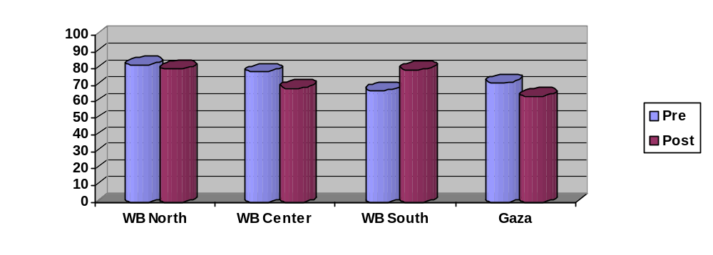Graphs showing comparative results of baseline and end-line surveys
Figure 1: Respiratory tract infections (ARI) % among children under five in the last 3 months [status]
Figure 2: Medical consultation for children with ARI [behaviour]
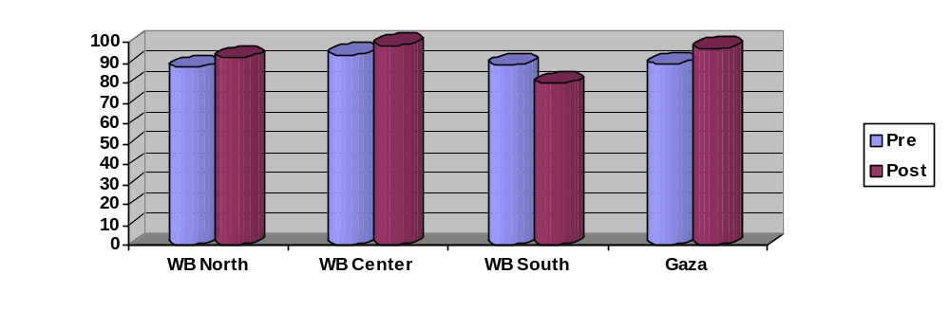
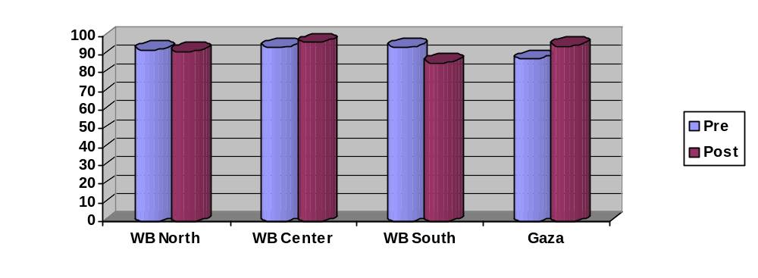Figure 3: Medication received (with or without prescription) for children with ARI [quality of care]
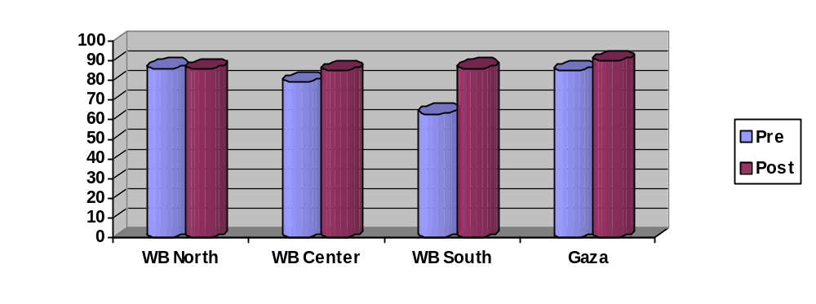Figure 4: Knowledge by mothers of warning signs of ARI (tachypnea, grunting, deterioration of the child’s status) [knowledge]

Figure 5: Knowledge of mothers about how to prepare oral rehydration solution (ORS) [knowledge]
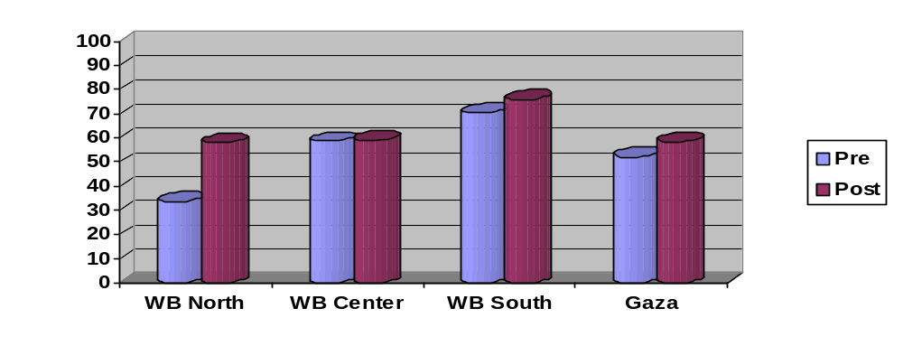
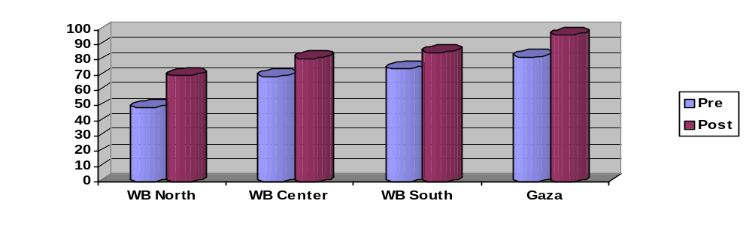Figure 6: Knowledge of mothers of how to administer ORS [knowledge]

Figure 7: Continuation of breast feeding among children with diarrhea [behaviour]
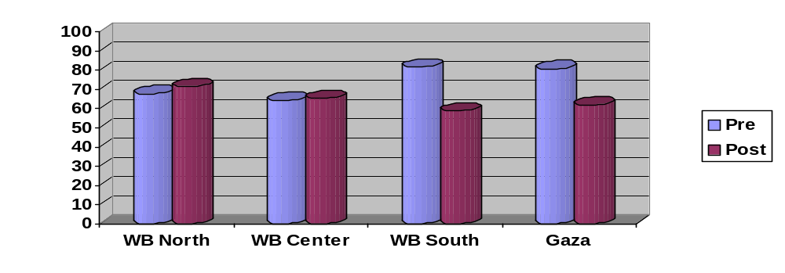
Figure 8: Delivery during the last two years [status]

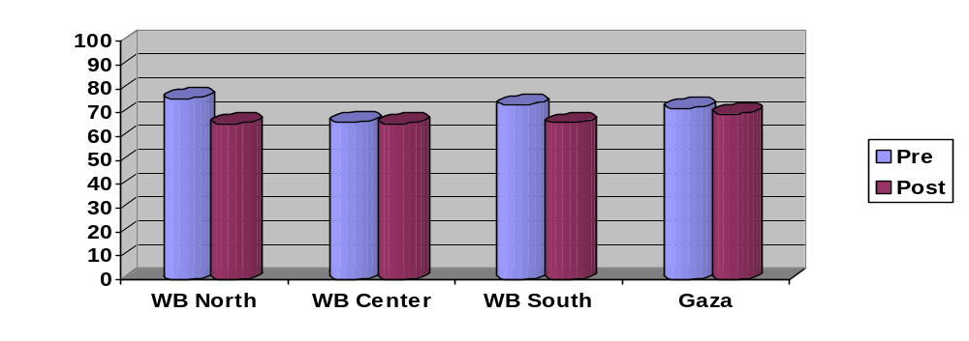
Figure 9: Exclusive breast feeding practices – supplemental feeding in 1st 4 months [behaviour]
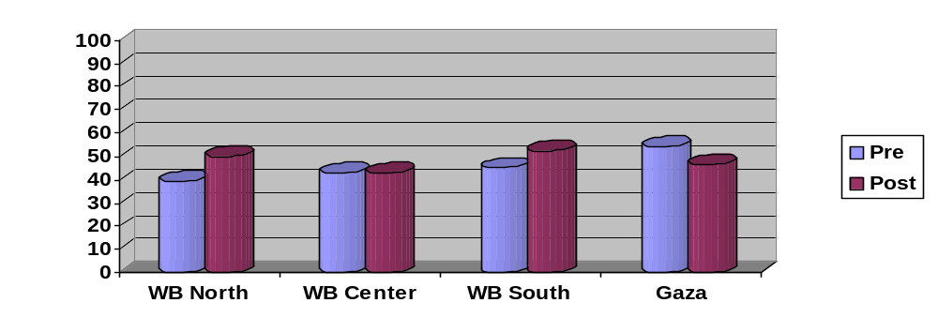Figure 10: Counseling women on health, e.g., anemia, urinary tract infections etc (at clinics or CHW) [quality of care]
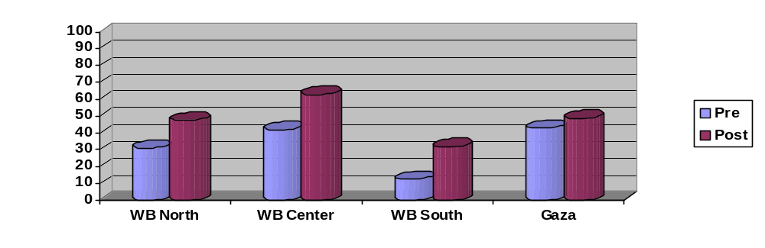
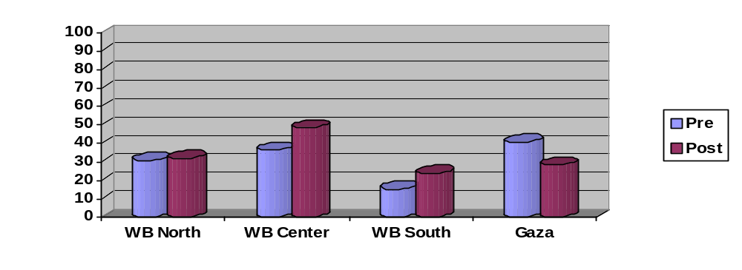Figure 11: % of women in menopause in the family [status]

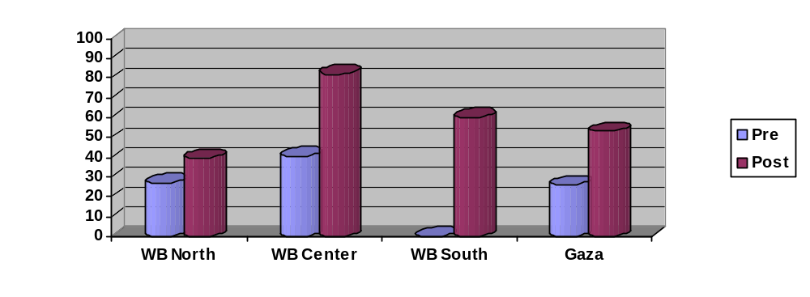Figure 12: % of women who get counseling on diet, psychological health and personnel hygiene [quality of care]

Figure 13: Hypertension among family members [status]
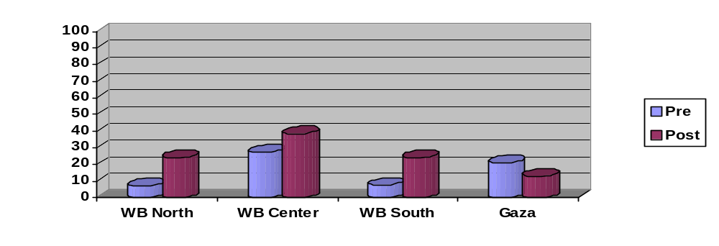

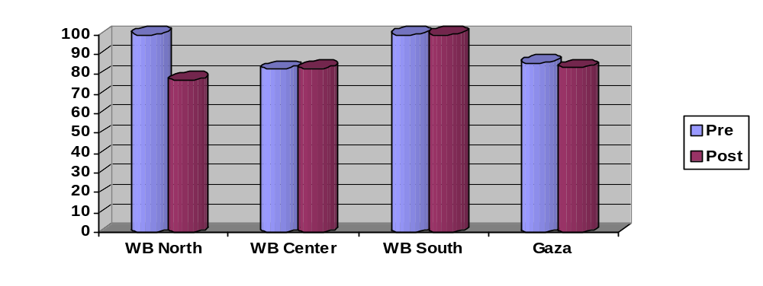Figure 14: Does the affected family member know controllable measures for hypertension (diet, physical exercises, follow up with clinics) [knowledge]
Figure 15: Does the affected member implements one of these controllable measures [behaviour]
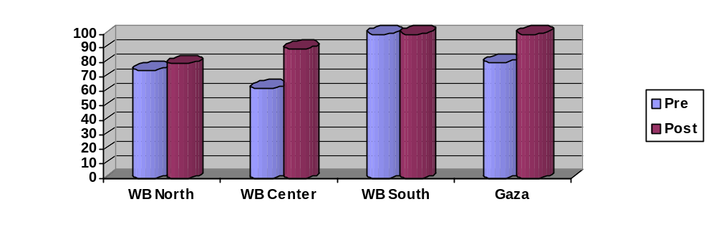
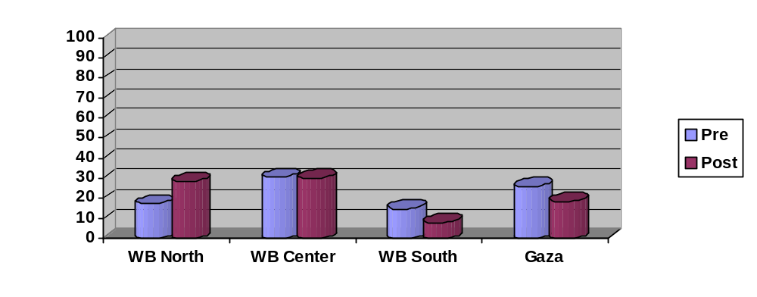Figure 16: Diabetes mellitus among family members [status]

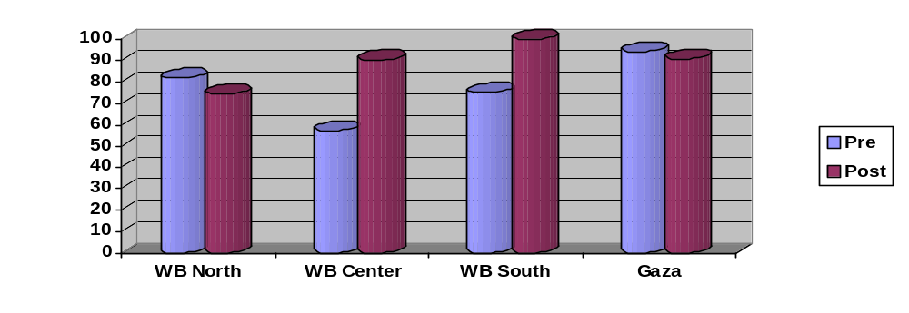Figure 17: Does the affected member implements one of these control measures [behaviour]

Tables for the results of both baseline and end-line household surveys
Note – all responses in this table totaled to 100% on any issue
Response | WB North |  | WB Middle |  | WB South |  | Gaza |  | Total |  | P_value
Response | Pre | Post | Pre | Post | Pre | Post | Pre | Post | Pre | Post | P_value
1. Respiratory tract infections (ARI) % among children under five in the last three months
Yes | 82.1 | 79.5 | 77.9 | 68.2 | 66.7 | 79.3 | 71.6 | 63.3 | 76.5 | 72.5 | 0.257
No | 17.9 | 20.5 | 22.1 | 31.8 | 33.3 | 20.7 | 28.4 | 36.7 | 23.5 | 27.5 | 0.257
2. Medical consultation for children with ARI
Yes | 87.9 | 92.6 | 94.0 | 98.8 | 88.9 | 80.0 | 89.6 | 97.2 | 90.5 | 94.5 | 0.111
No | 12.1 | 7.4 | 6.0 | 1.2 | 11.1 | 20.0 | 10.4 | 2.8 | 9.5 | 5.5 | 0.111
3. Medication received (with or without prescription) for children with ARI (see separate table below for types of medicine received)
Yes | 92.5 | 91.8 | 94.0 | 96.5 | 94.1 | 85.7 | 87.5 | 94.7 | 92.0 | 93.4 | 0.565
No | 7.5 | 8.2 | 6.0 | 3.5 | 5.9 | 14.3 | 12.5 | 5.3 | 8.0 | 6.6 | 0.565
4. Knowledge of mothers of warning signs of ARI (tachypnea, grunting, deterioration of the child’s status)
Yes | 68.4 | 86.0 | 79.3 | 85.2 | 63.0 | 86.2 | 85.1 | 90.0 | 75.8 | 86.4 | 0.001
No | 31.6 | 14.0 | 20.7 | 14.8 | 37.0 | 13.8 | 14.9 | 10.0 | 24.2 | 13.6 | 0.001
5. Knowledge of mothers about how to prepare oral rehydration solution (ORS)
Yes | 33.7 | 57.9 | 58.6 | 58.9 | 70.4 | 75.9 | 52.2 | 58.3 | 50.4 | 59.9 | 0.019
No | 66.3 | 42.1 | 41.4 | 41.1 | 29.6 | 24.1 | 47.8 | 41.7 | 49.6 | 40.1 | 0.019
6. Knowledge of mothers about how to administer ORS
Yes | 48.8 | 69.6 | 69.4 | 81.3 | 74.1 | 85.2 | 82.1 | 96.6 | 66.5 | 79.9 | < 0.001
No | 51.2 | 30.4 | 30.6 | 18.8 | 25.9 | 14.8 | 17.9 | 3.4 | 33.5 | 20.1 | < 0.001
7. Continuation of breast feeding among children with diarrhea
Yes | 67.5 | 71.4 | 64.0 | 65.1 | 81.5 | 58.6 | 80.6 | 61.7 | 71.1 | 66.3 | 0.554
No | 14.5 | 15.9 | 8.1 | 10.9 | 7.4 | 6.9 | 9.0 | 8.3 | 10.3 | 11.9 | 0.554
Did not get diarrhea | 14.5 | 11.9 | 18.6 | 15.5 | 11.1 | 31.0 | 10.4 | 30.0 | 14.4 | 18.0 | 0.554
Do not know | 3.6 | 0.8 | 9.3 | 8.5 | 0.0 | 3.4 | 0.0 | 0.0 | 4.2 | 3.8 | 0.554
8. Delivery during the last two years
Yes | 75.9 | 65.4 | 65.9 | 65.4 | 73.1 | 65.5 | 71.6 | 69.5 | 71.3 | 66.1 | 0.172
No | 24.1 | 34.6 | 34.1 | 34.6 | 26.9 | 34.5 | 28.4 | 30.5 | 28.7 | 33.9 | 0.172
9. Exclusive breast feeding practices - Food supplements given to infant in the first 4 months
Yes | 39.1 | 50.0 | 42.9 | 42.7 | 45.0 | 52.6 | 54.2 | 46.3 | 44.8 | 46.9 | 0.670
No | 60.9 | 50.0 | 57.1 | 57.3 | 55.0 | 47.4 | 45.8 | 53.7 | 55.2 | 53.1 | 0.670
10. Women received counseling on women health issues during last 3 months, e.g., anemia, urinary tract infections etc. (at clinics or from CHW)
Yes | 37.0 | 47.6 | 41.8 | 63.0 | 12.5 | 31.6 | 42.9 | 48.8 | 37.3 | 52.0 | 0.002
No | 63.0 | 52.4 | 58.2 | 37.0 | 87.5 | 68.4 | 57.1 | 51.2 | 62.7 | 48.0 | 0.002
11. Presence of any women in menopause in the family
Yes | 30.9 | 32.1 | 36.6 | 48.8 | 15.4 | 24.0 | 40.9 | 28.3 | 33.7 | 37.5 | 0.352
No | 69.1 | 67.9 | 63.4 | 51.2 | 84.6 | 76.0 | 59.1 | 71.7 | 66.3 | 62.5 | 0.352
12. Did any menopausal women receive counseling regarding her diet, psychological health and personnel hygiene (see separate table below for source of counseling)
Yes | 26.9 | 39.4 | 40.6 | 82.0 | 0.0 | 60.0 | 25.9 | 52.9 | 30.3 | 64.7 | < 0.001
No | 73.1 | 60.6 | 59.4 | 18.0 | 100.0 | 40.0 | 74.1 | 47.1 | 69.7 | 35.3 | < 0.001
13. Presence of hypertension among any family members
Yes | 7.1 | 23.9 | 27.2 | 38.3 | 7.4 | 24.0 | 20.9 | 12.7 | 17.0 | 27.7 | 0.002
No | 92.9 | 76.1 | 72.8 | 61.7 | 92.6 | 76.0 | 79.1 | 87.3 | 83.0 | 72.3 | 0.002
14. Affected person knows control measures for hypertension (diet, physical exercises, follow up with clinics)
Yes | 100.0 | 76.9 | 82.6 | 82.9 | 100.0 | 100.0 | 85.7 | 83.3 | 86.7 | 82.1 | 0.504
No | 0.0 | 23.1 | 17.4 | 17.1 | 0.0 | 0.0 | 14.3 | 16.7 | 13.3 | 17.9 | 0.504
15. Does the affected member implement at least one of these control measures for hypertension
Yes | 75.0 | 79.2 | 62.1 | 89.7 | 100.0 | 100.0 | 80.0 | 100.0 | 70.4 | 87.7 | 0.015
No | 25.0 | 20.8 | 37.9 | 10.3 | 0.0 | 0.0 | 20.0 | 0.0 | 29.6 | 12.3 | 0.015
16. Presence of diabetes mellitus in any family members
Yes | 17.1 | 28.3 | 30.5 | 30.0 | 14.8 | 8.0 | 25.8 | 18.3 | 23.3 | 25.5 | 0.556
No | 82.9 | 71.7 | 69.5 | 70.0 | 85.2 | 92.0 | 74.2 | 81.7 | 76.7 | 74.5 | 0.556
17. Does the affected member implement at least one of these control measures for diabetes
Yes | 81.8 | 74.2 | 57.1 | 90.3 | 75.0 | 100.0 | 94.1 | 90.9 | 73.3 | 84.0 | 0.129
No | 18.2 | 25.8 | 42.9 | 9.7 | 25.0 | 0.0 | 5.9 | 9.1 | 26.7 | 16.0 | 0.129

Detailed tables for selected issues
Response | WB North |  | WB Middle |  | WB South |  | Gaza |  | Total |  | P_value
Response | Pre | Post | Pre | Post | Pre | Post | Pre | Post | Pre | Post | P_value
Type of medication received for ARI in children
Anti-tussive | 6.3 | 9.3 | 11.3 | 14.1 | 18.8 | 11.8 | 4.8 | 8.6 | 8.7 | 11.1 | < 0.001
Anti-pyretic | 9.5 | 7.0 | 24.2 | 15.4 | 0.0 | 0.0 | 0.0 | 0.0 | 11.5 | 8.3 | < 0.001
Antibiotic | 84.1 | 47.7 | 64.5 | 42.3 | 81.3 | 17.6 | 95.2 | 54.3 | 79.8 | 44.4 | < 0.001
All | 0.0 | 14.0 | 0.0 | 3.8 | 0.0 | 29.4 | 0.0 | 5.7 | 0.0 | 10.2 | < 0.001
Antipyretic and Antibiotics | 0.0 | 15.1 | 0.0 | 19.2 | 0.0 | 41.2 | 0.0 | 17.1 | 0.0 | 19.0 | < 0.001
Anti-tussive and Antipyretics | 0.0 | 7.0 | 0.0 | 1.3 | 0.0 | 0.0 | 0.0 | 5.7 | 0.0 | 4.2 | < 0.001
Antipyretic and Antiboitics | 0.0 | 0.0 | 0.0 | 3.8 | 0.0 | 0.0 | 0.0 | 8.6 | 0.0 | 2.8 | < 0.001

Response | WB North |  | WB Middle |  | WB South |  | Gaza |  | Total |  | P_value
Response | Pre | Post | Pre | Post | Pre | Post | Pre | Post | Pre | Post | P_value
Source of counseling for menopausal women who received any counseling on health issues
Home visits | 10.0 | 27.3 | 60.0 | 66.0 | 100.0 | 0.0 | 0.0 | 33.3 | 33.3 | 55.6 | 0.133
Clinic visits | 90.0 | 45.5 | 25.0 | 25.5 | 0.0 | 100.0 | 36.4 | 66.7 | 42.9 | 33.3 | 0.133
media | 0.0 | 0.0 | 10.0 | 2.1 | 0.0 | 0.0 | 9.1 | 0.0 | 7.1 | 1.6 | 0.133
Friends/ neighbor | 0.0 | 0.0 | 0.0 | 4.3 | 0.0 | 0.0 | 9.1 | 0.0 | 2.4 | 3.2 | 0.133
Other | 0.0 | 27.3 | 5.0 | 2.1 | 0.0 | 0.0 | 45.5 | 0.0 | 14.3 | 6.3 | 0.133

Many of the originals for these protocols were developed by the Palestinian NGO sector before the PA and the MoH came into being. The MoH has then revised and adapted them to the current situation of the country.
Note: rather than shifting the CHWs into the clinics, there are more recommendations for expanding the community-based roles of the CHWs. This note, however, does highlight the concurrent shortage of clinic based nurses, particularly since the practical nursing programme was terminated several years ago. As such, the evaluation team does support the idea of a secondary review of nurse training needs so that suggestions of this kind will not detract from the community focus of the CHWs and PHC in Palestine.
Ideas extracted from field discussions and other experiences; indicative of potential opportunities that could be utilized to achieve recommendations or further develop CHWs and community health programming
Endnotes ? Giacaman, R. (2004) Psycho-social/mental health care in the Occupied Palestinian Territories: The embryonic system. Institute of Community and Public Health & The Centre for Continuing Education, Birzeit University.
Barghouti, M. et al (2004) Health and segregation: The impact of the Israeli Separation Wall on access to health care services. HDIP. MoH Women’s Health – doing a study on referral and feedback system; no report yet MoH Women’s Health – collaborating with UNFPA on developing indicators for monitoring community care MoH Women’s Health – doing a pilot study on intensive home visiting for the first week after delivery, in Ramallah; preliminary report in Arabic MoH (including Women’s Health) – doing a pilot study in 6 districts of the ‘comprehensive clinic’ approach; no report yet MoH Women’s Health – pilot programme in Gaza and Hebron on psychosocial care by CHWs, with FP Society; no report yet HDIP – planning for a model trial of community based counseling approach

